Safety Data Sheet

Acetylene

Section 1: Product and Company Identification
Metro Welding Supply Corp.
12620 Southfield Road
Detroit, MI 48223
(313) 834-1660 [phone]
(313) 835-3562 [fax]
http://www.metrowelding.com/

Product Code: Acetylene

Section 2: Hazards Identification
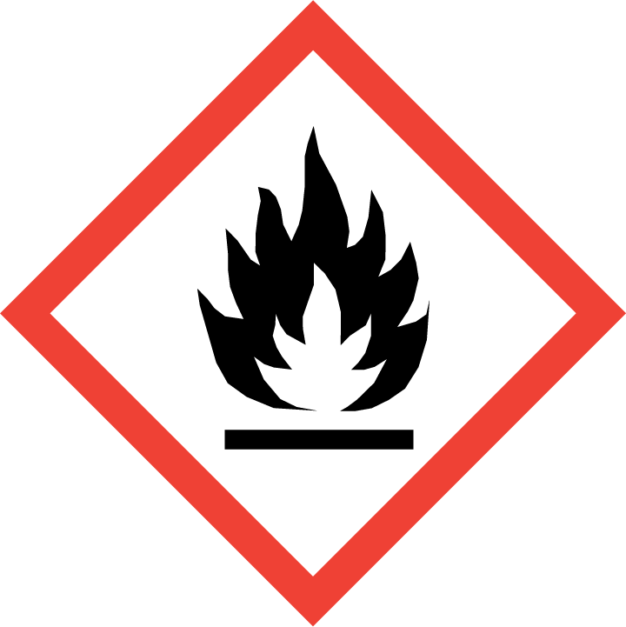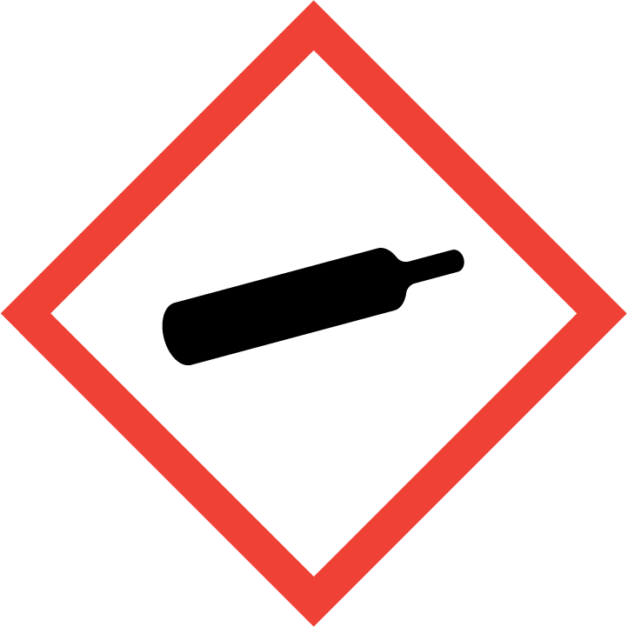
Danger

Hazard Classification:
Flammable (Category 1)
Gases Under Pressure

Hazard Statements:
Contains gas under pressure; may explode if heated
Extremely flammable gas

Precautionary Statements
Prevention:
Keep away from heat/sparks/open flames/hot surfaces. - No smoking.

Response:
Eliminate all ignition sources if safe to do so.
Leaking gas fire: Do not extinguish, unless leak can be stopped safely.

Storage:
Protect from sunlight.
Store in well-ventilated place.

Section 3: Composition/Information on Ingredients

CAS #
74-86-2

Chemical Substance | Chemical Family | Trade Names
ACETYLENE, DISSOLVED | hydrocarbons, aliphatic | ACETYLENE; ETHYNE; WELDING GAS; ACETYLEN; ETHINE; NARCYLEN; VINYLENE; UN 1001; C2H2

Section 4: First Aid Measures
Skin Contact | Eye Contact | Ingestion | Inhalation | Note to Physicians
Gas: Not applicable. Liquid: Wash exposed skin with soap and water. | Gas: Not applicable. Liquid: Flush eyes with plenty of water. | Not applicable. | If adverse effects occur, remove to uncontaminated area. Give artificial respiration if not breathing. If breathing is difficult, oxygen should be administered by qualified personnel. Get immediate medical attention. | For inhalation, consider oxygen.

Section 5: Fire Fighting Measures
Suitable Extinguishing Media | Products of Combustion | Protection of Firefighters
Carbon dioxide, regular dry chemical Large fires: Use regular foam or flood with fine water spray. | Oxides of carbon | - Respiratory protection may be needed for frequent or heavy exposure.  - Any self-contained breathing apparatus with a full facepiece.

Section 6: Accidental Release Measures
Personal Precautions | Environmental Precautions | Methods for Containment
Keep unnecessary people away, isolate hazard area and deny entry. Ventilate closed spaces before entering. | Avoid heat, flames, sparks and other sources of ignition. | Stop leak if possible without personal risk. Reduce vapors with water spray. Remove sources of ignition.

Methods for Cleanup | Other Information
Evacuate, stop leak if possible. Remove sources of ignition. | None

Section 7: Handling and Storage
Handling | Storage
Avoid heat, flames, sparks and other sources of ignition. Grounding and bonding required. Secure to prevent tipping. Subject to storage regulations: U.S. OSHA 29 CFR 1910.101. Keep separated from incompatible substances. | Store and handle in accordance with all current regulations and standards. Protect from physical damage. Store outside or in a detached building. Keep separated from incompatible substances. Store in a cool, dry place. Store in a well-ventilated area.

Section 8: Exposure Controls/Personal Protection
Exposure Guidelines
ACETYLENE, DISSOVED: ACETYLENE: ACGIH (simple asphyxiant) 2500 ppm (2662 mg/m3) NIOSH recommended ceiling

Engineering Controls
Handle only in fully enclosed systems.
Eye Protection | Skin Protection | Respiratory Protection
Eye protection not required, but recommended. | Protective clothing is not required. | Respiratory protection may be needed for frequent or heavy exposure.

General Hygiene considerations
- Avoid breathing vapor or mist
- Avoid contact with eyes and skin
- Wash thoroughly after handling and before eating or drinking

Section 9: Physical and Chemical Properties
Physical State | Appearance | Color | Change in Appearance | Physical Form | Odor | Taste
Gas | Colorless | Colorless | N/A | Liquefied gas | Sweet odor | N/A

Flash Point | Flammability | Partition Coefficient | Autoignition Temperature | Upper Explosive Limits | Lower Explosive Limits
Flammable gas. Can be ignited at all normal temperatures. A flash point of 0 F (-18 C) (CC) has been reported. |  | 2691.53 (log = 3.44) (estimated from water solubility) | 581 F (305 C) | 81%; 100% if there is a substantial energy ignition source, and under certain conditions of pressure, container size and shape.‘ | 0.025

Boiling Point | Freezing Point | Vapor Pressure | Vapor Density | Specific Gravity | Water Solubility | pH | Odor Threshold | Evaporation Rate | Viscosity
-103 F (-75 C) @ 170 kPa abs (24.7 psi abs) or 69 kPa gage (10 psi gage) | Not available | 760 mmHg @ -84 C | 0.9 (Air=1) | Not applicable | 0.94% @ 25 C | Not applicable | 240 mg/m3 (226 ppm) (detection) (4); 657 mg/m3 (620 ppm) (not specified) (8) 1300-2750 mg/m3 (1222-2585 ppm) (not specified) | Not applicable | 0.010 cP @ 20 C

Molecular Weight | Molecular Formula | Density | Weight per Gallon | Volatility by Volume | Volatility | Solvent Solubility
26.04 | H-C-C-H | 1.1747 g/L @ 0 C | Not available | Not available | Not applicable | Soluble: Acetone, benzene, chloroform, ether

Section 10: Stability and Reactivity
Stability | Conditions to Avoid | Incompatible Materials
May decompose violently on heating. May explode when heated. | May decompose violently on heating. May explode when heated. | Metals, halogens, oxidizing materials, metal carbide, reducing agents, halo carbons  BRASS. CALCIUM HYPOCHLORITE, COPPER, MERCURY AND SILVER SALTS, HALOGENS, HEAVY METALS, HYDRIDES, LIQUID NITROGEN, NITRIC ACID , OXYGEN, OZONE, PERCHLORIC ACID, POTASSIUM

Hazardous Decomposition Products | Possibility of Hazardous Reactions
Hydrogen | Polymerizes with evolution of heat. Avoid contact with curing agents, accelerators, and/or initiators.

Section 11: Toxicology Information

Acute Effects
Oral LD50 | Dermal LD50 | Inhalation
Not established | Not established | Nausea, vomiting, chest pain, wheezing, headache, drowsiness, dizziness, loss of coordination, bluish skin color, suffocation, lung congestion, coma

Eye Irritation | Skin Irritation | Sensitization
No information on significant adverse effects | Rash | Central nervous system depression, difficulty breathing, asphyxiant

Chronic Effects
Carcinogenicity | Mutagenicity | Reproductive Effects | Developmental Effects
Not established | Not established | Not established | No data

Section 12: Ecological Information

Fate and Transport
Eco toxicity | Persistence / Degradability | Bioaccumulation / Accumulation | Mobility in Environment
Fish toxicity: Not available  Invertibrate toxicity: Not available  Algal toxicity: Not available  Phyto toxicity: Not available  Other toxicity: Not available | Relatively non-persistent in the environment. Highly volatile from water. | Accumulates very little in the bodies of living organisms. | Not expected to leach through the soil or the sediment.

Section 13: Disposal Considerations
Dispose in accordance with all applicable regulations. Subject to disposal regulations: U.S. EPA 40 CFR 262. Hazardous Waste Number(s): D001. D003.

Section 14: Transportation Information

U.S. DOT 49 CFR 172.101
Proper Shipping Name | ID Number | Hazard Class or Division | Packing Group | Labeling Requirements | Passenger Aircraft or Railcar Quantity Limitations | Cargo Aircraft Only Quantity Limitations | Additional Shipping Description
Acetylene, dissolved | UN1001 | 2.1 | Not applicable | 2.1 | Forbidden | 15 kg | N/A

Canadian Transportation of Dangerous Goods
Shipping Name | UN Number | Class | Packing Group / Risk Group
Acetylene, dissolved | UN1001 | 2.1 | Not applicable

Section 15: Regulatory Information

U.S. Regulations
CERCLA Sections | SARA 355.30 | SARA 355.40
Not regulated. | Not regulated. | Not regulated.

SARA 370.21
Acute | Chronic | Fire | Reactive | Sudden Release
Yes | No | Yes | Yes | Yes

SARA 372.65
Not regulated.

OSHA Process Safety
Not regulated.

State Regulations
CA Proposition 65
Not regulated.

Canadian Regulations
WHMIS Classification
A, B1

National Inventory Status
US Inventory (TSCA) | TSCA 12b Export Notification | Canada Inventory (DSL/NDSL)
Listed on inventory. | Not listed. | Not determined.

Section 16: Other Information
NFPA Rating
HEALTH=1 FIRE=4 REACTIVITY=3
0 = minimal hazard, 1 = slight hazard, 2 = moderate hazard, 3 = severe hazard, 4 = extreme hazard

