Safety Data Sheet

1-Hexene

Section 1: Product and Company Identification
Metro Welding Supply Corp.
12620 Southfield Road
Detroit, MI 48223
(313) 834-1660 [phone]
(313) 835-3562 [fax]
http://www.metrowelding.com/

Product Code: 1-Hexene

Section 2: Hazards Identification
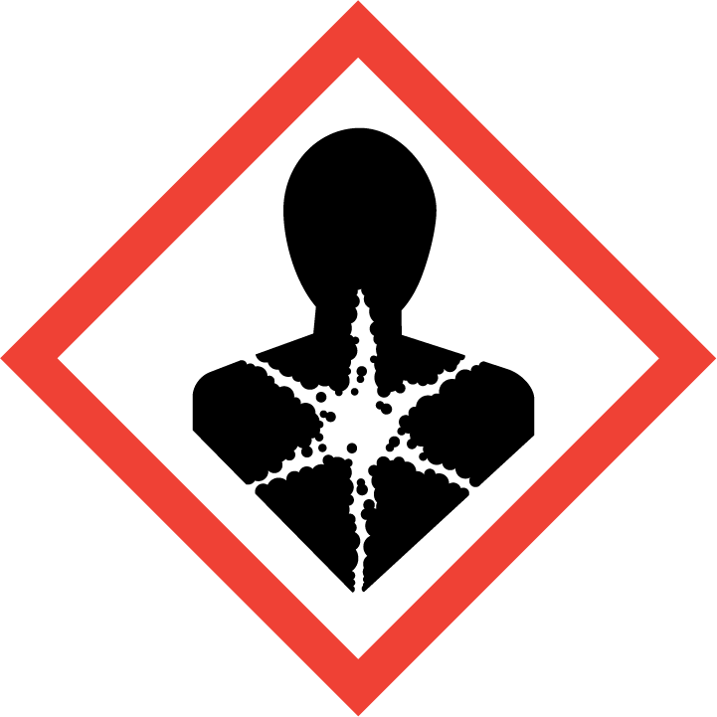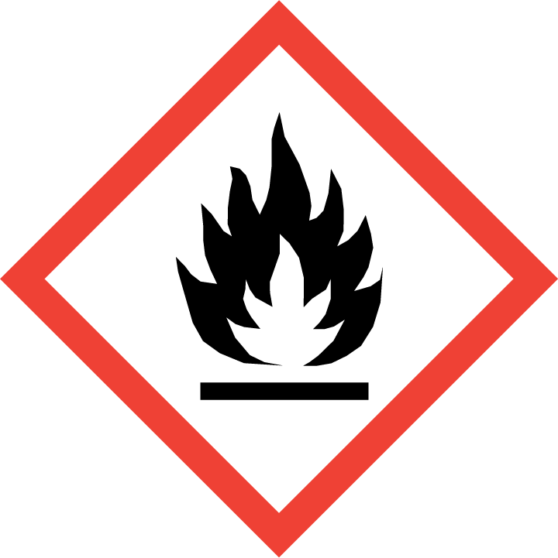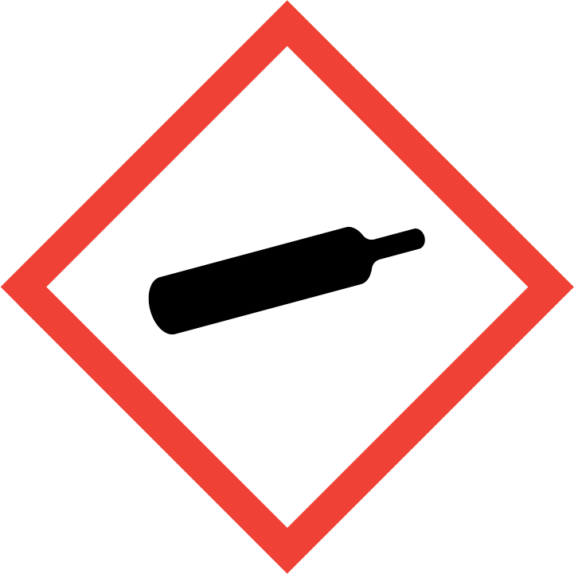
Danger

Hazard Classification:
Aspiration Hazard (Category 1)
Flammable (Category 1)
Gases Under Pressure

Hazard Statements:
Contains gas under pressure; may explode if heated
Extremely flammable gas
May be fatal if swallowed and enters airways

Precautionary Statements
Prevention:
Keep away from heat/sparks/open flames/hot surfaces. - No smoking.

Response:
Do NOT induce vomiting.
Eliminate all ignition sources if safe to do so.
If swallowed: Rinse mouth. Do NOT induce vomiting.
Immediately call a poison center or doctor.
Leaking gas fire: Do not extinguish, unless leak can be stopped safely.

Storage:
Protect from sunlight.
Store in well-ventilated place.
Store locked up.

Disposal:
Dispose of contents and/or container in accordance with applicable regulations.

Section 3: Composition/Information on Ingredients

CAS #
592-41-6

Chemical Substance | Chemical Family | Trade Names
1-HEXENE | hydrocarbons, aliphatic | HEXENE; HEXYLENE; BUTYLETHYLENE; 1-N-HEXENE; HEX-1-ENE; ALPHAHEXENE; UN 2370; C6H12

Section 4: First Aid Measures
Skin Contact | Eye Contact | Ingestion | Inhalation | Note to Physicians
Wash skin with soap and water for at least 15 minutes while removing contaminated clothing and shoes. Get medical attention, if needed. Thoroughly clean and dry contaminated clothing and shoes before reuse. | Flush eyes with plenty of water for at least 15 minutes. Then get immediate medical attention. | Get medical attention immediately. | If adverse effects occur, remove to uncontaminated area. Give artificial respiration if not breathing. Get immediate medical attention. | For ingestion, consider gastric lavage.

Section 5: Fire Fighting Measures
Suitable Extinguishing Media | Products of Combustion | Protection of Firefighters
Regular dry chemical, carbon dioxide, water, regular foam Large fires: Use regular foam or flood with fine water spray. | Carbon monoxide, carbon dioxide, water and toxic and irritating fumes | - Any self-contained breathing apparatus that has a full facepiece and is operated in a pressure-demand or other positive-pressure mode.  - Any self-contained breathing apparatus with a full facepiece.

Section 6: Accidental Release Measures
Personal Precautions | Environmental Precautions | Methods for Containment
Keep unnecessary people away, isolate hazard area and deny entry. | Avoid heat, flames, sparks and other sources of ignition. | Stop leak if possible without personal risk. Reduce vapors with water spray. Remove sources of ignition.

Methods for Cleanup | Other Information
Small spills: Absorb with sand or other non-combustible material. Collect spilled material in appropriate container for disposal. Large spills: Dike for later disposal. | None

Section 7: Handling and Storage
Handling | Storage
Store and handle in accordance with all current regulations and standards. Subject to storage regulations: U.S. OSHA 29 CFR 1910.106. Grounding and bonding required. | Keep separated from incompatible substances.

Section 8: Exposure Controls/Personal Protection
Exposure Guidelines
1-HEXENE: 50 ppm ACGIH TWA

Engineering Controls
Handle only in fully enclosed systems.
Eye Protection | Skin Protection | Respiratory Protection
Wear splash resistant safety goggles. Provide an emergency eye wash fountain and quick drench shower in the immediate work area. | Wear appropriate chemical resistant clothing. | Any self-contained breathing apparatus that has a full facepiece and is operated in a pressure-demand or other positive-pressure mode.

General Hygiene considerations
- Avoid breathing vapor or mist
- Avoid contact with eyes and skin
- Wash thoroughly after handling and before eating or drinking

Section 9: Physical and Chemical Properties
Physical State | Appearance | Color | Change in Appearance | Physical Form | Odor | Taste
Liquid | Colorless | Colorless | N/A | Gas | Not available | N/A

Flash Point | Flammability | Partition Coefficient | Autoignition Temperature | Upper Explosive Limits | Lower Explosive Limits
-15 F (-26 C) (CC) | IB |  | 487 F (253 C) | 0.092 | 0.012

Boiling Point | Freezing Point | Vapor Pressure | Vapor Density | Specific Gravity | Water Solubility | pH | Odor Threshold | Evaporation Rate | Viscosity
145 F (63 C) | -220 F (-140 C) | 310 mmHg @ 38 C | 3 (Air=1) | 0.6731 | Insoluble | Not available | Not available | Not available | 0.35 mPa.s (0.35 centipoises) @ 20 C; 0.25 mPa.s (0.25 centipoises) @ 25 C

Molecular Weight | Molecular Formula | Density | Weight per Gallon | Volatility by Volume | Volatility | Solvent Solubility
84.16 | C-H3-(C-H2)3-C-H-C-H2 | Not available | Not available | 100% | Not available | Soluble: Alcohol, ether, benzene, chloroform, petroleum ether

Section 10: Stability and Reactivity
Stability | Conditions to Avoid | Incompatible Materials
Stable at normal temperatures and pressure. | Stable at normal temperatures and pressure. | Oxidizing materials

Hazardous Decomposition Products | Possibility of Hazardous Reactions
Oxides of carbon. May form peroxides on prolonged exposure to air. | Will not polymerize.

Section 11: Toxicology Information

Acute Effects
Oral LD50 | Dermal LD50 | Inhalation
LD50 (oral, rat): greater than 5600 mg/kg | LD50 (dermal, rabbit): greater than 2000 mg/kg (cited as at 2.0 g/kg 0/8 rabbits died | Irritation, vomiting, difficulty breathing, symptoms of drunkenness, bluish skin color

Eye Irritation | Skin Irritation | Sensitization
Irritation | Irritation | Respiratory tract irritation, skin irritation, eye irritation, central nervous system depression

Chronic Effects
Carcinogenicity | Mutagenicity | Reproductive Effects | Developmental Effects
Not listed | Not established | Not established | No data

Section 12: Ecological Information

Fate and Transport
Eco toxicity | Persistence / Degradability | Bioaccumulation / Accumulation | Mobility in Environment
Fish toxicity: 96 Hr LC50 Oncorhynchus mykiss: 5.6 mg/L [semi-static]  Invertibrate toxicity: 48 Hr EC50 Daphnia magna: 230 mg/L; 48 Hr EC50 Daphnia magna: 30 mg/L [Static]  Algal toxicity: 96 Hr EC50 Pseudokirchneriella subcapitata: >1000 mg/L  Phyto toxicity: Not available  Other toxicity: Not available | Not available | Not available | Not available

Section 13: Disposal Considerations
Subject to disposal regulations: U.S. EPA 40 CFR 262. Hazardous Waste Number(s): D001. Dispose in accordance with all applicable regulations.

Section 14: Transportation Information

U.S. DOT 49 CFR 172.101
Proper Shipping Name | ID Number | Hazard Class or Division | Packing Group | Labeling Requirements | Passenger Aircraft or Railcar Quantity Limitations | Cargo Aircraft Only Quantity Limitations | Additional Shipping Description
1-Hexene | UN2370 | 3 | II | 3 | 5 kg or L | N/A | N/A

Canadian Transportation of Dangerous Goods
Shipping Name | UN Number | Class | Packing Group / Risk Group
1-Hexene | UN2370 | 3 | II

Section 15: Regulatory Information

U.S. Regulations
CERCLA Sections | SARA 355.30 | SARA 355.40
Not regulated. | Not regulated. | Not regulated.

SARA 370.21
Acute | Chronic | Fire | Reactive | Sudden Release
Yes | No | Yes | No | No

SARA 372.65
Not regulated.

OSHA Process Safety
Not regulated.

State Regulations
CA Proposition 65
Not regulated.

Canadian Regulations
WHMIS Classification
B, D2

National Inventory Status
US Inventory (TSCA) | TSCA 12b Export Notification | Canada Inventory (DSL/NDSL)
Listed on inventory. | Not listed. | Not determined.

Section 16: Other Information
NFPA Rating
HEALTH=2 FIRE=3 REACTIVITY=0
0 = minimal hazard, 1 = slight hazard, 2 = moderate hazard, 3 = severe hazard, 4 = extreme hazard

