Safety Data Sheet

Phosphine

Section 1: Product and Company Identification
Metro Welding Supply Corp.
12620 Southfield Road
Detroit, MI 48223
(313) 834-1660 [phone]
(313) 835-3562 [fax]
http://www.metrowelding.com/

Product Code: Phosphine

Section 2: Hazards Identification
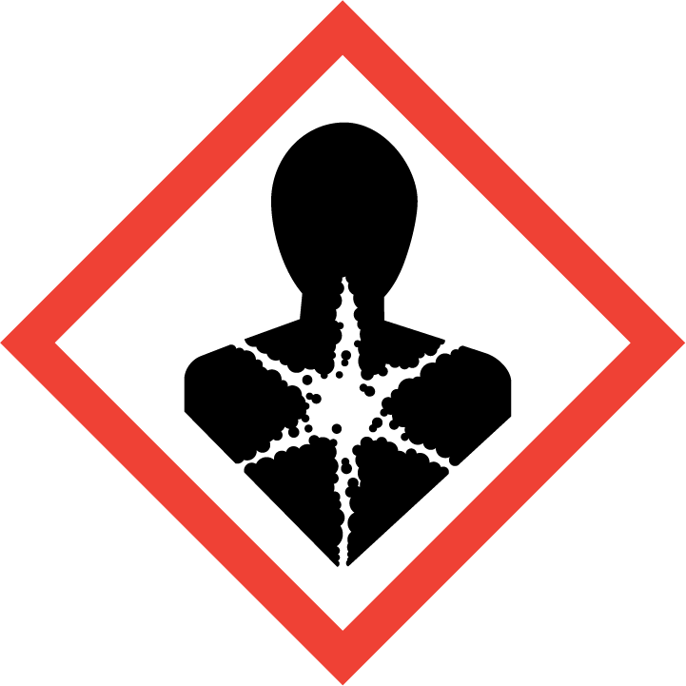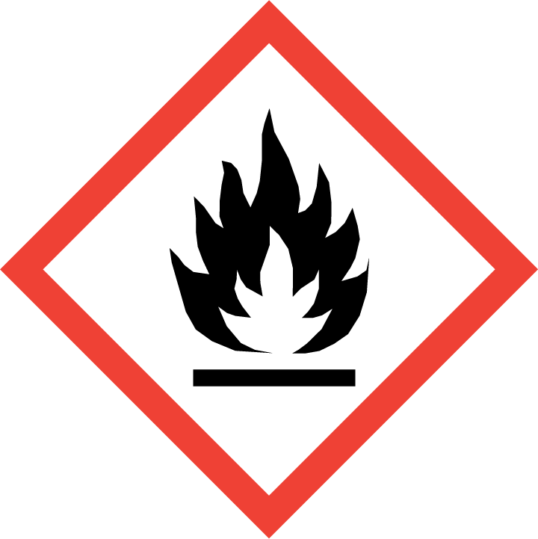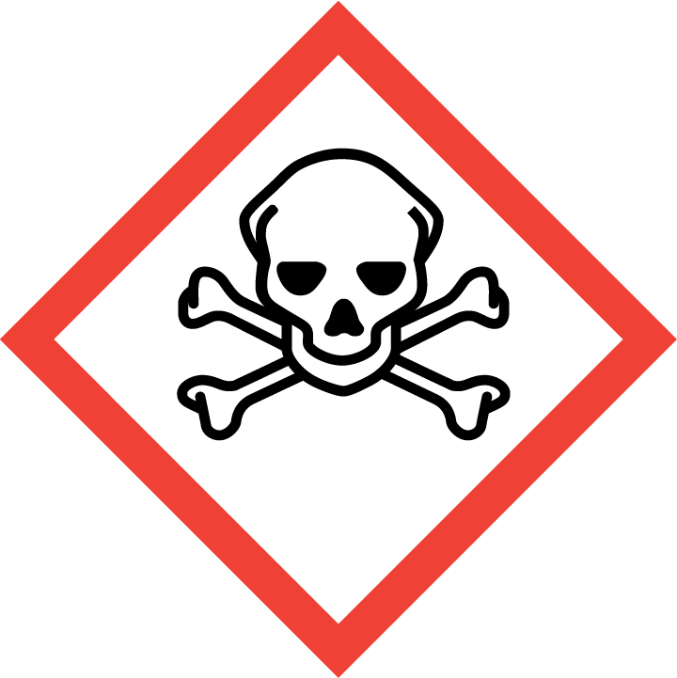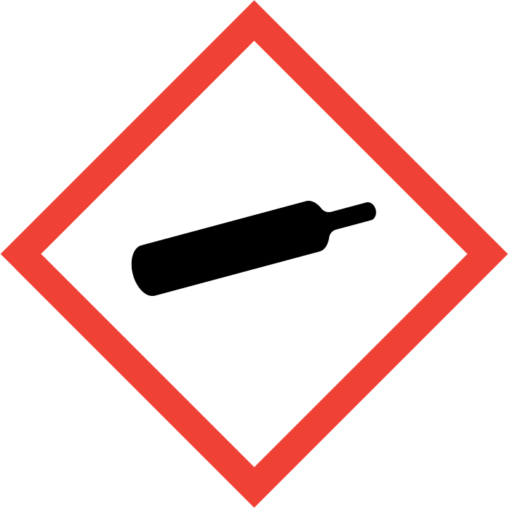
Danger

Hazard Classification:
Acute Gas Inhale Toxicity (Category 1)
Acute Vapor Inhale Toxicity (Category 4)
Aspiration Hazard (Category 1)
Flammable (Category 1)
Flammable Aerosol (Category 1)
Gases Under Pressure

Hazard Statements:
Contains gas under pressure; may explode if heated
Extremely flammable aerosol
Extremely flammable gas
Fatal if inhaled
Harmful if inhaled
May be fatal if swallowed and enters airways

Precautionary Statements
Prevention:
Do not breathe dust/fume/gas/mist/ vapors/spray..
[In case of inadequate ventilation] wear respiratory protection.
Use only outdoors or in a well-ventilated area.
Keep away from heat/sparks/open flames/hot surfaces. - No smoking.
Pressurized container: Do not pierce or burn, even after use.
Do not spray on an open flame or other ignition source.

Response:
Eliminate all ignition sources if safe to do so.
Immediately call a poison center or doctor.
Leaking gas fire: Do not extinguish, unless leak can be stopped safely.
Do NOT induce vomiting.
Specific treatment is urgent.
If swallowed: Rinse mouth. Do NOT induce vomiting.
If inhaled: Remove person to fresh air and keep comfortable for breathing.

Storage:
Store in a well-ventilated place. Keep container tightly closed.
Protect from sunlight.
Store locked up.
Do not expose to temperatures exceeding 50C/122F.

Disposal:
Dispose of contents and/or container in accordance with applicable regulations.

Section 3: Composition/Information on Ingredients

CAS #
7803-51-2

Chemical Substance | Chemical Family | Trade Names
PHOSPHINE | hydrides | HYDROGEN PHOSPHIDE; CELPHOS; DELICIA; DETIA; DETIA GAS EX-B; GASEX-B; PHOSPHORUS TRIHYDRIDE; RCRA P096; UN 2199

Section 4: First Aid Measures
Skin Contact | Eye Contact | Ingestion | Inhalation | Note to Physicians
If frostbite or freezing occur, immediately flush with plenty of lukewarm water (105-115 F; 41-46 C). DO NOT USE HOT WATER. If warm water is not available, gently wrap affected parts in blankets. Get immediate medical attention. | Contact with liquid: Immediately flush eyes with plenty of water for at least 15 minutes. Then get immediate medical attention. | If a large amount is swallowed, get medical attention. | If adverse effects occur, remove to uncontaminated area. Give artificial respiration if not breathing. Get immediate medical attention. | None

Section 5: Fire Fighting Measures
Suitable Extinguishing Media | Products of Combustion | Protection of Firefighters
Let burn unless leak can be stopped immediately. Large fires: Use regular foam or flood with fine water spray. | Hydrogen, forms explosive mixtures with air | - Any supplied-air respirator operated in a pressure-demand or other positive-pressure mode. Use chemical resistant suit.  - Any supplied-air respirator operated in a pressure-demand or other positive-pressure mode. Use chemical resistant suit.

Section 6: Accidental Release Measures
Personal Precautions | Environmental Precautions | Methods for Containment
Keep unnecessary people away, isolate hazard area and deny entry. Ventilate closed spaces before entering. | Avoid heat, flames, sparks and other sources of ignition. | Stop leak if possible without personal risk. Reduce vapors with water spray. Remove sources of ignition.

Methods for Cleanup | Other Information
Stop leak, evacuate area, and contact emergency personnel. | Notify Local Emergency Planning Committee and State Emergency Response Commission for release greater than or equal to RG (U.S. SARA Section 304). If release occurs in the U.S. and is reportable under CERCLA Section 103, notify the National Response Center at (800)424-8802 (USA) or (202)426-2675 (USA).

Section 7: Handling and Storage
Handling | Storage
Store and handle in accordance with all current regulations and standards. Subject to storage regulations: U.S. OSHA 29 CFR 1910.101. Notify State Emergency Response Commission for storage or use at amounts greater than or equal to the TPQ (U.S. EPA SARA Section 302). SARA Section 303 requires facilities storing a material with a TPQ to participate in local emergency response planning (U.S. EPA 40 CFR 355.30). | Keep separated from incompatible substances.

Section 8: Exposure Controls/Personal Protection
Exposure Guidelines
PHOPHINE: 0.3 ppm (0.4 mg/m3) OSHA TWA 1 ppm (1 mg/m3) OSHA STEL (vacated by 58 FR 35338, June 30, 1993) 0.3 ppm ACGIH TWA 1 ppm ACGIH STEL 0.3 ppm (0.4 mg/m3) NIOSH recommended TWA 10 hour(s) 1 ppm (1 mg/m3) NIOSH recommended STEL

Engineering Controls
Handle only in fully enclosed systems.
Eye Protection | Skin Protection | Respiratory Protection
For the gas: Eye protection not required, but recommended. For the liquid: Wear splash resistant safety goggles. Contact lenses should not be worn. Provide an emergency eye wash fountain and quick drench shower in the immediate work area. | For the gas: Wear appropriate chemical resistant clothing. For the liquid: Wear appropriate protective, cold insulating clothing. | Any supplied-air respirator operated in a pressure-demand or other positive-pressure mode. Use chemical resistant suit.

General Hygiene considerations
- Avoid breathing vapor or mist
- Avoid contact with eyes and skin
- Wash thoroughly after handling and before eating or drinking

Section 9: Physical and Chemical Properties
Physical State | Appearance | Color | Change in Appearance | Physical Form | Odor | Taste
Gas | Clear | Colorless | N/A | Gas, liquid | Unpleasant odor, fishy odor, garlic odor | N/A

Flash Point | Flammability | Partition Coefficient | Autoignition Temperature | Upper Explosive Limits | Lower Explosive Limits
Flammable | Not available | Not available | 212 F (100 C) | 0.98 | 0.01

Boiling Point | Freezing Point | Vapor Pressure | Vapor Density | Specific Gravity | Water Solubility | pH | Odor Threshold | Evaporation Rate | Viscosity
-126 F (-87.7 C) | -208.3 F (-133.5 C) | 41.9 bar @ 20 C | 1.17 (Air=1) | 77°F (25°C) and 1 atm: 1.18 | 26% @ 17 C | Neutral in solution | 0.021 ppm | Not applicable | Not available

Molecular Weight | Molecular Formula | Density | Weight per Gallon | Volatility by Volume | Volatility | Solvent Solubility
34 | P-H3 | Not available | Not available | 100% | Not applicable | Soluble: Alcohol, ether, cuprous chloride solutions, cyclohexanol

Section 10: Stability and Reactivity
Stability | Conditions to Avoid | Incompatible Materials
May ignite on exposure to air. | May ignite on exposure to air. | Acids, halogens, oxidizing materials, halo carbons, metal nitrates, nitrous oxide, potassium, ammonia

Hazardous Decomposition Products | Possibility of Hazardous Reactions
Oxides of phosphorus | Will not polymerize.

Section 11: Toxicology Information

Acute Effects
Oral LD50 | Dermal LD50 | Inhalation
LC50, 1 hr, rat = 20 ppm | Not available | Toxic. irritation, garlic odor, tearing, nausea, vomiting, diarrhea, stomach pain, difficulty breathing, irregular heartbeat, headache, drowsiness, symptoms of drunkenness, fainting, tingling sensation, visual disturbances, dilated pupils, bluish skin color, lung congestion, kidney damage, liver damage, paralysis, convulsions, coma, death

Eye Irritation | Skin Irritation | Sensitization
Liquid: frostbite, blurred vision | Liquid: blisters, frostbite | Potentially fatal if inhaled, respiratory tract irritation, central nervous system depression

Chronic Effects
Carcinogenicity | Mutagenicity | Reproductive Effects | Developmental Effects
Not available | Available. | Not available | No data

Section 12: Ecological Information

Fate and Transport
Eco toxicity | Persistence / Degradability | Bioaccumulation / Accumulation | Mobility in Environment
Fish toxicity: Not available  Invertibrate toxicity: Not available  Algal toxicity: Not available  Phyto toxicity: Not available  Other toxicity: Not available | Not available | Not available | Not available

Section 13: Disposal Considerations
Dispose in accordance with all applicable regulations. Subject to disposal regulations: U.S. EPA 40 CFR 262. Hazardous Waste Number(s): P096.

Section 14: Transportation Information

U.S. DOT 49 CFR 172.101
Proper Shipping Name | ID Number | Hazard Class or Division | Packing Group | Labeling Requirements | Passenger Aircraft or Railcar Quantity Limitations | Cargo Aircraft Only Quantity Limitations | Additional Shipping Description
Phosphine | UN2199 | 2.3 | Not applicable | 2.3; 2.1 | Forbidden | Forbidden | Toxic-Inhalation Hazard Zone A

Canadian Transportation of Dangerous Goods
Shipping Name | UN Number | Class | Packing Group / Risk Group
Phosphine | UN2199 | 2.3; 2.1 | Not applicable

Section 15: Regulatory Information

U.S. Regulations
CERCLA Sections | SARA 355.30 | SARA 355.40
100 LBS RQ | 500 LBS TPQ | 100 LBS RQ

SARA 370.21
Acute | Chronic | Fire | Reactive | Sudden Release
Yes | No | Yes | Yes | Yes

SARA 372.65
PHOSPHINE

OSHA Process Safety
100 LBS TQ

State Regulations
CA Proposition 65
Not regulated.

Canadian Regulations
WHMIS Classification
ABD1

National Inventory Status
US Inventory (TSCA) | TSCA 12b Export Notification | Canada Inventory (DSL/NDSL)
Listed on inventory. | Not listed. | Not determined.

Section 16: Other Information
NFPA Rating
HEALTH=4 FIRE=4 REACTIVITY=2
0 = minimal hazard, 1 = slight hazard, 2 = moderate hazard, 3 = severe hazard, 4 = extreme hazard

