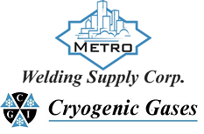 | Safety Data Sheet  Carbon Monoxide

Section 1: Product and Company Identification
Metro Welding Supply Corp.
12620 Southfield Road
Detroit, MI 48223
(313) 834-1660 [phone]
(313) 835-3562 [fax]
http://www.metrowelding.com/

Product Code: Carbon Monoxide

Section 2: Hazards Identification
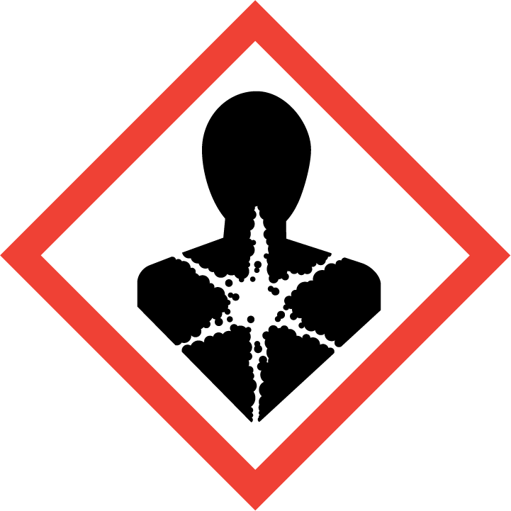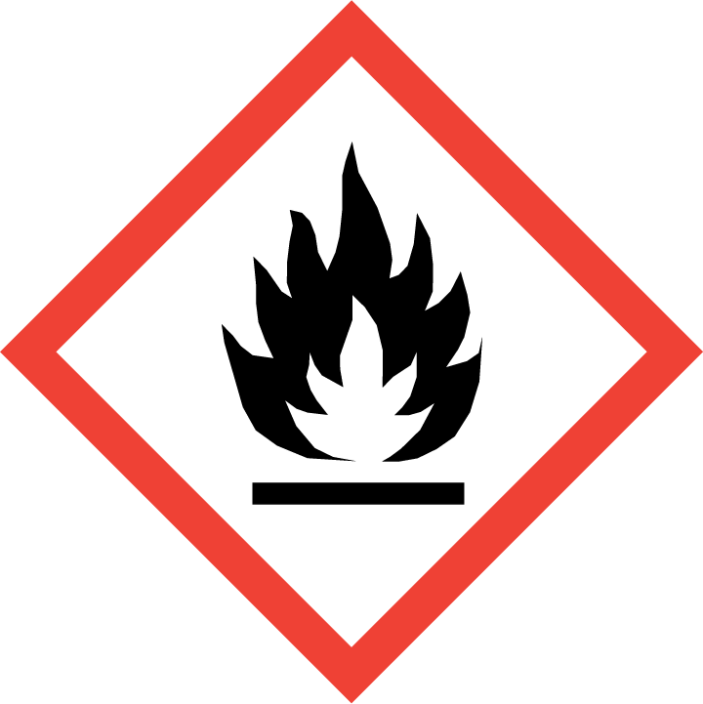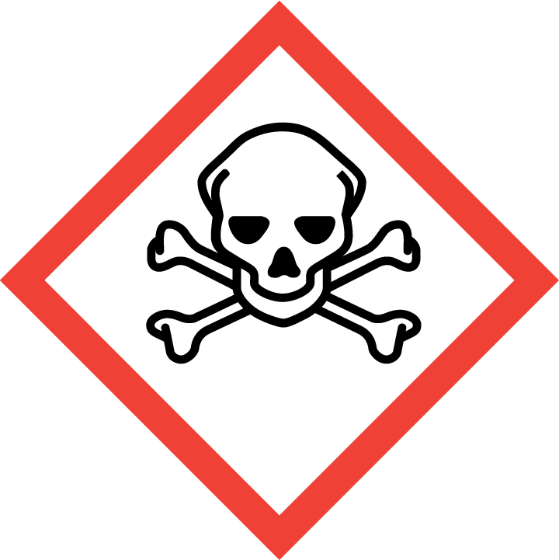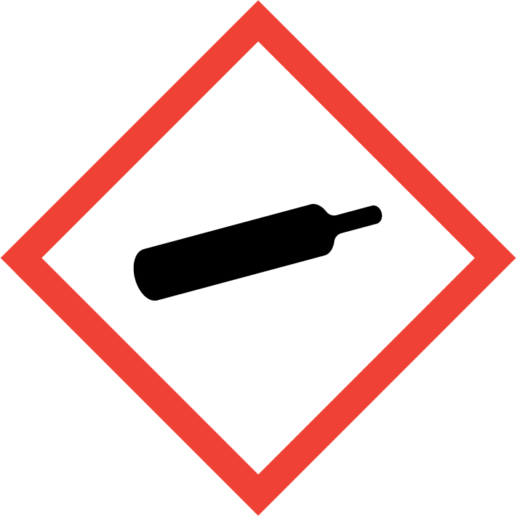
Danger

Hazard Classification:
Acute Gas Inhale Toxicity (Category 3)
Aspiration Hazard (Category 1)
Flammable (Category 1)
Flammable Aerosol (Category 1)
Gases Under Pressure

Hazard Statements:
Contains gas under pressure; may explode if heated
Extremely flammable aerosol
Extremely flammable gas
May be fatal if swallowed and enters airways
Toxic if inhaled

Precautionary Statements
Prevention:
Avoid breathing dust/fume/gas/mist/ vapors/spray.
[In case of inadequate ventilation] wear respiratory protection.
Use only outdoors or in a well-ventilated area.
Keep away from heat/sparks/open flames/hot surfaces. - No smoking.
Pressurized container: Do not pierce or burn, even after use.
Do not spray on an open flame or other ignition source.

Response:
Leaking gas fire: Do not extinguish, unless leak can be stopped safely.
Eliminate all ignition sources if safe to do so.
Do NOT induce vomiting.
If swallowed: Rinse mouth. Do NOT induce vomiting.
If inhaled: Remove person to fresh air and keep comfortable for breathing.
Immediately call a poison center or doctor.

Storage:
Store in a well-ventilated place. Keep container tightly closed.
Protect from sunlight.
Store locked up.
Do not expose to temperatures exceeding 50C/122F.

Disposal:
Dispose of contents and/or container in accordance with applicable regulations.

Section 3: Composition/Information on Ingredients

CAS #
630-08-0

Chemical Substance | Chemical Family | Trade Names
CARBON MONOXIDE | inorganic, gas | CARBON OXIDE; CARBON OXIDE (CO); UN 1016; CO

Section 4: First Aid Measures
Skin Contact | Eye Contact | Ingestion | Inhalation | Note to Physicians
Wash skin with soap and water for at least 15 minutes while removing contaminated clothing and shoes. Get medical attention, if needed. Thoroughly clean and dry contaminated clothing and shoes before reuse. | Flush eyes with plenty of water for at least 15 minutes. Then get immediate medical attention. | If a large amount is swallowed, get medical attention. | If adverse effects occur, remove to uncontaminated area. Give artificial respiration if not breathing. If breathing is difficult, oxygen should be administered by qualified personnel. Get immediate medical attention. | For inhalation, consider oxygen.

Section 5: Fire Fighting Measures
Suitable Extinguishing Media | Products of Combustion | Protection of Firefighters
Carbon dioxide, regular dry chemical Large fires: Use regular foam or flood with fine water spray. | Carbon dioxide | - Any supplied-air respirator with full facepiece and operated in a pressure-demand or other positive-pressure mode in combination with a separate escape supply.  - Any supplied-air respirator with full facepiece and operated in a pressure-demand or other positive-pressure mode in combination with a separate escape supply.

Section 6: Accidental Release Measures
Personal Precautions | Environmental Precautions | Methods for Containment
Keep unnecessary people away, isolate hazard area and deny entry. Ventilate closed spaces before entering. | Avoid heat, flames, sparks and other sources of ignition. Keep out of water supplies and sewers. | Stop leak if possible without personal risk. Reduce vapors with water spray. Remove sources of ignition.

Methods for Cleanup | Other Information
Stop leak, evacuate area. Wear protective equipment. | Subject to California Safe Drinking Water and Toxic Enforcement Act of 1986 (Proposition 65).

Section 7: Handling and Storage
Handling | Storage
Keep separated from incompatible substances. | Store and handle in accordance with all current regulations and standards. Grounding and bonding required. Subject to storage regulations: U.S. OSHA 29 CFR 1910.101.

Section 8: Exposure Controls/Personal Protection
Exposure Guidelines
CARBON MONOXIDE: 50 ppm (55 mg/m3) OSHA TWA 35 ppm (40 mg/m3) OSHA TWA (vacated by 58 FR 35338, June 30, 1993) 200 ppm (229 mg/m3) OSHA ceiling (vacated by 58 FR 35338, June 30, 1993) 25 ppm ACGIH TWA 35 ppm (40 mg/m3) NIOSH recommended TWA 10 hour(s) 200 ppm (229 mg/m3) NIOSH recommended ceiling

Engineering Controls
Handle only in fully enclosed systems.
Eye Protection | Skin Protection | Respiratory Protection
Eye protection not required, but recommended. | Protective clothing is not required. | Any supplied-air respirator with full facepiece and operated in a pressure-demand or other positive-pressure mode in combination with a separate escape supply.

General Hygiene considerations
- Avoid breathing vapor or mist
- Avoid contact with eyes and skin
- Wash thoroughly after handling and before eating or drinking

Section 9: Physical and Chemical Properties
Physical State | Appearance | Color | Change in Appearance | Physical Form | Odor | Taste
Gas | Colorless | Colorless | N/A | Gas | Odorless | Tasteless

Flash Point | Flammability | Partition Coefficient | Autoignition Temperature | Upper Explosive Limits | Lower Explosive Limits
Flammable | Not available | 1479.11 (log = 3.17) (estimated from water solubility) | 1128-1202 F (609-650 C) | 0.74 | 12.0-12.5%

Boiling Point | Freezing Point | Vapor Pressure | Vapor Density | Specific Gravity | Water Solubility | pH | Odor Threshold | Evaporation Rate | Viscosity
-312.7 F (-191.5 C) | -326 F (-199 C) | 760 mmHg @ -191 C gas; cannot be liquefied at room temperature | 0.968 (Air=1) | Not applicable | 2.3% @ 20 C | Not applicable | Not available | Not applicable | 0.01657 cP @ 0 C

Molecular Weight | Molecular Formula | Density | Weight per Gallon | Volatility by Volume | Volatility | Solvent Solubility
28.01 | C-O | 1.250 g/L @ 0 C | Not available | 100% | Not applicable | Soluble: Alcohol, benzene, acetic acid, ethyl acetate, chloroform, cuprous chloride solutions

Section 10: Stability and Reactivity
Stability | Conditions to Avoid | Incompatible Materials
Stable at normal temperatures and pressure. | Stable at normal temperatures and pressure. | Oxidizing materials, halogens, metal oxides, metals, combustible materials, lithium

Hazardous Decomposition Products | Possibility of Hazardous Reactions
Oxides of carbon | Will not polymerize.

Section 11: Toxicology Information

Acute Effects
Oral LD50 | Dermal LD50 | Inhalation
LC50 Inhalation Gas. Rat 1807 ppm 4 hours | Not available | Changes in body temperature, changes in blood pressure, nausea, vomiting, chest pain, difficulty breathing, irregular heartbeat, headache, drowsiness, dizziness, disorientation, hallucinations, pain in extremities, tremors, loss of coordination, hearing loss, visual disturbances, eye damage, suffocation, blood disorders, convulsions, coma

Eye Irritation | Skin Irritation | Sensitization
No information on significant adverse effects | No information on significant adverse effects | Blood damage, suffocation

Chronic Effects
Carcinogenicity | Mutagenicity | Reproductive Effects | Developmental Effects
Not available | Available. | Available. | No data

Section 12: Ecological Information

Fate and Transport
Eco toxicity | Persistence / Degradability | Bioaccumulation / Accumulation | Mobility in Environment
Fish toxicity: 75000 ug/L 1 day(s) LC100 (Mortality) Orangespotted sunfish (Lepomis humilis)  Invertibrate toxicity: Not available  Algal toxicity: Not available  Phyto toxicity: Not available  Other toxicity: Not available | Relatively non-persistent in the environment. Highly volatile from water. | Not available | Not expected to leach through the soil or the sediment.

Section 13: Disposal Considerations
Dispose in accordance with all applicable regulations. Subject to disposal regulations: U.S. EPA 40 CFR 262. Hazardous Waste Number(s): D001.

Section 14: Transportation Information

U.S. DOT 49 CFR 172.101
Proper Shipping Name | ID Number | Hazard Class or Division | Packing Group | Labeling Requirements | Passenger Aircraft or Railcar Quantity Limitations | Cargo Aircraft Only Quantity Limitations | Additional Shipping Description
Carbon monoxide, compressed | UN1016 | 2.3 | Not applicable | 2.3; 2.1 | Forbidden | 25 kg | Toxic-Inhalation Hazard Zone D

Canadian Transportation of Dangerous Goods
Shipping Name | UN Number | Class | Packing Group / Risk Group
Carbon monoxide, compressed | UN1016 | 2.3; 2.1 | Not applicable

Section 15: Regulatory Information

U.S. Regulations
CERCLA Sections | SARA 355.30 | SARA 355.40
Not regulated. | Not regulated. | Not regulated.

SARA 370.21
Acute | Chronic | Fire | Reactive | Sudden Release
Yes | No | Yes | No | Yes

SARA 372.65
Not regulated.

OSHA Process Safety
Not regulated.

State Regulations
CA Proposition 65
Known to the state of California to cause the following: Carbon monoxide Developmental toxicity (Jul 01, 1989)

Canadian Regulations
WHMIS Classification
A, B1, D1A, D2A.

National Inventory Status
US Inventory (TSCA) | TSCA 12b Export Notification | Canada Inventory (DSL/NDSL)
Listed on inventory. | Not listed. | Listed on inventory.

Section 16: Other Information
NFPA Rating
HEALTH=3 FIRE=4 REACTIVITY=0
0 = minimal hazard, 1 = slight hazard, 2 = moderate hazard, 3 = severe hazard, 4 = extreme hazard

