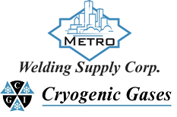 | Safety Data Sheet  Ethyl Chloride

Section 1: Product and Company Identification
Metro Welding Supply Corp.
12620 Southfield Road
Detroit, MI 48223
(313) 834-1660 [phone]
(313) 835-3562 [fax]
http://www.metrowelding.com/

Product Code: Ethyl Chloride

Section 2: Hazards Identification
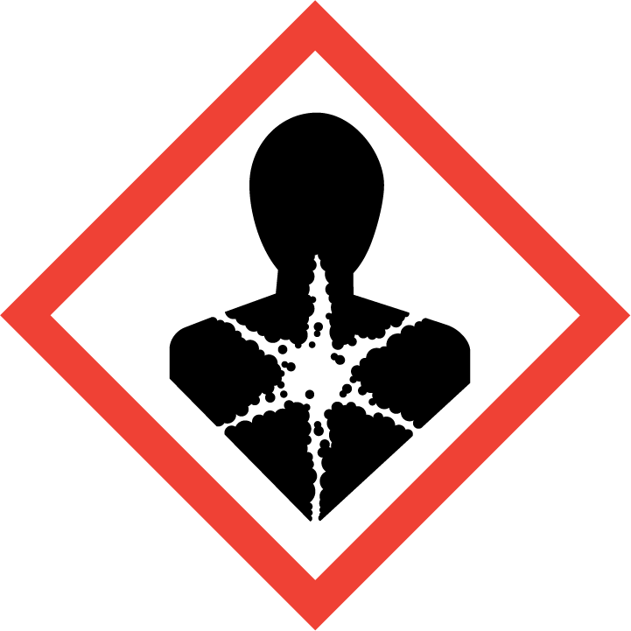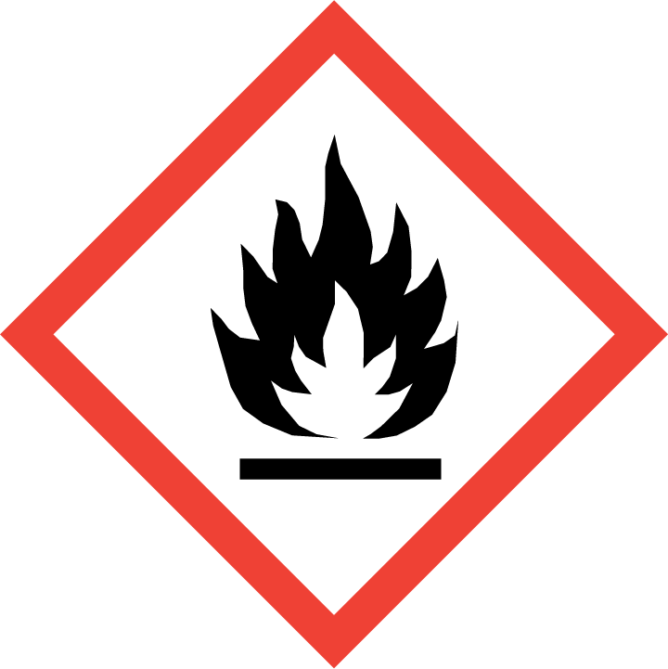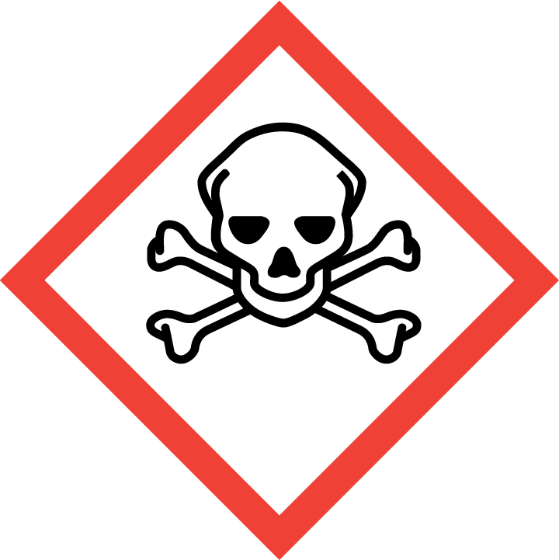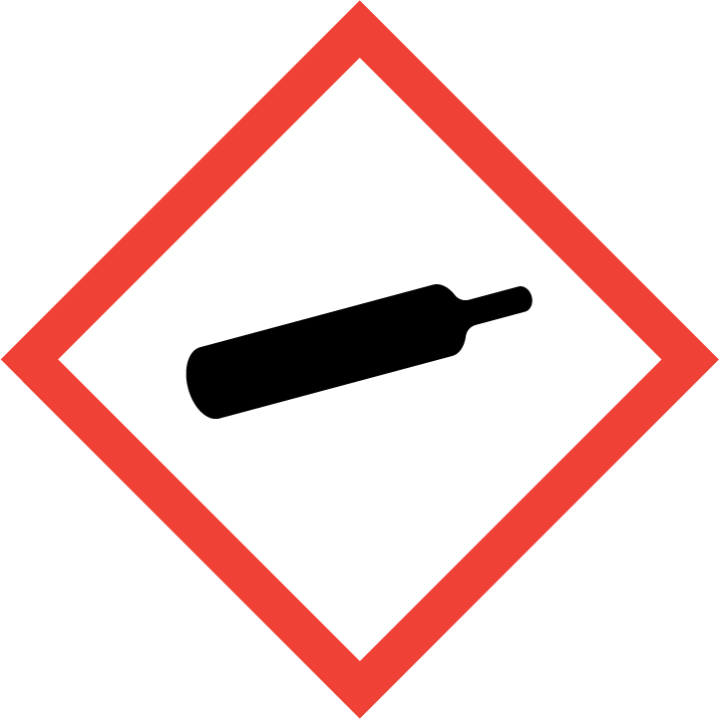
Danger

Hazard Classification:
Acute Gas Inhale Toxicity (Category 2)
Aspiration Hazard (Category 1)
Carcinogenicity (Category 1.B)
Eye Effects (Category 2.B)
Flammable (Category 1)
Flammable Aerosol (Category 1)
Gases Under Pressure

Hazard Statements:
Causes eye irritation
Contains gas under pressure; may explode if heated
Extremely flammable aerosol
Extremely flammable gas
Fatal if inhaled
May be fatal if swallowed and enters airways
May cause cancer

Precautionary Statements
Prevention:
Do not breathe dust/fume/gas/mist/ vapors/spray..
[In case of inadequate ventilation] wear respiratory protection.
Do not handle until all safety precautions have been read and understood.
Wash thoroughly after handling.
Use only outdoors or in a well-ventilated area.
Wear protective gloves, protective clothing, eye protection and face protection.
Obtain special instructions before use.
Keep away from heat/sparks/open flames/hot surfaces. - No smoking.
Pressurized container: Do not pierce or burn, even after use.
Do not spray on an open flame or other ignition source.

Response:
Eliminate all ignition sources if safe to do so.
Immediately call a poison center or doctor.
Leaking gas fire: Do not extinguish, unless leak can be stopped safely.
Do NOT induce vomiting.
Specific treatment is urgent.
If swallowed: Rinse mouth. Do NOT induce vomiting.
If exposed or concerned: Get medical advice/attention.
If in eyes: Rinse cautiously with water for several minutes. Remove contact lenses, if present and easy to do. Continue rinsing.
If inhaled: Remove person to fresh air and keep comfortable for breathing.

Storage:
Store in a well-ventilated place. Keep container tightly closed.
Protect from sunlight.
Store locked up.
Do not expose to temperatures exceeding 50C/122F.

Disposal:
Dispose of contents and/or container in accordance with applicable regulations.

Section 3: Composition/Information on Ingredients

CAS #
75-00-3

Chemical Substance | Chemical Family | Trade Names
ETHYL CHLORIDE | halogenated, aliphatic | CHLOROETHANE; MONOCHLOROETHANE; MURIATIC ETHER; KELENE; HYDROCHLORIC ETHER; ETHER HYDROCHLORIC; ETHER MURIATIC; NARCOTILE; AETHYLIS; CHELEN; CHLORETHYL; CHLORIDUM; CHLORYL; CHLORYL ANESTHETIC; ETHER CHLORATUS; AETHYLIS CHLORIDUM; STCC 4908162; UN 1037; C2H5CL

Section 4: First Aid Measures
Skin Contact | Eye Contact | Ingestion | Inhalation | Note to Physicians
If frostbite or freezing occur, immediately flush with plenty of lukewarm water (105-115 F; 41-46 C). DO NOT USE HOT WATER. If warm water is not available, gently wrap affected parts in blankets. Get immediate medical attention. | Flush eyes with plenty of water for at least 15 minutes. Then get immediate medical attention. | Contact local poison control center or physician immediately. Never make an unconscious person vomit or drink fluids. When vomiting occurs, keep head lower than hips to help prevent aspiration. If person is unconscious, turn head to side. Get medical attention. | If adverse effects occur, remove to uncontaminated area. Give artificial respiration if not breathing. If breathing is difficult, oxygen should be administered by qualified personnel. Get immediate medical attention. | Not available

Section 5: Fire Fighting Measures
Suitable Extinguishing Media | Products of Combustion | Protection of Firefighters
Regular dry chemical, carbon dioxide, regular foam | Hydrogen chloride gas, phosgene. | - Any self-contained breathing apparatus that has a full facepiece and is operated in a pressure-demand or other positive-pressure mode. Use chemical protective clothing.  - Not available

Section 6: Accidental Release Measures
Personal Precautions | Environmental Precautions | Methods for Containment
Keep unnecessary people away, isolate hazard area and deny entry. | Avoid heat, flames, sparks and other sources of ignition. | Stop leak if possible without personal risk. Reduce vapors with water spray.

Methods for Cleanup | Other Information
Small spills: Absorb with sand or other non-combustible material. Collect spilled material in appropriate container for disposal. Large spills: Dike for later disposal. Remove sources of ignition. | Notify Local Emergency Planning Committee and State Emergency Response Commission for release greater than or equal to RQ (U.S. SARA Section 304). If release occurs in the U.S. and is reportable under CERCLA Section 103, notify the National Response Center at (800)424-8802 (USA) or (202)426-2675 (USA). Subject to California Safe Drinking Water and Toxic Enforcement Act of 1986 (Proposition 65).

Section 7: Handling and Storage
Handling | Storage
Store and handle in accordance with all current regulations and standards. Subject to storage regulations: U.S. OSHA 29 CFR 1910.101. Grounding and bonding required. Protect from physical damage. Store outside or in a detached building. Store with flammable liquids. Keep separated from incompatible substances. Avoid contact with light. Store in a cool, dry place. Store in a well-ventilated area. Keep separated from incompatible substances. | Avoid contact with eyes, skin and clothing. Keep container closed. Use only with adequate ventilation. Keep away from heat, sparks and flame. To avoid fire, minimize ignition sources. Use explosion-proof electrical (ventilating, lighting and material handling) equipment. Do not puncture or incinerate container. Wash thoroughly after handling. High pressure gas. Use equipment rated for cylinder pressure. Close valve after each use and when empty.

Section 8: Exposure Controls/Personal Protection
Exposure Guidelines
ETHYL CHLORIDE: 1000 ppm (2600 mg/m3) OSHA TWA 100 ppm ACGIH TWA (skin) NIOSH (handle with caution in workplace)

Engineering Controls
Handle only in fully enclosed systems.
Eye Protection | Skin Protection | Respiratory Protection
For the gas: Eye protection not required, but recommended. For the liquid: Wear splash resistant safety goggles. Contact lenses should not be worn. Provide an emergency eye wash fountain and quick drench shower in the immediate work area. | For the gas: Protective clothing is not required. For the liquid: Wear appropriate protective, cold insulating clothing. | Any self-contained breathing apparatus that has a full facepiece and is operated in a pressure-demand or other positive-pressure mode. Use chemical protective clothing.

General Hygiene considerations
- Avoid breathing vapor or mist
- Avoid contact with eyes and skin
- Wash thoroughly after handling and before eating or drinking

Section 9: Physical and Chemical Properties
Physical State | Appearance | Color | Change in Appearance | Physical Form | Odor | Taste
Gas | Colorless | Colorless | N/A | Gas | Pungent, ether-like odor | Burning taste

Flash Point | Flammability | Partition Coefficient | Autoignition Temperature | Upper Explosive Limits | Lower Explosive Limits
-58 F (-50 C) (CC) | Not available | Not available | 966 F (519 C) | 0.154 | 0.038

Boiling Point | Freezing Point | Vapor Pressure | Vapor Density | Specific Gravity | Water Solubility | pH | Odor Threshold | Evaporation Rate | Viscosity
54 F (12 C) | -213 F (-136 C) | 1000 mmHg @ 20 C | 2.2 (Air=1) | 0.9 | 0.6% | Not applicable | 4.2 ppm (method not specified) (10); 140 ppm (50% detection); 680 ppm (100% detection) | Not applicable | 0.26 mPa.s (0.26 centipoise) @ 20 C

Molecular Weight | Molecular Formula | Density | Weight per Gallon | Volatility by Volume | Volatility | Solvent Solubility
64.52 | C2-H5-CL | 0.1649 | Not available | Not available | Not applicable | Soluble: Alcohol, ether, organic solvents

Section 10: Stability and Reactivity
Stability | Conditions to Avoid | Incompatible Materials
Stable at normal temperatures and pressure. May react on contact with water. May release toxic and/or flammable gases. | Stable at normal temperatures and pressure. May react on contact with water. May release toxic and/or flammable gases. | Metals, oxidizing materials, water, aluminum, powdered metals

Hazardous Decomposition Products | Possibility of Hazardous Reactions
Acid halides, phosgene, hydrochloric acid | Will not polymerize.

Section 11: Toxicology Information

Acute Effects
Oral LD50 | Dermal LD50 | Inhalation
(LC50): 80 ppm 4 hour(s) [Rat]. | Not available | Irritation, blisters, blurred vision, nausea, vomiting, irregular heartbeat, headache, sore throat, frostbite, symptoms of drunkenness, disorientation, kidney damage, liver damage

Eye Irritation | Skin Irritation | Sensitization
Irritation, blurred vision | Irritation, blisters, frostbite | Eye irritation, central nervous system depression

Chronic Effects
Carcinogenicity | Mutagenicity | Reproductive Effects | Developmental Effects
IARC: Human No Adequate Data, Animal Limited Evidence, Group 3; ACGIH: A3 -Confirmed Animal Carcinogen | Available. | Available. | No data

Section 12: Ecological Information

Fate and Transport
Eco toxicity | Persistence / Degradability | Bioaccumulation / Accumulation | Mobility in Environment
Fish toxicity: Not available  Invertibrate toxicity: Not available  Algal toxicity: Not available  Phyto toxicity: Not available  Other toxicity: Not available | 53- 91% degradation in 28 days of incubation) | None | Not available

Section 13: Disposal Considerations
Subject to disposal regulations: U.S. EPA 40 CFR 262. Hazardous Waste Number(s): D001. Dispose in accordance with all applicable regulations.

Section 14: Transportation Information

U.S. DOT 49 CFR 172.101
Proper Shipping Name | ID Number | Hazard Class or Division | Packing Group | Labeling Requirements | Passenger Aircraft or Railcar Quantity Limitations | Cargo Aircraft Only Quantity Limitations | Additional Shipping Description
Ethyl chloride | UN1037 | 2.1 | Not applicable | 2.1 | Forbidden | 150 kg | None

Canadian Transportation of Dangerous Goods
Shipping Name | UN Number | Class | Packing Group / Risk Group
Ethyl chloride | UN1037 | 2.1 | Not applicable

Section 15: Regulatory Information

U.S. Regulations
CERCLA Sections | SARA 355.30 | SARA 355.40
100 LBS RQ | Not regulated. | Not regulated.

SARA 370.21
Acute | Chronic | Fire | Reactive | Sudden Release
Yes | No | Yes | Yes | No

SARA 372.65
CHLOROETHANE (ETHYL CHLORIDE)

OSHA Process Safety
Not regulated.

State Regulations
CA Proposition 65
Known to the state of California to cause the following: Chloroethane (Ethyl chloride) Cancer (Jul 01, 1990)

Canadian Regulations
WHMIS Classification
A, B1

National Inventory Status
US Inventory (TSCA) | TSCA 12b Export Notification | Canada Inventory (DSL/NDSL)
Listed on inventory. | Not listed. | Not determined.

Section 16: Other Information
NFPA Rating
HEALTH=2 FIRE=4 REACTIVITY=0
0 = minimal hazard, 1 = slight hazard, 2 = moderate hazard, 3 = severe hazard, 4 = extreme hazard

