Safety Data Sheet

Ethylene Oxide

Section 1: Product and Company Identification
Metro Welding Supply Corp.
12620 Southfield Road
Detroit, MI 48223
(313) 834-1660 [phone]
(313) 835-3562 [fax]
http://www.metrowelding.com/

Product Code: Ethylene Oxide

Section 2: Hazards Identification
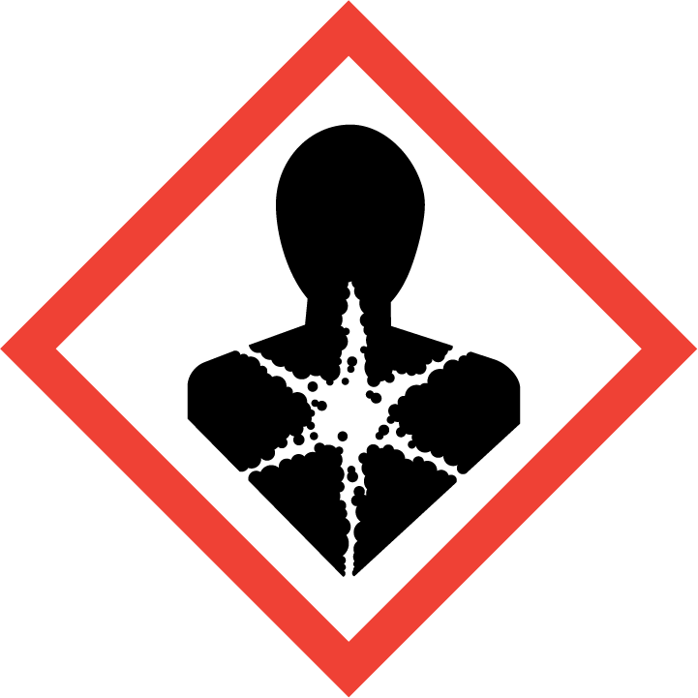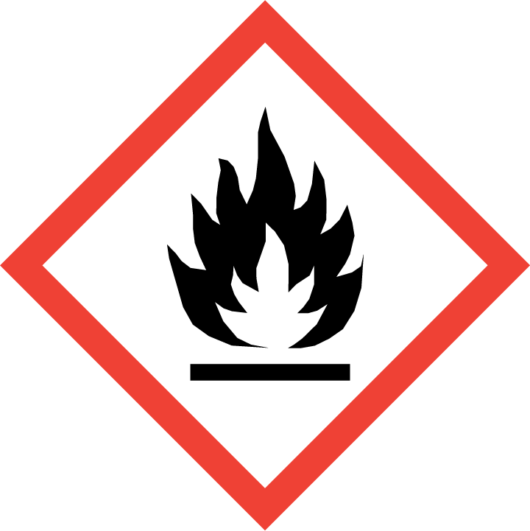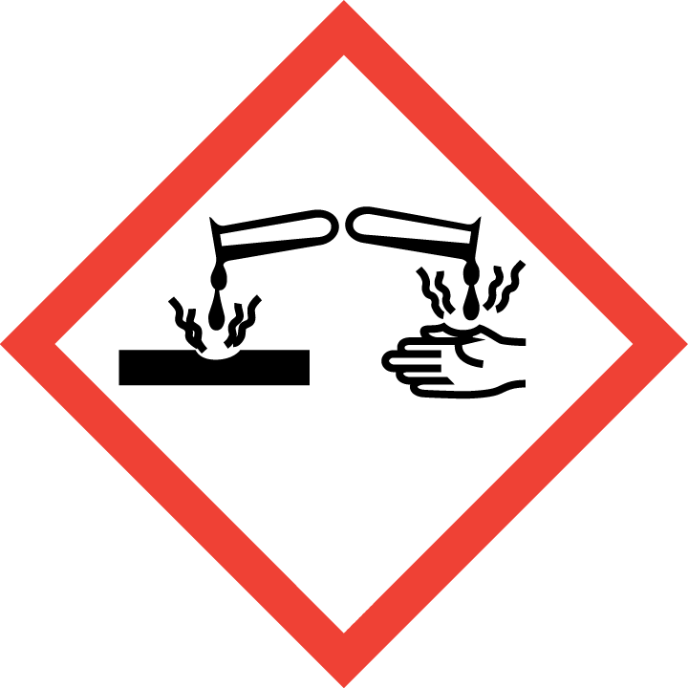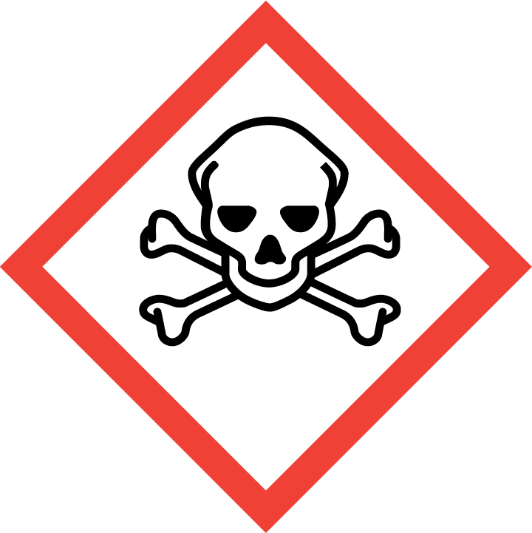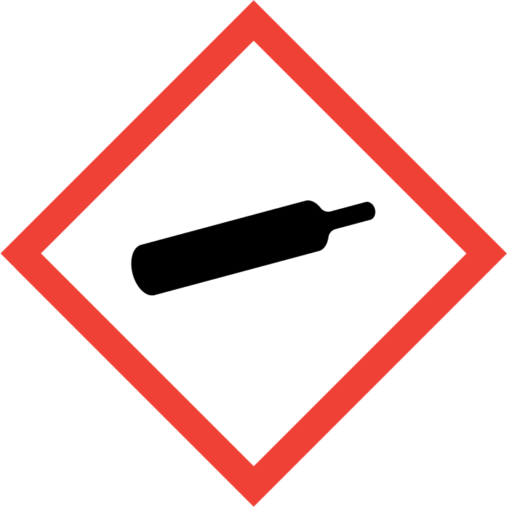
Danger

Hazard Classification:
Acute Gas Inhale Toxicity (Category 3)
Acute Oral Toxicity (Category 3)
Aspiration Hazard (Category 1)
Carcinogenicity (Category 1.B)
Eye Effects (Category 1)
Flammable (Category 1)
Flammable Aerosol (Category 1)
Gases Under Pressure
Skin Corrosion (Category 2)

Hazard Statements:
Causes serious eye damage
Causes skin irritation
Contains gas under pressure; may explode if heated
Extremely flammable aerosol
Extremely flammable gas
May be fatal if swallowed and enters airways
May cause cancer
Toxic if inhaled
Toxic if swallowed

Precautionary Statements
Prevention:
Wash thoroughly after handling.
Avoid breathing dust/fume/gas/mist/ vapors/spray.
Do not eat, drink or smoke when using this product.
[In case of inadequate ventilation] wear respiratory protection.
Do not handle until all safety precautions have been read and understood.
Use only outdoors or in a well-ventilated area.
Wear protective gloves, protective clothing, eye protection and face protection.
Obtain special instructions before use.
Keep away from heat/sparks/open flames/hot surfaces. - No smoking.
Pressurized container: Do not pierce or burn, even after use.
Do not spray on an open flame or other ignition source.

Response:
Eliminate all ignition sources if safe to do so.
If on skin: Wash with plenty of water.
Immediately call a poison center or doctor.
Leaking gas fire: Do not extinguish, unless leak can be stopped safely.
Do NOT induce vomiting.
If swallowed: Rinse mouth. Do NOT induce vomiting.
Take off contaminated clothing and wash it before reuse.
If exposed or concerned: Get medical advice/attention.
If skin irritation occurs: Get medical advice/attention.
If in eyes: Rinse cautiously with water for several minutes. Remove contact lenses, if present and easy to do. Continue rinsing.
If inhaled: Remove person to fresh air and keep comfortable for breathing.

Storage:
Store in a well-ventilated place. Keep container tightly closed.
Protect from sunlight.
Store locked up.
Do not expose to temperatures exceeding 50C/122F.

Disposal:
Dispose of contents and/or container in accordance with applicable regulations.

Section 3: Composition/Information on Ingredients

CAS #
75-21-8

Chemical Substance | Chemical Family | Trade Names
ETHYLENE OXIDE | Organic oxide / cyclic ether / aliphatic oxirane / aliphatic epoxide | OXIRANE; DIHYROOXIRENE; DIMETHYLENE OXIDE; EPOXYETHANE; 1,2-EPOXYETHANE; ETHENE OXIDE; ETO; EO; OXACYCLOPROPANE; OXANE; OXIDOETHANE; ALPHA,BETA-OXIDOETHANE; OXIRAN; RCRA U115; STCC 4906610; UN 1040; C2H4O

Section 4: First Aid Measures
Skin Contact | Eye Contact | Ingestion | Inhalation | Note to Physicians
If frostbite or freezing occur, immediately flush with plenty of lukewarm water (105-115 F; 41-46 C). DO NOT USE HOT WATER. If warm water is not available, gently wrap affected parts in blankets. Get immediate medical attention. | Wash eyes immediately with large amounts of water, occasionally lifting upper and lower lids, until no evidence of chemical remains. Get medical attention immediately. | Contact local poison control center or physician immediately. Never make an unconscious person vomit or drink fluids. When vomiting occurs, keep head lower than hips to help prevent aspiration. If person is unconscious, turn head to side. Get medical attention immediately. | If adverse effects occur, remove to uncontaminated area. Give artificial respiration if not breathing. Avoid mouth-to-mouth contact by using mouth guards or shields. If breathing is difficult, oxygen should be administered by qualified personnel. Get immediate medical attention. | For inhalation, consider oxygen. For ingestion, consider gastric lavage and activated charcoal slurry.

Section 5: Fire Fighting Measures
Suitable Extinguishing Media | Products of Combustion | Protection of Firefighters
Carbon dioxide, regular dry chemical, water Large fires: Use alcohol-resistant foam or flood with fine water spray. | Carbon monoxide, carbon dioxide and toxic and irritating fumes, carbon, acetaldehyde | - Any self-contained breathing apparatus that has a full facepiece and is operated in a pressure-demand or other positive-pressure mode. Full body chemical protective suit.  - Any self-contained breathing apparatus that has a full facepiece and is operated in a pressure-demand or other positive-pressure mode. Full body chemical protective suit.

Section 6: Accidental Release Measures
Personal Precautions | Environmental Precautions | Methods for Containment
Keep unnecessary people away, isolate hazard area and deny entry. | Avoid heat, flames, sparks and other sources of ignition. Keep out of water supplies and sewers. | Stop leak if possible without personal risk. Reduce vapors with water spray. Do not get water inside container. Remove sources of ignition.

Methods for Cleanup | Other Information
Small spills: Flood with water. Large spills: Dike for later disposal. | Notify Local Emergency Planning Committee and State Emergency Response Commission for release greater than or equal to RQ (U.S. SARA Section 304). If release occurs in the U.S. and is reportable under CERCLA Section 103, notify the National Response Center at (800)424-8802 (USA) or (202)426-2675 (USA). Subject to California Safe Drinking Water and Toxic Enforcement Act of 1986 (Proposition 65).

Section 7: Handling and Storage
Handling | Storage
Store and handle in accordance with all current regulations and standards. Subject to storage regulations: U.S. OSHA 29 CFR 1910.106. Store below 30 C. Store outside or in a detached building. Avoid contact with light. Store in a cool, dry place. Use diking sufficient to contain total contents plus 10%. Store with flammable liquids. Keep separated from incompatible substances. Grounding and bonding required. Notify State Emergency Response Commission for storage or use at amounts greater than or equal to the TPQ (U.S. EPA SARA Section 302). SARA Section 303 requires facilities storing a material with a TPQ to participate in local emergency response planning (U.S. EPA 40 CFR 355.30). | Keep separated from incompatible substances. Protect from physical damage.

Section 8: Exposure Controls/Personal Protection
Exposure Guidelines
ETHYLENE OXIDE: 1 ppm OSHA TWA 5 ppm OSHA excursion limit 15 minute(s) 0.5 ppm OSHA action level 1 ppm ACGIH TWA 0.1 ppm (0.18 mg/m3) NIOSH recommended TWA 10 hour(s) (not to exceed) 5 ppm (9 mg/m3) NIOSH recommended ceiling 10 minute(s)

Engineering Controls
Handle only in fully enclosed systems.
Eye Protection | Skin Protection | Respiratory Protection
Wear splash resistant safety goggles with a face shield. Provide an emergency eye wash fountain and quick drench shower in the immediate work area. | For the gas: Wear appropriate chemical resistant clothing. For the liquid: Wear appropriate protective, cold insulating clothing. Wear appropriate chemical resistant clothing. | Any self-contained breathing apparatus that has a full facepiece and is operated in a pressure-demand or other positive-pressure mode. Full body chemical protective suit.

General Hygiene considerations
- Avoid breathing vapor or mist
- Avoid contact with eyes and skin
- Wash thoroughly after handling and before eating or drinking

Section 9: Physical and Chemical Properties
Physical State | Appearance | Color | Change in Appearance | Physical Form | Odor | Taste
Gas | Colorless | Colorless | N/A | Liquid | Sweet odor | N/A

Flash Point | Flammability | Partition Coefficient | Autoignition Temperature | Upper Explosive Limits | Lower Explosive Limits
-4 F (-20 C) (CC) (pure ethylene oxide) | Not available | Not available | 804 F (429 C) | 1 | 0.03

Boiling Point | Freezing Point | Vapor Pressure | Vapor Density | Specific Gravity | Water Solubility | pH | Odor Threshold | Evaporation Rate | Viscosity
50.7 F (10.4 C) (pure ethylene oxide) | -168 F (-111 C) | 1095 mmHg @ 20 C | 1.5 (Air=1) | 0.8824 @ 10 C | Soluble | Not applicable | 500 ppm | Not applicable | 0.0095 cP @ 20 C

Molecular Weight | Molecular Formula | Density | Weight per Gallon | Volatility by Volume | Volatility | Solvent Solubility
44.06 | (C-H2)2-O | Not available | Not available | 100% | 1 | Soluble: Alcohol, ether, acetone, benzene, carbon tetrachloride, organic solvents

Section 10: Stability and Reactivity
Stability | Conditions to Avoid | Incompatible Materials
May decompose explosively when heated above 427 C. Normally stable in the absence of catalysts. | May decompose explosively when heated above 427 C. Normally stable in the absence of catalysts. | Acids, combustible materials, bases, metal salts, metal oxides, amines, halo carbons, metals, cyanides, oxidizing materials, porous refractory insulation, alcohols

Hazardous Decomposition Products | Possibility of Hazardous Reactions
Oxides of carbon | May polymerize violently or explosively. May polymerize when heated. Avoid contact with incompatible materials.

Section 11: Toxicology Information

Acute Effects
Oral LD50 | Dermal LD50 | Inhalation
72 mg/kg oral-rat LD50 | Not available | Irritation, lack of sense of smell, tearing, nausea, vomiting, diarrhea, difficulty breathing, irregular heartbeat, headache, drowsiness, symptoms of drunkenness, disorientation, bluish skin color, lung congestion, lung damage, kidney damage, paralysis, reproductive effects, convulsions

Eye Irritation | Skin Irritation | Sensitization
Irritation (possibly severe), frostbite, tearing | Irritation (possibly severe), allergic reactions, blisters | Harmful if inhaled or swallowed, skin burns, eye burns, respiratory tract irritation, central nervous system depression, allergic reactions, cancer hazard (in humans), possible reproductive hazard, mutagen

Chronic Effects
Carcinogenicity | Mutagenicity | Reproductive Effects | Developmental Effects
OSHA: Carcinogen; NTP: Known Human Carcinogen; IARC: Human Limited Evidence, Animal Sufficient Evidence, Group 1; ACGIH: A2 -Suspected Human Carcinogen | Available. | Available. | No data

Section 12: Ecological Information

Fate and Transport
Eco toxicity | Persistence / Degradability | Bioaccumulation / Accumulation | Mobility in Environment
Fish toxicity: Acute LC50 84000 to 96000 ug/L Fresh water Fish - Fathead minnow - Pimephales promelas 96 hours  Invertibrate toxicity: 490000 ug/L 48 hour(s) LC50 (Mortality) Brine shrimp (Artemia sp)  Algal toxicity: Not available  Phyto toxicity: Not available  Other toxicity: Not available | Not available | Not available | Not available

Section 13: Disposal Considerations
Subject to disposal regulations: U.S. EPA 40 CFR 262. Hazardous Waste Number(s): U115. Dispose in accordance with all applicable regulations.

Section 14: Transportation Information

U.S. DOT 49 CFR 172.101
Proper Shipping Name | ID Number | Hazard Class or Division | Packing Group | Labeling Requirements | Passenger Aircraft or Railcar Quantity Limitations | Cargo Aircraft Only Quantity Limitations | Additional Shipping Description
ETHYLENE OXIDE; or ETHYLENE OXIDE WITH NITROGEN up to a total pressure of 1 MPa (10 bar) at 50 degrees C | UN1040 | 2.3 | Not applicable | 2.3; 2.1 | Forbidden | Forbidden | Toxic-Inhalation Hazard Zone D

Canadian Transportation of Dangerous Goods
Shipping Name | UN Number | Class | Packing Group / Risk Group
ETHYLENE OXIDE; or ETHYLENE OXIDE WITH NITROGEN up to a total pressure of 1 MPa (10 bar) at 50 degrees C | UN1040 | 2.3; 2.1 | Not applicable

Section 15: Regulatory Information

U.S. Regulations
CERCLA Sections | SARA 355.30 | SARA 355.40
ETHYLENE OXIDE: 10 LBS RQ Acetaldehyde: 1000 LBS RQ ACETIC ACID: 5000 LBS RQ | 1000 LBS TPQ | 10 LBS RQ

SARA 370.21
Acute | Chronic | Fire | Reactive | Sudden Release
Yes | Yes | Yes | Yes | Yes

SARA 372.65
ETHYLENE OXIDE

OSHA Process Safety
ETHYLENE OXIDE: 5000 LBS TQ Acetaldehyde: 2500 LBS TQ

State Regulations
CA Proposition 65
Known to the state of California to cause the following: ETHYLENE OXIDE Cancer (Jul 01, 1987) Female reproductive toxicity (Feb 27, 1987) Acetaldehyde Cancer (Apr 01, 1988)

Canadian Regulations
WHMIS Classification
A, B1, D1A, D2A, E, F

National Inventory Status
US Inventory (TSCA) | TSCA 12b Export Notification | Canada Inventory (DSL/NDSL)
Listed on inventory. | Not listed. | Not determined.

Section 16: Other Information
NFPA Rating
HEALTH=3 FIRE=4 REACTIVITY=3
0 = minimal hazard, 1 = slight hazard, 2 = moderate hazard, 3 = severe hazard, 4 = extreme hazard

