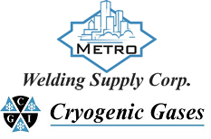 | Safety Data Sheet  Trimethylamine

Section 1: Product and Company Identification
Metro Welding Supply Corp.
12620 Southfield Road
Detroit, MI 48223
(313) 834-1660 [phone]
(313) 835-3562 [fax]
http://www.metrowelding.com/

Product Code: Trimethylamine

Section 2: Hazards Identification
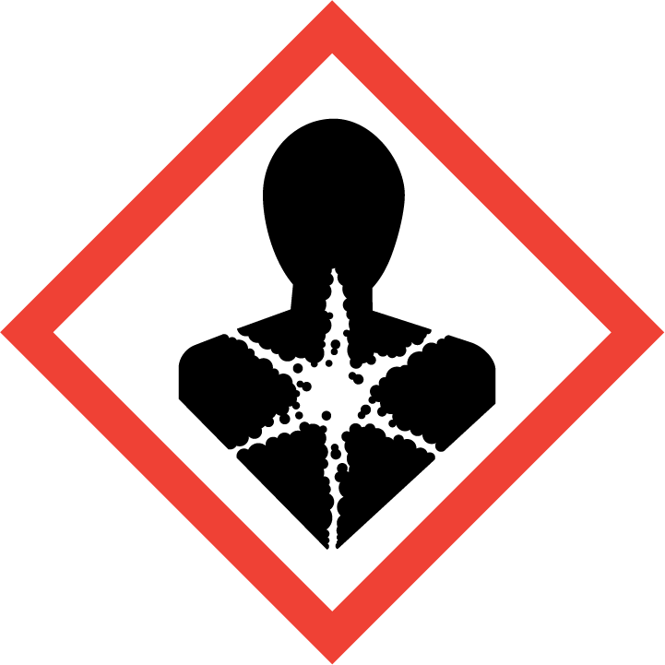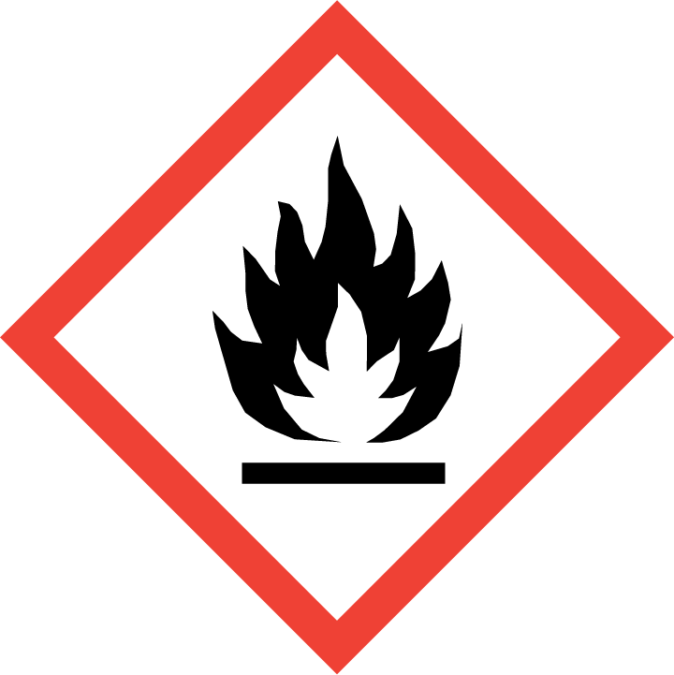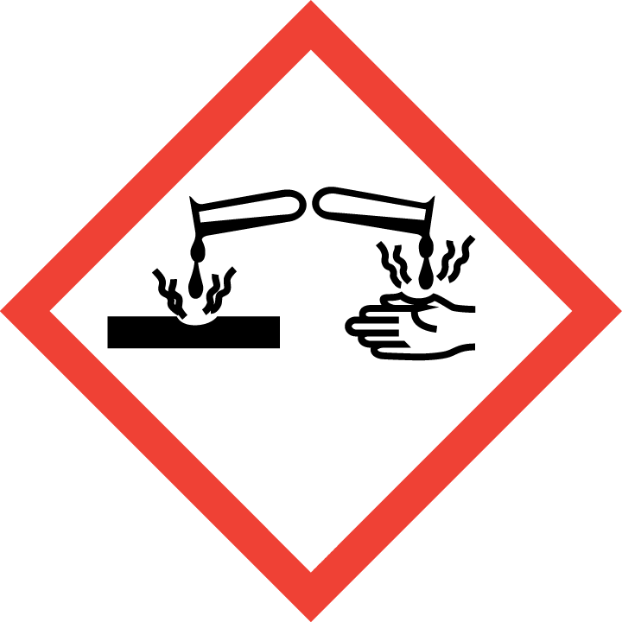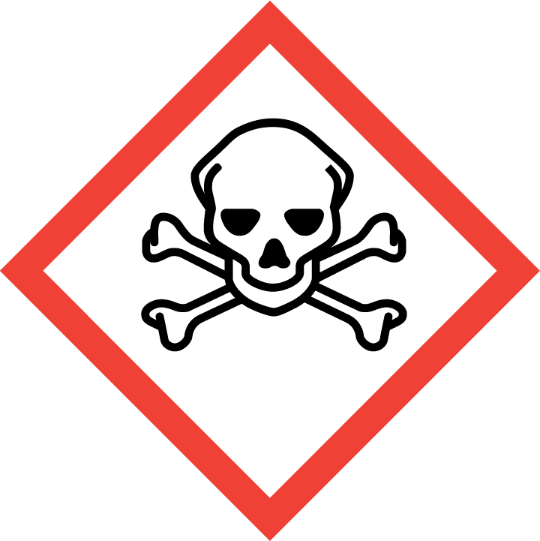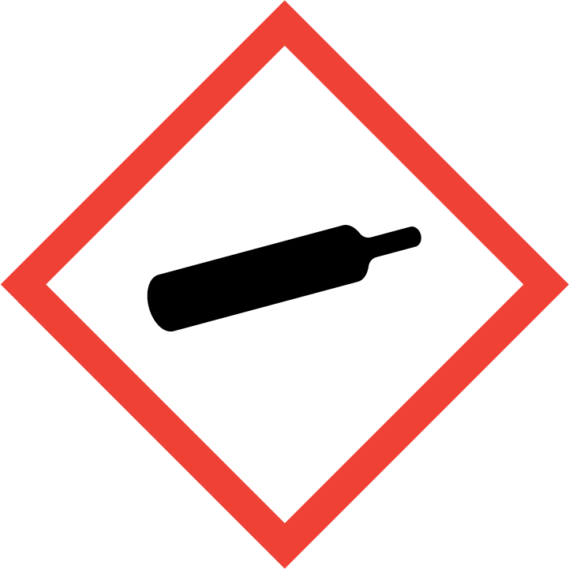
Danger

Hazard Classification:
Acute Gas Inhale Toxicity (Category 1)
Acute Oral Toxicity (Category 4)
Acute Vapor Inhale Toxicity (Category 4)
Aspiration Hazard (Category 1)
Eye Effects (Category 1)
Flammable (Category 1)
Flammable Aerosol (Category 1)
Gases Under Pressure

Hazard Statements:
Causes serious eye damage
Contains gas under pressure; may explode if heated
Extremely flammable aerosol
Extremely flammable gas
Fatal if inhaled
Harmful if inhaled
Harmful if swallowed
May be fatal if swallowed and enters airways

Precautionary Statements
Prevention:
Wash thoroughly after handling.
Wear eye protection/face protection.
Do not eat, drink or smoke when using this product.
[In case of inadequate ventilation] wear respiratory protection.
Do not breathe dust/fume/gas/mist/ vapors/spray..
Use only outdoors or in a well-ventilated area.
Keep away from heat/sparks/open flames/hot surfaces. - No smoking.
Pressurized container: Do not pierce or burn, even after use.
Do not spray on an open flame or other ignition source.

Response:
Eliminate all ignition sources if safe to do so.
Immediately call a poison center or doctor.
Leaking gas fire: Do not extinguish, unless leak can be stopped safely.
Do NOT induce vomiting.
Specific treatment is urgent.
If swallowed: Rinse mouth. Do NOT induce vomiting.
If in eyes: Rinse cautiously with water for several minutes. Remove contact lenses, if present and easy to do. Continue rinsing.
If inhaled: Remove person to fresh air and keep comfortable for breathing.

Storage:
Store in a well-ventilated place. Keep container tightly closed.
Protect from sunlight.
Store locked up.
Do not expose to temperatures exceeding 50C/122F.

Disposal:
Dispose of contents and/or container in accordance with applicable regulations.

Section 3: Composition/Information on Ingredients

CAS #
75-50-3

Chemical Substance | Chemical Family | Trade Names
TRIMETHYLAMINE | amines, aliphatic | N,N-DIMETHYLMETHANAMINE; N,N-DIMETHYL METHANAMINE; N,NDIMETHYL, METHYLAMINE; METHANAMINE, N,N-DIMETHYL-; TRIMETHYLAMINE, ANHYDROUS; N-TRIMETHYLAMINE; TMA; UN 1083; C3H9N

Section 4: First Aid Measures
Skin Contact | Eye Contact | Ingestion | Inhalation | Note to Physicians
Wash skin with soap and water for at least 15 minutes while removing contaminated clothing and shoes. Get medical attention, if needed. Thoroughly clean and dry contaminated clothing before reuse. Destroy contaminated shoes. | Immediately flush eyes with plenty of water for at least 15 minutes. Then get immediate medical attention. | If swallowed, drink plenty of water, DO NOT induce vomiting. Get immediate medical attention. | If adverse effects occur, remove to uncontaminated area. Give artificial respiration if not breathing. If breathing is difficult, oxygen should be administered by qualified personnel. Get immediate medical attention. | For inhalation, consider oxygen. Avoid gastric lavage or emesis.

Section 5: Fire Fighting Measures
Suitable Extinguishing Media | Products of Combustion | Protection of Firefighters
Regular dry chemical Large fires: Use regular foam or flood with fine water spray. avoid carbon dioxide | Ammonia, oxides of carbon, oxides of nitrogen | - Any self-contained breathing apparatus with a full facepiece. Use a chemical protective suit.  - Any self-contained breathing apparatus with a full facepiece. Use a chemical protective suit.

Section 6: Accidental Release Measures
Personal Precautions | Environmental Precautions | Methods for Containment
Keep unnecessary people away, isolate hazard area and deny entry. | Avoid heat, flames, sparks and other sources of ignition. | Stop leak if possible without personal risk. Reduce vapors with water spray. Remove sources of ignition. Dig holding area such as lagoon, pond or pit for containment. Trap spilled material at bottom in deep water pockets, excavated holding areas or within sand bag barriers.

Methods for Cleanup | Other Information
Collect runoff for disposal as potential hazardous waste. Dike for later disposal. Absorb with sand or other non-combustible material. Add an alkaline material (lime, crushed limestone, sodium bicarbonate, or soda ash). Apply detergents, soaps, alcohols or another surface active agent. Absorb with activated carbon. Collect spilled material using mechanical equipment. | Notify Local Emergency Planning Committee and State Emergency Response Commission for release greater than or equal to RQ (U.S. SARA Section 304). If release occurs in the U.S. and is reportable under ERCLA Section 103, notify the National Response Center at (800)424-8802 (USA) or (202)426-2675 (USA).

Section 7: Handling and Storage
Handling | Storage
Store and handle in accordance with all current regulations and standards. Store below 52 C. Store in a cool, dry place. Store in a well-ventilated area. Store outside or in a detached building. Avoid contact with water or moisture. Subject to storage regulations: U.S OSHA 29 CFR 1910.101. | Protect from physical damage. Keep separated from incompatible substances.

Section 8: Exposure Controls/Personal Protection
Exposure Guidelines
TRIMETHYLAMINE: 10 ppm (24 mg/m3) OSHA TWA (vacated by 58 FR 35338, June 30, 1993) 15 ppm (36 mg/m3) OSHA STEL (vacated by 58 FR 35338, June 30, 1993) 5 ppm ACGIH TWA 15 ppm ACGIH STEL 10 ppm (24 mg/m3) NIOSH recommended TWA 10 hour(s) 15 ppm (36 mg/m3) NOISH recommended STEL 1 ppm AIHA WEEL recommended TWA

Engineering Controls
Handle only in fully enclosed systems.
Eye Protection | Skin Protection | Respiratory Protection
Wear splash resistant safety goggles with a face shield. Provide an emergency eye wash fountain and quick drench shower in the immediate work area. | Wear appropriate chemical resistant clothing. | Any self-contained breathing apparatus with a full facepiece. Use a chemical protective suit.

General Hygiene considerations
- Avoid breathing vapor or mist
- Avoid contact with eyes and skin
- Wash thoroughly after handling and before eating or drinking

Section 9: Physical and Chemical Properties
Physical State | Appearance | Color | Change in Appearance | Physical Form | Odor | Taste
Gas | Clear | Colorless | N/A | Gas | Ammonia odor, fishy odor, pungent odor | Salty taste

Flash Point | Flammability | Partition Coefficient | Autoignition Temperature | Upper Explosive Limits | Lower Explosive Limits
10 F (-12 C) (CC) | Not available | 0.16 (log = -0.796) | 374 F (190 C) | 0.116 | 0.02

Boiling Point | Freezing Point | Vapor Pressure | Vapor Density | Specific Gravity | Water Solubility | pH | Odor Threshold | Evaporation Rate | Viscosity
25-37 F (-4 to 3 C) | -191 to -179 F (-124 to -117 C) | 1.9 atm @ 21.1 C | 2.04-2.10 (Air=1) | 0.6356-0.6709 | 41000 mg/100 g @ 19 C | Strongly basic | 0.00021 ppm | >1 (butyl acetate=1) | Not available

Molecular Weight | Molecular Formula | Density | Weight per Gallon | Volatility by Volume | Volatility | Solvent Solubility
59.11 | (C-H3)3-N | 2.592 kg/m3 @ 21.1 C | 5.3 lbs | Not available | Not applicable | Soluble: Alcohol, benzene, chloroform, ethanol, ether, toluene, xylene

Section 10: Stability and Reactivity
Stability | Conditions to Avoid | Incompatible Materials
Stable at normal temperatures and pressure. | Stable at normal temperatures and pressure. | Acids, combustible materials, metals, halogens, halo carbons, oxidizing materials, reducing agents

Hazardous Decomposition Products | Possibility of Hazardous Reactions
Ammonia, oxides of carbon, oxides of nitrogen; in the absence of oxygen: amides, cyanates, cyanogen, hydrogen cyanide, isocyanates, nitriles, nitrogen compounds, oxides of carbon | Will not polymerize.

Section 11: Toxicology Information

Acute Effects
Oral LD50 | Dermal LD50 | Inhalation
500 mg/kg oral-rat LD50 | Not available | Burns

Eye Irritation | Skin Irritation | Sensitization
Burns, tearing | Burns, absorption may occur, nausea, headache | Harmful if inhaled, harmful if swallowed, respiratory tract burns, skin burns, mucous membrane burns, tears

Chronic Effects
Carcinogenicity | Mutagenicity | Reproductive Effects | Developmental Effects
Not available | Not available | Available. | No data

Section 12: Ecological Information

Fate and Transport
Eco toxicity | Persistence / Degradability | Bioaccumulation / Accumulation | Mobility in Environment
Fish toxicity: Not available  Invertibrate toxicity: 1000000 ug/L 48 hour(s) LC50 (Mortality) Medaka, high-eyes (Oryzias latipes)  Algal toxicity: 5900 ug/L 96 hour(s) (Physiological) Green algae (Gloeotaenium loitlesbergerianu)  Phyto toxicity: Not available  Other toxicity: May cause pH changes in aqueous ecological systems | Not available | Accumulates very little in the bodies of living organisms. | Leaches through the soil or the sediment at a very rapid rate.

Section 13: Disposal Considerations
Dispose in accordance with all applicable regulations. Subject to disposal regulations: U.S. EPA 40 CFR 262. Hazardous Waste Number(s): D001.

Section 14: Transportation Information

U.S. DOT 49 CFR 172.101
Proper Shipping Name | ID Number | Hazard Class or Division | Packing Group | Labeling Requirements | Passenger Aircraft or Railcar Quantity Limitations | Cargo Aircraft Only Quantity Limitations | Additional Shipping Description
Trimethylamine, anhydrous | UN1083 | 2.1 | Not applicable | 2.1 | Forbidden | 150 kg | N/A

Canadian Transportation of Dangerous Goods
Shipping Name | UN Number | Class | Packing Group / Risk Group
Trimethylamine, anhydrous | UN1083 | 2.1 | Not applicable

Section 15: Regulatory Information

U.S. Regulations
CERCLA Sections | SARA 355.30 | SARA 355.40
100 LBS RQ | Not regulated. | Not regulated.

SARA 370.21
Acute | Chronic | Fire | Reactive | Sudden Release
Yes | No | Yes | No | Yes

SARA 372.65
Not regulated.

OSHA Process Safety
Not regulated.

State Regulations
CA Proposition 65
Not regulated.

Canadian Regulations
WHMIS Classification
ABD1E

National Inventory Status
US Inventory (TSCA) | TSCA 12b Export Notification | Canada Inventory (DSL/NDSL)
Listed on inventory. | Not listed. | Not determined.

Section 16: Other Information
NFPA Rating
HEALTH=3 FIRE=4 REACTIVITY=0
0 = minimal hazard, 1 = slight hazard, 2 = moderate hazard, 3 = severe hazard, 4 = extreme hazard

