Safety Data Sheet

Hexane

Section 1: Product and Company Identification
Metro Welding Supply Corp.
12620 Southfield Road
Detroit, MI 48223
(313) 834-1660 [phone]
(313) 835-3562 [fax]
http://www.metrowelding.com/

Product Code: Hexane

Section 2: Hazards Identification
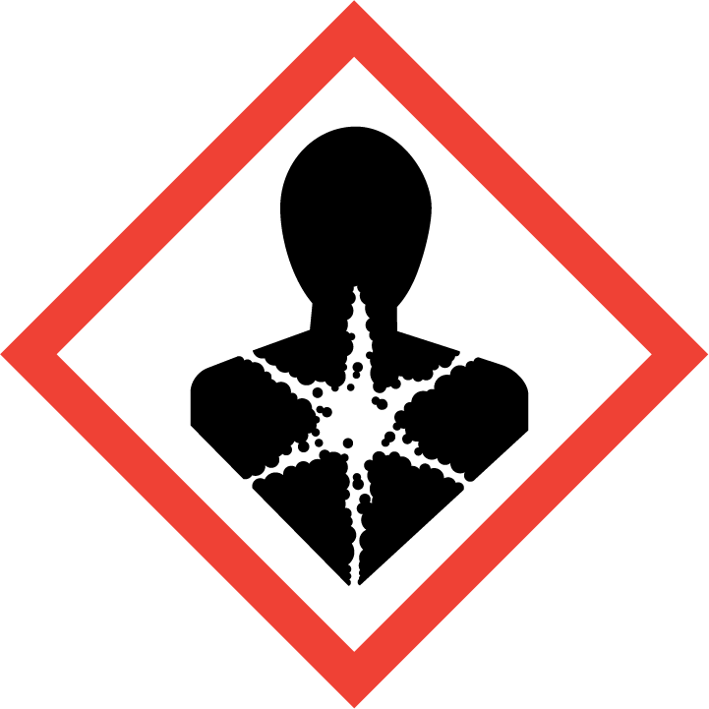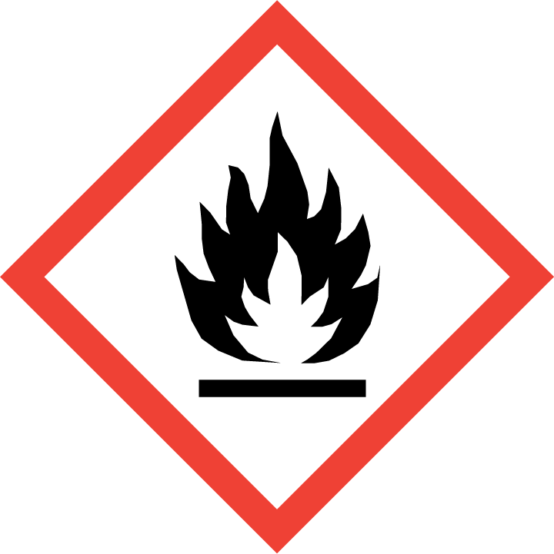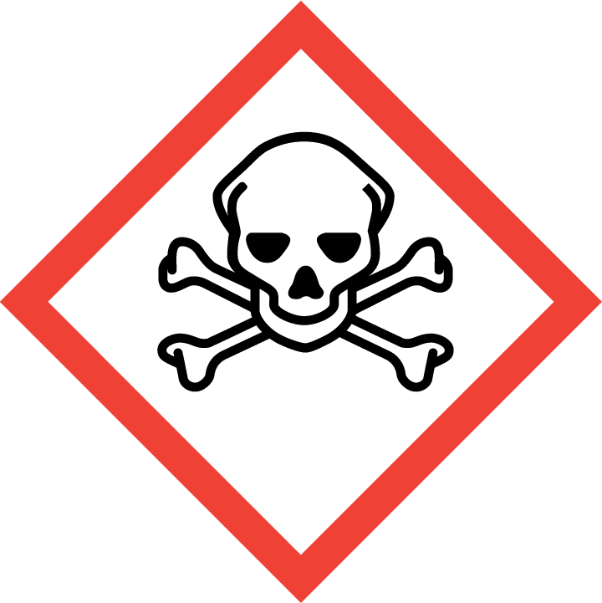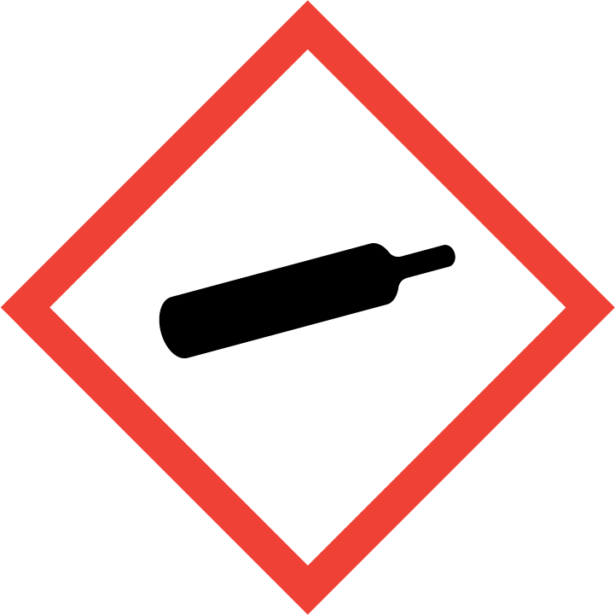
Danger

Hazard Classification:
Acute Dermal Toxicity (Category 1)
Acute Oral Toxicity (Category 2)
Aspiration Hazard (Category 1)
Eye Effects (Category 2.B)
Flammable (Category 1)
Flammable Aerosol (Category 1)
Gases Under Pressure

Hazard Statements:
Causes eye irritation
Contains gas under pressure; may explode if heated
Extremely flammable aerosol
Extremely flammable gas
Fatal if swallowed
Fatal in contact with skin
May be fatal if swallowed and enters airways
Toxic to aquatic life

Precautionary Statements
Prevention:
Wash thoroughly after handling.
Do not eat, drink or smoke when using this product.
Do not get in eyes, on skin, or on clothing.
Wear protective gloves and protective clothing.
Keep away from heat/sparks/open flames/hot surfaces. - No smoking.
Pressurized container: Do not pierce or burn, even after use.
Do not spray on an open flame or other ignition source.

Response:
Eliminate all ignition sources if safe to do so.
Immediately call a poison center or doctor.
Leaking gas fire: Do not extinguish, unless leak can be stopped safely.
Do NOT induce vomiting.
Take off immediately all contaminated clothing and wash it before reuse.
If swallowed: Rinse mouth. Do NOT induce vomiting.
If in eyes: Rinse cautiously with water for several minutes. Remove contact lenses, if present and easy to do. Continue rinsing.
Wash with plenty of water

Storage:
Protect from sunlight.
Store in well-ventilated place.
Store locked up.
Do not expose to temperatures exceeding 50C/122F.

Disposal:
Dispose of contents and/or container in accordance with applicable regulations.

Section 3: Composition/Information on Ingredients

CAS #
110-54-3

Chemical Substance | Chemical Family | Trade Names
HEXANE | hydrocarbons, aliphatic | N-HEXANE; 1-HEXANE; HEXYL HYDRIDE; 1-HEXANE; NORMAL HEXANE; SKELLYSOLVE B; UN 1208; CAPROYL HYDRIDE; C6H14

Section 4: First Aid Measures
Skin Contact | Eye Contact | Ingestion | Inhalation | Note to Physicians
Wash skin with soap and water for at least 15 minutes while removing contaminated clothing and shoes. Get medical attention, if needed. Thoroughly clean and dry contaminated clothing and shoes before reuse. | Flush eyes with plenty of water for at least 15 minutes. Then get immediate medical attention. | Aspiration hazard. DO NOT induce vomiting. If vomiting occurs, keep head lower than hips to help prevent aspiration. Get immediate medical attention. Give artificial respiration if not breathing. | If adverse effects occur, remove to uncontaminated area. Give artificial respiration if not breathing. If breathing is difficult, oxygen should be administered by qualified personnel. Get immediate medical attention. | There is no specific antidote. Treatment of overexposure should be directed at the control of symptoms and the clinical condition of the patient. Long-term exposure to n-hexane can cause damage to the peripheral nervous system.

Section 5: Fire Fighting Measures
Suitable Extinguishing Media | Products of Combustion | Protection of Firefighters
Regular dry chemical, carbon dioxide, water, regular foam Large fires: Use regular foam or flood with fine water spray. | Carbon monoxide, carbon dioxide and toxic and irritating fumes | - Any appropriate escape-type, self-contained breathing apparatus.  - Protective material types: rubber

Section 6: Accidental Release Measures
Personal Precautions | Environmental Precautions | Methods for Containment
Keep unnecessary people away, isolate hazard area and deny entry. | Avoid heat, flames, sparks and other sources of ignition. | Stop leak if possible without personal risk. Reduce vapors with water spray.

Methods for Cleanup | Other Information
Small spills: Absorb with sand or other non-combustible material. Collect spilled material in appropriate container for disposal. Large spills: Dike for later disposal. Remove sources of ignition. | Notify Local Emergency Planning Committee and State Emergency Response Commission for release greater than or equal to RQ (U.S. SARA Section 304). If release occurs in the U.S. and is reportable under CERCLA Section 103, notify the National Response Center at (800)424-8802 (USA) or (202)426-2675 (USA).

Section 7: Handling and Storage
Handling | Storage
Store and handle in accordance with all current regulations and standards. Store in a tightly closed container. Store in a well-ventilated area. Store in a cool, dry place. Subject to storage regulations: U.S. OSHA 29 CFR 1910.106. | Grounding and bonding required. Keep separated from incompatible substances.

Section 8: Exposure Controls/Personal Protection
Exposure Guidelines
N-HEXANE: 500 ppm (1800 mg/m3) OSHA TWA 50 ppm (180 mg/m3) OSHA TWA (vacated by 58 FR 35338, June 30, 1993) 50 ppm ACGIH TWA (skin) 50 ppm (180 mg/m3) NIOSH recommended TWA 10 hour(s)

Engineering Controls
Handle only in fully enclosed systems.
Eye Protection | Skin Protection | Respiratory Protection
Wear splash resistant safety goggles with a face shield. Provide an emergency eye wash fountain and quick drench shower in the immediate work area. | Wear appropriate chemical resistant clothing. | Any appropriate escape-type, self-contained breathing apparatus.

General Hygiene considerations
- Avoid breathing vapor or mist
- Avoid contact with eyes and skin
- Wash thoroughly after handling and before eating or drinking

Section 9: Physical and Chemical Properties
Physical State | Appearance | Color | Change in Appearance | Physical Form | Odor | Taste
Liquid | Clear | Colorless | N/A | Liquid | Faint odor, gasoline odor | N/A

Flash Point | Flammability | Partition Coefficient | Autoignition Temperature | Upper Explosive Limits | Lower Explosive Limits
-9.4 F (-23 C) (CC); -7 F (-21.7 C) (CC) | IB | 139315.68 (log = 5.148) (estimated from water solubility) | 437 F (225 C) | 0.075 | 0.011

Boiling Point | Freezing Point | Vapor Pressure | Vapor Density | Specific Gravity | Water Solubility | pH | Odor Threshold | Evaporation Rate | Viscosity
156 F (69 C) | -139 F (-95 C) | 124 mmHg @ 20 C | 3 (Air=1) | 0.6603 | 0.014% @ 20 C | Neutral | 64-244 ppm | 8.9 (n-butyl acetate = 1) | 0.32 cP @ 25 C

Molecular Weight | Molecular Formula | Density | Weight per Gallon | Volatility by Volume | Volatility | Solvent Solubility
86.18 | C-H3-(C-H2)4-C-H3 | Not available | Not available | Not available | 675 g/l VOC (w/v) | Soluble: Alcohol, ether, chloroform, acetone, organic solvents

Section 10: Stability and Reactivity
Stability | Conditions to Avoid | Incompatible Materials
Stable at normal temperatures and pressure. | Stable at normal temperatures and pressure. | Oxidizing materials, halogens, combustible materials, chlorine dioxide, fluorine, nitrogen dioxide, potassium chlorate, chlorine, chlorosulfuric acid

Hazardous Decomposition Products | Possibility of Hazardous Reactions
Oxides of carbon | Will not polymerize.

Section 11: Toxicology Information

Acute Effects
Oral LD50 | Dermal LD50 | Inhalation
>5 gm/kg oral-rat LD50 | >2 gm/kg skin-rabbit LD50 | Irritation, nausea, irregular heartbeat, headache, drowsiness, dizziness, mood swings, loss of coordination, lung congestion, nerve damage, brain damage, unconsciousness

Eye Irritation | Skin Irritation | Sensitization
Mild irritation | Irritation | Respiratory tract irritation, skin irritation, eye irritation, aspiration hazard, central nervous system depression, nerve damage, asphyxiant

Chronic Effects
Carcinogenicity | Mutagenicity | Reproductive Effects | Developmental Effects
Not listed. | Available. | Available. | No data

Section 12: Ecological Information

Fate and Transport
Eco toxicity | Persistence / Degradability | Bioaccumulation / Accumulation | Mobility in Environment
Fish toxicity: 2500 ug/L 96 hour(s) LC50 (Mortality) Fathead minnow (Pimephales promelas)  Invertibrate toxicity: Not available  Algal toxicity: 75 ug/L 28 hour(s) (Population Growth) Green algae (Chlamydomonas sp)  Phyto toxicity: Not available  Other toxicity: Not available | Relatively non-persistent in the environment. Highly volatile from water. | Accumulates very little in the bodies of living organisms. | Not expected to leach through the soil or the sediment.

Section 13: Disposal Considerations
Dispose in accordance with all applicable regulations. Subject to disposal regulations: U.S. EPA 40 CFR 262. Hazardous Waste Number(s): D001.

Section 14: Transportation Information

U.S. DOT 49 CFR 172.101
Proper Shipping Name | ID Number | Hazard Class or Division | Packing Group | Labeling Requirements | Passenger Aircraft or Railcar Quantity Limitations | Cargo Aircraft Only Quantity Limitations | Additional Shipping Description
Hexanes | UN1208 | 3 | II | 3 | 5 kg or L | N/A | N/A

Canadian Transportation of Dangerous Goods
Shipping Name | UN Number | Class | Packing Group / Risk Group
Hexanes | UN1208 | 3 | II

Section 15: Regulatory Information

U.S. Regulations
CERCLA Sections | SARA 355.30 | SARA 355.40
5000 LBS RQ | Not regulated. | Not regulated.

SARA 370.21
Acute | Chronic | Fire | Reactive | Sudden Release
Yes | Yes | Yes | No | No

SARA 372.65
N-HEXANE

OSHA Process Safety
Not regulated.

State Regulations
CA Proposition 65
Not regulated.

Canadian Regulations
WHMIS Classification
B2, D2A, D2B

National Inventory Status
US Inventory (TSCA) | TSCA 12b Export Notification | Canada Inventory (DSL/NDSL)
Listed on inventory. | Not listed. | Listed on DSL.

Section 16: Other Information
NFPA Rating
HEALTH=2 FIRE=3 REACTIVITY=0
0 = minimal hazard, 1 = slight hazard, 2 = moderate hazard, 3 = severe hazard, 4 = extreme hazard

