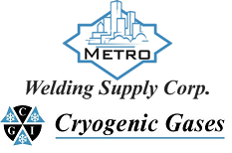 | Safety Data Sheet  Methyl Alcohol

Section 1: Product and Company Identification
Metro Welding Supply Corp.
12620 Southfield Road
Detroit, MI 48223
(313) 834-1660 [phone]
(313) 835-3562 [fax]
http://www.metrowelding.com/

Product Code: Methyl Alcohol

Section 2: Hazards Identification
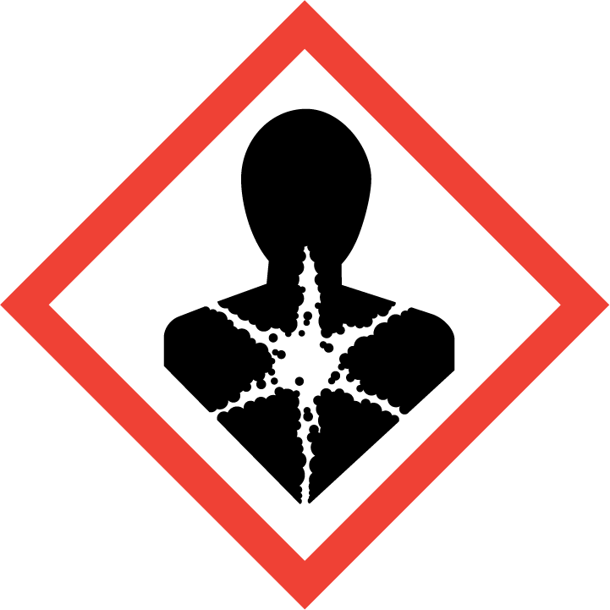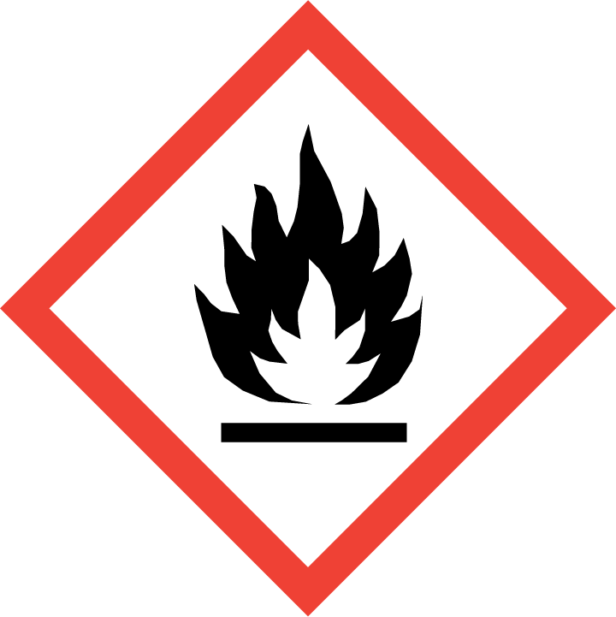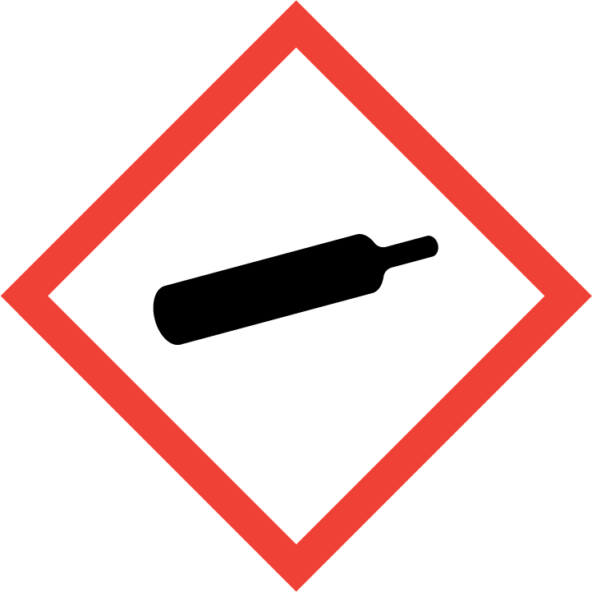
Danger

Hazard Classification:
Aspiration Hazard (Category 1)
Carcinogenicity (Category 2)
Eye Effects (Category 2.B)
Flammable (Category 1)
Flammable Aerosol (Category 1)
Gases Under Pressure

Hazard Statements:
Causes eye irritation
Contains gas under pressure; may explode if heated
Extremely flammable aerosol
Extremely flammable gas
May be fatal if swallowed and enters airways
Suspected of causing cancer

Precautionary Statements
Prevention:
Wash thoroughly after handling.
Do not handle until all safety precautions have been read and understood.
Wear protective gloves, protective clothing, eye protection and face protection.
Obtain special instructions before use.
Keep away from heat/sparks/open flames/hot surfaces. - No smoking.
Pressurized container: Do not pierce or burn, even after use.
Do not spray on an open flame or other ignition source.

Response:
Eliminate all ignition sources if safe to do so.
Immediately call a poison center or doctor.
Leaking gas fire: Do not extinguish, unless leak can be stopped safely.
Do NOT induce vomiting.
If swallowed: Rinse mouth. Do NOT induce vomiting.
If exposed or concerned: Get medical advice/attention.
If in eyes: Rinse cautiously with water for several minutes. Remove contact lenses, if present and easy to do. Continue rinsing.

Storage:
Protect from sunlight.
Store in well-ventilated place.
Store locked up.
Do not expose to temperatures exceeding 50C/122F.

Disposal:
Dispose of contents and/or container in accordance with applicable regulations.

Section 3: Composition/Information on Ingredients

CAS #
67-56-1

Chemical Substance | Chemical Family | Trade Names
METHYL ALCOHOL | hydroxyls, aliphatic | METHANOL; WOOD ALCOHOL; METHYL HYDROXIDE; CARBINOL; MONOHYDROXYMETHANE; WOOD SPIRIT; WOOD NAPHTHA; METHYLOL; COLONIAL SPIRIT; COLUMBIAN SPIRIT; PYROXYLIC SPIRIT; STCC 4909230; UN 1230; RCRA U154; CH4O

Section 4: First Aid Measures
Skin Contact | Eye Contact | Ingestion | Inhalation | Note to Physicians
Wash skin with soap and water for at least 15 minutes while removing contaminated clothing and shoes. Get medical attention, if needed. Thoroughly clean and dry contaminated clothing and shoes before reuse. | Flush eyes with plenty of water for at least 15 minutes. Then get immediate medical attention. | Aspiration hazard. DO NOT induce vomiting. If vomiting occurs, keep head lower than hips to help prevent aspiration. Get immediate medical attention. Give artificial respiration if not breathing. | If adverse effects occur, remove to uncontaminated area. Give artificial respiration if not breathing. Get immediate medical attention. | Antidote: ethanol, oral; calcium gluconate/glucose, intravenous. 4-methylpyrazole, oral, intravenous.

Section 5: Fire Fighting Measures
Suitable Extinguishing Media | Products of Combustion | Protection of Firefighters
Regular dry chemical, carbon dioxide, water, regular foam Large fires: Use regular foam or flood with fine water spray. | Carbon monoxide, carbon dioxide and toxic and irritating fumes | - Any self-contained breathing apparatus that has a full facepiece and is operated in a pressure-demand or other positive-pressure mode.  - Any self-contained breathing apparatus that has a full facepiece and is operated in a pressure-demand or other positive-pressure mode.

Section 6: Accidental Release Measures
Personal Precautions | Environmental Precautions | Methods for Containment
Keep unnecessary people away, isolate hazard area and deny entry. Ventilate area. | Avoid heat, flames, sparks and other sources of ignition. | Stop leak if possible without personal risk. Reduce vapors with water spray. Remove sources of ignition.

Methods for Cleanup | Other Information
Small spills: Absorb with sand or other non-combustible material. Collect spilled material in appropriate container for disposal. Large spills: Dike for later disposal. | Notify Local Emergency Planning Committee and State Emergency Response Commission for release greater than or equal to RQ (U.S. SARA Section 304). If release occurs in the U.S. and is reportable under CERCLA Section 103, notify the National Response Center at (800)424-8802 (USA) or (202)426-2675 (USA).

Section 7: Handling and Storage
Handling | Storage
Store and handle in accordance with all current regulations and standards. Subject to storage regulations: U.S. OSHA 29 CFR 1910.106. Grounding and bonding required. | Protect from physical damage. Keep separated from incompatible substances. Store outside or in a detached building. Inside storage: Store with flammable liquids. Keep separated from incompatible substances.

Section 8: Exposure Controls/Personal Protection
Exposure Guidelines
TLV-TWA: 200 ppm skin (ACIGH)

Engineering Controls
Handle only in fully enclosed systems.
Eye Protection | Skin Protection | Respiratory Protection
Wear safety goggles. Provide eye wash fountain and quick drench shower. | Wear chemical resistant clothing. | Any self-contained breathing apparatus that has a full facepiece and is operated in a pressure-demand or other positive-pressure mode.

General Hygiene considerations
- Avoid breathing vapor or mist
- Avoid contact with eyes and skin
- Wash thoroughly after handling and before eating or drinking

Section 9: Physical and Chemical Properties
Physical State | Appearance | Color | Change in Appearance | Physical Form | Odor | Taste
Liquid | Clear | Colorless | N/A | Liquid | Mild alcohol odor | N/A

Flash Point | Flammability | Partition Coefficient | Autoignition Temperature | Upper Explosive Limits | Lower Explosive Limits
52 F (11 C) (CC); also reported as 54 F (12.2 C) (CC) | Not available | Not available | 725 F (385 C) | 36% | 5.5%

Boiling Point | Freezing Point | Vapor Pressure | Vapor Density | Specific Gravity | Water Solubility | pH | Odor Threshold | Evaporation Rate | Viscosity
148.5 F | -143.9 F | 96 mmHg at 20C | 1.1 (air = 1) (calculated) | (Air = 1) at 70°F (21.1°C) and 1 atm: 1.11 | Soluble in all proportions | Not available | 4.2-5960 ppm (geometric mean: 160 ppm) (detection); 53-8940 ppm (geometric mean: 690 ppm) (recognition) | 2.1 | Dynamic - 0.59 mPa.s (0.59 centipoises) at 20 deg C

Molecular Weight | Molecular Formula | Density | Weight per Gallon | Volatility by Volume | Volatility | Solvent Solubility
32.04 | C-H4-O | Not available | Not available | 100% | Not available | Soluble: Soluble in all proportions in ethanol, other alcohols, benzene, chloroform, diethyl ether, other ethers, esters, ketones, and most other organic solvents

Section 10: Stability and Reactivity
Stability | Conditions to Avoid | Incompatible Materials
Normally stable. | Normally stable. | Oxidizing agents, peroxides, metals, alkali metals, acetyl bromide

Hazardous Decomposition Products | Possibility of Hazardous Reactions
Decomposes on heating to produce carbon monoxide and formaldehyde. | Not known.

Section 11: Toxicology Information

Acute Effects
Oral LD50 | Dermal LD50 | Inhalation
LD50 (oral, rat): 5628 mg/kg | LD50 (dermal, rabbit): 15800 mg/kg (cited as 20 mL/kg) | Mild central nervous system depressant, nausea, headache, vomiting, dizziness, sensitivity to light, blurred, double and/or snowy vision, and blindness

Eye Irritation | Skin Irritation | Sensitization
Irritation | Mild central nervous system depressant, nausea, headache, vomiting, dizziness, sensitivity to light, blurred, double and/or snowy vision, and blindness | Mild central nervous system depressant. May cause headache, nausea, dizziness, drowsiness, and incoordination. Severe vision effects, including increased sensitivity to light, blurred vision, and blindness may develop following an 8-24 hour symptom-free period. Coma and death may result.

Chronic Effects
Carcinogenicity | Mutagenicity | Reproductive Effects | Developmental Effects
May be carcinogenic. | Insufficient information | Not available | No data

Section 12: Ecological Information

Fate and Transport
Eco toxicity | Persistence / Degradability | Bioaccumulation / Accumulation | Mobility in Environment
Fish toxicity: Acute EC50 22200 to 23400 mg/L Fresh water Daphnia - Water flea - Daphnia obtusa - Neonate - <24 hours 48 hours  Invertibrate toxicity: Acute LC50 2500000 ug/L Marine water Crustaceans - Common shrimp, sand shrimp - Crangon crangon - Adult 48 hours  Algal toxicity: Not available  Phyto toxicity: Not available  Other toxicity: Not available | Not available | Not available | Not available

Section 13: Disposal Considerations
Use a licensed waste disposal contractor. Dispose of according to all regulations.

Section 14: Transportation Information

U.S. DOT 49 CFR 172.101
Proper Shipping Name | ID Number | Hazard Class or Division | Packing Group | Labeling Requirements | Passenger Aircraft or Railcar Quantity Limitations | Cargo Aircraft Only Quantity Limitations | Additional Shipping Description
METHANOL | UN1230 | 3, 6.1 | II | FLAMMABLE LIQUID, POISON | 1 kg or L | N/A | N/A

Canadian Transportation of Dangerous Goods
Shipping Name | UN Number | Class | Packing Group / Risk Group
METHANOL | UN1230 | 3 | II

Section 15: Regulatory Information

U.S. Regulations
CERCLA Sections | SARA 355.30 | SARA 355.40
Not regulated. | Not regulated. | Not regulated.

SARA 370.21
Acute | Chronic | Fire | Reactive | Sudden Release
Not regulated. | Not regulated. | Not regulated. | Not regulated. | Not regulated.

SARA 372.65
Not regulated.

OSHA Process Safety
Not regulated.

State Regulations
CA Proposition 65
N/A

Canadian Regulations
WHMIS Classification
B2, D1B, D2A, D2B

National Inventory Status
US Inventory (TSCA) | TSCA 12b Export Notification | Canada Inventory (DSL/NDSL)
Listed on inventory. | N/A | N/A

Section 16: Other Information
NFPA Rating
Not available
0 = minimal hazard, 1 = slight hazard, 2 = moderate hazard, 3 = severe hazard, 4 = extreme hazard

