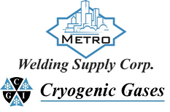 | Safety Data Sheet  Methyl Chloride

Section 1: Product and Company Identification
Metro Welding Supply Corp.
12620 Southfield Road
Detroit, MI 48223
(313) 834-1660 [phone]
(313) 835-3562 [fax]
http://www.metrowelding.com/

Product Code: Methyl Chloride

Section 2: Hazards Identification
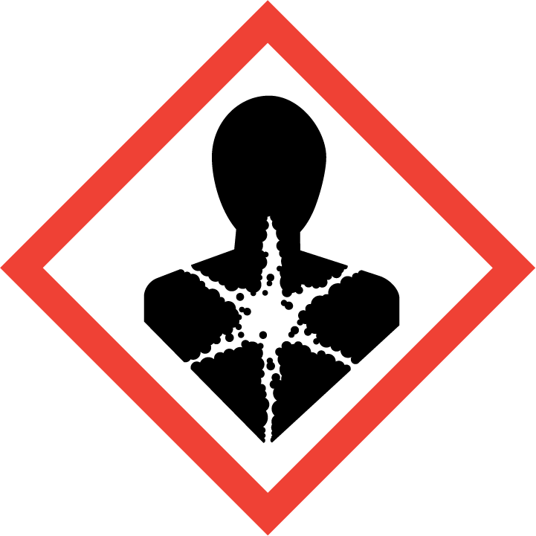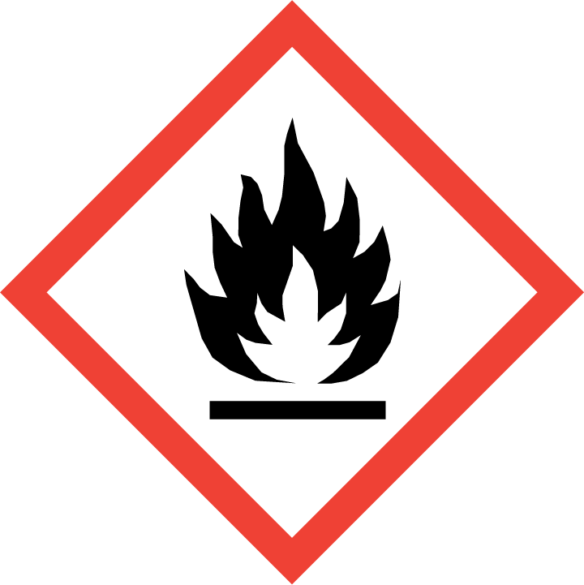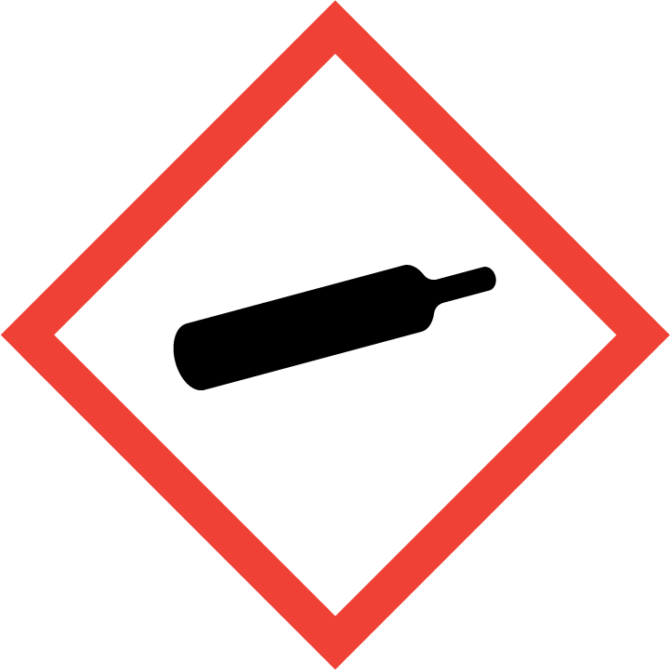
Danger

Hazard Classification:
Acute Oral Toxicity (Category 4)
Aspiration Hazard (Category 1)
Flammable (Category 1)
Flammable Aerosol (Category 1)
Gases Under Pressure
Skin Corrosion (Category 2)

Hazard Statements:
Causes skin irritation
Contains gas under pressure; may explode if heated
Extremely flammable aerosol
Extremely flammable gas
Harmful if swallowed
May be fatal if swallowed and enters airways

Precautionary Statements
Prevention:
Wash thoroughly after handling.
Do not eat, drink or smoke when using this product.
Wear protective gloves and protective clothing.
Keep away from heat/sparks/open flames/hot surfaces. - No smoking.
Pressurized container: Do not pierce or burn, even after use.
Do not spray on an open flame or other ignition source.

Response:
Leaking gas fire: Do not extinguish, unless leak can be stopped safely.
Immediately call a poison center or doctor.
Eliminate all ignition sources if safe to do so.
Do NOT induce vomiting.
If on skin: Wash with plenty of water.
If swallowed: Rinse mouth. Do NOT induce vomiting.
Take off contaminated clothing and wash it before reuse.
If skin irritation occurs: Get medical advice/attention.

Storage:
Protect from sunlight.
Store in well-ventilated place.
Store locked up.
Do not expose to temperatures exceeding 50C/122F.

Disposal:
Dispose of contents and/or container in accordance with applicable regulations.

Section 3: Composition/Information on Ingredients

CAS #
74-87-3

Chemical Substance | Chemical Family | Trade Names
METHYL CHLORIDE | halogenated, aliphatic | CHLOROMETHANE; MONOCHLOROMETHANE; RCRA U045; UN 1063; CH3Cl

Section 4: First Aid Measures
Skin Contact | Eye Contact | Ingestion | Inhalation | Note to Physicians
If frostbite or freezing occur, immediately flush with plenty of lukewarm water (105-115 F; 41-46 C). DO NOT USE HOT WATER. If warm water is not available, gently wrap affected parts in blankets. Get immediate medical attention. | Wash eyes immediately with large amounts of water, occasionally lifting upper and lower lids, until no evidence of chemical remains. Get medical attention immediately. | Never make an unconscious person vomit or drink fluids. Give large amounts of water. DO NOT induce vomiting. If vomiting occurs, keep head lower than hips to help prevent aspiration. If person is unconscious, turn head to side. Get medical attention immediately. | If adverse effects occur, remove to uncontaminated area. Give artificial respiration if not breathing. If breathing is difficult, oxygen should be administered by qualified personnel. Get immediate medical attention. | For inhalation, consider oxygen.

Section 5: Fire Fighting Measures
Suitable Extinguishing Media | Products of Combustion | Protection of Firefighters
Let burn unless leak can be stopped immediately. Large fires: Use regular foam or flood with fine water spray. | Hydrogen chloride and carbonyl chloride | - Any self-contained breathing apparatus with a full facepiece.  - Any self-contained breathing apparatus with a full facepiece.

Section 6: Accidental Release Measures
Personal Precautions | Environmental Precautions | Methods for Containment
Keep unnecessary people away, isolate hazard area and deny entry. Ventilate closed spaces before entering. | Avoid heat, flames, sparks and other sources of ignition. Keep out of water supplies and sewers. | Stop leak if possible without personal risk. Reduce vapors with water spray. Remove sources of ignition.

Methods for Cleanup | Other Information
Contact emergency personnel | Notify Local Emergency Planning Committee and State Emergency Response Commission for release greater than or equal to RQ (U.S. SARA Section 304). If release occurs in the U.S. and is reportable under CERCLA Section 103, notify the National Response Center at (800)424-8802 (USA) or (202)426-2675 (USA). Subject to California Safe Drinking Water and Toxic Enforcement Act of 1986 (Proposition 65).

Section 7: Handling and Storage
Handling | Storage
Store and handle in accordance with all current regulations and standards. Protect from physical damage. Store in a cool, dry place. Store in a well-ventilated area. Store outside or in a detached building. Subject to storage regulations: U.S. OSHA 29 CFR 1910.106. Grounding and bonding required. Keep separated from incompatible substances. | Avoid heat, flames, sparks and other sources of ignition.

Section 8: Exposure Controls/Personal Protection
Exposure Guidelines
METHYL CHLORIDE: 100 ppm OSHA TWA 200 ppm OSHA ceiling 300 ppm OSHA peak (5 minutes in any 3 hours) 50 ppm (103 mg/m3) OSHA TWA (vacated by 58 FR 35338, June 30, 1993) 100 ppm (207 mg/m3) OSHA STEL (vacated by 58 FR 35338, June 30, 1993) 50 ppm ACGIH TWA (skin) 100 ppm ACGIH STEL (skin) NIOSH TWA (lowest feasible concentration)

Engineering Controls
Handle only in fully enclosed systems.
Eye Protection | Skin Protection | Respiratory Protection
Wear splash resistant safety goggles with a face shield. Provide an emergency eye wash fountain and quick drench shower in the immediate work area. | Wear appropriate chemical resistant clothing. | Any self-contained breathing apparatus with a full facepiece.

General Hygiene considerations
- Avoid breathing vapor or mist
- Avoid contact with eyes and skin
- Wash thoroughly after handling and before eating or drinking

Section 9: Physical and Chemical Properties
Physical State | Appearance | Color | Change in Appearance | Physical Form | Odor | Taste
Gas | Colorless | Colorless | N/A | Gas | Sweet odor | Sweet taste

Flash Point | Flammability | Partition Coefficient | Autoignition Temperature | Upper Explosive Limits | Lower Explosive Limits
<32 F (<0 C) (CC) | Not available | Not available | 1170 F (632 C) | 0.174 | 0.081

Boiling Point | Freezing Point | Vapor Pressure | Vapor Density | Specific Gravity | Water Solubility | pH | Odor Threshold | Evaporation Rate | Viscosity
-11 F (-24 C) | -144 F (-98 C) | 3600 mmHg @ 20 C | 1.8 (Air=1) | 0.915 @ 20 C | Slightly soluble | Not applicable | 10 ppm | Not applicable | Not available

Molecular Weight | Molecular Formula | Density | Weight per Gallon | Volatility by Volume | Volatility | Solvent Solubility
50.49 | C-H3-CL | Not available | Not available | Not available | Not applicable | Soluble: Alcohol, ether, benzene, acetone, chloroform, acetic acid

Section 10: Stability and Reactivity
Stability | Conditions to Avoid | Incompatible Materials
Stable at normal temperatures and pressure. | Stable at normal temperatures and pressure. | Metals, halogens

Hazardous Decomposition Products | Possibility of Hazardous Reactions
Phosgene, acid halides, oxides of carbon, hydrogen chloride, chlorine, phosgene, carbonyl chloride, ethylene and other olefins, and carbon monoxide | Will not polymerize.

Section 11: Toxicology Information

Acute Effects
Oral LD50 | Dermal LD50 | Inhalation
1800 mg/kg oral-rat LD50 | Not available | Nausea, vomiting, diarrhea, headache, drowsiness, symptoms of drunkenness, visual disturbances, bluish skin color, lung congestion, nerve damage, paralysis, convulsions, coma

Eye Irritation | Skin Irritation | Sensitization
Frostbite | Irritation, blisters, symptoms of drunkenness, nerve damage | Central nervous system depression

Chronic Effects
Carcinogenicity | Mutagenicity | Reproductive Effects | Developmental Effects
IARC: Human Inadequate Evidence, Animal Inadequate Evidence, Group 3; ACGIH: A4 -Not Classifiable as a Human Carcinogen | Available. | Available. | No data

Section 12: Ecological Information

Fate and Transport
Eco toxicity | Persistence / Degradability | Bioaccumulation / Accumulation | Mobility in Environment
Fish toxicity: 270000 ug/L 96 hour(s) LC50 (Mortality) Inland silverside (Menidia beryllina)  Invertibrate toxicity: >8000000 ug/L 72 month(s) (Population Growth) Flagellate euglenoid (Entosiphon sulcatum)  Algal toxicity: Not available  Phyto toxicity: Not available  Other toxicity: Not available | Not available | Not available | Not available

Section 13: Disposal Considerations
Dispose in accordance with all applicable regulations. Subject to disposal regulations: U.S. EPA 40 CFR 262. Hazardous Waste Number(s): U045.

Section 14: Transportation Information

U.S. DOT 49 CFR 172.101
Proper Shipping Name | ID Number | Hazard Class or Division | Packing Group | Labeling Requirements | Passenger Aircraft or Railcar Quantity Limitations | Cargo Aircraft Only Quantity Limitations | Additional Shipping Description
METHYL CHLORIDE, or REFRIGERANT GAS R 40 | UN1063 | 2.1 | Not applicable | 2.1 | Forbidden | 100kg | N/A

Canadian Transportation of Dangerous Goods
Shipping Name | UN Number | Class | Packing Group / Risk Group
METHYL CHLORIDE; or REFRIGERANT GAS R 40 | UN1063 | 2.1 | Not applicable

Section 15: Regulatory Information

U.S. Regulations
CERCLA Sections | SARA 355.30 | SARA 355.40
100 LBS RQ | Not regulated. | Not regulated.

SARA 370.21
Acute | Chronic | Fire | Reactive | Sudden Release
Yes | Yes | Yes | No | Yes

SARA 372.65
METHYL CHLORIDE

OSHA Process Safety
15000 LBS TQ

State Regulations
CA Proposition 65
Known to the state of California to cause the following: METHYL CHLORIDE Developmental toxicity (Mar 10, 2000)

Canadian Regulations
WHMIS Classification
Included for disclosure at 1% or greater, proposed for disclosure at 0.1% or greater.

National Inventory Status
US Inventory (TSCA) | TSCA 12b Export Notification | Canada Inventory (DSL/NDSL)
Listed on inventory. | Not listed. | Not determined.

Section 16: Other Information
NFPA Rating
HEALTH=2 FIRE=4 REACTIVITY=0
0 = minimal hazard, 1 = slight hazard, 2 = moderate hazard, 3 = severe hazard, 4 = extreme hazard

