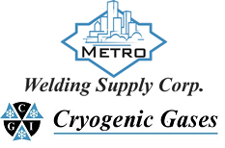 | Safety Data Sheet  Nitric Oxide

Section 1: Product and Company Identification
Metro Welding Supply Corp.
12620 Southfield Road
Detroit, MI 48223
(313) 834-1660 [phone]
(313) 835-3562 [fax]
http://www.metrowelding.com/

Product Code: Nitric Oxide

Section 2: Hazards Identification
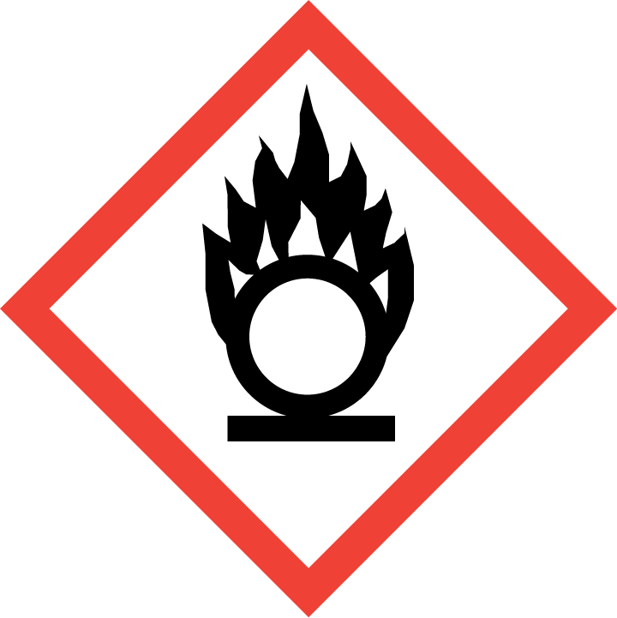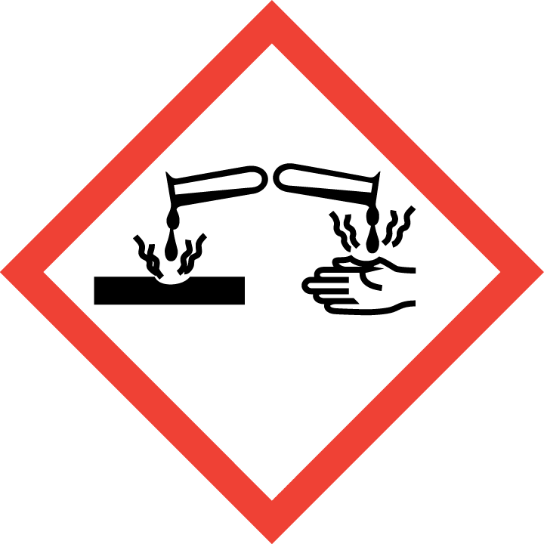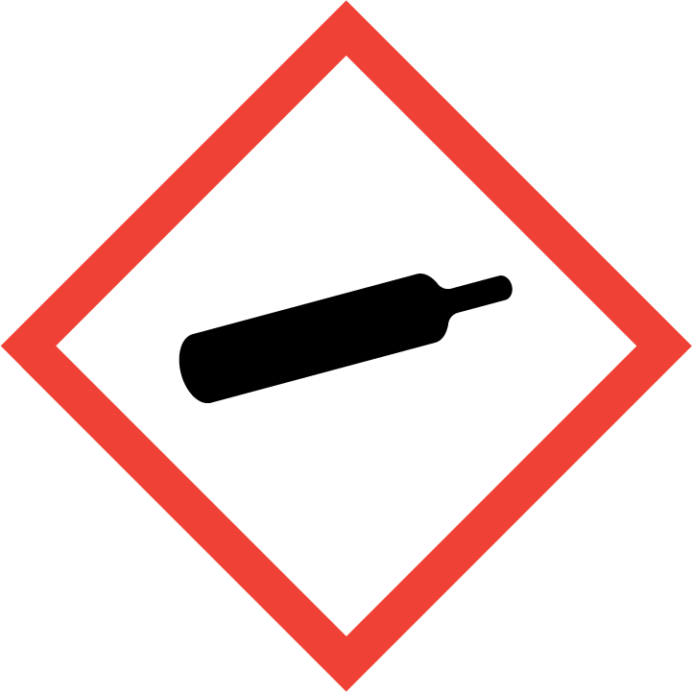
Danger

Hazard Classification:
Corrosive To Metal (Category 1)
Gases Under Pressure
Oxidizing Gas (Category 1)

Hazard Statements:
Contains gas under pressure; may explode if heated
May be corrosive to metals
May cause or intensify fire; oxidizer

Precautionary Statements
Prevention:
Keep reduction valves/valves and fittings free from oil and grease.
Keep only in original container.
Keep and store away from clothing and combustible materials.

Response:
Absorb spillage to prevent material damage.
In case of fire: Stop leak if safe to do so.

Storage:
Protect from sunlight.
Store in well-ventilated place.
Store in corrosive resistant container with a resistant inner liner.

Section 3: Composition/Information on Ingredients

CAS #
10102-43-9

Chemical Substance | Chemical Family | Trade Names
NITRIC OXIDE | inorganic, gas | NITROGEN OXIDE (NO); NITRIC OXIDE (NO); NITRIC OXIDE TRIMER; NITROGEN MONOXIDE; NITROGEN MONOOXIDE; NITROGEN OXIDE (N4O4); NITROSYL RADICAL; RCRA P076; STCC 4920330; UN 1660; NO

Section 4: First Aid Measures
Skin Contact | Eye Contact | Ingestion | Inhalation | Note to Physicians
Wash skin with soap and water for at least 15 minutes while removing contaminated clothing and shoes. Get medical attention, if needed. Thoroughly clean and dry contaminated clothing and shoes before reuse. | Flush eyes with plenty of water for at least 15 minutes. Then get immediate medical attention. | If a large amount is swallowed, get medical attention. | If adverse effects occur, remove to uncontaminated area. Give artificial respiration if not breathing. Get immediate medical attention. | None

Section 5: Fire Fighting Measures
Suitable Extinguishing Media | Products of Combustion | Protection of Firefighters
Water Do not use dry chemicals, carbon dioxide or halogenated extinguishing agents. Large fires: Flood with fine water spray. | Nitrogen oxides | - Any self-contained breathing apparatus with a full facepiece.  - Any self-contained breathing apparatus with a full facepiece.

Section 6: Accidental Release Measures
Personal Precautions | Environmental Precautions | Methods for Containment
Keep unnecessary people away, isolate hazard area and deny entry. Ventilate closed spaces before entering. Avoid contact with combustible materials. | Avoid contamination of water, soil, drains, and sewers. | Stop leak if possible without personal risk.

Methods for Cleanup | Other Information
Contact emergency personnel. | Notify Local Emergency Planning Committee and State Emergency Response Commission for release greater than or equal to RQ (U.S. SARA Section 304). If release occurs in the U.S. and is reportable under CERCLA Section 103, notify the National Response Ceter at (800)424-8802 (USA) or (202)426-2675 (USA).

Section 7: Handling and Storage
Handling | Storage
Store and handle in accordance with all current regulations and standards. NFPA 430 Code for the Storage of Liquid and Solid Oxidizing Materials. Notify State Emergency Response Commission for storage or use at amounts greater than or equal to the TPQ (U.S. EPA SARA Section 302). SARA Section 303 requires facilities storing a material with a TPQ to participate in local emergency response planning (U.S. EPA 40 CFR 355.30). | Keep separated from incompatible substances.

Section 8: Exposure Controls/Personal Protection
Exposure Guidelines
NITRIC OXIDE: 25 ppm (30 mg/m3) OSHA TWA 25 ppm ACGIH TWA 25 ppm (30 mg/m3) NIOSH recommended TWA 10 hour(s)

Engineering Controls
Handle only in fully enclosed systems.
Eye Protection | Skin Protection | Respiratory Protection
Wear splash resistant safety goggles. Provide an emergency eye wash fountain and quick drench shower in the immediate work area. | Wear appropriate chemical resistant clothing. | Any self-contained breathing apparatus with a full facepiece.

General Hygiene considerations
- Avoid breathing vapor or mist
- Avoid contact with eyes and skin
- Wash thoroughly after handling and before eating or drinking

Section 9: Physical and Chemical Properties
Physical State | Appearance | Color | Change in Appearance | Physical Form | Odor | Taste
Gas | Clear | Colorless | N/A | Gas | Not available | N/A

Flash Point | Flammability | Partition Coefficient | Autoignition Temperature | Upper Explosive Limits | Lower Explosive Limits
Not applicable | Not available | Not available | Nonflammable | Nonflammable | Nonflammable

Boiling Point | Freezing Point | Vapor Pressure | Vapor Density | Specific Gravity | Water Solubility | pH | Odor Threshold | Evaporation Rate | Viscosity
-242 F (-152 C) | -263 F (-164 C) | 26000 mmHg @ 20 C | 1.036 (Air=1) | Not applicable | 7.3% @ 0 C | Not applicable | 0.3-1.0 ppm | Not applicable | 0.0188 cP @ 25 C

Molecular Weight | Molecular Formula | Density | Weight per Gallon | Volatility by Volume | Volatility | Solvent Solubility
30.01 | N-O | 1.3402 g/L | Not available | Not available | Not applicable | Soluble: Sulfuric acid, alcohol, ferrous sulfate solutions, carbon disulfide

Section 10: Stability and Reactivity
Stability | Conditions to Avoid | Incompatible Materials
May react on contact with air. May react on contact with water. Releases toxic, corrosive, flammable or explosive gases. May explode during distillation or evaporation. | May react on contact with air. May react on contact with water. Releases toxic, corrosive, flammable or explosive gases. May explode during distillation or evaporation. | Metals, bases, metal oxides, reducing agents, combustible materials, halo carbons, oxidizing materials, halogens, metal carbide, metal salts

Hazardous Decomposition Products | Possibility of Hazardous Reactions
Oxides of nitrogen | Will not polymerize.

Section 11: Toxicology Information

Acute Effects
Oral LD50 | Dermal LD50 | Inhalation
LC50 Inhalation Gas. Rat 1068 mg/m³ 4 hours | Not available | Irritation, nausea, vomiting, stomach pain, chest pain, difficulty breathing, headache, dizziness, bluish skin color, lung congestion

Eye Irritation | Skin Irritation | Sensitization
Irritation (possibly severe) | Irritation (possibly severe) | Harmful if inhaled, respiratory tract irritation, skin irritation, blood damage

Chronic Effects
Carcinogenicity | Mutagenicity | Reproductive Effects | Developmental Effects
Not available | Available. | Not available | No data

Section 12: Ecological Information

Fate and Transport
Eco toxicity | Persistence / Degradability | Bioaccumulation / Accumulation | Mobility in Environment
Fish toxicity: Not available  Invertibrate toxicity: Not available  Algal toxicity: Not available  Phyto toxicity: Not available  Other toxicity: Not available | Readily biodegrades | Not available | Not expected to leach through the soil or the sediment.

Section 13: Disposal Considerations
Subject to disposal regulations: U.S. EPA 40 CFR 262. Hazardous Waste Number(s): D001. D003. Dispose in accordance with all applicable regulations.

Section 14: Transportation Information

U.S. DOT 49 CFR 172.101
Proper Shipping Name | ID Number | Hazard Class or Division | Packing Group | Labeling Requirements | Passenger Aircraft or Railcar Quantity Limitations | Cargo Aircraft Only Quantity Limitations | Additional Shipping Description
Nitric oxide, compressed | UN1660 | 2.3 | Not applicable | 2.3; 5.1;8 | Forbidden | Forbidden | Toxic-Inhalation Hazard Zone A

Canadian Transportation of Dangerous Goods
Shipping Name | UN Number | Class | Packing Group / Risk Group
Nitric oxide, compressed | UN1660 | 2.3; 5.1; 8 | Not applicable

Section 15: Regulatory Information

U.S. Regulations
CERCLA Sections | SARA 355.30 | SARA 355.40
10 LBS RQ | 100 LBS TPQ | 10 LBS RQ

SARA 370.21
Acute | Chronic | Fire | Reactive | Sudden Release
Yes | No | No | No | Yes

SARA 372.65
Not regulated.

OSHA Process Safety
250 LBS TQ

State Regulations
CA Proposition 65
Not regulated.

Canadian Regulations
WHMIS Classification
ACD1

National Inventory Status
US Inventory (TSCA) | TSCA 12b Export Notification | Canada Inventory (DSL/NDSL)
Listed on inventory. | Not listed. | Not determined.

Section 16: Other Information
NFPA Rating
HEALTH=4 FIRE=0 REACTIVITY=1
0 = minimal hazard, 1 = slight hazard, 2 = moderate hazard, 3 = severe hazard, 4 = extreme hazard

