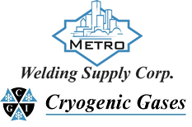 | Safety Data Sheet  Chlorine

Section 1: Product and Company Identification
Metro Welding Supply Corp.
12620 Southfield Road
Detroit, MI 48223
(313) 834-1660 [phone]
(313) 835-3562 [fax]
http://www.metrowelding.com/

Product Code: Chlorine

Section 2: Hazards Identification
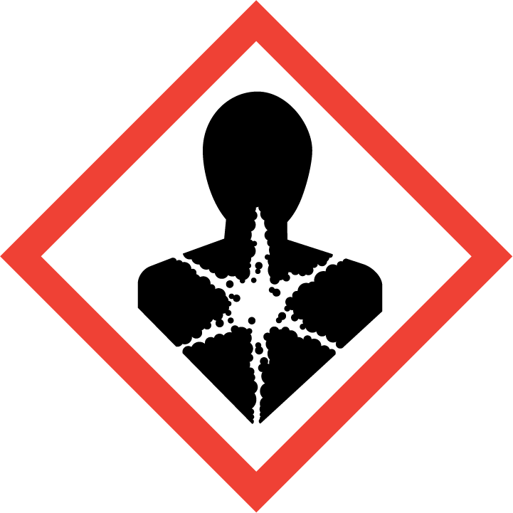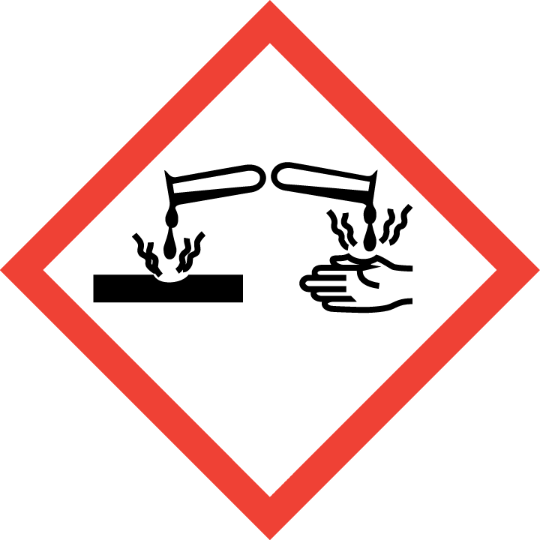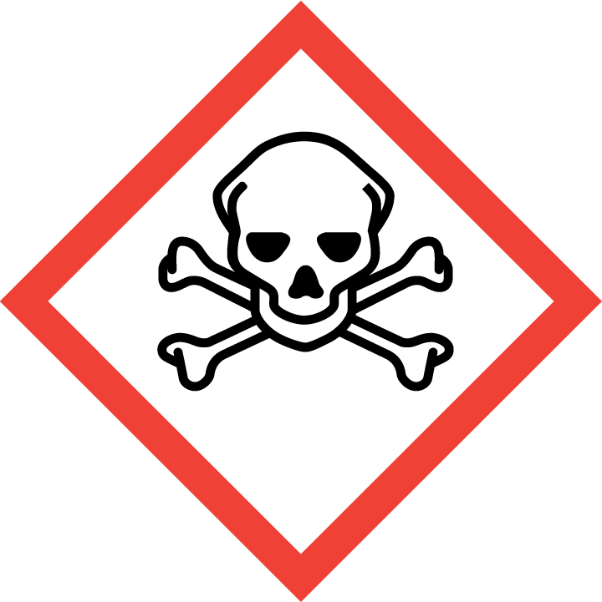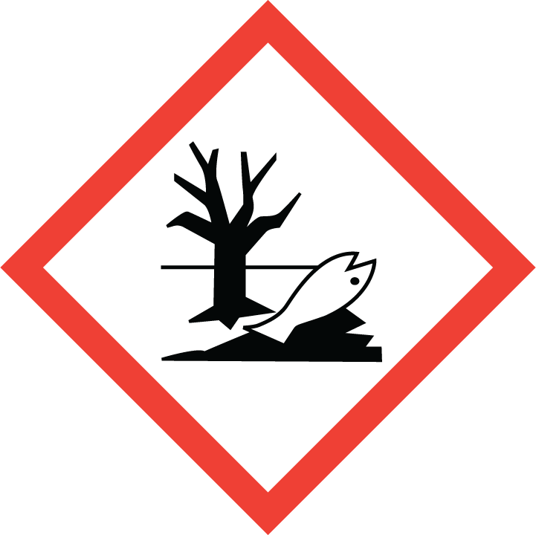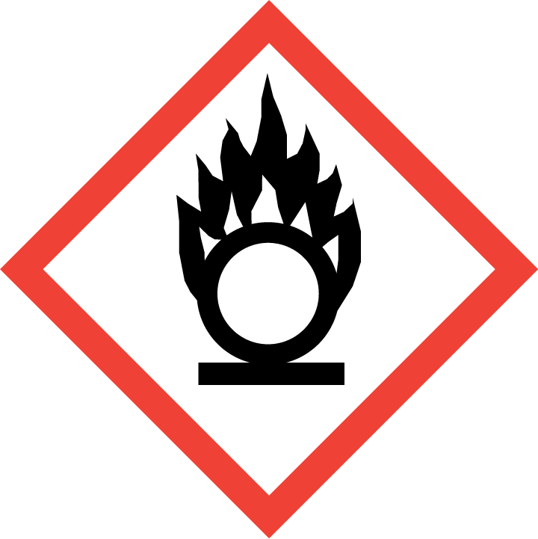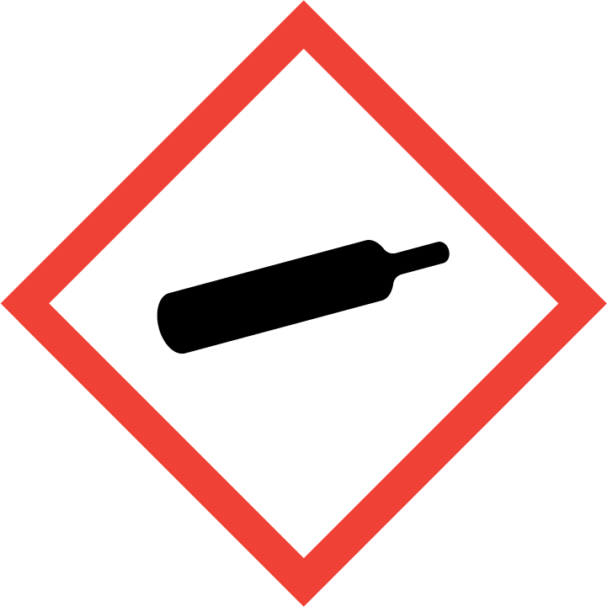
Danger

Hazard Classification:
Acute Aquatic Toxicity (Category 1)
Acute Gas Inhale Toxicity (Category 2)
Acute Oral Toxicity (Category 1)
Aspiration Hazard (Category 1)
Corrosive To Metal (Category 1)
Eye Effects (Category 1)
Gases Under Pressure
Oxidizing Gas (Category 1)

Hazard Statements:
Causes serious eye damage
Contains gas under pressure; may explode if heated
Fatal if inhaled
Fatal if swallowed
May be corrosive to metals
May be fatal if swallowed and enters airways
May cause or intensify fire; oxidizer
Very toxic to aquatic life

Precautionary Statements
Prevention:
Wash thoroughly after handling.
Wear eye protection/face protection.
Do not eat, drink or smoke when using this product.
[In case of inadequate ventilation] wear respiratory protection.
Keep and store away from clothing and combustible materials.
Do not breathe dust/fume/gas/mist/ vapors/spray..
Keep reduction valves/valves and fittings free from oil and grease.
Use only outdoors or in a well-ventilated area.
Keep only in original container.

Response:
Immediately call a poison center or doctor.
In case of fire: Stop leak if safe to do so.
Absorb spillage to prevent material damage.
Do NOT induce vomiting.
Specific treatment is urgent.
If swallowed: Rinse mouth. Do NOT induce vomiting.
If in eyes: Rinse cautiously with water for several minutes. Remove contact lenses, if present and easy to do. Continue rinsing.
If inhaled: Remove person to fresh air and keep comfortable for breathing.

Storage:
Store in a well-ventilated place. Keep container tightly closed.
Protect from sunlight.
Store locked up.
Store in corrosive resistant container with a resistant inner liner.

Disposal:
Dispose of contents and/or container in accordance with applicable regulations.

Section 3: Composition/Information on Ingredients

CAS #
7782-50-5

Chemical Substance | Chemical Family | Trade Names
CHLORINE | halogens, gas | CHLORINE MOLECULAR; DIATOMIC CHLORINE; DICHLORINE; MOLECULAR CHLORINE; UN 1017; Cl2

Section 4: First Aid Measures
Skin Contact | Eye Contact | Ingestion | Inhalation | Note to Physicians
Wash skin with soap and water for at least 15 minutes while removing contaminated clothing and shoes. Get immediate medical attention. Thoroughly clean and dry contaminated clothing before reuse. Destroy contaminated shoes. | Immediately flush eyes with plenty of water for at least 15 minutes. Then get immediate medical attention. | Not likely route of exposure. | If adverse effects occur, remove to uncontaminated area. Give artificial respiration if not breathing. If breathing is difficult, oxygen should be administered by qualified personnel. Get immediate medical attention. | For inhalation, consider oxygen. Avoid gastric lavage or emesis.

Section 5: Fire Fighting Measures
Suitable Extinguishing Media | Products of Combustion | Protection of Firefighters
Non-flammable. Use appropriate extinguishing media for surrounding fire. | Non-flammable | - Full-body encapsulating chemical protective suit with positive pressure self-contained breathing apparatus  - Non-flammable.

Section 6: Accidental Release Measures
Personal Precautions | Environmental Precautions | Methods for Containment
Keep unnecessary people away, isolate hazard area and deny entry. Ventilate closed spaces before entering. Evacuate area and downwind locations. | Avoid contact with combustible materials. | Stop leak if possible without personal risk. Reduce vapors with water spray. Dig holding area such as lagoon, pond or pit for containment. Trap spilled material at bottom in deep water pockets, excavated holding areas or within sand bag barriers.

Methods for Cleanup | Other Information
Collect runoff for disposal as potential hazardous waste. Dike for later disposal. Absorb with sand or other non-combustible material. Add an alkaline material (lime, crushed limestone, sodium bicarbonate, or soda ash). Add an alkaline material (lime, crushed limestone, sodium bicarbonate, or soda ash). Absorb with activated carbon. Collect spilled material using mechanical equipment. | Notify Local Emergency Planning Committee and State Emergency Response Commission for release greater than or equal to RQ (U.S. SARA Section 304). If release occurs in the U.S. and is reportable under CERCLA Section 103, notify the National Response Center at (800)424-8802 (USA) or (202)426-2675 (USA).

Section 7: Handling and Storage
Handling | Storage
Notify State Emergency Response Commission for storage or use at amounts greater than or equal to the TPQ (U.S. EPA SARA Section 302). SARA Section 303 requires facilities storing a material with a TPQ to participate in local emergency response planning (U.S. EPA 40 CFR 355.30). | Store and handle in accordance with all current regulations and standards. Protect from physical damage. Keep separated from incompatible substances. Store outside or in a detached building.

Section 8: Exposure Controls/Personal Protection
Exposure Guidelines
CHLORINE: 1 ppm (3 mg/m3) OSHA ceiling 0.5 ppm (1.5 mg/m3) OSHA TWA (vacated by 58 FR 35338, June 30, 1993) 1 ppm (3 mg/m3) OSHA STEL (vacated by 58 FR 35338, June 30, 1993) 0.5 ppm ACGIH TWA 1 ppm ACGIH STEL 0.5 ppm (1.45 mg/m3) NIOSH recommended ceiling 15 minute(s)

Engineering Controls
Handle only in fully enclosed systems.
Eye Protection | Skin Protection | Respiratory Protection
Wear splash resistant safety goggles with a face shield. Provide an emergency eye wash fountain and quick drench shower in the immediate work area. | Wear appropriate chemical resistant clothing. | Full-body encapsulating chemical protective suit with positive pressure self-contained breathing apparatus

General Hygiene considerations
- Avoid breathing vapor or mist
- Avoid contact with eyes and skin
- Wash thoroughly after handling and before eating or drinking

Section 9: Physical and Chemical Properties
Physical State | Appearance | Color | Change in Appearance | Physical Form | Odor | Taste
Gas | Yellow or green | Yellow or green | N/A | Gas | Distinct odor, irritating odor | N/A

Flash Point | Flammability | Partition Coefficient | Autoignition Temperature | Upper Explosive Limits | Lower Explosive Limits
Not combustible (does not burn). However, chlorine is a strong oxidizing agent and is a serious fire risk. | Not available | Not available | Not available | Not available | Not available

Boiling Point | Freezing Point | Vapor Pressure | Vapor Density | Specific Gravity | Water Solubility | pH | Odor Threshold | Evaporation Rate | Viscosity
-29.1 F (-33.97 C) | -150 F (-101 C) | 5168 mmHg @ 21 C | 2.49 (Air=1) | Not applicable | 1.46% @ 0 C | Not applicable | 0.01 ppm | Not applicable | 0.01327 cP @ 20 C

Molecular Weight | Molecular Formula | Density | Weight per Gallon | Volatility by Volume | Volatility | Solvent Solubility
70.906 | Cl2 | 3.214 g/L @ 0 C | Not available | 100% | Not applicable | Soluble: Alkali

Section 10: Stability and Reactivity
Stability | Conditions to Avoid | Incompatible Materials
Stable at normal temperatures and pressure. It reacts with water to form a weak, highly corrosive solutions of hydrochloric acid and hypochlorous acid, which can decompose to hydrochloric acid and oxygen. | Stable at normal temperatures and pressure. It reacts with water to form a weak, highly corrosive solutions of hydrochloric acid and hypochlorous acid, which can decompose to hydrochloric acid and oxygen. | Combustible materials, bases, metals, halogens, metal salts, reducing agents, amines, metal carbide, metal oxides, oxidizing materials, halo carbons, acids

Hazardous Decomposition Products | Possibility of Hazardous Reactions
Corrosive hydrogen chloride, hydrochloric acid and hypochlorous acid. | Will not polymerize.

Section 11: Toxicology Information

Acute Effects
Oral LD50 | Dermal LD50 | Inhalation
0.86 mg/L (1 hr-Rat) | Not available | Burns, chest pain, difficulty breathing, headache, dizziness, hyperactivity, emotional disturbances, bluish skin color, lung damage, death

Eye Irritation | Skin Irritation | Sensitization
Burns | Burns | Harmful, toxic if inhaled, respiratory tract burns, skin burns, eye burns

Chronic Effects
Carcinogenicity | Mutagenicity | Reproductive Effects | Developmental Effects
ACGIH: A4 -Not Classifiable as a Human Carcinogen | Available. | Available. | No data

Section 12: Ecological Information

Fate and Transport
Eco toxicity | Persistence / Degradability | Bioaccumulation / Accumulation | Mobility in Environment
Fish toxicity: LC50 Fathead minnow: 0.07 to 0.15 (96 hour); 390 ug/L 96 hour(s) LC50 (Mortality) Orangethroat darter (Etheostoma spectabile)  Invertibrate toxicity: 637.5 ug/L 1 hour(s) LC50 (Mortality) Pacific oyster (Crassostrea gigas)  Algal toxicity: 50-1000 ug/L 23 hour(s) (Population) Algae,phytoplankton,algal mat (Algae)  Phyto toxicity: Not available  Other toxicity: 20 ug/L 96 day(s) (Growth) Water-milfoil (Myriophyllum spicatum) | The atmospheric half-life and lifetime of this material due to photolysis is estimated at 10 and 14 minutes, respectively. The half-life of free resid | Not expected | Not available

Section 13: Disposal Considerations
Subject to disposal regulations: U.S. EPA 40 CFR 262. Hazardous Waste Number(s): D001. Dispose in accordance with all applicable regulations.

Section 14: Transportation Information

U.S. DOT 49 CFR 172.101
Proper Shipping Name | ID Number | Hazard Class or Division | Packing Group | Labeling Requirements | Passenger Aircraft or Railcar Quantity Limitations | Cargo Aircraft Only Quantity Limitations | Additional Shipping Description
Chlorine | UN1017 | 2.3 | Not applicable | 2.3; 8 | Forbidden | Forbidden | Toxic-Inhalation Hazard Zone B

Canadian Transportation of Dangerous Goods
Shipping Name | UN Number | Class | Packing Group / Risk Group
Chlorine | UN1017 | 2.3; 8 | Not applicable

Section 15: Regulatory Information

U.S. Regulations
CERCLA Sections | SARA 355.30 | SARA 355.40
10 LBS RQ | 100 LBS TPQ | 10 LBS RQ

SARA 370.21
Acute | Chronic | Fire | Reactive | Sudden Release
Yes | No | No | No | Yes

SARA 372.65
CHLORINE

OSHA Process Safety
1500 LBS TQ

State Regulations
CA Proposition 65
Not regulated.

Canadian Regulations
WHMIS Classification
A, D1A, E

National Inventory Status
US Inventory (TSCA) | TSCA 12b Export Notification | Canada Inventory (DSL/NDSL)
Listed on inventory. | Not listed. | Not determined.

Section 16: Other Information
NFPA Rating
HEALTH=4 FIRE=0 REACTIVITY=0
0 = minimal hazard, 1 = slight hazard, 2 = moderate hazard, 3 = severe hazard, 4 = extreme hazard

