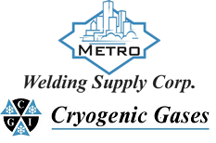 | Safety Data Sheet  Anhydrous Ammonia

Section 1: Product and Company Identification
Metro Welding Supply Corp.
12620 Southfield Road
Detroit, MI 48223
(313) 834-1660 [phone]
(313) 835-3562 [fax]
http://www.metrowelding.com/

Product Code: Anhydrous Ammonia

Section 2: Hazards Identification
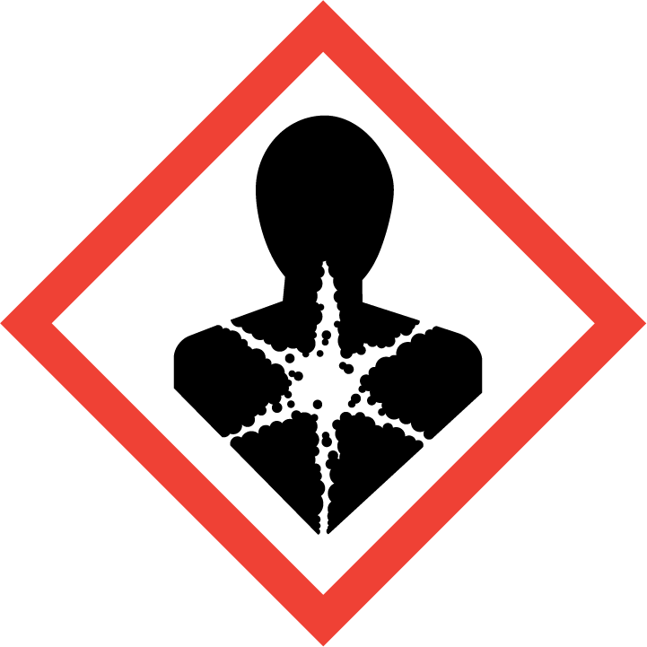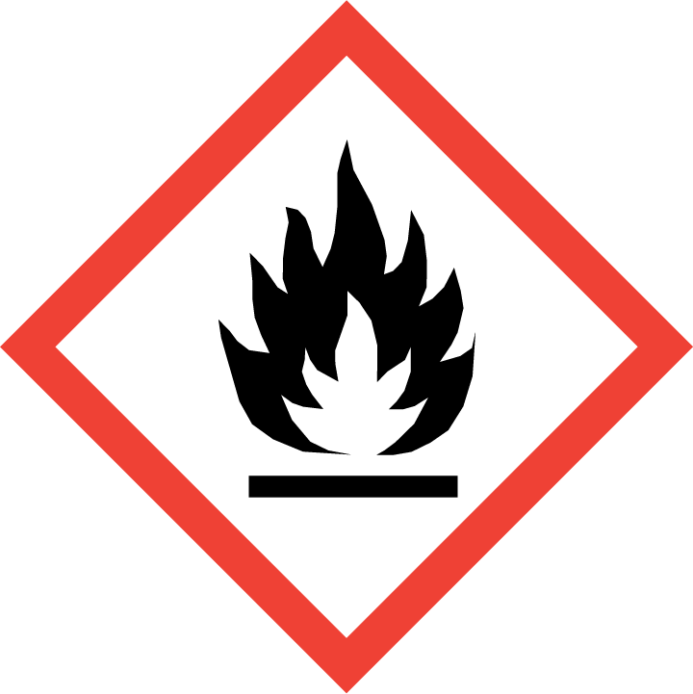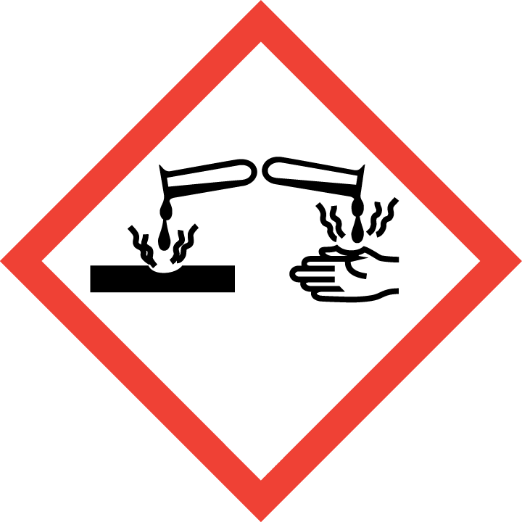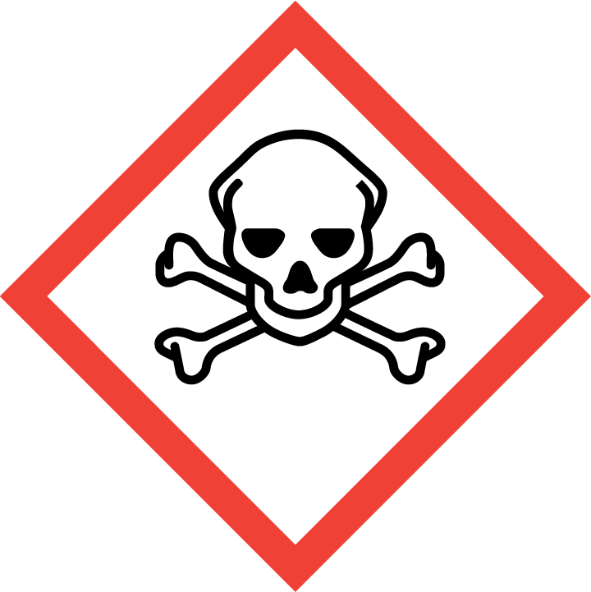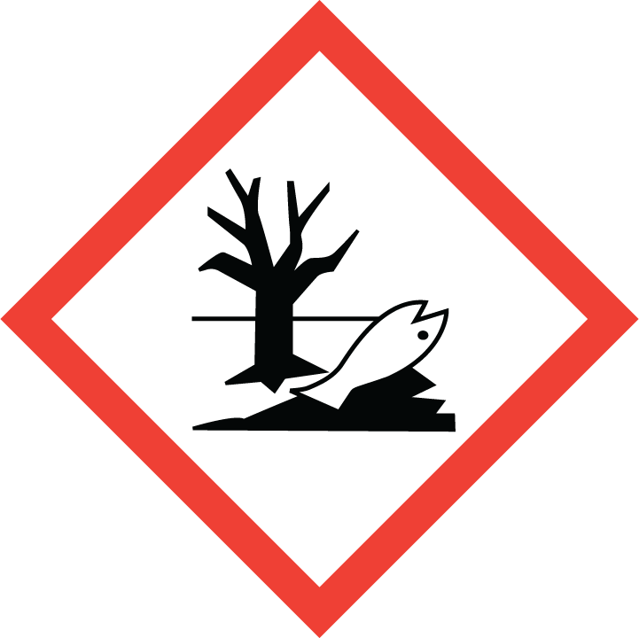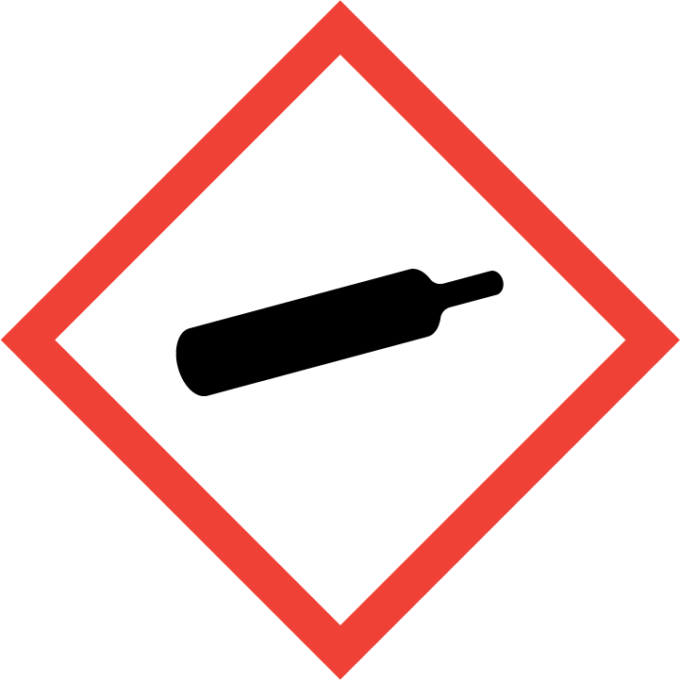
Danger

Hazard Classification:
Acute Aquatic Toxicity (Category 1)
Acute Gas Inhale Toxicity (Category 3)
Aspiration Hazard (Category 1)
Chronic Aquatic Toxicity (Category 1)
Eye Effects (Category 1)
Flammable (Category 1)
Gases Under Pressure
Skin Corrosion (Category 1.B)

Hazard Statements:
Causes serious eye damage
Causes severe skin burns and eye damage
Contains gas under pressure; may explode if heated
Extremely flammable gas
May be fatal if swallowed and enters airways
Toxic if inhaled
Very toxic to aquatic life
Very toxic to aquatic life with long lasting effects

Precautionary Statements
Prevention:
Wash thoroughly after handling.
[In case of inadequate ventilation] wear respiratory protection.
Do not breathe dust/fume/gas/mist/ vapors/spray..
Use only outdoors or in a well-ventilated area.
Wear protective gloves, protective clothing, eye protection and face protection.
Keep away from heat/sparks/open flames/hot surfaces. - No smoking.

Response:
Eliminate all ignition sources if safe to do so.
If on skin (or hair): Take off immediately all contaminated clothing. Rinse skin with water/shower.
Immediately call a poison center or doctor.
Leaking gas fire: Do not extinguish, unless leak can be stopped safely.
Do NOT induce vomiting.
If swallowed: Rinse mouth. Do NOT induce vomiting.
If in eyes: Rinse cautiously with water for several minutes. Remove contact lenses, if present and easy to do. Continue rinsing.
If inhaled: Remove person to fresh air and keep comfortable for breathing.

Storage:
Store in a well-ventilated place. Keep container tightly closed.
Protect from sunlight.
Store locked up.

Disposal:
Dispose of contents and/or container in accordance with applicable regulations.

Section 3: Composition/Information on Ingredients

CAS #
7664-41-7

Chemical Substance | Chemical Family | Trade Names
AMMONIA, ANHYDROUS | inorganic, gas | ANHYDROUS AMMONIA; AMMONIA GAS; AMMONIA; SPIRIT OF HARTSHORN; AMMONIA, ANHYDROUS, LIQUIFIED; UN 1005; H3N

Section 4: First Aid Measures
Skin Contact | Eye Contact | Ingestion | Inhalation | Note to Physicians
Wash skin with soap and water for at least 15 minutes while removing contaminated clothing and shoes. Get immediate medical attention. Thoroughly clean and dry contaminated clothing before reuse. Destroy contaminated shoes. | Immediately flush eyes with plenty of water for at least 15 minutes. Then get immediate medical attention. | Gas: Not a likely route of exposure | If adverse effects occur, remove to uncontaminated area. Give artificial respiration if not breathing. If breathing is difficult, oxygen should be administered by qualified personnel. Get immediate medical attention. Wear personal protective equipment if gas still present. | For inhalation, consider oxygen.

Section 5: Fire Fighting Measures
Suitable Extinguishing Media | Products of Combustion | Protection of Firefighters
Carbon dioxide, regular dry chemical Large fires: Use regular foam or flood with fine water spray. | Nitrogen dioxide, ammonium nitrate | - Any supplied-air respirator with full facepiece and operated in a pressure-demand or other positive-pressure mode in combination with a separate escape supply, with full-body encapsulating, chemical protective suit.  - Wear protective gear with respiratory support.

Section 6: Accidental Release Measures
Personal Precautions | Environmental Precautions | Methods for Containment
Keep unnecessary people away, isolate hazard area and deny entry. Stay upwind and keep out of low areas. Ventilate closed spaces before entering. Evacuation radius: 150 feet. | Avoid dispersal of spilled material and runoff and contact with soil, waterways, drains  and sewers. | Stop leak if possible without personal risk. Reduce vapors with water spray. Do not get water directly on material. Do not get water inside container. Trap spilled material at bottom in deep water pockets, excavated holding areas or within sand bag barriers.

Methods for Cleanup | Other Information
Small spills: Flood with water. Large spills: Dike for later disposal. Collect spilled material using mechanical equipment. Dike for later disposal. Add dilute acid. Absorb with sand or other non-combustible material. Collect runoff for disposal as potential hazardous waste.  Do not direct water at source of leak of liquid ammonia. | Notify Local Emergency Planning Committee and State Emergency Response Commission for release greater than or equal to RQ (U.S. SARA Section 304). If release occurs in the U.S. and is reportable under CERCLA Section 103, notify the National Response Center at (800)424-8802 (USA) or (202)426-2675 (USA).

Section 7: Handling and Storage
Handling | Storage
Avoid heat, flames, sparks and other sources of ignition. Keep separated from incompatible substances. | Store and handle in accordance with all current regulations and standards. Subject to storage regulations: U.S. OSHA 29 CFR 1910.111. Protect from physical damage. Store outside or in a detached building. Inside storage: Store in a cool, dry place. Store in a well-ventilated area.  Store in a cool, dry place. Store in a well-ventilated area. Notify State Emergency Response Commission for storage or use at amounts greater than or equal to the TPQ (U.S. EPA SARA Section 302). SARA Section 303 requires facilities storing a material with a TPQ to participate in local emergency response planning (U.S. EPA 40 CFR 355.30).

Section 8: Exposure Controls/Personal Protection
Exposure Guidelines
AMMONIA, ANHYDROUS: 50 ppm (35 mg/m3) OSHA TWA 35 ppm (27 mg/m3) OSHA STEL (vacated by 58 FR 35338, June 30, 1993) 25 ppm ACGIH TWA 35 ppm ACGIH STEL 25 ppm (18 mg/m3) NIOSH recommended TWA 10 hour(s) 35 ppm (27 mg/m3) NIOSH recommended STEL

Engineering Controls
Handle only in fully enclosed systems.
Eye Protection | Skin Protection | Respiratory Protection
Wear splash resistant safety goggles with a face shield. Provide an emergency eye wash fountain and quick drench shower in the immediate work area. | Wear appropriate chemical resistant clothing. | Any supplied-air respirator with full facepiece and operated in a pressure-demand or other positive-pressure mode in combination with a separate escape supply, with full-body encapsulating, chemical protective suit.

General Hygiene considerations
- Avoid breathing vapor or mist
- Avoid contact with eyes and skin
- Wash thoroughly after handling and before eating or drinking

Section 9: Physical and Chemical Properties
Physical State | Appearance | Color | Change in Appearance | Physical Form | Odor | Taste
Gas | Colorless | Colorless | N/A | Gas, liquid | Pungent odor | N/A

Flash Point | Flammability | Partition Coefficient | Autoignition Temperature | Upper Explosive Limits | Lower Explosive Limits
Not available |  |  | 1204 F (651 C) | 0.28 | 0.15

Boiling Point | Freezing Point | Vapor Pressure | Vapor Density | Specific Gravity | Water Solubility | pH | Odor Threshold | Evaporation Rate | Viscosity
-27 F (-33 C) | -108 F (-78 C) | 6658 mmHg @ 21 C | 0.5967 (Air=1) | Not applicable (gas); 0.682 @ -33.4 C (liquefied gas) | 38% @ 20 C | 11.6 (1.0 N solution) | 1-5 ppm | Not applicable | 0.255 mPa.s (0.255 centipoises) @ -33.5 C (liquefied gas)

Molecular Weight | Molecular Formula | Density | Weight per Gallon | Volatility by Volume | Volatility | Solvent Solubility
17.03 | N-H3 | 0.7067 g/L @ 25 C | Not available | Not available | Not applicable | Soluble: Methanol, ethanol, chloroform, ether, organic solvents

Section 10: Stability and Reactivity
Stability | Conditions to Avoid | Incompatible Materials
Stable at normal temperatures and pressure. | Stable at normal temperatures and pressure. | Acids, combustible materials, metals, oxidizing materials, metal salts, halo carbons, halogens, amines, reducing agents, cyanides, bases

Hazardous Decomposition Products | Possibility of Hazardous Reactions
Ammonia, oxides of nitrogen | Will not polymerize.

Section 11: Toxicology Information

Acute Effects
Oral LD50 | Dermal LD50 | Inhalation
2000 ppm/4 hour(s) inhalation-rat LC50 | Not established | Burns, severe irritant, pulmonary edema at concentrations over 1500 ppm

Eye Irritation | Skin Irritation | Sensitization
Burns, blindness | Burns, liquefied gas can cause frostbite | Respiratory tract burns, skin burns, eye burns, mucous membrane burns, corrosive to eyes

Chronic Effects
Carcinogenicity | Mutagenicity | Reproductive Effects | Developmental Effects
Not listed | Available. | Not established | No data

Section 12: Ecological Information

Fate and Transport
Eco toxicity | Persistence / Degradability | Bioaccumulation / Accumulation | Mobility in Environment
Fish toxicity: Acute LC50 0.88 mg/L 96 hour(s) Orangethroat; 1600 ug/L 96 hour(s) LC50 (Mortality) Common jollytail (Galaxias maculatus)  Invertibrate toxicity: 7700 ug/L 96 hour(s) LC50 (Immobilization) Ark shell (Anadara granosa)  Algal toxicity: 2100-2300 ug/L NR hour(s) (Abundance) Algae, phytoplankton, algal mat (Algae)  Phyto toxicity: 16500 ug/L 30 hour(s) (Abundance) Common water-nymph (Najas guadalupensis)  Other toxicity: Not available | Not available | Not available | Not available

Section 13: Disposal Considerations
Dispose in accordance with all applicable regulations.

Section 14: Transportation Information

U.S. DOT 49 CFR 172.101
Proper Shipping Name | ID Number | Hazard Class or Division | Packing Group | Labeling Requirements | Passenger Aircraft or Railcar Quantity Limitations | Cargo Aircraft Only Quantity Limitations | Additional Shipping Description
Ammonia, anhydrous | UN1005 | 2.2, 2.3 | Not applicable | 2.3; 8 | Forbidden | Forbidden | Toxic-Inhalation Hazard Zone D

Canadian Transportation of Dangerous Goods
Shipping Name | UN Number | Class | Packing Group / Risk Group
AMMONIA, ANHYDROUS; or ANHYDROUS AMMONIA | UN1005 | 2.3; 8 | Not applicable

Section 15: Regulatory Information

U.S. Regulations
CERCLA Sections | SARA 355.30 | SARA 355.40
100 LBS RQ | 500 LBS TPQ | 100 LBS RQ

SARA 370.21
Acute | Chronic | Fire | Reactive | Sudden Release
Yes | No | No | No | Yes

SARA 372.65
AMMONIA, ANHYDROUS

OSHA Process Safety
10000 LBS TQ

State Regulations
CA Proposition 65
Not regulated.

Canadian Regulations
WHMIS Classification
A, B1, D1A, E

National Inventory Status
US Inventory (TSCA) | TSCA 12b Export Notification | Canada Inventory (DSL/NDSL)
Listed on inventory. | Not listed. | Not determined.

Section 16: Other Information
NFPA Rating
HEALTH=3 FIRE=1 REACTIVITY=0
0 = minimal hazard, 1 = slight hazard, 2 = moderate hazard, 3 = severe hazard, 4 = extreme hazard

