Safety Data Sheet

Carbon Dioxide

Section 1: Product and Company Identification
Metro Welding Supply Corp.
12620 Southfield Road
Detroit, MI 48223
(313) 834-1660 [phone]
(313) 835-3562 [fax]
http://www.metrowelding.com/

Product Code: Carbon Dioxide

Section 2: Hazards Identification
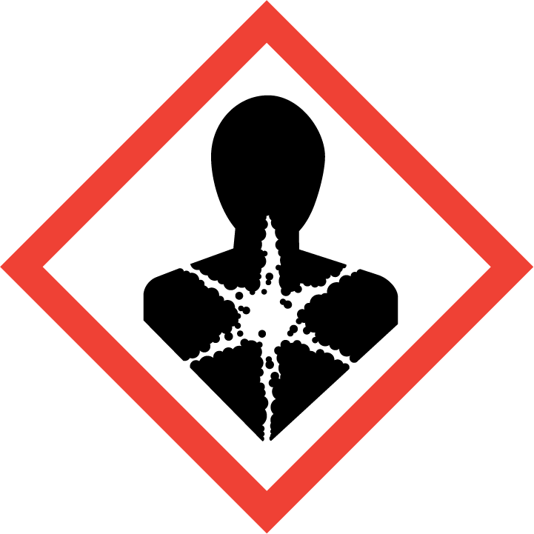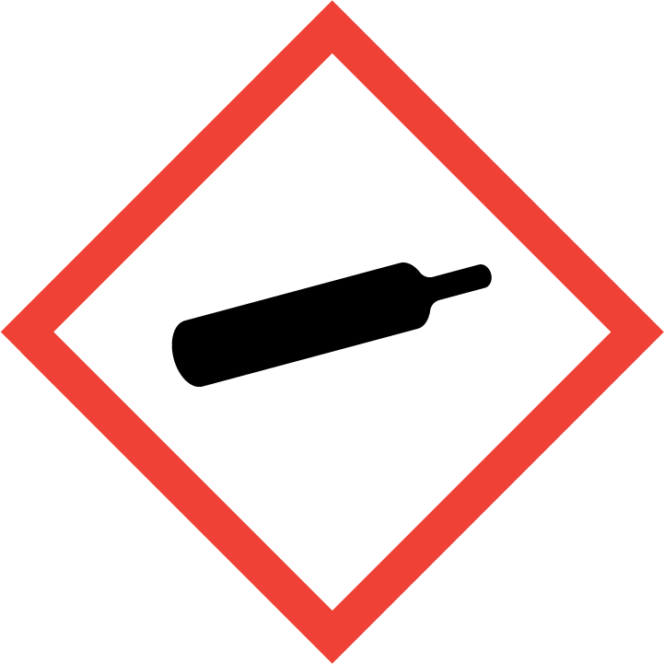
Danger

Hazard Classification:
Aspiration Hazard (Category 1)
Eye Effects (Category 2.B)
Gases Under Pressure

Hazard Statements:
Causes eye irritation
Contains gas under pressure; may explode if heated
May be fatal if swallowed and enters airways

Precautionary Statements
Prevention:
Wash thoroughly after handling.

Response:
Do NOT induce vomiting.
If in eyes: Rinse cautiously with water for several minutes. Remove contact lenses, if present and easy to do. Continue rinsing.
If swallowed: Rinse mouth. Do NOT induce vomiting.
Immediately call a poison center or doctor.

Storage:
Protect from sunlight.
Store in well-ventilated place.
Store locked up.

Disposal:
Dispose of contents and/or container in accordance with applicable regulations.

Section 3: Composition/Information on Ingredients

CAS #
124-38-9

Chemical Substance | Chemical Family | Trade Names
CARBON DIOXIDE, GAS | oxides of carbon | CARBONIC ACID GAS; CARBONIC ANHYDRIDE; CARBON DIOXIDE; CARBON OXIDE; UN 1013; CO2

Section 4: First Aid Measures
Skin Contact | Eye Contact | Ingestion | Inhalation | Note to Physicians
If frostbite or freezing occur, immediately flush with plenty of lukewarm water (105-115 F; 41-46 C). DO NOT USE HOT WATER. If warm water is not available, gently wrap affected parts in blankets. Get immediate medical attention. | Contact with liquid: Immediately flush eyes with plenty of water for at least 15 minutes. Then get immediate medical attention. | Do not induce vomiting. | If adverse effects occur, remove to uncontaminated area. Give artificial respiration if not breathing. If breathing is difficult, oxygen should be administered by qualified personnel. Get immediate medical attention. | For inhalation, consider oxygen.

Section 5: Fire Fighting Measures
Suitable Extinguishing Media | Products of Combustion | Protection of Firefighters
Non-flammable | Non-flammable | - Any appropriate escape-type, self-contained breathing apparatus.  - Non-flammable

Section 6: Accidental Release Measures
Personal Precautions | Environmental Precautions | Methods for Containment
Keep unnecessary people away, isolate hazard area and deny entry. Ventilate closed spaces before entering. Do not touch spilled material. | Subject to California Safe Drinking Water and Toxic Enforcement Act of 1986 (Proposition 65). Keep out of  water supplies and sewers. | Stop leak if possible without personal risk.

Methods for Cleanup | Other Information
Stop leak, evacuate, remove source of ignition. | None

Section 7: Handling and Storage
Handling | Storage
Subject to storage regulations: U.S. OSHA 29 CFR 1910.101. Keep separated from incompatible substances. | Store and handle in accordance with all current regulations and standards

Section 8: Exposure Controls/Personal Protection
Exposure Guidelines
CARBON DIOXIDE, GAS: CARBON DIOXIDE: 5000 ppm (9000 mg/m3) OSHA TWA 10000 ppm (18000 mg/m3) OSHA TWA (vacated by 58 FR 35338, June 30, 1993) 30000 ppm (54000 mg/m3) OSHA STEL (vacated by 58 FR 35338, June 30, 1993) 5000 ppm ACGIH TWA 30000 ppm ACGIH STEL 5000 ppm (9000 mg/m3) NIOSH recommended TWA 10 hour(s) 30000 ppm (54000 mg/m3) NIOSH recommended STEL

Engineering Controls
Handle only in fully enclosed systems.
Eye Protection | Skin Protection | Respiratory Protection
For the gas: Eye protection not required, but recommended. For the liquid: Wear splash resistant safety goggles. Contact lenses should not be worn. Provide an emergency eye wash fountain and quick drench shower in the immediate work area. | For the gas: Protective clothing is not required. For the liquid: Wear appropriate protective, cold insulating clothing. | Any appropriate escape-type, self-contained breathing apparatus.

General Hygiene considerations
- Avoid breathing vapor or mist
- Avoid contact with eyes and skin
- Wash thoroughly after handling and before eating or drinking

Section 9: Physical and Chemical Properties
Physical State | Appearance | Color | Change in Appearance | Physical Form | Odor | Taste
Gas | Colorless | Colorless | N/A | Gas | Odorless | Acid taste

Flash Point | Flammability | Partition Coefficient | Autoignition Temperature | Upper Explosive Limits | Lower Explosive Limits
Not flammable | Not available | N/A | Nonflammable | Nonflammable | Nonflammable

Boiling Point | Freezing Point | Vapor Pressure | Vapor Density | Specific Gravity | Water Solubility | pH | Odor Threshold | Evaporation Rate | Viscosity
Not available | -71 F (-57 C) @ 4000 mmHg | 43700 mmHg @ 21 C | 1.5 (Air=1) | 1.522 @ 21 C | Soluble | 3.7 (saturated aqueous solution) @ 101.3 kPa (carbonic acid) | Not available | Not applicable | 0.01657 cP @ 0 C

Molecular Weight | Molecular Formula | Density | Weight per Gallon | Volatility by Volume | Volatility | Solvent Solubility
44.01 | C-O2 | 0.114 | Not available | Not applicable | Not applicable | Soluble: Alcohol, acetone, hydrocarbons, organic solvents

Section 10: Stability and Reactivity
Stability | Conditions to Avoid | Incompatible Materials
Stable at normal temperatures and pressure. | Stable at normal temperatures and pressure. | Combustible materials, oxidizing materials, metal salts, reducing agents, metal carbide, metals, bases

Hazardous Decomposition Products | Possibility of Hazardous Reactions
Carbon monoxide | Will not polymerize.

Section 11: Toxicology Information

Acute Effects
Oral LD50 | Dermal LD50 | Inhalation
Not established | Not established | Ringing in the ears, nausea, irregular heartbeat, headache, drowsiness, dizziness, tingling sensation, visual disturbances, suffocation, convulsions, coma

Eye Irritation | Skin Irritation | Sensitization
Irritation, frostbite, blurred vision | Liquid: blisters, frostbite | Difficulty breathing

Chronic Effects
Carcinogenicity | Mutagenicity | Reproductive Effects | Developmental Effects
Not available | Not established | Available. | No data

Section 12: Ecological Information

Fate and Transport
Eco toxicity | Persistence / Degradability | Bioaccumulation / Accumulation | Mobility in Environment
Fish toxicity: 150000 ug/L 48 day(s) (Mortality) Brown trout (Salmo trutta)  Invertibrate toxicity: Not available  Algal toxicity: Not available  Phyto toxicity: Not available  Other toxicity: Not available | Relatively non-persistent in the environment. Moderately volatile from water. | Accumulates very little in the bodies of living organisms. | Leaches through the soil

Section 13: Disposal Considerations
Dispose in accordance with all applicable regulations.

Section 14: Transportation Information

U.S. DOT 49 CFR 172.101
Proper Shipping Name | ID Number | Hazard Class or Division | Packing Group | Labeling Requirements | Passenger Aircraft or Railcar Quantity Limitations | Cargo Aircraft Only Quantity Limitations | Additional Shipping Description
Carbon dioxide | UN1013 | 2.2 | Not applicable | 2.2 | 75 kg or L | 150kg | None

Canadian Transportation of Dangerous Goods
Shipping Name | UN Number | Class | Packing Group / Risk Group
Carbon dioxide | UN1013 | 2.2 | Not applicable

Section 15: Regulatory Information

U.S. Regulations
CERCLA Sections | SARA 355.30 | SARA 355.40
Not regulated. | Not regulated. | Not regulated.

SARA 370.21
Acute | Chronic | Fire | Reactive | Sudden Release
Yes | No | No | No | Yes

SARA 372.65
Not regulated.

OSHA Process Safety
Not regulated.

State Regulations
CA Proposition 65
Not regulated.

Canadian Regulations
WHMIS Classification
A

National Inventory Status
US Inventory (TSCA) | TSCA 12b Export Notification | Canada Inventory (DSL/NDSL)
Listed on inventory. | Not listed. | Listed on inventory.

Section 16: Other Information
NFPA Rating
HEALTH=2 FIRE=0 REACTIVITY=0
0 = minimal hazard, 1 = slight hazard, 2 = moderate hazard, 3 = severe hazard, 4 = extreme hazard

