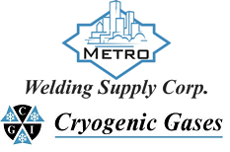 | Safety Data Sheet  Sulfur Dioxide

Section 1: Product and Company Identification
Metro Welding Supply Corp.
12620 Southfield Road
Detroit, MI 48223
(313) 834-1660 [phone]
(313) 835-3562 [fax]
http://www.metrowelding.com/

Product Code: Sulfur Dioxide

Section 2: Hazards Identification
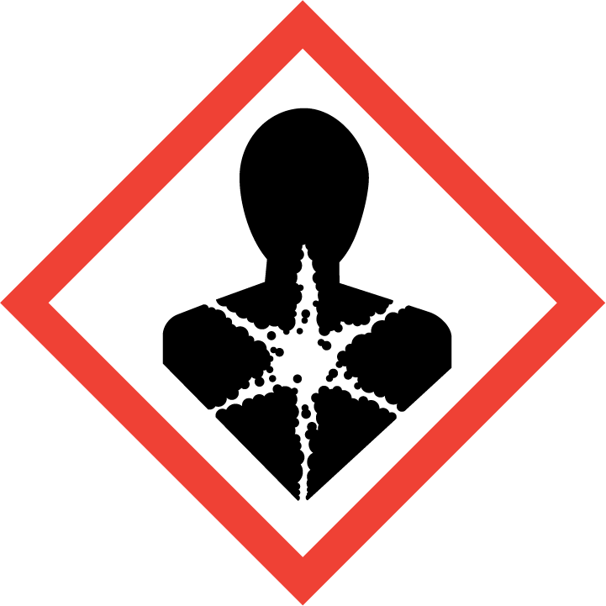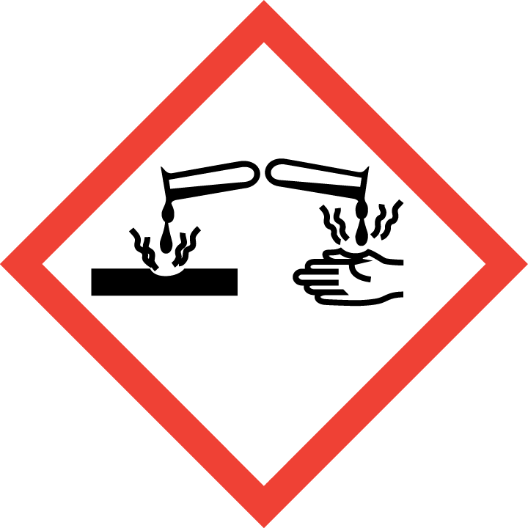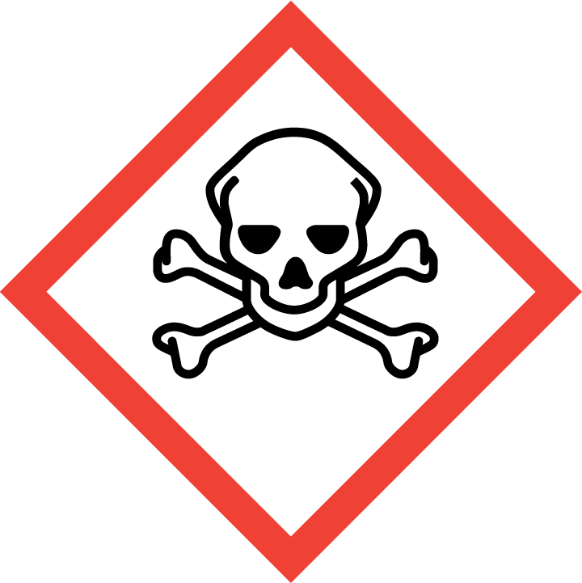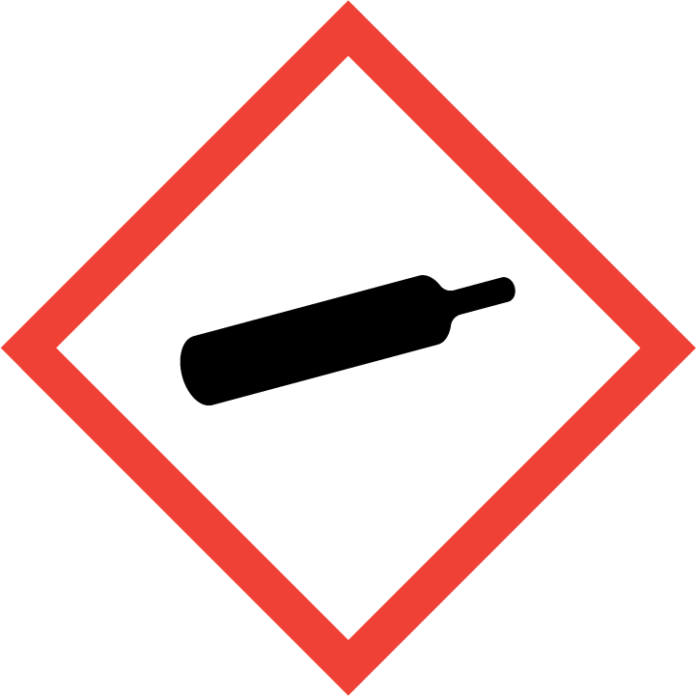
Danger

Hazard Classification:
Acute Gas Inhale Toxicity (Category 3)
Aspiration Hazard (Category 1)
Corrosive To Metal (Category 1)
Eye Effects (Category 1)
Gases Under Pressure
Skin Corrosion (Category 1.C)

Hazard Statements:
Causes serious eye damage
Causes severe skin burns and eye damage
Contains gas under pressure; may explode if heated
May be corrosive to metals
May be fatal if swallowed and enters airways
Toxic if inhaled
Toxic to aquatic life

Precautionary Statements
Prevention:
Wash thoroughly after handling.
Do not breathe dust/fume/gas/mist/ vapors/spray..
[In case of inadequate ventilation] wear respiratory protection.
Use only outdoors or in a well-ventilated area.
Keep only in original container.
Wear protective gloves, protective clothing, eye protection and face protection.

Response:
If on skin (or hair): Take off immediately all contaminated clothing. Rinse skin with water/shower.
Immediately call a poison center or doctor.
Do NOT induce vomiting.
Absorb spillage to prevent material damage.
If swallowed: Rinse mouth. Do NOT induce vomiting.
If in eyes: Rinse cautiously with water for several minutes. Remove contact lenses, if present and easy to do. Continue rinsing.
If inhaled: Remove person to fresh air and keep comfortable for breathing.

Storage:
Store in a well-ventilated place. Keep container tightly closed.
Protect from sunlight.
Store locked up.
Store in corrosive resistant container with a resistant inner liner.

Disposal:
Dispose of contents and/or container in accordance with applicable regulations.

Section 3: Composition/Information on Ingredients

CAS #
7446-09-5

Chemical Substance | Chemical Family | Trade Names
SULFUR DIOXIDE | inorganic, gas | SULFUROUS ACID ANHYDRIDE; SULFUROUS OXIDE; SULPHUR DIOXIDE; SULFUROUS ANHYDRIDE; FERMENTICIDE LIQUID; SULFUR DIOXIDE(SO2); SULFUR OXIDE; SULFUR OXIDE(SO2); STCC 4904290; UN 1079; O2S

Section 4: First Aid Measures
Skin Contact | Eye Contact | Ingestion | Inhalation | Note to Physicians
Wash skin with soap and water for at least 15 minutes while removing contaminated clothing and shoes. Get immediate medical attention. Thoroughly clean and dry contaminated clothing before reuse. Destroy contaminated shoes. | Immediately flush eyes with plenty of water for at least 15 minutes. Then get immediate medical attention. | If a large amount is swallowed, get medical attention. | If adverse effects occur, remove to uncontaminated area. Give artificial respiration if not breathing. If breathing is difficult, oxygen should be administered by qualified personnel. Get immediate medical attention. | For inhalation, consider oxygen.

Section 5: Fire Fighting Measures
Suitable Extinguishing Media | Products of Combustion | Protection of Firefighters
Non-flammable. Use suitable extinguishing media for surrounding fire. | None known | - Non-flammable  - Non-flammable

Section 6: Accidental Release Measures
Personal Precautions | Environmental Precautions | Methods for Containment
Keep unnecessary people away, isolate hazard area and deny entry. Stay upwind and keep out of low areas. Ventilate closed spaces before entering. Evacuation radius: 150 feet. | Avoid contamination of environment. | Stop leak if possible without personal risk. Reduce vapors with water spray. Do not get water directly on material.

Methods for Cleanup | Other Information
Stop leak, evacuate area. Contact emergency personnel. | Notify Local Emergency Planning Committee and State Emergency Response Commission for release greater than or equal to RQ (U.S. SARA Section 304). If release occurs in the U.S. and is reportable under CERCLA Section 103, notify the National Response Center at (800)424-8802 (USA) or (202)426-2675 (USA).

Section 7: Handling and Storage
Handling | Storage
Store and handle in accordance with all current regulations and standards. Protect from physical damage. Store outside or in a detached building. Store in a well-ventilated area. Notify State Emergency Response Commission for storage or use at amounts greater than or equal to the TPQ (U.S. EPA SARA Section 302). SARA Section 303 requires facilities storing a material with a TPQ to participate in local emergency response planning (U.S. EPA 40 CFR 355.30). | Keep separated from incompatible substances. Use in ventilated area.

Section 8: Exposure Controls/Personal Protection
Exposure Guidelines
SULFUR DIOXIDE: 2 ppm (5 mg/m3) OSHA TWA (vacated by 58 FR 35338, June 30, 1993) 5 ppm (13 mg/m3) OSHA STEL (vacated by 58 FR 35338, June 30, 1993) 5 ppm (13 mg/m3) OSHA TWA 2 ppm ACGIH TWA 5 ppm ACGIH STEL 2 ppm (5 mg/m3) NIOSH recommended TWA 10 hour(s) 5 ppm (13 mg/m3) NIOSH recommended STEL

Engineering Controls
Handle only in fully enclosed systems.
Eye Protection | Skin Protection | Respiratory Protection
Wear splash resistant safety goggles with a face shield. Provide an emergency eye wash fountain and quick drench shower in the immediate work area. | For the gas: Wear appropriate chemical resistant clothing. For the liquid: Wear appropriate protective, cold insulating clothing. | Non-flammable

General Hygiene considerations
- Avoid breathing vapor or mist
- Avoid contact with eyes and skin
- Wash thoroughly after handling and before eating or drinking

Section 9: Physical and Chemical Properties
Physical State | Appearance | Color | Change in Appearance | Physical Form | Odor | Taste
Gas | Clear | Colorless | N/A | Gas | Irritating odor | N/A

Flash Point | Flammability | Partition Coefficient | Autoignition Temperature | Upper Explosive Limits | Lower Explosive Limits
Not flammable | Not available | Not available | Nonflammable | Nonflammable | Nonflammable

Boiling Point | Freezing Point | Vapor Pressure | Vapor Density | Specific Gravity | Water Solubility | pH | Odor Threshold | Evaporation Rate | Viscosity
14 F (-10 C) | -99 F (-73 C) | 2432 mmHg @ 20 C | 2.26 (Air=1) | 1.462 @ -10 C | 22.8% @ 0 C | Acidic in solution | 3-5 ppm | >1 (butyl acetate=1) | Not available

Molecular Weight | Molecular Formula | Density | Weight per Gallon | Volatility by Volume | Volatility | Solvent Solubility
64.06 | S-O2 | 0.169 | Not available | Not available | Not applicable | Soluble: Alcohol, acetic acid, sulfuric acid, ether, chloroform, benzene, sulfuryl chloride, nitrobenzenes, toluene, acetone

Section 10: Stability and Reactivity
Stability | Conditions to Avoid | Incompatible Materials
Stable at normal temperatures and pressure. | Stable at normal temperatures and pressure. | Combustible materials, metals, bases, oxidizing materials, halogens, metal carbide, metal oxides, peroxides, reducing agents, potassium, sodium, nitryl chloride, acrolein, metal oxides, carbide

Hazardous Decomposition Products | Possibility of Hazardous Reactions
Forms sulfurous acid solution on reaction with water. | Will not polymerize.

Section 11: Toxicology Information

Acute Effects
Oral LD50 | Dermal LD50 | Inhalation
LC50, 1 hr, rat = 2520 ppm | Not available | Allergic reactions, burns, toxic

Eye Irritation | Skin Irritation | Sensitization
Corrosive, burns | Corrosive, burns | Respiratory tract burns, skin burns, eye burns, allergic reactions

Chronic Effects
Carcinogenicity | Mutagenicity | Reproductive Effects | Developmental Effects
IARC: Human Inadequate Evidence, Animal Limited Evidence, Group 3; ACGIH: A4 -Not Classifiable as a Human Carcinogen | Available. | Available. | No data

Section 12: Ecological Information

Fate and Transport
Eco toxicity | Persistence / Degradability | Bioaccumulation / Accumulation | Mobility in Environment
Fish toxicity: 3000 ug/L 0.667-0.833 hour(s) (Avoidance) Atlantic menhaden (Brevoortia tyrannus)  Invertibrate toxicity: Not available  Algal toxicity: 500 ug/L 6 day(s) (Cellular) Green algae (Rhizoclonium hieroglyphicum)  Phyto toxicity: Not available  Other toxicity: >=150 ug/L NR hour(s) (Biochemical) Duckweed (Lemna minor) | Not available | Not available | Not available

Section 13: Disposal Considerations
Dispose in accordance with all applicable regulations.

Section 14: Transportation Information

U.S. DOT 49 CFR 172.101
Proper Shipping Name | ID Number | Hazard Class or Division | Packing Group | Labeling Requirements | Passenger Aircraft or Railcar Quantity Limitations | Cargo Aircraft Only Quantity Limitations | Additional Shipping Description
Sulfur dioxide | UN1079 | 2.3 | Not applicable | 2.3; 8 | Forbidden | Forbidden | Toxic-Inhalation Hazard Zone C

Canadian Transportation of Dangerous Goods
Shipping Name | UN Number | Class | Packing Group / Risk Group
Sulfur dioxide | UN1079 | 2.3; 8 | Not applicable

Section 15: Regulatory Information

U.S. Regulations
CERCLA Sections | SARA 355.30 | SARA 355.40
Not regulated. | 500 LBS TPQ | 500 LBS RQ

SARA 370.21
Acute | Chronic | Fire | Reactive | Sudden Release
Yes | Yes | No | No | Yes

SARA 372.65
Not regulated.

OSHA Process Safety
1000 LBS TQ

State Regulations
CA Proposition 65
Not regulated.

Canadian Regulations
WHMIS Classification
AD1

National Inventory Status
US Inventory (TSCA) | TSCA 12b Export Notification | Canada Inventory (DSL/NDSL)
Listed on inventory. | Not listed. | Not determined.

Section 16: Other Information
NFPA Rating
HEALTH=3 FIRE=0 REACTIVITY=0
0 = minimal hazard, 1 = slight hazard, 2 = moderate hazard, 3 = severe hazard, 4 = extreme hazard

