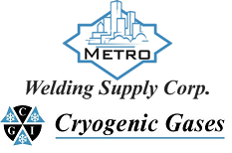 | Safety Data Sheet  Methane

Section 1: Product and Company Identification
Metro Welding Supply Corp.
12620 Southfield Road
Detroit, MI 48223
(313) 834-1660 [phone]
(313) 835-3562 [fax]
http://www.metrowelding.com/

Product Code: Methane

Section 2: Hazards Identification
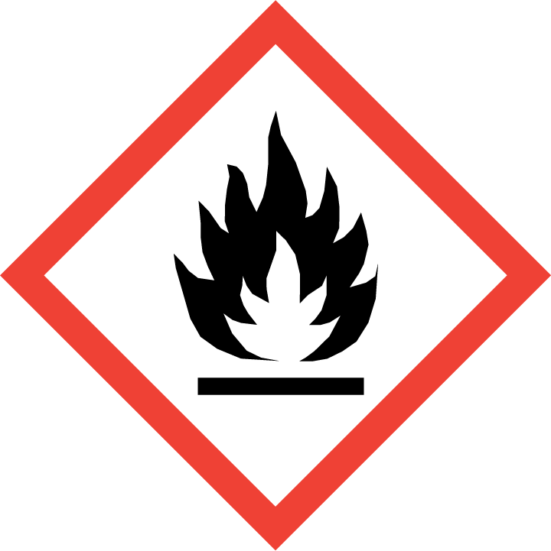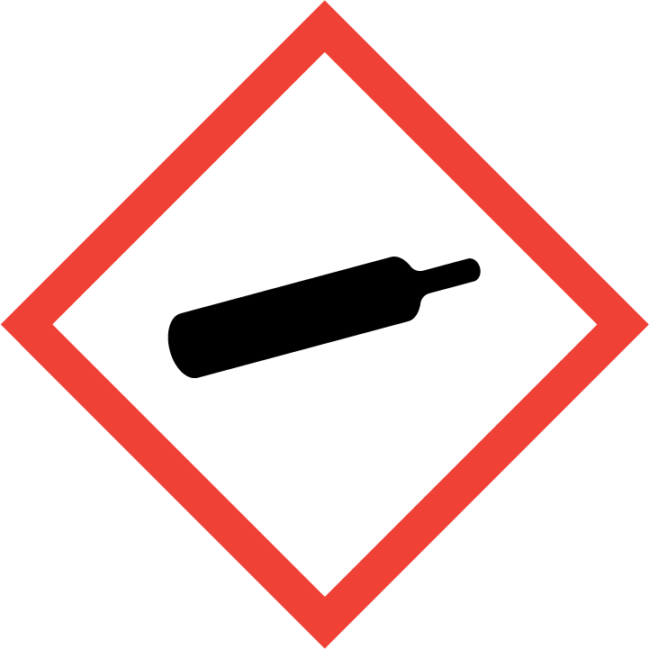
Danger

Hazard Classification:
Flammable (Category 1)
Flammable Aerosol (Category 1)
Gases Under Pressure

Hazard Statements:
Contains gas under pressure; may explode if heated
Extremely flammable aerosol
Extremely flammable gas

Precautionary Statements
Prevention:
Keep away from heat/sparks/open flames/hot surfaces. - No smoking.
Pressurized container: Do not pierce or burn, even after use.
Do not spray on an open flame or other ignition source.

Response:
Eliminate all ignition sources if safe to do so.
Leaking gas fire: Do not extinguish, unless leak can be stopped safely.

Storage:
Protect from sunlight.
Store in well-ventilated place.
Do not expose to temperatures exceeding 50C/122F.

Section 3: Composition/Information on Ingredients

CAS #
74-82-8

Chemical Substance | Chemical Family | Trade Names
METHANE, COMPRESSED GAS | hydrocarbons, gas | FIRE DAMP; MARSH GAS; METHYL HYDRIDE; NATURAL GAS; METHANE; UN 1971; R50; CH4

Section 4: First Aid Measures
Skin Contact | Eye Contact | Ingestion | Inhalation | Note to Physicians
Wash exposed skin with soap and water. | Flush eyes with plenty of water. | If a large amount is swallowed, get medical attention. | If adverse effects occur, remove to uncontaminated area. Give artificial respiration if not breathing. If breathing is difficult, oxygen should be administered by qualified personnel. Get immediate medical attention. | For inhalation, consider oxygen.

Section 5: Fire Fighting Measures
Suitable Extinguishing Media | Products of Combustion | Protection of Firefighters
Carbon dioxide, regular dry chemical Large fires: Use regular foam or flood with fine water spray. | Carbon monoxide, carbon dioxide, water | - Respiratory protection may be needed for frequent or heavy exposure. Any self-contained breathing apparatus with a full facepiece.  - Respiratory protection may be needed for frequent or heavy exposure. Any self-contained breathing apparatus with a full facepiece.

Section 6: Accidental Release Measures
Personal Precautions | Environmental Precautions | Methods for Containment
Keep unnecessary people away, isolate hazard area and deny entry. Ventilate closed spaces before entering. | Avoid heat, flames, sparks and other sources of ignition. | Stop leak if possible without personal risk. Reduce vapors with water spray. Remove sources of ignition.

Methods for Cleanup | Other Information
Not available | Not available

Section 7: Handling and Storage
Handling | Storage
Store and handle in accordance with all current regulations and standards. Grounding and bonding required. Subject to storage regulations: U.S. OSHA 29 CFR 1910.101. | Keep separated from incompatible substances.

Section 8: Exposure Controls/Personal Protection
Exposure Guidelines
METHANE, COMPRESSED GAS: ALIPHATIC HYDROCARBON GASES ALKANE (C1-C4): 1000 ppm ACGIH TWA METHANE: No occupational exposure limits established. ALIPHATIC HYDROCARBON GASES ALKANE (C1-C4): 1000 ppm ACGIH TWA

Engineering Controls
Handle only in fully enclosed systems.
Eye Protection | Skin Protection | Respiratory Protection
Eye protection not required, but recommended. | Protective clothing is not required. | Respiratory protection may be needed for frequent or heavy exposure. Any self-contained breathing apparatus with a full facepiece.

General Hygiene considerations
- Avoid breathing vapor or mist
- Avoid contact with eyes and skin
- Wash thoroughly after handling and before eating or drinking

Section 9: Physical and Chemical Properties
Physical State | Appearance | Color | Change in Appearance | Physical Form | Odor | Taste
Gas | Colorless | Colorless | N/A | Gas, liquid | Odorless | Tasteless

Flash Point | Flammability | Partition Coefficient | Autoignition Temperature | Upper Explosive Limits | Lower Explosive Limits
-369 F (-223 C) | Not available | 724.44 (log = 2.87) (estimated from water solubility) | 999 F (537 C) | 15% | 5%

Boiling Point | Freezing Point | Vapor Pressure | Vapor Density | Specific Gravity | Water Solubility | pH | Odor Threshold | Evaporation Rate | Viscosity
-260 F (-162 C) | -297 F (-183 C) | 760 mmHg @ -161 C | 0.555 (Air=1) | Not applicable | 3.5% @ 17 C | Not applicable | Not available | Not applicable | 0.01118 cP @ 27 C

Molecular Weight | Molecular Formula | Density | Weight per Gallon | Volatility by Volume | Volatility | Solvent Solubility
16.04 | C-H4 | 0.717 g/L @ 0 C | Not available | Not applicable | Not applicable | Soluble: Alcohol, ether, benzene, organic solvents

Section 10: Stability and Reactivity
Stability | Conditions to Avoid | Incompatible Materials
Stable at normal temperatures and pressure. | Stable at normal temperatures and pressure. | Halogens, oxidizing materials, combustible materials

Hazardous Decomposition Products | Possibility of Hazardous Reactions
Oxides of carbon | Will not polymerize.

Section 11: Toxicology Information

Acute Effects
Oral LD50 | Dermal LD50 | Inhalation
Not available | Not available | Nausea, vomiting, difficulty breathing, irregular heartbeat, headache, drowsiness, fatigue, dizziness, disorientation, mood swings, tingling sensation, loss of coordination, suffocation, convulsions, unconsciousness, coma

Eye Irritation | Skin Irritation | Sensitization
No information on significant adverse effects | No information on significant adverse effects | Difficulty breathing

Chronic Effects
Carcinogenicity | Mutagenicity | Reproductive Effects | Developmental Effects
Not available | Not available | Not available | No data

Section 12: Ecological Information

Fate and Transport
Eco toxicity | Persistence / Degradability | Bioaccumulation / Accumulation | Mobility in Environment
Fish toxicity: Not available  Invertibrate toxicity: Not available  Algal toxicity: Not available  Phyto toxicity: Not available  Other toxicity: Not available | Relatively non-persistent in the environment. Moderately volatile from water. | Accumulates very little in the bodies of living organisms. | Not expected to leach through the soil or the sediment.

Section 13: Disposal Considerations
Dispose in accordance with all applicable regulations. Subject to disposal regulations: U.S. EPA 40 CFR 262. Hazardous Waste Number(s): D001.

Section 14: Transportation Information

U.S. DOT 49 CFR 172.101
Proper Shipping Name | ID Number | Hazard Class or Division | Packing Group | Labeling Requirements | Passenger Aircraft or Railcar Quantity Limitations | Cargo Aircraft Only Quantity Limitations | Additional Shipping Description
Methane, compressed | UN1971 | 2.1 | Not applicable | 2.1 | Forbidden | 150 kg | N/A

Canadian Transportation of Dangerous Goods
Shipping Name | UN Number | Class | Packing Group / Risk Group
Methane, compressed | UN1971 | 2.1 | Not applicable

Section 15: Regulatory Information

U.S. Regulations
CERCLA Sections | SARA 355.30 | SARA 355.40
Not regulated. | Not regulated. | Not regulated.

SARA 370.21
Acute | Chronic | Fire | Reactive | Sudden Release
Yes | No | Yes | No | Yes

SARA 372.65
Not regulated.

OSHA Process Safety
Not regulated.

State Regulations
CA Proposition 65
Not regulated.

Canadian Regulations
WHMIS Classification
A, B1

National Inventory Status
US Inventory (TSCA) | TSCA 12b Export Notification | Canada Inventory (DSL/NDSL)
Listed on inventory. | Not listed. | Listed on inventory.

Section 16: Other Information
NFPA Rating
HEALTH=1 FIRE=4 REACTIVITY=0
0 = minimal hazard, 1 = slight hazard, 2 = moderate hazard, 3 = severe hazard, 4 = extreme hazard

