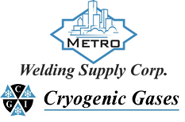 | Safety Data Sheet  Silicon Tetrafluoride

Section 1: Product and Company Identification
Metro Welding Supply Corp.
12620 Southfield Road
Detroit, MI 48223
(313) 834-1660 [phone]
(313) 835-3562 [fax]
http://www.metrowelding.com/

Product Code: Silicon Tetrafluoride

Section 2: Hazards Identification
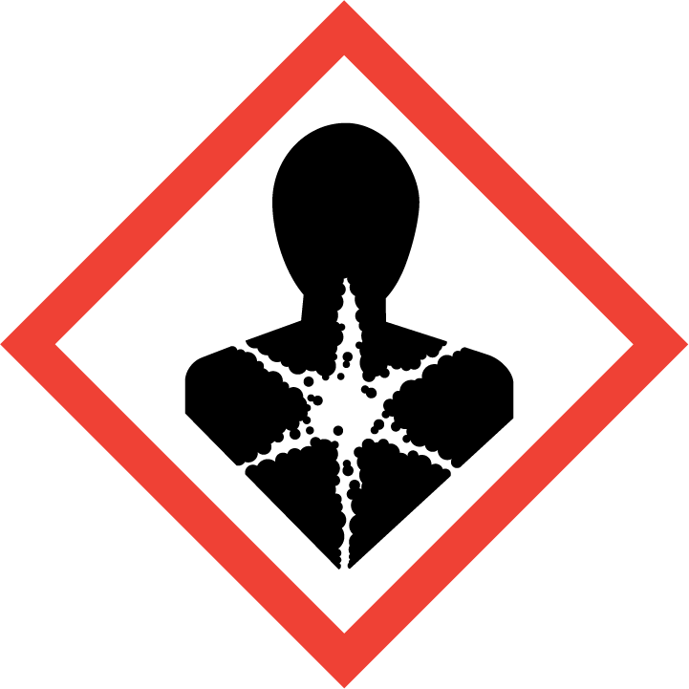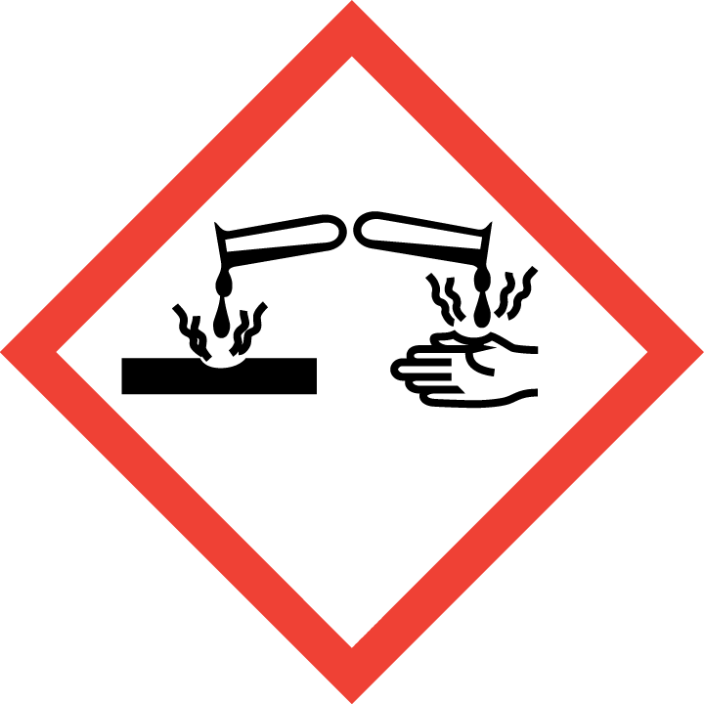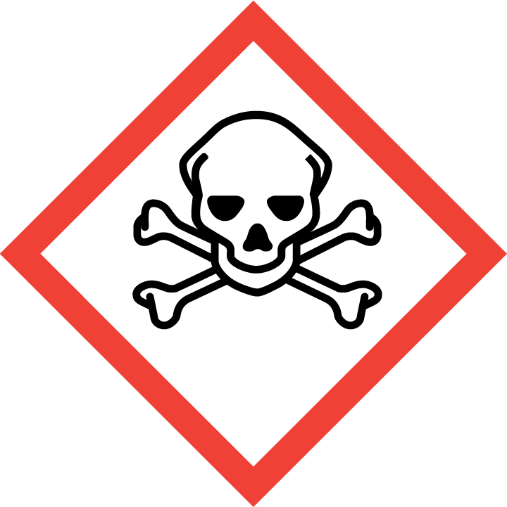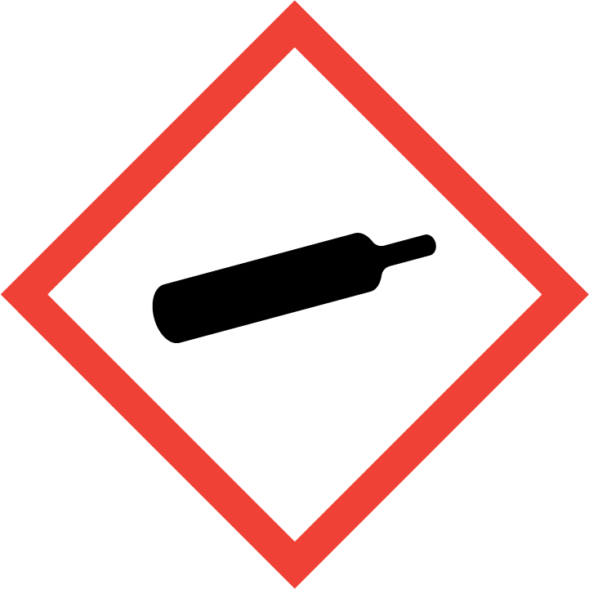
Danger

Hazard Classification:
Acute Gas Inhale Toxicity (Category 3)
Aspiration Hazard (Category 1)
Corrosive To Metal (Category 1)
Eye Effects (Category 1)
Gases Under Pressure

Hazard Statements:
Causes serious eye damage
Contains gas under pressure; may explode if heated
May be corrosive to metals
May be fatal if swallowed and enters airways
Toxic if inhaled

Precautionary Statements
Prevention:
Wear eye protection/face protection.
Use only outdoors or in a well-ventilated area.
Avoid breathing dust/fume/gas/mist/ vapors/spray.
Keep only in original container.
[In case of inadequate ventilation] wear respiratory protection.

Response:
Immediately call a poison center or doctor.
Do NOT induce vomiting.
Absorb spillage to prevent material damage.
If swallowed: Rinse mouth. Do NOT induce vomiting.
If in eyes: Rinse cautiously with water for several minutes. Remove contact lenses, if present and easy to do. Continue rinsing.
If inhaled: Remove person to fresh air and keep comfortable for breathing.

Storage:
Store in a well-ventilated place. Keep container tightly closed.
Protect from sunlight.
Store locked up.
Store in corrosive resistant container with a resistant inner liner.

Disposal:
Dispose of contents and/or container in accordance with applicable regulations.

Section 3: Composition/Information on Ingredients

CAS #
7783-61-1

Chemical Substance | Chemical Family | Trade Names
SILICON TETRAFLUORIDE | silicone/siloxane | SILANE, TETRAFLUORO-; TETRAFLUOROSILANE; SILICON FLUORIDE; PERFLUOROSILANE; SILICON TETRAFLUORIDE (SiF4); SILICON FLUORIDE (SiF4); UN 1859; F4Si

Section 4: First Aid Measures
Skin Contact | Eye Contact | Ingestion | Inhalation | Note to Physicians
Wash skin with soap and water for at least 15 minutes while removing contaminated clothing and shoes. Get immediate medical attention. Thoroughly clean and dry contaminated clothing before reuse. Destroy contaminated shoes. | Immediately flush eyes with plenty of water for at least 15 minutes. Then get immediate medical attention. | If swallowed, drink plenty of water, DO NOT induce vomiting. Get immediate medical attention. | If adverse effects occur, remove to uncontaminated area. Give artificial respiration if not breathing. If breathing is difficult, oxygen should be administered by qualified personnel. Get immediate medical attention. | For inhalation, consider oxygen. For skin contact, consider ice water bath, iced alcohol, iced magnesium sulfate, magnesium oxide/ glycerin gels, calcium gluconate gel or benzalkonium chloride solution. Avoid gastric lavage or emesis.

Section 5: Fire Fighting Measures
Suitable Extinguishing Media | Products of Combustion | Protection of Firefighters
Carbon dioxide, regular dry chemical Large fires: Use regular foam or flood with fine water spray. | Water or Moisture: acids, hydrogen fluoride | - Any self-contained breathing apparatus with a full facepiece.  - Any self-contained breathing apparatus with a full facepiece.

Section 6: Accidental Release Measures
Personal Precautions | Environmental Precautions | Methods for Containment
Keep unnecessary people away, isolate hazard area and deny entry. Do not touch spilled material. | Prevent environmental contamination. Discard according to applicable regulations. | Stop leak if possible without personal risk. Reduce vapors with water spray.

Methods for Cleanup | Other Information
Small spills: Absorb with sand or other non-combustible material. Collect spilled material in appropriate container for disposal. Large spills: Dike for later disposal. | None

Section 7: Handling and Storage
Handling | Storage
Store and handle in accordance with all current regulations and standards. Subject to storage regulations: U.S. OSHA 29 CFR 1910.101. Store below 52 C. Store in cool, dry place. Store in a well-ventilated area. | Keep separated from incompatible substances.

Section 8: Exposure Controls/Personal Protection
Exposure Guidelines
SILICON TETRAFLUORIDE: 2.5 mg(F)/m3 OSHA TWA 2.5 mg(F)/m3 ACGIH TWA 2.5 mg(F)/m3 NIOSH recommended TWA 10 hour(s).

Engineering Controls
Handle only in fully enclosed systems.
Eye Protection | Skin Protection | Respiratory Protection
Wear splash resistant safety goggles with a face shield. Provide an emergency eye wash fountain and quick drench shower in the immediate work area. | Wear appropriate chemical resistant clothing. | Any self-contained breathing apparatus with a full facepiece.

General Hygiene considerations
- Avoid breathing vapor or mist
- Avoid contact with eyes and skin
- Wash thoroughly after handling and before eating or drinking

Section 9: Physical and Chemical Properties
Physical State | Appearance | Color | Change in Appearance | Physical Form | Odor | Taste
Gas | Clear | Colorless | N/A | Gas | Irritating odor, pungent odor | N/A

Flash Point | Flammability | Partition Coefficient | Autoignition Temperature | Upper Explosive Limits | Lower Explosive Limits
Not flammable | Not available | Not available | Nonflammable | Nonflammable | Nonflammable

Boiling Point | Freezing Point | Vapor Pressure | Vapor Density | Specific Gravity | Water Solubility | pH | Odor Threshold | Evaporation Rate | Viscosity
-123 F (-86 C) | -130 F (-90 C) | Not available | 3.63 (Air=1) | 1.7 @ -95 C | Decomposes | Acidic in solution | Not available | Not applicable

Molecular Weight | Molecular Formula | Density | Weight per Gallon | Volatility by Volume | Volatility | Solvent Solubility
104.09 | F4-Si | 0.266 | Not available | Not available | Not applicable | Soluble: Absolute alcohol, hydrofluoric acid

Section 10: Stability and Reactivity
Stability | Conditions to Avoid | Incompatible Materials
Reacts violently with water, releasing toxic gases. Releases corrosive gases. | Reacts violently with water, releasing toxic gases. Releases corrosive gases. | Acids, alcohols, bases, metal salts, metals, oxidizing materials

Hazardous Decomposition Products | Possibility of Hazardous Reactions
Acids, hydrogen fluoride | Will not polymerize.

Section 11: Toxicology Information

Acute Effects
Oral LD50 | Dermal LD50 | Inhalation
LC50 Inhalation Gas. Rat 4544 ppm 1 hours | Not available | Burns

Eye Irritation | Skin Irritation | Sensitization
Burns | Burns | Respiratory tract burns, skin burns, eye burns, mucous membrane burns

Chronic Effects
Carcinogenicity | Mutagenicity | Reproductive Effects | Developmental Effects
ACGIH: A4 -Not Classifiable as a Human Carcinogen (Fluorides) | Not available | Not available | No data

Section 12: Ecological Information

Fate and Transport
Eco toxicity | Persistence / Degradability | Bioaccumulation / Accumulation | Mobility in Environment
Fish toxicity: Not available  Invertibrate toxicity: Not available  Algal toxicity: Not available  Phyto toxicity: Not available  Other toxicity: Not available | Not available | Not available | Not available

Section 13: Disposal Considerations
Dispose in accordance with all applicable regulations.

Section 14: Transportation Information

U.S. DOT 49 CFR 172.101
Proper Shipping Name | ID Number | Hazard Class or Division | Packing Group | Labeling Requirements | Passenger Aircraft or Railcar Quantity Limitations | Cargo Aircraft Only Quantity Limitations | Additional Shipping Description
Silicon tetrafluoride | UN1859 | 2.3 | Not applicable | 2.3; 8 | Forbidden | Forbidden | Toxic-Inhalation Hazard Zone B

Canadian Transportation of Dangerous Goods
Shipping Name | UN Number | Class | Packing Group / Risk Group
Silicon tetrafluoride, compressed | UN1859 | 2.3; 8 | Not applicable

Section 15: Regulatory Information

U.S. Regulations
CERCLA Sections | SARA 355.30 | SARA 355.40
Not regulated. | Not regulated. | Not regulated.

SARA 370.21
Acute | Chronic | Fire | Reactive | Sudden Release
Yes | Yes | No | Yes | Yes

SARA 372.65
Not regulated.

OSHA Process Safety
Not regulated.

State Regulations
CA Proposition 65
Not regulated.

Canadian Regulations
WHMIS Classification
AD1E

National Inventory Status
US Inventory (TSCA) | TSCA 12b Export Notification | Canada Inventory (DSL/NDSL)
Listed on inventory. | Not listed. | Not determined.

Section 16: Other Information
NFPA Rating
HEALTH=3 FIRE=0 REACTIVITY=2
0 = minimal hazard, 1 = slight hazard, 2 = moderate hazard, 3 = severe hazard, 4 = extreme hazard

