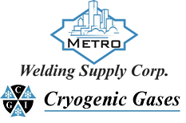 | Safety Data Sheet  2,2 Dimethylpropane (Neopentane)

Section 1: Product and Company Identification
Metro Welding Supply Corp.
12620 Southfield Road
Detroit, MI 48223
(313) 834-1660 [phone]
(313) 835-3562 [fax]
http://www.metrowelding.com/

Product Code: 2,2 Dimethylpropane (Neopentane)

Section 2: Hazards Identification
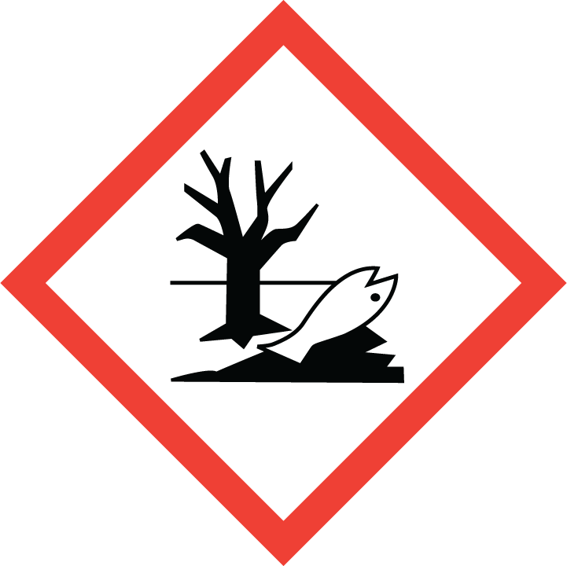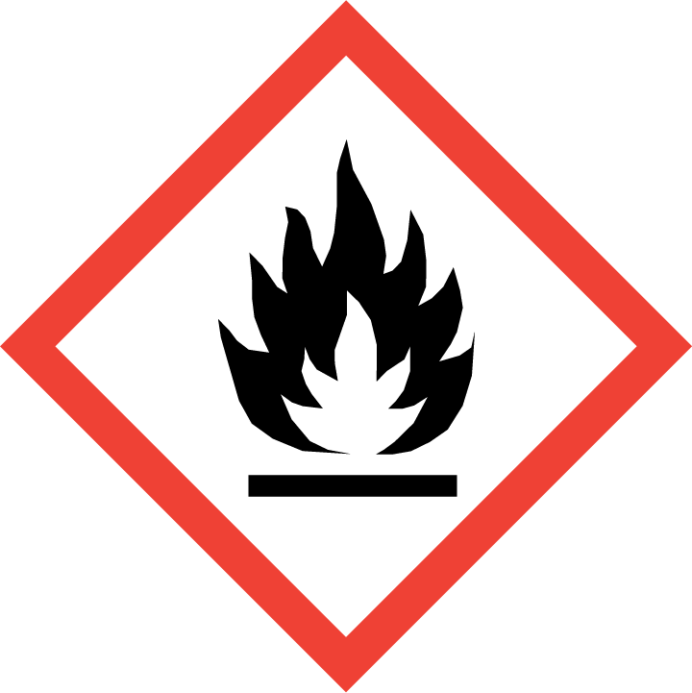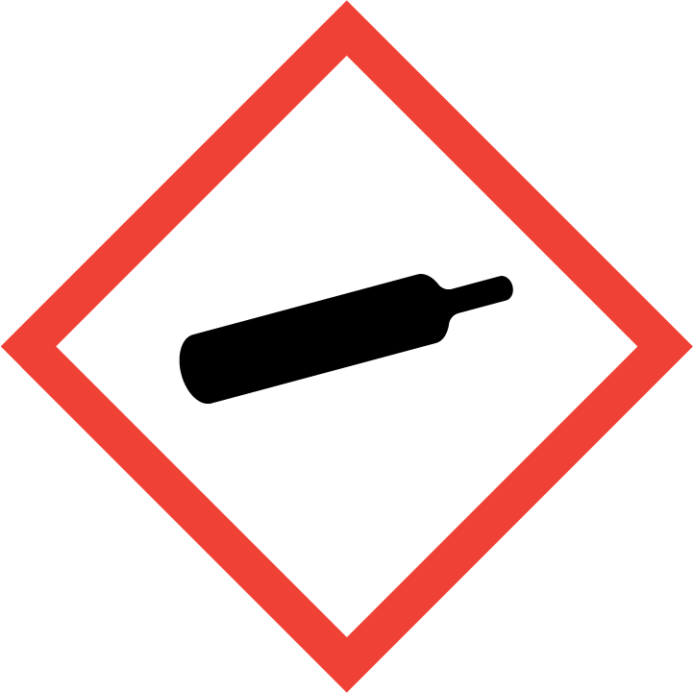
Danger

Hazard Classification:
Flammable (Category 1)
Gases Under Pressure

Hazard Statements:
Contains gas under pressure; may explode if heated
Extremely flammable gas
Toxic to aquatic life with long lasting effects

Precautionary Statements
Prevention:
Keep away from heat/sparks/open flames/hot surfaces. - No smoking.

Response:
Eliminate all ignition sources if safe to do so.
Leaking gas fire: Do not extinguish, unless leak can be stopped safely.

Storage:
Protect from sunlight.
Store in well-ventilated place.

Section 3: Composition/Information on Ingredients

CAS #
463-82-1

Chemical Substance | Chemical Family | Trade Names
NEOPENTANE | hydrocarbons, aliphatic | TETRAMETHYLMETHANE; 2,2-DIMETHYLPROPANE; PROPANE,2,2-DIMETHYL-; TERT-PENTANE; 1,1,1-TRIMETHYLETHANE; TRIMETHYL-PROPYLMETHANE; PENTANE; UN 2044; C5H12

Section 4: First Aid Measures
Skin Contact | Eye Contact | Ingestion | Inhalation | Note to Physicians
If frostbite or freezing occur, immediately flush with plenty of lukewarm water (105- 115 F; 41-46 C). DO NOT USE HOT WATER. If warm water is not available, gently wrap affected parts in blankets. Get immediate medical attention. | Flush eyes with plenty of water. | If a large amount is swallowed, get medical attention. | If adverse effects occur, remove to uncontaminated area. Give artificial respiration if not breathing. If breathing is difficult, oxygen should be administered by qualified personnel. Get immediate medical attention. | For inhalation, consider oxygen.

Section 5: Fire Fighting Measures
Suitable Extinguishing Media | Products of Combustion | Protection of Firefighters
Carbon dioxide, regular dry chemical Large fires: Flood with fine water spray. |  | - Any supplied-air respirator with a full facepiece that is operated in a pressure-demand or other positive-pressure mode. Any self-contained breathing apparatus that has a full facepiece and is operated in a pressure-demand or other positive-pressure mode.  - Use a self-contained breathing apparatus.

Section 6: Accidental Release Measures
Personal Precautions | Environmental Precautions | Methods for Containment
Keep unnecessary people away, isolate hazard area and deny entry. Do not touch spilled material. Ventilate closed spaces before entering. | Avoid heat, flames, sparks and other sources of ignition. | Stop leak if possible without personal risk. Reduce vapors with water spray. Remove sources of ignition.

Methods for Cleanup | Other Information
Contact emergency personnel. Stop leak and evacuate area. Avoid sparks or fire. Cover with activated carbon. Dispose of in closed containers. | None

Section 7: Handling and Storage
Handling | Storage
Grounding and bonding required. Keep separated from incompatible substances. | Store and handle in accordance with all current regulations and standards. Subject to storage regulations: U.S. OSHA 29 CFR 1910.101.

Section 8: Exposure Controls/Personal Protection
Exposure Guidelines
NEOPENTANE: ALKANES (C5-C8): 350 mg/m3 NIOSH recommended TWA 10 hour(s); 1800 mg/m3 NIOSH recommended ceiling 15 minute(s) NEOPENTANE: 600 ppm ACGIH TWA

Engineering Controls
Handle only in fully enclosed systems.
Eye Protection | Skin Protection | Respiratory Protection
For the gas: Eye protection not required, but recommended. For the liquid: Wear splash resistant safety goggles. Contact lenses should not be worn. Provide an emergency eye wash fountain and quick drench shower in the immediate work area. | For the gas: Protective clothing is not required. For the liquid: Wear appropriate protective, cold insulating clothing. | Any supplied-air respirator with a full facepiece that is operated in a pressure-demand or other positive-pressure mode. Any self-contained breathing apparatus that has a full facepiece and is operated in a pressure-demand or other positive-pressure mode.

General Hygiene considerations
- Avoid breathing vapor or mist
- Avoid contact with eyes and skin
- Wash thoroughly after handling and before eating or drinking

Section 9: Physical and Chemical Properties
Physical State | Appearance | Color | Change in Appearance | Physical Form | Odor | Taste
Gas | Colorless | Colorless | N/A | Gas | Not available | N/A

Flash Point | Flammability | Partition Coefficient | Autoignition Temperature | Upper Explosive Limits | Lower Explosive Limits
<19 F (<-7 C) |  |  | 842 F (450 C) | 0.075 | 0.014

Boiling Point | Freezing Point | Vapor Pressure | Vapor Density | Specific Gravity | Water Solubility | pH | Odor Threshold | Evaporation Rate | Viscosity
50 F (10 C) | 1 F (-17 C) | 1125 mmHg @ 21.1 C | 2.5 (Air=1) | 0.6135 | Insoluble | Not applicable | Not available | Not applicable | 0.007 cP @ 21.1 C

Molecular Weight | Molecular Formula | Density | Weight per Gallon | Volatility by Volume | Volatility | Solvent Solubility
72.15 | (C-H3)4-C | 0.2001 lb/ft3 | Not available | Not available | Not applicable | Soluble: Alcohol, ether

Section 10: Stability and Reactivity
Stability | Conditions to Avoid | Incompatible Materials
Stable at normal temperatures and pressure. | Stable at normal temperatures and pressure. | Oxidizing materials

Hazardous Decomposition Products | Possibility of Hazardous Reactions
Oxides of carbon | Will not polymerize.

Section 11: Toxicology Information

Acute Effects
Oral LD50 | Dermal LD50 | Inhalation
Not established | Not established | Nausea, vomiting, dizziness, suffocation, convulsions, coma

Eye Irritation | Skin Irritation | Sensitization
Mild irritation, frostbite, blurred vision | Blisters, frostbite | Difficulty breathing

Chronic Effects
Carcinogenicity | Mutagenicity | Reproductive Effects | Developmental Effects
Not listed | Not established | Not established | No data

Section 12: Ecological Information

Fate and Transport
Eco toxicity | Persistence / Degradability | Bioaccumulation / Accumulation | Mobility in Environment
Fish toxicity: Not available  Invertibrate toxicity: Not available  Algal toxicity: Not available  Phyto toxicity: Not available  Other toxicity: Not available | Not available | Not available | Not available

Section 13: Disposal Considerations
Dispose in accordance with all applicable regulations. Subject to disposal regulations: U.S. EPA 40 CFR 262. Hazardous Waste Number(s): D001.

Section 14: Transportation Information

U.S. DOT 49 CFR 172.101
Proper Shipping Name | ID Number | Hazard Class or Division | Packing Group | Labeling Requirements | Passenger Aircraft or Railcar Quantity Limitations | Cargo Aircraft Only Quantity Limitations | Additional Shipping Description
2,2-Dimethylpropane | UN2044 | 2.1 | Not applicable | 2.1 | Forbidden | 150 kg | None

Canadian Transportation of Dangerous Goods
Shipping Name | UN Number | Class | Packing Group / Risk Group
2,2-Dimethylpropane | UN2044 | 2.1 | Not applicable

Section 15: Regulatory Information

U.S. Regulations
CERCLA Sections | SARA 355.30 | SARA 355.40
Not regulated. | Not regulated. | Not regulated.

SARA 370.21
Acute | Chronic | Fire | Reactive | Sudden Release
Yes | No | Yes | No | Yes

SARA 372.65
Not regulated.

OSHA Process Safety
Not regulated.

State Regulations
CA Proposition 65
Not regulated.

Canadian Regulations
WHMIS Classification
A B1

National Inventory Status
US Inventory (TSCA) | TSCA 12b Export Notification | Canada Inventory (DSL/NDSL)
Listed on inventory. | Not listed. | Not determined.

Section 16: Other Information
NFPA Rating
HEALTH=1 FIRE=4 REACTIVITY=0
0 = minimal hazard, 1 = slight hazard, 2 = moderate hazard, 3 = severe hazard, 4 = extreme hazard

