Safety Data Sheet

1,3-Butadiene

Section 1: Product and Company Identification
Metro Welding Supply Corp.
12620 Southfield Road
Detroit, MI 48223
(313) 834-1660 [phone]
(313) 835-3562 [fax]
http://www.metrowelding.com/

Product Code: 1,3-Butadiene

Section 2: Hazards Identification
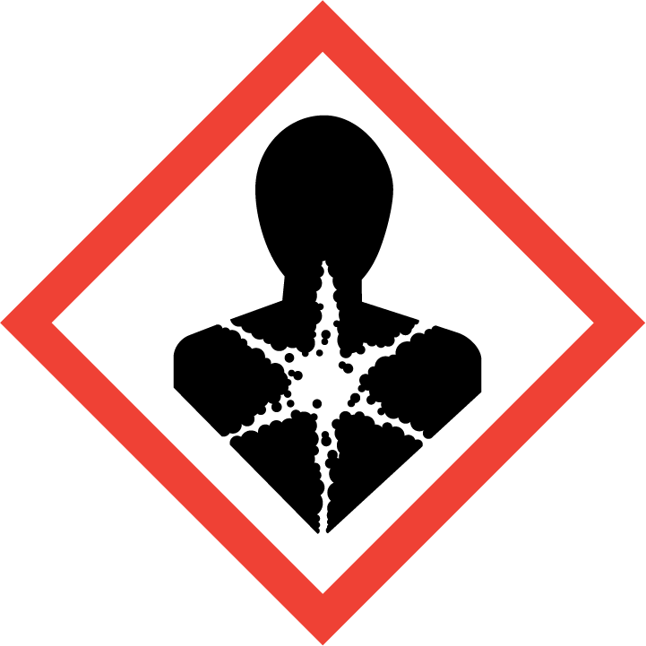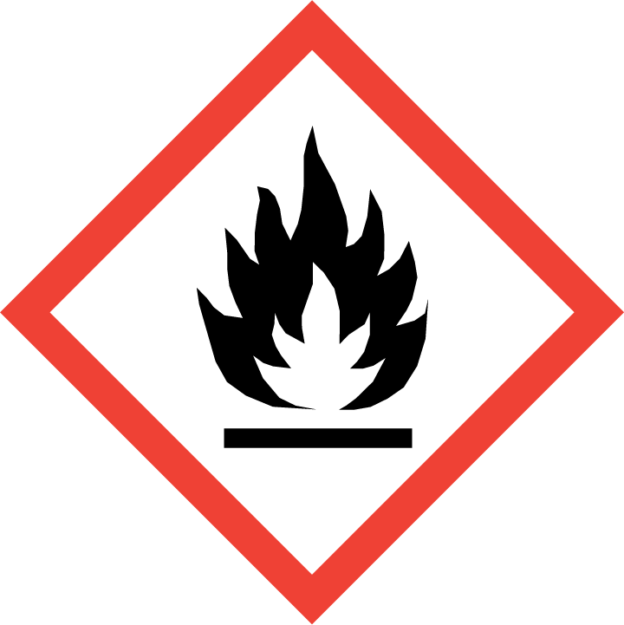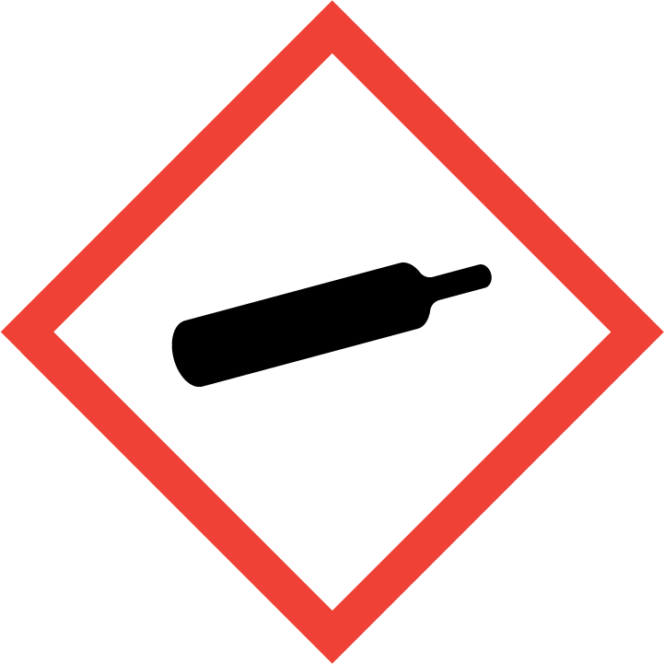
Danger

Hazard Classification:
Carcinogenicity (Category 1.A)
Flammable (Category 1)
Flammable Aerosol (Category 1)
Gases Under Pressure
Germ Cell Mutagenicity (Category 1.B)

Hazard Statements:
Contains gas under pressure; may explode if heated
Extremely flammable aerosol
Extremely flammable gas
May cause cancer
May cause genetic defects

Precautionary Statements
Prevention:
Do not handle until all safety precautions have been read and understood.
Wear protective gloves, protective clothing, eye protection and face protection.
Obtain special instructions before use.
Keep away from heat/sparks/open flames/hot surfaces. - No smoking.
Pressurized container: Do not pierce or burn, even after use.
Do not spray on an open flame or other ignition source.

Response:
Eliminate all ignition sources if safe to do so.
Leaking gas fire: Do not extinguish, unless leak can be stopped safely.
If exposed or concerned: Get medical advice/attention.

Storage:
Protect from sunlight.
Store in well-ventilated place.
Store locked up.
Do not expose to temperatures exceeding 50C/122F.

Disposal:
Dispose of contents and/or container in accordance with applicable regulations.

Section 3: Composition/Information on Ingredients

CAS #
106-99-0

Chemical Substance | Chemical Family | Trade Names
1,3-BUTADIENE | hydrocarbons, aliphatic | BUTADIENE, INHIBITED; BIVINYL; BIETHYLENE; PYRROLYLENE; VINYLETHYLENE; DIVINYL; BUTA-1,3-DIENE; ALPHA,GAMMA-BUTADIENE; ERYTHRENE; METHYLALLENE; BUTADIENE; UN 1010; C4H6

Section 4: First Aid Measures
Skin Contact | Eye Contact | Ingestion | Inhalation | Note to Physicians
Liquid: If frostbite or freezing occur, immediately flush with plenty of lukewarm water (105-115 F; 41-46 C). DO NOT USE HOT WATER. If warm water is not available, gently wrap affected parts in blankets. Get immediate medical attention. | Liquid: Wash eyes immediately with large amounts of water, occasionally lifting upper and lower lids, until no evidence of chemical remains. Get medical attention immediately. | Liquid: If a large amount is swallowed, get medical attention. | If adverse effects occur, remove to uncontaminated area. Give artificial respiration if not breathing. If breathing is difficult, oxygen should be administered by qualified personnel. Get immediate medical attention. | For inhalation, consider oxygen.

Section 5: Fire Fighting Measures
Suitable Extinguishing Media | Products of Combustion | Protection of Firefighters
Carbon dioxide, regular dry chemical Large fires: Use regular foam or flood with fine water spray. | Toxic carbon monoxide may be given off during combustion. | - Use self-contained breathing apparatus.

Section 6: Accidental Release Measures
Personal Precautions | Environmental Precautions | Methods for Containment
Keep unnecessary people away, isolate hazard area and deny entry. | Avoid heat, flames, sparks and other sources of ignition. | Stop leak if possible without personal risk. Reduce vapors with water spray. Remove sources of ignition.

Methods for Cleanup | Other Information
Stop leak, evacuate and ventilate the area. | Notify Local Emergency Planning Committee and State Emergency Response Commission for release greater than or equal to RQ (U.S. SARA Section 304). If release occurs in the U.S. and is reportable under CERCLA Section 103, notify the National Response Center at (800)424-8802 (USA) or (202)426-2675 (USA). Subject to California Safe Drinking Water and Toxic Enforcement Act of 1986 (Proposition 65). Keep out of water supplies and sewers.

Section 7: Handling and Storage
Handling | Storage
Store and handle in accordance with all current regulations and standards. Grounding and bonding required. Store outside or in a detached building. Secure to prevent tipping. Store in a cool, dry place. Store in a well-ventilated area. | Avoid heat, flames, sparks and other sources of ignition. Subject to storage regulations: U.S. OSHA 29 CFR 1910.101. See original container for storage recommendations. Keep separated from incompatible substances.

Section 8: Exposure Controls/Personal Protection
Exposure Guidelines
BUTADIENE, INHIBITED: 1,3-BUTADIENE: 1 ppm OSHA TWA 5 ppm OSHA STEL 15 minute(s) 0.5 ppm OSHA action level 2 ppm ACGIH TWA NIOSH TWA (lowest feasible concentration)

Engineering Controls
Handle only in fully enclosed systems.
Eye Protection | Skin Protection | Respiratory Protection
For the gas: Eye protection not required, but recommended. For the liquid: Wear splash resistant safety goggles. Contact lenses should not be worn. Provide an emergency eye wash fountain and quick drench shower in the immediate work area. | For the gas: Protective clothing is not required. For the liquid: Wear appropriate protective, cold insulating clothing. | Use self-contained breathing apparatus.

General Hygiene considerations
- Avoid breathing vapor or mist
- Avoid contact with eyes and skin
- Wash thoroughly after handling and before eating or drinking

Section 9: Physical and Chemical Properties
Physical State | Appearance | Color | Change in Appearance | Physical Form | Odor | Taste
Gas | Colorless | Colorless | N/A | Gas | Distinct odor | N/A

Flash Point | Flammability | Partition Coefficient | Autoignition Temperature | Upper Explosive Limits | Lower Explosive Limits
-105 F (-76 C) |  |  | 788 F (420 C) | 0.115 | 0.02

Boiling Point | Freezing Point | Vapor Pressure | Vapor Density | Specific Gravity | Water Solubility | pH | Odor Threshold | Evaporation Rate | Viscosity
23 F (-5 C) | -164 F (-109 C) | 910 mmHg @ 20 C | 1.87 (Air=1) | 0.6211 @ 20 C | 0.05% @ 20 C | Not applicable | 1.6 ppm | >25 (butyl acetate=1) | 0.00075 mPa.s (0.00075 centipoise) @ 20 C and 101.33 kPa; 0.33 mPa.s (0.33 centipoise) @ -40 C; 0.25 mPa.s (0.25 centipoise) @ 0 C

Molecular Weight | Molecular Formula | Density | Weight per Gallon | Volatility by Volume | Volatility | Solvent Solubility
54.09 | C-H2:C-H-C-H:C-H2 | Not available | Not available | 100% | Not applicable | Soluble: Organic solvents, ether, acetone, benzene, ethanol, cyclohexane, methanol, carbon tetrachloride, chloroform

Section 10: Stability and Reactivity
Stability | Conditions to Avoid | Incompatible Materials
May explode if exposed to shock, friction or heating.  Stable when inhibited. Explosive, shock- and heat-sensitive polymeric peroxides may be produced in the presence of air. The polyperoxide formed is insoluble in 1,3-butadiene and forms a separate layer, thus increasing the hazard. | May explode if exposed to shock, friction or heating.  Stable when inhibited. Explosive, shock- and heat-sensitive polymeric peroxides may be produced in the presence of air. The polyperoxide formed is insoluble in 1,3-butadiene and forms a separate layer, thus increasing the hazard. | Metal carbide, metal salts, combustible materials, metals, oxidizing materials, halogens, metal oxides, copper, aluminum tetrahydroborate, vinylacetylene, crotonaldehyde, boron triflouride and phenol

Hazardous Decomposition Products | Possibility of Hazardous Reactions
Oxides of carbon | May polymerize. Avoid contact with heat, air, light, initiators or curing agents. May polymerize with evolution of heat. Closed containers may rupture violently.

Section 11: Toxicology Information

Acute Effects
Oral LD50 | Dermal LD50 | Inhalation
5480 mg/kg oral-rat LD50 | Not established | Irritation, nausea, headache, drowsiness, dizziness, loss of coordination

Eye Irritation | Skin Irritation | Sensitization
Irritation, blurred vision at very high concentration | Liquid: blisters, frostbite | Central nervous system depression, cancer hazard (in humans)

Chronic Effects
Carcinogenicity | Mutagenicity | Reproductive Effects | Developmental Effects
OSHA: Carcinogen; NTP: Known Human Carcinogen; IARC: Human Limited Evidence, Animal Sufficient Evidence, Group 2A; ACGIH: A2 -Suspected Human Carcinogen; EC: Category 2 | Available. | Available. | No data

Section 12: Ecological Information

Fate and Transport
Eco toxicity | Persistence / Degradability | Bioaccumulation / Accumulation | Mobility in Environment
Fish toxicity: 24 Hr LC50 Lagodon rhomboides: 71.5 mg/L  Invertibrate toxicity: 96 Hr EC50 Daphnia magna: 24.8 mg/L  Algal toxicity: Not available  Phyto toxicity: Not available  Other toxicity: Not available | Not available | Not available | Not available

Section 13: Disposal Considerations
Dispose in accordance with all applicable regulations. Subject to disposal regulations: U.S. EPA 40 CFR 262. Hazardous Waste Number(s): D001. D003.

Section 14: Transportation Information

U.S. DOT 49 CFR 172.101
Proper Shipping Name | ID Number | Hazard Class or Division | Packing Group | Labeling Requirements | Passenger Aircraft or Railcar Quantity Limitations | Cargo Aircraft Only Quantity Limitations | Additional Shipping Description
Butadienes, stabilized | UN1010 | 2.1 | Not available | 2.1 | Forbidden | 150 kg | N/A

Canadian Transportation of Dangerous Goods
Shipping Name | UN Number | Class | Packing Group / Risk Group
BUTADIENES, STABILIZED OR BUTADIENES AND HYDROCARBON MIXTURE, stabilized containing more than 40 percent butadienes | UN1010 | 2.1 | N/A

Section 15: Regulatory Information

U.S. Regulations
CERCLA Sections | SARA 355.30 | SARA 355.40
1,3-Butadiene: 10 LBS RQ | Not regulated. | Not regulated.

SARA 370.21
Acute | Chronic | Fire | Reactive | Sudden Release
Yes | Yes | Yes | Yes | Yes

SARA 372.65
1,3-Butadiene

OSHA Process Safety
Not regulated.

State Regulations
CA Proposition 65
Known to the state of California to cause the following: 1,3-Butadiene Cancer (Apr 01, 1988) Developmental toxicity (Apr 16, 2004) Male reproductive toxicity (Apr 16, 2004) Female reproductive toxicity (Apr 16, 2004)

Canadian Regulations
WHMIS Classification
A, B1, D2A, F

National Inventory Status
US Inventory (TSCA) | TSCA 12b Export Notification | Canada Inventory (DSL/NDSL)
Listed on inventory. | Not listed. | Listed on inventory.

Section 16: Other Information
NFPA Rating
HEALTH=1 FIRE=4 REACTIVITY=2
0 = minimal hazard, 1 = slight hazard, 2 = moderate hazard, 3 = severe hazard, 4 = extreme hazard

