Safety Data Sheet

TRIFLUOROMETHANE (HC-23)

Section 1: Product and Company Identification
Metro Welding Supply Corp.
12620 Southfield Road
Detroit, MI 48223
(313) 834-1660 [phone]
(313) 835-3562 [fax]
http://www.metrowelding.com/

Product Code: TRIFLUOROMETHANE (HC-23)

Section 2: Hazards Identification
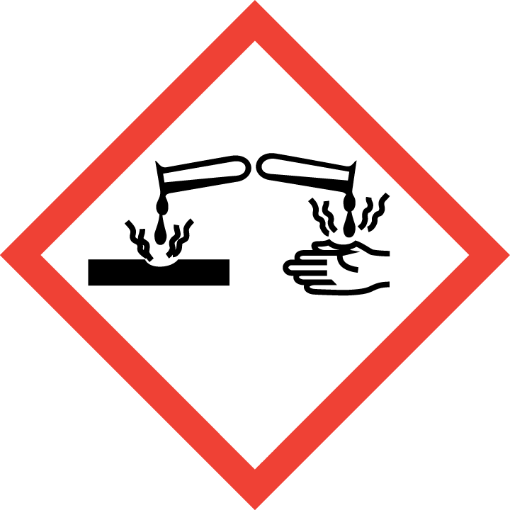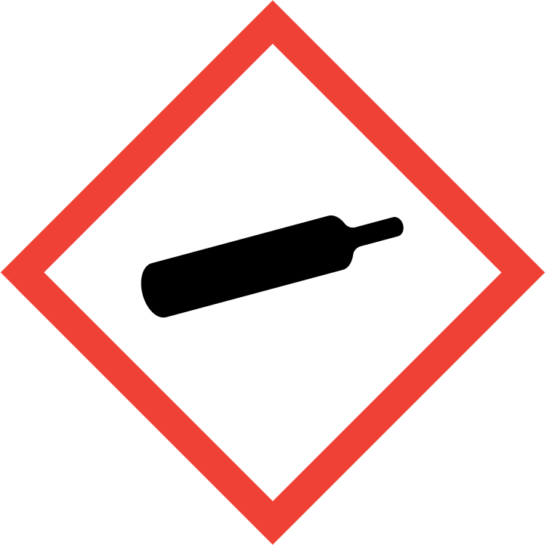
Warning

Hazard Classification:
Corrosive To Metal (Category 1)
Eye Effects (Category 2.B)
Gases Under Pressure

Hazard Statements:
Causes eye irritation
Contains gas under pressure; may explode if heated
May be corrosive to metals

Precautionary Statements
Prevention:
Wash thoroughly after handling.
Keep only in original container.

Response:
If in eyes: Rinse cautiously with water for several minutes. Remove contact lenses, if present and easy to do. Continue rinsing.
Absorb spillage to prevent material damage.

Storage:
Protect from sunlight.
Store in well-ventilated place.
Store in corrosive resistant container with a resistant inner liner.

Section 3: Composition/Information on Ingredients

CAS #
75-46-7

Chemical Substance | Chemical Family | Trade Names
TRIFLUOROMETHANE (HC-23) |  | Fluoroform; Arcton 1; Fluoryl; Freon F-23; Freon 23; Genetron 23; Methyl trifluoride; R  23; Trifluoromethane; CHF3; Arcton; Halocarbon 23; UN 1984; Carbon trifluoride; Genetron HFC23; Propellant 23; Refrigerant 23

Section 4: First Aid Measures
Skin Contact | Eye Contact | Ingestion | Inhalation | Note to Physicians
Flush with plenty of water | Flush with plenty of water for at least 15 minutes | Unlikely. | Move to fresh air. Give artificial respiration if not breathing. If breathing is difficult, oxygen should be administered by qualified personnel. Get immediate medical attention.

Section 5: Fire Fighting Measures
Suitable Extinguishing Media | Products of Combustion | Protection of Firefighters
Non-flammable. Use extinguishing agent suitable for the surrounding fire. | Carbon dioxide, carbon monoxide, halogenated compounds, carbonyl halides | - Fire-fighters wear appropriate protective equipment and self-contained breathing apparatus

Section 6: Accidental Release Measures
Personal Precautions | Environmental Precautions | Methods for Containment
Contact emergency personnel immediately. Keep unnecessary people away, isolate hazard area and deny entry. | Avoid dispersal of spilled material and runoff and contact with soil, waterways, and swerves. | Not available

Methods for Cleanup | Other Information
Contact emergency personnel. stop leak if possible without risk. | Not available

Section 7: Handling and Storage
Handling | Storage
Store upright, with valve protection cap, and firmly secured to prevent falling. Cylinder temperature should not exceed 52 degs C. | High pressure gas. Do not puncture or incinerate container. Store and handle in accordance with all current regulations and standards.

Section 8: Exposure Controls/Personal Protection
Exposure Guidelines
Not available

Engineering Controls
No specific controls are needed.
Eye Protection | Skin Protection | Respiratory Protection
Use approved standard safety eyewear. | Use personal protective equipment based on task being performed.

General Hygiene considerations
- Avoid breathing vapor or mist
- Avoid contact with eyes and skin
- Wash thoroughly after handling and before eating or drinking

Section 9: Physical and Chemical Properties
Physical State | Appearance | Color | Change in Appearance | Physical Form | Odor | Taste
Gas | Clear, colorless liquid and vapor | Colorless |  | Gas | Faint ethereal odor | Not found

Flash Point | Flammability | Partition Coefficient | Autoignition Temperature | Upper Explosive Limits | Lower Explosive Limits
Not applicable | Not applicable |  | 765 C | None | None

Boiling Point | Freezing Point | Vapor Pressure | Vapor Density | Specific Gravity | Water Solubility | pH | Odor Threshold | Evaporation Rate | Viscosity
-82.1 C | -155 C | 623.4 psia at 70 deg F | 2.4 (Air=1) | 21.1 C | Unknown | Neutral | Not found | >1 (butyl acetate=1)

Molecular Weight | Molecular Formula | Density | Weight per Gallon | Volatility by Volume | Volatility | Solvent Solubility
70.013 | CHF3 |  |  | 100% | Not available

Section 10: Stability and Reactivity
Stability | Conditions to Avoid | Incompatible Materials
Stable | Stable | At very high temperatures and/or appropriate pressures, avoid freshly abraded aluminum surfaces and chemically reactive metals (potassium, calcium, powdered aluminum, magnesium, and zinc)

Hazardous Decomposition Products | Possibility of Hazardous Reactions
Halogens, halogen acids and possibly carbonyl halides | Will not occur

Section 11: Toxicology Information

Acute Effects
Oral LD50 | Dermal LD50 | Inhalation
Not available | Not available | Symptoms of asphyxiation, loss of coordination, increased pulse rate, deeper respiration

Eye Irritation | Skin Irritation | Sensitization
Liquid contact causes severe irritation and frost bit. mist may irritate | Irritation. liquid contact can cause frostbite | Central nervous system depression cardiac arrhythmia

Chronic Effects
Carcinogenicity | Mutagenicity | Reproductive Effects | Developmental Effects
No known significant effects or critical hazards | At very high temperatures and/or appropriate pressures, avoid freshly abraded aluminum surfaces and chemically reactive metals (potassium, calcium, p | At very high temperatures and/or appropriate pressures, avoid freshly abraded aluminum surfaces and chemically reactive metals (potassium, calcium, p | No data

Section 12: Ecological Information

Fate and Transport
Eco toxicity | Persistence / Degradability | Bioaccumulation / Accumulation | Mobility in Environment
Fish toxicity: Not available  Invertibrate toxicity: not available  Algal toxicity: not available  Phyto toxicity: not available  Other toxicity: not available | Not available | Not available | Not available

Section 13: Disposal Considerations
Must disposed of in accordance with appropriate federal, state, and local regulation.

Section 14: Transportation Information

U.S. DOT 49 CFR 172.101
Proper Shipping Name | ID Number | Hazard Class or Division | Packing Group | Labeling Requirements | Passenger Aircraft or Railcar Quantity Limitations | Cargo Aircraft Only Quantity Limitations | Additional Shipping Description
TRIFLUOROMETHAN OR REFRIGERANT GAS R23 | UN1984 | 2.2 | NOT APPLICABLE | 2.2 | 75 kg | 150 kg | Not available

Canadian Transportation of Dangerous Goods
Shipping Name | UN Number | Class | Packing Group / Risk Group
TRIFLUOROMETHAN OR REFRIGERANT GAS R23 | UN1984 | 2.2 | Not available

Section 15: Regulatory Information

U.S. Regulations
CERCLA Sections | SARA 355.30 | SARA 355.40
Not available | Not available | Not available

SARA 370.21
Acute | Chronic | Fire | Reactive | Sudden Release
Not available | Not available | NOT AVAILABLE | NOT AVAILABLE | NOT AVAILABLE

SARA 372.65
NOT AVAILABLE

OSHA Process Safety
NOT AVAILABLE

State Regulations
CA Proposition 65
NOT AVAILABLE

Canadian Regulations
WHMIS Classification
Class A: Compressed Gas

National Inventory Status
US Inventory (TSCA) | TSCA 12b Export Notification | Canada Inventory (DSL/NDSL)
Listed | Not listed | Not available

Section 16: Other Information
NFPA Rating
HEALTH:1, FLAMMABILITY: 0, INSTABILITY: 0
0 = minimal hazard, 1 = slight hazard, 2 = moderate hazard, 3 = severe hazard, 4 = extreme hazard

