Safety Data Sheet

Nitrous Oxide

Section 1: Product and Company Identification
Metro Welding Supply Corp.
12620 Southfield Road
Detroit, MI 48223
(313) 834-1660 [phone]
(313) 835-3562 [fax]
http://www.metrowelding.com/

Product Code: Nitrous Oxide

Section 2: Hazards Identification
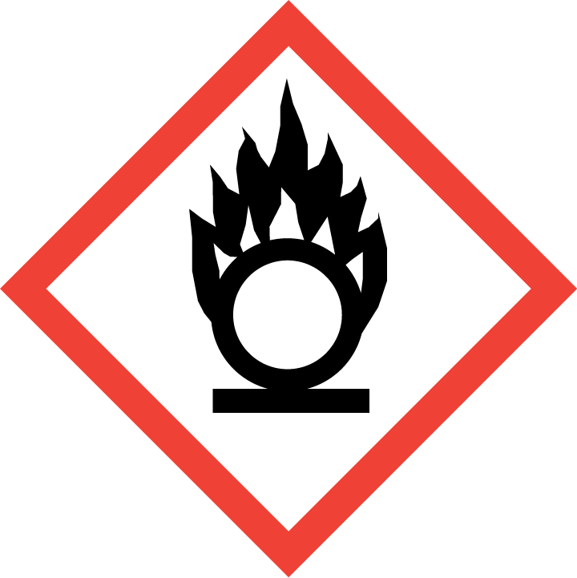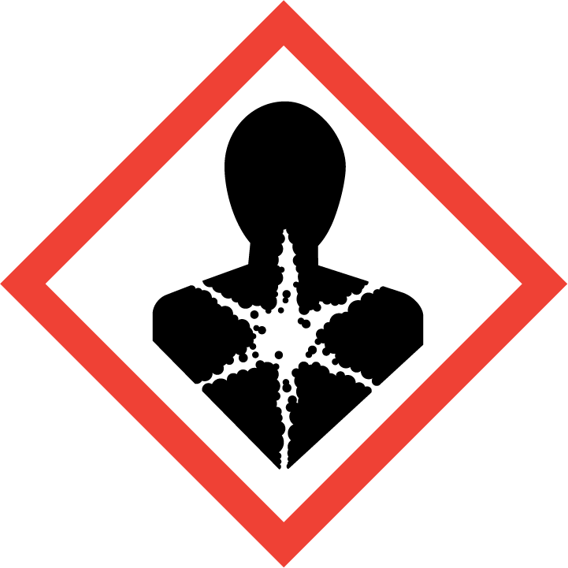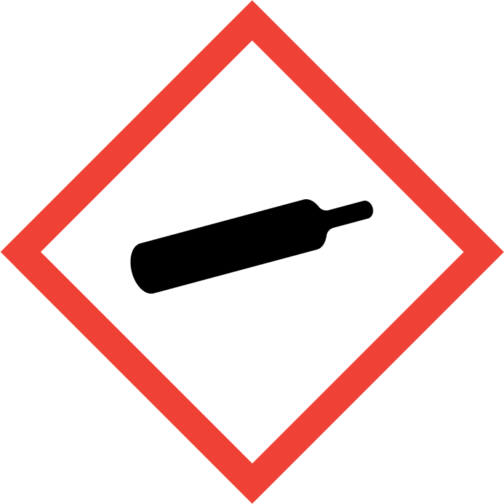
Danger

Hazard Classification:
Aspiration Hazard (Category 1)
Gases Under Pressure
Oxidizing Gas (Category 1)

Hazard Statements:
Contains gas under pressure; may explode if heated
May be fatal if swallowed and enters airways
May cause or intensify fire; oxidizer

Precautionary Statements
Prevention:
Keep reduction valves/valves and fittings free from oil and grease.
Keep and store away from clothing and combustible materials.

Response:
Do NOT induce vomiting.
If swallowed: Rinse mouth. Do NOT induce vomiting.
Immediately call a poison center or doctor.
In case of fire: Stop leak if safe to do so.

Storage:
Protect from sunlight.
Store in well-ventilated place.
Store locked up.

Disposal:
Dispose of contents and/or container in accordance with applicable regulations.

Section 3: Composition/Information on Ingredients

CAS #
10024-97-2

Chemical Substance | Chemical Family | Trade Names
NITROUS OXIDE | inorganic, gas | DINITROGEN MONOXIDE; FACTITIOUS AIR; LAUGHING GAS; HYPONITROUS ACID ANHYDRIDE; NITROGEN (I) OXIDE; NITROGEN OXIDE; STCC 4904340; UN 1070; NITROGEN OXIDE (N2O); DINITROGEN OXIDE; NITROUS OXIDE, COMPRESSED; N2O

Section 4: First Aid Measures
Skin Contact | Eye Contact | Ingestion | Inhalation | Note to Physicians
If frostbite or freezing occur, immediately flush with plenty of lukewarm water (105-115 F; 41-46 C). DO NOT USE HOT WATER. If warm water is not available, gently wrap affected parts in blankets. Get immediate medical attention. | Flush eyes with plenty of water. | If a large amount is swallowed, get medical attention. | If adverse effects occur, remove to uncontaminated area. Give artificial respiration if not breathing. If breathing is difficult, oxygen should be administered by qualified personnel. Get immediate medical attention. | For inhalation, consider oxygen.

Section 5: Fire Fighting Measures
Suitable Extinguishing Media | Products of Combustion | Protection of Firefighters
Non-flammable. Use suitable extinguishing media for surrounding fire. | Non-flammable | - Non-flammable

Section 6: Accidental Release Measures
Personal Precautions | Environmental Precautions | Methods for Containment
Keep unnecessary people away, isolate hazard area and deny entry. Ventilate closed spaces before entering. Avoid contact with combustible materials. | No adverse effects expected. | Stop leak if possible without personal risk.

Methods for Cleanup | Other Information
Stop leak, evacuate and ventilate area. | None

Section 7: Handling and Storage
Handling | Storage
Store and handle in accordance with all current regulations and standards. Subject to storage regulations: U.S. OSHA 29 CFR 1910.105. | Keep separated from incompatible substances.

Section 8: Exposure Controls/Personal Protection
Exposure Guidelines
NITROUS OXIDE: 50 ppm ACGIH TWA 25 ppm (46 mg/m3) NIOSH recommended TWA (halogenated anesthetic gas)

Engineering Controls
Handle only in fully enclosed systems.
Eye Protection | Skin Protection | Respiratory Protection
For the gas: Eye protection not required, but recommended. For the liquid: Wear splash resistant safety goggles. Contact lenses should not be worn. Provide an emergency eye wash fountain and quick drench shower in the immediate work area. | For the gas: Protective clothing is not required. For the liquid: Wear appropriate protective, cold insulating clothing. | Non-flammable

General Hygiene considerations
- Avoid breathing vapor or mist
- Avoid contact with eyes and skin
- Wash thoroughly after handling and before eating or drinking

Section 9: Physical and Chemical Properties
Physical State | Appearance | Color | Change in Appearance | Physical Form | Odor | Taste
Gas | Clear | Colorless | N/A | Gas | Sweet odor | Sweet taste

Flash Point | Flammability | Partition Coefficient | Autoignition Temperature | Upper Explosive Limits | Lower Explosive Limits
Not flammable | Not available | Not available | Nonflammable | Nonflammable | Nonflammable

Boiling Point | Freezing Point | Vapor Pressure | Vapor Density | Specific Gravity | Water Solubility | pH | Odor Threshold | Evaporation Rate | Viscosity
-128 F (-89 C) | -132 F (-91 C) | 760 mmHg @ -88 C | 1.53 (Air=1) | Not applicable | 59% @ 25 C | Not applicable | Not available | Not applicable | 0.0145 cP @ 25 C

Molecular Weight | Molecular Formula | Density | Weight per Gallon | Volatility by Volume | Volatility | Solvent Solubility
44.01 | N2-O | 1.8122 g/L @ 25 C | Not available | Not applicable | Not applicable | Soluble: Sulfuric acid, alcohol, alkali solutions, ether, oils

Section 10: Stability and Reactivity
Stability | Conditions to Avoid | Incompatible Materials
Stable at normal temperatures and pressure. Decomposes to nitrogen and oxygen at high temperatures | Stable at normal temperatures and pressure. Decomposes to nitrogen and oxygen at high temperatures | Combustible materials, metals, bases, reducing agents, peroxides, metal salts, metal oxides, hydrogen

Hazardous Decomposition Products | Possibility of Hazardous Reactions
Oxides of nitrogen | Will not polymerize.

Section 11: Toxicology Information

Acute Effects
Oral LD50 | Dermal LD50 | Inhalation
Not available | Not available | Nausea, vomiting, symptoms of drunkenness, hyperactivity or drowsiness, hearing loss, suffocation, death

Eye Irritation | Skin Irritation | Sensitization
Liquid: frostbite, blurred vision | Liquid: blisters, frostbite | Potentially fatal if inhaled, central nervous system depression, difficulty breathing TERATOGEN/EMBRYOTOXIN - can harm the unborn child, based on human information.

Chronic Effects
Carcinogenicity | Mutagenicity | Reproductive Effects | Developmental Effects
IARC: Human Inadequate Evidence, Animal Inadequate Evidence, Group 3 (Anesthetics, volatile); ACGIH: A4 -Not Classifiable as a Human Carcinogen | Available. | Available. | No data

Section 12: Ecological Information

Fate and Transport
Eco toxicity | Persistence / Degradability | Bioaccumulation / Accumulation | Mobility in Environment
Fish toxicity: Not available  Invertibrate toxicity: Not available  Algal toxicity: Not available  Phyto toxicity: Not available  Other toxicity: Not available | Not available | Not available | Not available

Section 13: Disposal Considerations
Dispose in accordance with all applicable regulations.

Section 14: Transportation Information

U.S. DOT 49 CFR 172.101
Proper Shipping Name | ID Number | Hazard Class or Division | Packing Group | Labeling Requirements | Passenger Aircraft or Railcar Quantity Limitations | Cargo Aircraft Only Quantity Limitations | Additional Shipping Description
Nitrous oxide | UN1070 | 2.2 | Not applicable | 2.2; 5.1 | N/A | N/A | N/A

Canadian Transportation of Dangerous Goods
Shipping Name | UN Number | Class | Packing Group / Risk Group
Nitrous oxide | UN1070 | 2.2; 5.1 | Not applicable

Section 15: Regulatory Information

U.S. Regulations
CERCLA Sections | SARA 355.30 | SARA 355.40
Not regulated. | Not regulated. | Not regulated.

SARA 370.21
Acute | Chronic | Fire | Reactive | Sudden Release
Yes | No | No | No | Yes

SARA 372.65
Not regulated.

OSHA Process Safety
Not regulated.

State Regulations
CA Proposition 65
Not regulated.

Canadian Regulations
WHMIS Classification
A,C

National Inventory Status
US Inventory (TSCA) | TSCA 12b Export Notification | Canada Inventory (DSL/NDSL)
Listed on inventory. | Not listed. | Not determined.

Section 16: Other Information
NFPA Rating
HEALTH=1 FIRE=0 REACTIVITY=0
0 = minimal hazard, 1 = slight hazard, 2 = moderate hazard, 3 = severe hazard, 4 = extreme hazard

