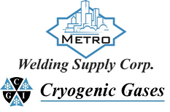 | Safety Data Sheet  Hydrogen Sulfide

Section 1: Product and Company Identification
Metro Welding Supply Corp.
12620 Southfield Road
Detroit, MI 48223
(313) 834-1660 [phone]
(313) 835-3562 [fax]
http://www.metrowelding.com/

Product Code: Hydrogen Sulfide

Section 2: Hazards Identification
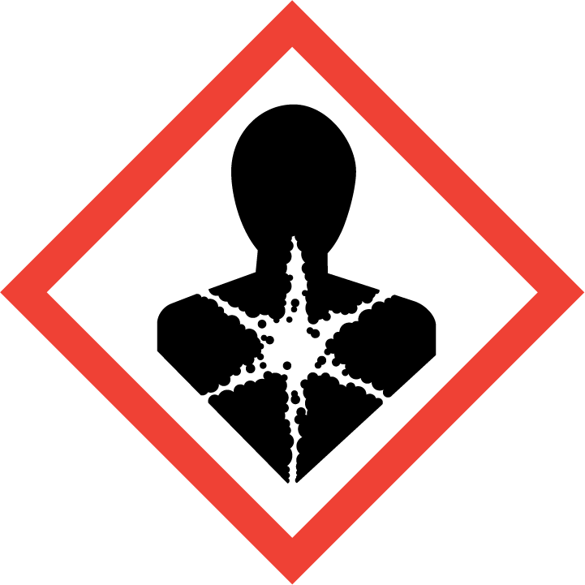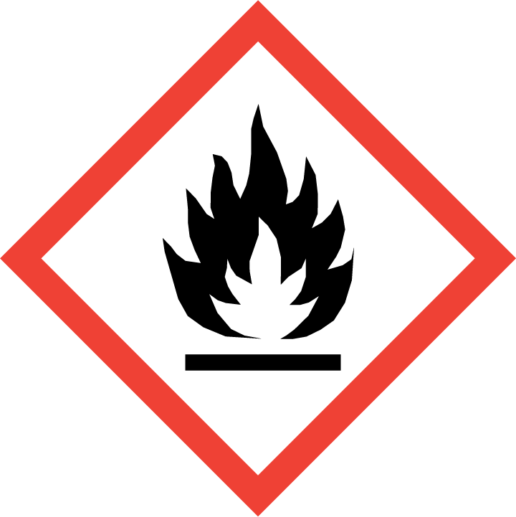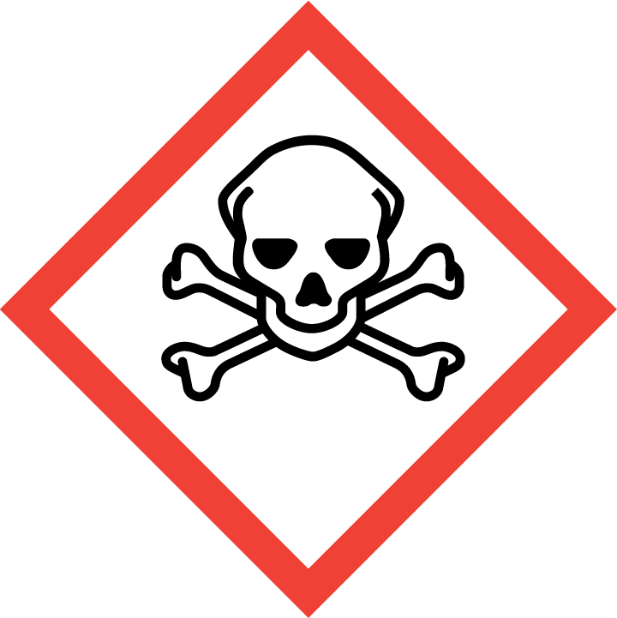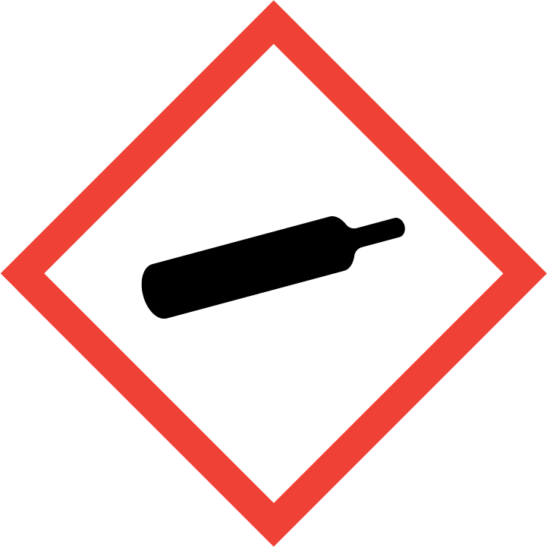
Danger

Hazard Classification:
Acute Gas Inhale Toxicity (Category 2)
Aspiration Hazard (Category 1)
Eye Effects (Category 2.B)
Flammable (Category 1)
Flammable Aerosol (Category 1)
Gases Under Pressure
Skin Corrosion (Category 2)

Hazard Statements:
Causes eye irritation
Causes skin irritation
Contains gas under pressure; may explode if heated
Extremely flammable aerosol
Extremely flammable gas
Fatal if inhaled
May be fatal if swallowed and enters airways
Toxic to aquatic life

Precautionary Statements
Prevention:
Wash thoroughly after handling.
[In case of inadequate ventilation] wear respiratory protection.
Do not breathe dust/fume/gas/mist/ vapors/spray..
Wear protective gloves and protective clothing.
Use only outdoors or in a well-ventilated area.
Keep away from heat/sparks/open flames/hot surfaces. - No smoking.
Pressurized container: Do not pierce or burn, even after use.
Do not spray on an open flame or other ignition source.

Response:
Eliminate all ignition sources if safe to do so.
If on skin: Wash with plenty of water.
Immediately call a poison center or doctor.
Leaking gas fire: Do not extinguish, unless leak can be stopped safely.
Do NOT induce vomiting.
Specific treatment is urgent.
If swallowed: Rinse mouth. Do NOT induce vomiting.
Take off contaminated clothing and wash it before reuse.
If skin irritation occurs: Get medical advice/attention.
If in eyes: Rinse cautiously with water for several minutes. Remove contact lenses, if present and easy to do. Continue rinsing.
If inhaled: Remove person to fresh air and keep comfortable for breathing.

Storage:
Store in a well-ventilated place. Keep container tightly closed.
Protect from sunlight.
Store locked up.
Do not expose to temperatures exceeding 50C/122F.

Disposal:
Dispose of contents and/or container in accordance with applicable regulations.

Section 3: Composition/Information on Ingredients

CAS #
7783-06-4

Chemical Substance | Chemical Family | Trade Names
HYDROGEN SULFIDE | inorganic, gas | HYDROGEN SULFIDE (H2S); DIHYDROGEN MONOSULFIDE; DIHYDROGEN SULFIDE; HYDROSULFURIC ACID; SULFUR DIHYDRIDE; SULFURETED HYDROGEN; SULFUR HYDRIDE; STINK DAMP; SEWER GAS; RCRA U135; UN 1053; H2S

Section 4: First Aid Measures
Skin Contact | Eye Contact | Ingestion | Inhalation | Note to Physicians
Wash skin with soap and water for at least 15 minutes while removing contaminated clothing and shoes. Get medical attention, if needed. Thoroughly clean and dry contaminated clothing and shoes before reuse. | Flush eyes with plenty of water for at least 15 minutes. Then get immediate medical attention. | If a large amount is swallowed, get medical attention. | If adverse effects occur, remove to uncontaminated area. Give artificial respiration if not breathing. If breathing is difficult, oxygen should be administered by qualified personnel. Get immediate medical attention. | For inhalation, consider oxygen.

Section 5: Fire Fighting Measures
Suitable Extinguishing Media | Products of Combustion | Protection of Firefighters
Let burn unless leak can be stopped immediately. Large fires: Use regular foam or flood with fine water spray. | Sulfur oxides | - Any self-contained breathing apparatus with a full facepiece.  - Protective material types: butyl rubber, polyvinyl chloride (PVC), neoprene

Section 6: Accidental Release Measures
Personal Precautions | Environmental Precautions | Methods for Containment
Keep unnecessary people away, isolate hazard area and deny entry. Stay upwind and keep out of low areas. Ventilate closed spaces before entering. Evacuation radius: 150 feet. For tank, rail car or tank truck: 800 meters (1/2 mile). Do not touch spilled material. | Avoid heat, flames, sparks and other sources of ignition. | Stop leak if possible without personal risk. Remove sources of ignition. Reduce vapors with water spray. Do not get water directly on material.

Methods for Cleanup | Other Information
Collect runoff for disposal as potential hazardous waste. Dike for later disposal. Absorb with sand or other non-combustible material. Add an alkaline material (lime, crushed limestone, sodium bicarbonate, or soda ash). | Notify Local Emergency Planning Committee and State Emergency Response Commission for release greater than or equal to RQ (U.S. SARA Section 304). If release occurs in the U.S. and is reportable under CERCLA Section 103, notify the National Response Center at (800)424-8802 (USA) or (202)426-2675 (USA).

Section 7: Handling and Storage
Handling | Storage
Store and handle in accordance with all current regulations and standards. Protect from physical damage. Store outside or in a detached building. Store in a cool, dry place. Store in a well-ventilated area. Avoid contact with light. Grounding and bonding required. Subject to storage regulations: U.S. OSHA 29 CFR 1910.101. Notify State Emergency Response Commission for storage or use at amounts greater than or equal to the TPQ (U.S. EPA SARA Section 302). SARA Section 303 requires facilities storing a material with a TPQ to participate in local emergency response planning (U.S. EPA 40 CFR 355.30). Keep separated from incompatible substances. | Subject to handling regulations: U.S. OSHA 29 CFR 1910.119.

Section 8: Exposure Controls/Personal Protection
Exposure Guidelines
HYDROGEN SULFIDE: 20 ppm OSHA ceiling 50 ppm OSHA peak 10 minute(s) (once if no other measurable exposure occurs) 10 ppm (14 mg/m3) OSHA TWA (vacated by 58 FR 35338, June 30, 1993) 15 ppm (21 mg/m3) OSHA STEL (vacated by 58 FR 35338, June 30, 1993) 10 ppm ACGIH TWA 15 ppm ACGIH STEL 10 ppm (15 mg/m3) NIOSH recommended ceiling 10 minute(s) TLV-TWA: 1ppm Upper respiratory irritation (ACGIH)

Engineering Controls
Handle only in fully enclosed systems.
Eye Protection | Skin Protection | Respiratory Protection
Wear splash resistant safety goggles with a face shield. Provide an emergency eye wash fountain and quick drench shower in the immediate work area. | Wear appropriate chemical resistant clothing. | Any self-contained breathing apparatus with a full facepiece.

General Hygiene considerations
- Avoid breathing vapor or mist
- Avoid contact with eyes and skin
- Wash thoroughly after handling and before eating or drinking

Section 9: Physical and Chemical Properties
Physical State | Appearance | Color | Change in Appearance | Physical Form | Odor | Taste
Gas | Colorless | Colorless | N/A | Gas | Rotten egg odor | N/A

Flash Point | Flammability | Partition Coefficient | Autoignition Temperature | Upper Explosive Limits | Lower Explosive Limits
Flammable | Not available | Not available | 500 F (260 C) | 44-46% | 4.0-4.3%

Boiling Point | Freezing Point | Vapor Pressure | Vapor Density | Specific Gravity | Water Solubility | pH | Odor Threshold | Evaporation Rate | Viscosity
-78 to -77 F (-61 to -60.3 C) | -123 F (-86 C) | 15200 mmHg @ 25 C | 1.2 (Air=1) | 1.192 | 2.58-2.9% @ 20 C | 4.5-<7 (saturated solution) | 0.13 ppm | Not applicable | 0.0128 cP @ 25 C

Molecular Weight | Molecular Formula | Density | Weight per Gallon | Volatility by Volume | Volatility | Solvent Solubility
34.08 | H2-S | 1.539 g/L @ 0 C | Not available | Not available | Not applicable | Soluble: Carbon disulfide, alcohol, ether, glycerol, gasolines, kerosene, crude oil, alkali solutions

Section 10: Stability and Reactivity
Stability | Conditions to Avoid | Incompatible Materials
Stable at normal temperatures and pressure. | Stable at normal temperatures and pressure. | Combustible materials, metals, oxidizing materials, halogens, metal oxides, metal salts, bases, rust, oxidants, oxygen, copper powder, acetaldehyde, silver fulminate

Hazardous Decomposition Products | Possibility of Hazardous Reactions
Oxides of sulfur | Will not polymerize.

Section 11: Toxicology Information

Acute Effects
Oral LD50 | Dermal LD50 | Inhalation
444 ppm inhalation-rat LC50 | Irritation 0.000125 ppm/5 hour(s) eyes-human | Irritation, lack of sense of smell, sensitivity to light, nausea, vomiting, difficulty breathing, headache, drowsiness, dizziness, disorientation, tremors, visual disturbances, suffocation, lung congestion, internal bleeding, heart damage, nerve damage, brain damage, coma, death

Eye Irritation | Skin Irritation | Sensitization
Irritation, sensitivity to light, visual disturbances | Irritation liquid: frostbite | Harmful if inhaled, respiratory tract irritation, skin irritation, eye irritation, blood damage

Chronic Effects
Carcinogenicity | Mutagenicity | Reproductive Effects | Developmental Effects
Not available | Not available | Available. | No data

Section 12: Ecological Information

Fate and Transport
Eco toxicity | Persistence / Degradability | Bioaccumulation / Accumulation | Mobility in Environment
Fish toxicity: Acute LC50 7 ug/L Fresh water Fish - Fathead minnow - Pimephales promelas - FRY 96 hours; 14.9 ug/L 96 hour(s) LC50 (Mortality) Fathead minnow (Pimeph  Invertibrate toxicity: 9730 ug/L 1.5 hour(s) (Mortality) Mediterranean mussel (Mytilus galloprovincialis)  Algal toxicity: Not available  Phyto toxicity: Not available  Other toxicity: Not available | Highly toxic to aquatic life. | Not available | Not available

Section 13: Disposal Considerations
Dispose in accordance with all applicable regulations. Subject to disposal regulations: U.S. EPA 40 CFR 262. Hazardous Waste Number(s): U135.

Section 14: Transportation Information

U.S. DOT 49 CFR 172.101
Proper Shipping Name | ID Number | Hazard Class or Division | Packing Group | Labeling Requirements | Passenger Aircraft or Railcar Quantity Limitations | Cargo Aircraft Only Quantity Limitations | Additional Shipping Description
Hydrogen sulfide | UN1053 | 2.3 | Not applicable | 2.3; 2.1 | Forbidden | Forbidden | Toxic-Inhalation Hazard Zone B

Canadian Transportation of Dangerous Goods
Shipping Name | UN Number | Class | Packing Group / Risk Group
HYDROGEN SULFIDE; or HYDROGEN SULPHIDE | UN1053 | 2.3; 2.1 | Not applicable

Section 15: Regulatory Information

U.S. Regulations
CERCLA Sections | SARA 355.30 | SARA 355.40
100 LBS RQ | 500 LBS TPQ | 100 LBS RQ

SARA 370.21
Acute | Chronic | Fire | Reactive | Sudden Release
Yes | No | Yes | No | Yes

SARA 372.65
HYDROGEN SULFIDE: Administrative stay issued Aug. 22, 1994

OSHA Process Safety
1500 LBS TQ

State Regulations
CA Proposition 65
Not regulated.

Canadian Regulations
WHMIS Classification
A, B1, D1A, D2B.

National Inventory Status
US Inventory (TSCA) | TSCA 12b Export Notification | Canada Inventory (DSL/NDSL)
Listed on inventory. | Not listed. | Listed on inventory.

Section 16: Other Information
NFPA Rating
HEALTH=4 FIRE=4 REACTIVITY=0
0 = minimal hazard, 1 = slight hazard, 2 = moderate hazard, 3 = severe hazard, 4 = extreme hazard

