Safety Data Sheet

Sulfur Hexafluoride

Section 1: Product and Company Identification
Metro Welding Supply Corp.
12620 Southfield Road
Detroit, MI 48223
(313) 834-1660 [phone]
(313) 835-3562 [fax]
http://www.metrowelding.com/

Product Code: Sulfur Hexafluoride

Section 2: Hazards Identification
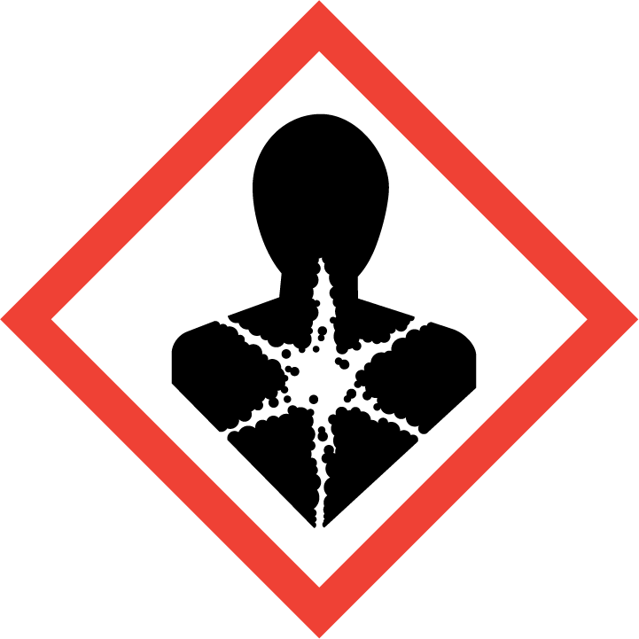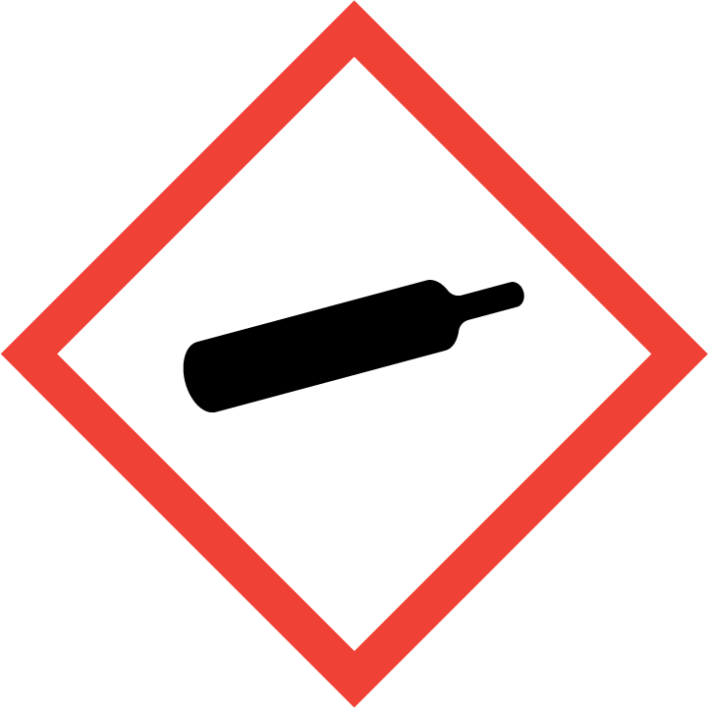
Danger

Hazard Classification:
Aspiration Hazard (Category 1)
Gases Under Pressure

Hazard Statements:
Contains gas under pressure; may explode if heated
May be fatal if swallowed and enters airways

Precautionary Statements

Response:
Do NOT induce vomiting.
If swallowed: Rinse mouth. Do NOT induce vomiting.
Immediately call a poison center or doctor.

Storage:
Protect from sunlight.
Store in well-ventilated place.
Store locked up.

Disposal:
Dispose of contents and/or container in accordance with applicable regulations.

Section 3: Composition/Information on Ingredients

CAS #
2551-62-4

Chemical Substance | Chemical Family | Trade Names
SULFUR HEXAFLUORIDE | inorganic, gas | SULFUR FLUORIDE; SULPHUR HEXAFLUORIDE; ELEGAS; UN 1080; SF6

Section 4: First Aid Measures
Skin Contact | Eye Contact | Ingestion | Inhalation | Note to Physicians
Wash exposed skin with soap and water. | Flush eyes with plenty of water. | If a large amount is swallowed, get medical attention. | If adverse effects occur, remove to uncontaminated area. Give artificial respiration if not breathing. If breathing is difficult, oxygen should be administered by qualified personnel. Get immediate medical attention. | For inhalation, consider oxygen.

Section 5: Fire Fighting Measures
Suitable Extinguishing Media | Products of Combustion | Protection of Firefighters
Non-flammable. Use suitable extinguishing media for surrounding fire. | Thermal decomposition products or combustion: fluorinated compounds, oxides of sulfur, sulfur compounds, hydrogen fluoride, hydrogen sulfide | - Respiratory protection may be needed for frequent or heavy exposure. Any self-contained breathing apparatus with a full facepiece.  - Respiratory protection may be needed for frequent or heavy exposure. Any self-contained breathing apparatus with a full facepiece.  - Protective material types: leather

Section 6: Accidental Release Measures
Personal Precautions | Environmental Precautions | Methods for Containment
Keep unnecessary people away, isolate hazard area and deny entry. Stay upwind and keep out of low areas. | Prevent environmental contamination. | Stop leak if possible without personal risk.

Methods for Cleanup | Other Information
Evacuate area, stop leak. Contact emergency personnel. | None

Section 7: Handling and Storage
Handling | Storage
Store and handle in accordance with all current regulations and standards. Store below 49 C. Avoid shock. Store in a well-ventilated area. Store in a tightly closed container. Keep away from heat, sparks and flame. Store in a cool, dry place. Subject to storage regulation: U.S. OSHA 29 CFR 1910.101. | Keep separated from incompatible substances. Secure to prevent tipping.

Section 8: Exposure Controls/Personal Protection
Exposure Guidelines
SULFUR HEXAFLUORIDE: 1000 ppm (6000 mg/m3) OSHA TWA 1000 ppm ACGIH TWA 1000 ppm (6000 mg/m3) NIOSH recommended TWA 10 hour(s)

Engineering Controls
Handle only in fully enclosed systems.
Eye Protection | Skin Protection | Respiratory Protection
Wear splash resistant safety goggles with a face shield. Provide an emergency eye wash fountain and quick drench shower in the immediate work area. | Protective clothing is not required. | Respiratory protection may be needed for frequent or heavy exposure. Any self-contained breathing apparatus with a full facepiece.

General Hygiene considerations
- Avoid breathing vapor or mist
- Avoid contact with eyes and skin
- Wash thoroughly after handling and before eating or drinking

Section 9: Physical and Chemical Properties
Physical State | Appearance | Color | Change in Appearance | Physical Form | Odor | Taste
Gas | Clear | Colorless | N/A | Gas | Odorless | N/A

Flash Point | Flammability | Partition Coefficient | Autoignition Temperature | Upper Explosive Limits | Lower Explosive Limits
Not flammable | Not available | 1.68 (log = 0.226) | Nonflammable | Nonflammable | Nonflammable

Boiling Point | Freezing Point | Vapor Pressure | Vapor Density | Specific Gravity | Water Solubility | pH | Odor Threshold | Evaporation Rate | Viscosity
Not available | -58.9 F (-50.5 C) | 16548 mmHg @ 20 C | 5.1 (Air=1) | 1.68 | Slightly soluble | Not applicable | Not available | Not applicable | 0.0156 cP @ 25 C

Molecular Weight | Molecular Formula | Density | Weight per Gallon | Volatility by Volume | Volatility | Solvent Solubility
146.06 | F6-S | 0.3847 | Not available | 1 | 1 | Soluble: Alcohol, ether, potassium hydroxide solutions, transformer oil

Section 10: Stability and Reactivity
Stability | Conditions to Avoid | Incompatible Materials
Stable at normal temperatures and pressure. | Stable at normal temperatures and pressure. | Combustible materials, metals, oxidizing materials

Hazardous Decomposition Products | Possibility of Hazardous Reactions
Fluorinated compounds, oxides of sulfur, sulfur compounds, hydrogen fluoride, hydrogen sulfide | Will not polymerize.

Section 11: Toxicology Information

Acute Effects
Oral LD50 | Dermal LD50 | Inhalation
Not available | Not available | Nausea, vomiting, difficulty breathing, dizziness, fatigue, emotional disturbances, tingling sensation, suffocation, convulsions, coma

Eye Irritation | Skin Irritation | Sensitization
No information on significant adverse effects | No information on significant adverse effects | Difficulty breathing

Chronic Effects
Carcinogenicity | Mutagenicity | Reproductive Effects | Developmental Effects
Not available | Not available | Not available | No data

Section 12: Ecological Information

Fate and Transport
Eco toxicity | Persistence / Degradability | Bioaccumulation / Accumulation | Mobility in Environment
Fish toxicity: Not available  Invertibrate toxicity: Not available  Algal toxicity: Not available  Phyto toxicity: Not available  Other toxicity: Not available | Highly volatile from water. | Not available | Leaches through the soil or the sediment at a moderate rate.

Section 13: Disposal Considerations
Dispose in accordance with all applicable regulations.

Section 14: Transportation Information

U.S. DOT 49 CFR 172.101
Proper Shipping Name | ID Number | Hazard Class or Division | Packing Group | Labeling Requirements | Passenger Aircraft or Railcar Quantity Limitations | Cargo Aircraft Only Quantity Limitations | Additional Shipping Description
Sulfur hexafluoride | UN1080 | 2.2 | Not applicable | 2.2 | 75 kg or L | 150 kg | N/A

Canadian Transportation of Dangerous Goods
Shipping Name | UN Number | Class | Packing Group / Risk Group
Sulfur hexafluoride | UN1080 | 2.2 | Not applicable

Section 15: Regulatory Information

U.S. Regulations
CERCLA Sections | SARA 355.30 | SARA 355.40
Not regulated. | Not regulated. | Not regulated.

SARA 370.21
Acute | Chronic | Fire | Reactive | Sudden Release
Yes | Yes | No | No | Yes

SARA 372.65
Not regulated.

OSHA Process Safety
Not regulated.

State Regulations
CA Proposition 65
Not regulated.

Canadian Regulations
WHMIS Classification
A.

National Inventory Status
US Inventory (TSCA) | TSCA 12b Export Notification | Canada Inventory (DSL/NDSL)
Listed on inventory. | Not listed. | Not determined.

Section 16: Other Information
NFPA Rating
HEALTH=1 FIRE=0 REACTIVITY=0
0 = minimal hazard, 1 = slight hazard, 2 = moderate hazard, 3 = severe hazard, 4 = extreme hazard

