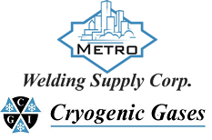 | Safety Data Sheet  Isooctane

Section 1: Product and Company Identification
Metro Welding Supply Corp.
12620 Southfield Road
Detroit, MI 48223
(313) 834-1660 [phone]
(313) 835-3562 [fax]
http://www.metrowelding.com/

Product Code: Isooctane

Section 2: Hazards Identification
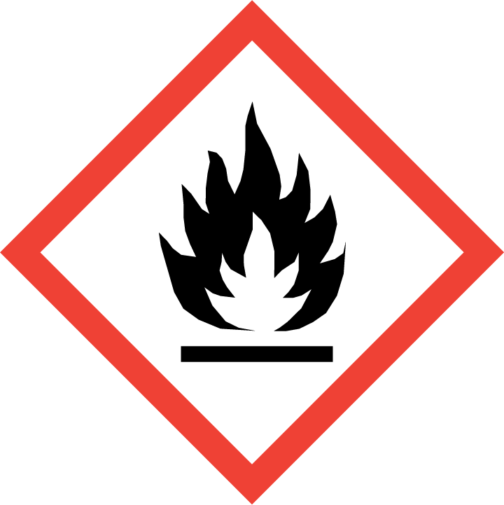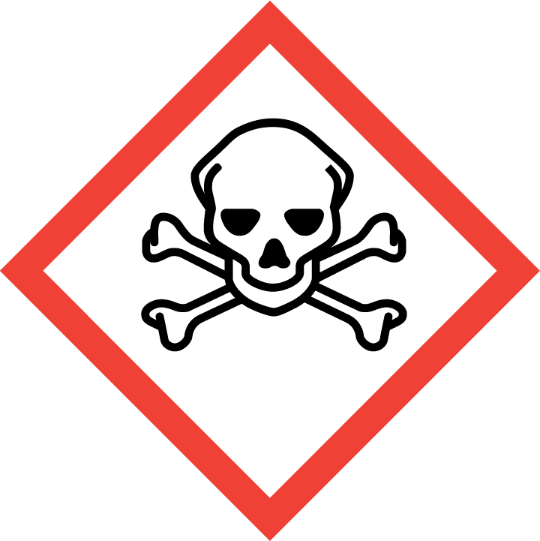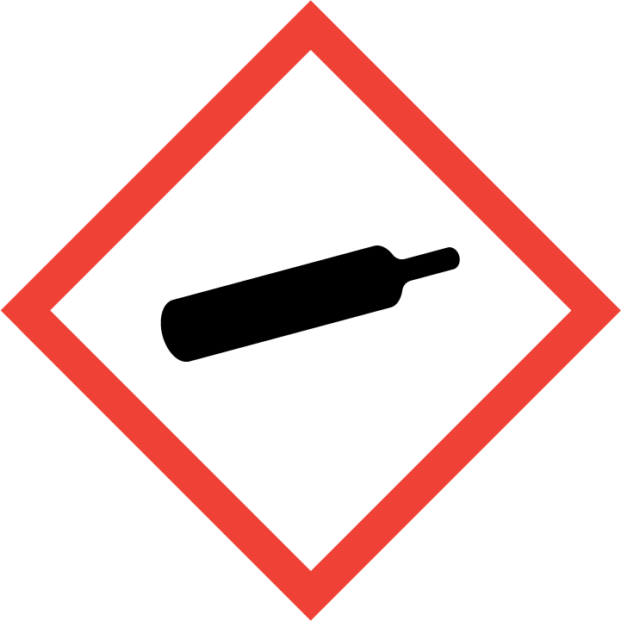
Danger

Hazard Classification:
Acute Gas Inhale Toxicity (Category 1)
Eye Effects (Category 2.B)
Flammable (Category 1)
Flammable Aerosol (Category 1)
Gases Under Pressure

Hazard Statements:
Causes eye irritation
Contains gas under pressure; may explode if heated
Extremely flammable aerosol
Extremely flammable gas
Fatal if inhaled

Precautionary Statements
Prevention:
Wash thoroughly after handling.
[In case of inadequate ventilation] wear respiratory protection.
Do not breathe dust/fume/gas/mist/ vapors/spray..
Use only outdoors or in a well-ventilated area.
Keep away from heat/sparks/open flames/hot surfaces. - No smoking.
Pressurized container: Do not pierce or burn, even after use.
Do not spray on an open flame or other ignition source.

Response:
Eliminate all ignition sources if safe to do so.
Immediately call a poison center or doctor.
Leaking gas fire: Do not extinguish, unless leak can be stopped safely.
Specific treatment is urgent.
If swallowed: Rinse mouth. Do NOT induce vomiting.
If in eyes: Rinse cautiously with water for several minutes. Remove contact lenses, if present and easy to do. Continue rinsing.
If inhaled: Remove person to fresh air and keep comfortable for breathing.

Storage:
Store in a well-ventilated place. Keep container tightly closed.
Protect from sunlight.
Store locked up.
Do not expose to temperatures exceeding 50C/122F.

Disposal:
Dispose of contents and/or container in accordance with applicable regulations.

Section 3: Composition/Information on Ingredients

CAS #
540-84-1

Chemical Substance | Chemical Family | Trade Names
ISOOCTANE | hydrocarbons, aliphatic | 2,2,4-TRIMETHYLPENTANE; ISOBUTYLTRIMETHYLMETHANE; 2,4,4-TRIMETHYLPENTANE; STCC 4908188; UN 1262; C8H18

Section 4: First Aid Measures
Skin Contact | Eye Contact | Ingestion | Inhalation | Note to Physicians
Wash skin with soap and water for at least 15 minutes while removing contaminated clothing and shoes. Get medical attention, if needed. Thoroughly clean and dry contaminated clothing and shoes before reuse. | Flush eyes with plenty of water for at least 15 minutes. Then get immediate medical attention. | Contact local poison control center or physician immediately. Never make an unconscious person vomit or drink fluids. When vomiting occurs, keep head lower than hips to help prevent aspiration. If person is unconscious, turn head to side. Get medical attention immediately. | If adverse effects occur, remove to uncontaminated area. Give artificial respiration if not breathing. Get immediate medical attention. | For ingestion, consider gastric lavage.

Section 5: Fire Fighting Measures
Suitable Extinguishing Media | Products of Combustion | Protection of Firefighters
Regular dry chemical, carbon dioxide, water, regular foam Large fires: Use regular foam or flood with fine water spray. | Carbon monoxide, carbon dioxide and toxic and irritating fumes | - Any self-contained breathing apparatus that has a full facepiece and is operated in a pressure-demand or other positive-pressure mode.  - Any self-contained breathing apparatus that has a full facepiece and is operated in a pressure-demand or other positive-pressure mode.  - Protective material types: rubber

Section 6: Accidental Release Measures
Personal Precautions | Environmental Precautions | Methods for Containment
Keep unnecessary people away, isolate hazard area and deny entry. | Avoid heat, flames, sparks and other sources of ignition. | Top leak if possible without personal risk. Reduce vapors with water spray. Remove sources of ignition.

Methods for Cleanup | Other Information
Small spills: Absorb with sand or other non-combustible material. Collect spilled material in appropriate container for disposal. Large spills: Dike for later disposal. | Notify Local Emergency Planning Committee and State Emergency Response Commission for release greater than or equal to RQ (U.S. SARA Section 304). If release occurs in the U.S. and is reportable under CERCLA Section 103, notify the National Response Center at (800)424-8802 (USA) or (202)426-2675 (USA).

Section 7: Handling and Storage
Handling | Storage
Store and handle in accordance with all current regulations and standards. Store in a tightly closed container. Store in a cool, dry place. Store in a well-ventilated area. Subject to storage regulations: U.S. OSHA 29 CFR 1910.106. | Grounding and bonding required. Keep separated from incompatible substances.

Section 8: Exposure Controls/Personal Protection
Exposure Guidelines
ISOOCTANE: OCTANE ISOMERS: 300 ppm ACGIH TWA

Engineering Controls
Handle only in fully enclosed systems.
Eye Protection | Skin Protection | Respiratory Protection
Wear splash resistant safety goggles. Provide an emergency eye wash fountain and quick drench shower in the immediate work area. | Wear appropriate chemical resistant clothing. | Any self-contained breathing apparatus that has a full facepiece and is operated in a pressure-demand or other positive-pressure mode.

General Hygiene considerations
- Avoid breathing vapor or mist
- Avoid contact with eyes and skin
- Wash thoroughly after handling and before eating or drinking

Section 9: Physical and Chemical Properties
Physical State | Appearance | Color | Change in Appearance | Physical Form | Odor | Taste
Liquid | Clear | Colorless | N/A | Liquid | Gasoline odor | N/A

Flash Point | Flammability | Partition Coefficient | Autoignition Temperature | Upper Explosive Limits | Lower Explosive Limits
10 F (-12 C) (CC) | IB | Not available | 784 F (418 C) | 0.06 | 0.011

Boiling Point | Freezing Point | Vapor Pressure | Vapor Density | Specific Gravity | Water Solubility | pH | Odor Threshold | Evaporation Rate | Viscosity
210 F (99 C) | -161 F (-107 C) | 41 mmHg @ 21 C | 3.9 (Air=1) | 0.69 | Insoluble | Not available | Not available | Not available | Not available

Molecular Weight | Molecular Formula | Density | Weight per Gallon | Volatility by Volume | Volatility | Solvent Solubility
114.23 | (C-H3)2-C-H-C-H2-C-(C-H3)3 | 0.69 g/cm3 at 20 °C (68 °F) | Not available | Not available | Not available | Soluble: Ether, alcohol, acetone, benzene, chloroform, toluene, xylene, carbon disulfide, carbon tetrachloride, dimethylformamide, oils

Section 10: Stability and Reactivity
Stability | Conditions to Avoid | Incompatible Materials
Stable at normal temperatures and pressure. | Stable at normal temperatures and pressure. | Oxidizing materials, reducing agents

Hazardous Decomposition Products | Possibility of Hazardous Reactions
Oxides of carbon | Will not polymerize.

Section 11: Toxicology Information

Acute Effects
Oral LD50 | Dermal LD50 | Inhalation
>5000 mg/kg oral-rat LD50 (Phillips 66) | >2000 mg/kg skin-rabbit LD50 (Phillips 66) | Irritation, nausea, difficulty breathing, headache, symptoms of drunkenness

Eye Irritation | Skin Irritation | Sensitization
Irritation | Irritation | Respiratory tract irritation, central nervous system depression

Chronic Effects
Carcinogenicity | Mutagenicity | Reproductive Effects | Developmental Effects
Not available | Available. | Not available | No data

Section 12: Ecological Information

Fate and Transport
Eco toxicity | Persistence / Degradability | Bioaccumulation / Accumulation | Mobility in Environment
Fish toxicity: Very toxic to aquatic life.  Invertibrate toxicity: Not available  Algal toxicity: Not available  Phyto toxicity: Not available  Other toxicity: Not available | Not available | Unlikely | Not available

Section 13: Disposal Considerations
Subject to disposal regulations: U.S. EPA 40 CFR 262. Hazardous Waste Number(s): D001. Dispose in accordance with all applicable regulations.

Section 14: Transportation Information

U.S. DOT 49 CFR 172.101
Proper Shipping Name | ID Number | Hazard Class or Division | Packing Group | Labeling Requirements | Passenger Aircraft or Railcar Quantity Limitations | Cargo Aircraft Only Quantity Limitations | Additional Shipping Description
Octanes | UN1262 | 3 | II | 3 | 5 kg or L | N/A | N/A

Canadian Transportation of Dangerous Goods
Shipping Name | UN Number | Class | Packing Group / Risk Group
Octanes | UN1262 | 3 | II

Section 15: Regulatory Information

U.S. Regulations
CERCLA Sections | SARA 355.30 | SARA 355.40
1000 LBS RQ | Not regulated. | Not regulated.

SARA 370.21
Acute | Chronic | Fire | Reactive | Sudden Release
Yes | No | Yes | No | No

SARA 372.65
Not regulated.

OSHA Process Safety
Not regulated.

State Regulations
CA Proposition 65
Not regulated.

Canadian Regulations
WHMIS Classification
B2

National Inventory Status
US Inventory (TSCA) | TSCA 12b Export Notification | Canada Inventory (DSL/NDSL)
Listed on inventory. | Not listed. | Not determined.

Section 16: Other Information
NFPA Rating
HEALTH=2 FIRE=3 REACTIVITY=0
0 = minimal hazard, 1 = slight hazard, 2 = moderate hazard, 3 = severe hazard, 4 = extreme hazard

