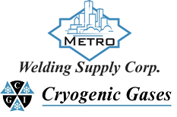 | Safety Data Sheet  Oxygen

Section 1: Product and Company Identification
Metro Welding Supply Corp.
12620 Southfield Road
Detroit, MI 48223
(313) 834-1660 [phone]
(313) 835-3562 [fax]
http://www.metrowelding.com/

Product Code: Oxygen

Section 2: Hazards Identification
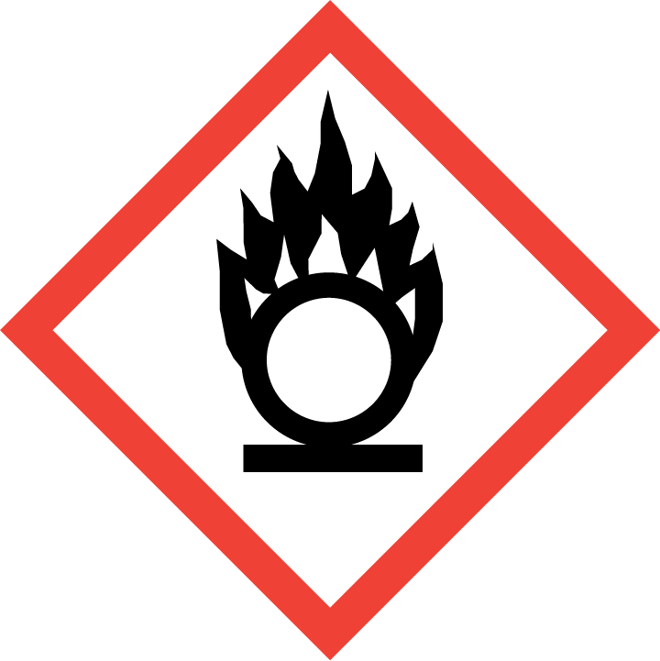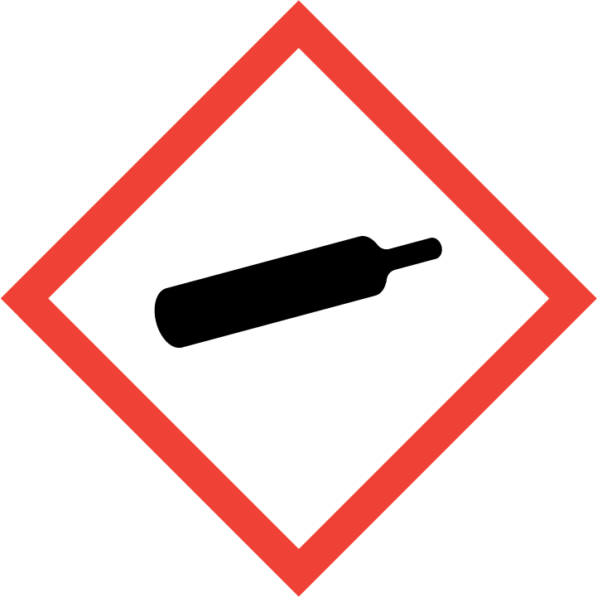
Danger

Hazard Classification:
Gases Under Pressure
Oxidizing Gas (Category 1)

Hazard Statements:
Contains gas under pressure; may explode if heated
May cause or intensify fire; oxidizer

Precautionary Statements
Prevention:
Keep reduction valves/valves and fittings free from oil and grease.
Keep and store away from clothing and combustible materials.

Response:
In case of fire: Stop leak if safe to do so.

Storage:
Protect from sunlight.
Store in well-ventilated place.

Section 3: Composition/Information on Ingredients

CAS #
7782-44-7

Chemical Substance | Chemical Family | Trade Names
OXYGEN, COMPRESSED GAS | inorganic, gas | OXYGEN; DIOXYGEN; MOLECULAR OXYGEN; OXYGEN MOLECULE; PURE OXYGEN; UN 1072; O2

Section 4: First Aid Measures
Skin Contact | Eye Contact | Ingestion | Inhalation | Note to Physicians
None expected | None expected | Not likely route of exposure | If adverse effects occur, remove to uncontaminated area. Give artificial respiration if not breathing. Get immediate medical attention. | None

Section 5: Fire Fighting Measures
Suitable Extinguishing Media | Products of Combustion | Protection of Firefighters
Non-flammable. Use extinguishing agent appropriate for the material which is burning. Use water in large quantities for fires involving oxygen. | Oxides of burning material | - Respiratory protection may be needed for frequent or heavy exposure.  - None

Section 6: Accidental Release Measures
Personal Precautions | Environmental Precautions | Methods for Containment
Keep unnecessary people away, isolate hazard area and deny entry. Ventilate closed spaces before entering. | Avoid contact with combustible materials. | Stop leak if possible without personal risk.

Methods for Cleanup | Other Information
Stop leak and ventilate | None

Section 7: Handling and Storage
Handling | Storage
Store and handle in accordance with all current regulations and standards. Subject to storage regulations: U.S. OSHA 29 CFR 1910.101. | Keep separated from incompatible substances.

Section 8: Exposure Controls/Personal Protection
Exposure Guidelines
OXYGEN, COMPRESSED GAS: No occupational exposure limits established.

Engineering Controls
Handle only in fully enclosed systems.
Eye Protection | Skin Protection | Respiratory Protection
Eye protection not required, but recommended. | Protective clothing is not required. | Respiratory protection may be needed for frequent or heavy exposure.

General Hygiene considerations
- Avoid breathing vapor or mist
- Avoid contact with eyes and skin
- Wash thoroughly after handling and before eating or drinking

Section 9: Physical and Chemical Properties
Physical State | Appearance | Color | Change in Appearance | Physical Form | Odor | Taste
Gas | Clear | Colorless | N/A | Gas | Odorless | Tasteless

Flash Point | Flammability | Partition Coefficient | Autoignition Temperature | Upper Explosive Limits | Lower Explosive Limits
Not flammable | Not available | Not available | Nonflammable | Nonflammable | Nonflammable

Boiling Point | Freezing Point | Vapor Pressure | Vapor Density | Specific Gravity | Water Solubility | pH | Odor Threshold | Evaporation Rate | Viscosity
-297 F (-183 C) | -360 F (-218 C) | 760 mmHg @ -183 C | 1.1 (Air=1) | Not applicable | 3.2% @ 25 C | Not applicable | Not available | Not applicable | 0.02075 cP @ 25 C

Molecular Weight | Molecular Formula | Density | Weight per Gallon | Volatility by Volume | Volatility | Solvent Solubility
31.9988 | O2 | 1.309 g/L @ 25 C | Not available | Not applicable | Not applicable | Soluble: Alcohol

Section 10: Stability and Reactivity
Stability | Conditions to Avoid | Incompatible Materials
Stable at normal temperatures and pressure. | Stable at normal temperatures and pressure. | Combustible materials, halo carbons, metals, bases, reducing agents, amines, metal salts, oxidizing materials, alkaline earth and alkali metals

Hazardous Decomposition Products | Possibility of Hazardous Reactions
Miscellaneous decomposition products | Will not polymerize.

Section 11: Toxicology Information

Acute Effects
Oral LD50 | Dermal LD50 | Inhalation
Not established | Not established | Irritation, changes in body temperature, nausea, difficulty breathing, irregular heartbeat, dizziness, disorientation, hallucinations, mood swings, pain in extremities, tremors, lung congestion, convulsions

Eye Irritation | Skin Irritation | Sensitization
No information on significant adverse effects | No information on significant adverse effects | No significant target effects reported.

Chronic Effects
Carcinogenicity | Mutagenicity | Reproductive Effects | Developmental Effects
Not known. | Available. | Available. | No data

Section 12: Ecological Information

Fate and Transport
Eco toxicity | Persistence / Degradability | Bioaccumulation / Accumulation | Mobility in Environment
Fish toxicity: Not available  Invertibrate toxicity: Not available  Algal toxicity: Not available  Phyto toxicity: Not available  Other toxicity: Not available | Not available | Low bioaccumulation | Not available

Section 13: Disposal Considerations
Dispose in accordance with all applicable regulations. Subject to disposal regulations: U.S. EPA 40 CFR 262. Hazardous Waste Number(s): D001.

Section 14: Transportation Information

U.S. DOT 49 CFR 172.101
Proper Shipping Name | ID Number | Hazard Class or Division | Packing Group | Labeling Requirements | Passenger Aircraft or Railcar Quantity Limitations | Cargo Aircraft Only Quantity Limitations | Additional Shipping Description
Oxygen, compressed | UN1072 | 2.2 | Not available | 2.2; 5.1 | 75 kg or L | 150 kg | N/A

Canadian Transportation of Dangerous Goods
Shipping Name | UN Number | Class | Packing Group / Risk Group
Oxygen, compressed | UN1072 | 2.2; 5.1 | Not applicable

Section 15: Regulatory Information

U.S. Regulations
CERCLA Sections | SARA 355.30 | SARA 355.40
Not regulated. | Not regulated. | Not regulated.

SARA 370.21
Acute | Chronic | Fire | Reactive | Sudden Release
No | No | Yes | No | Yes

SARA 372.65
Not regulated.

OSHA Process Safety
Not regulated.

State Regulations
CA Proposition 65
Not regulated.

Canadian Regulations
WHMIS Classification
A,C

National Inventory Status
US Inventory (TSCA) | TSCA 12b Export Notification | Canada Inventory (DSL/NDSL)
Listed on inventory. | Not listed. | Not determined.

Section 16: Other Information
NFPA Rating
HEALTH=0 FIRE=0 REACTIVITY=0
0 = minimal hazard, 1 = slight hazard, 2 = moderate hazard, 3 = severe hazard, 4 = extreme hazard

