Safety Data Sheet

Ethylene

Section 1: Product and Company Identification
Metro Welding Supply Corp.
12620 Southfield Road
Detroit, MI 48223
(313) 834-1660 [phone]
(313) 835-3562 [fax]
http://www.metrowelding.com/

Product Code: Ethylene

Section 2: Hazards Identification
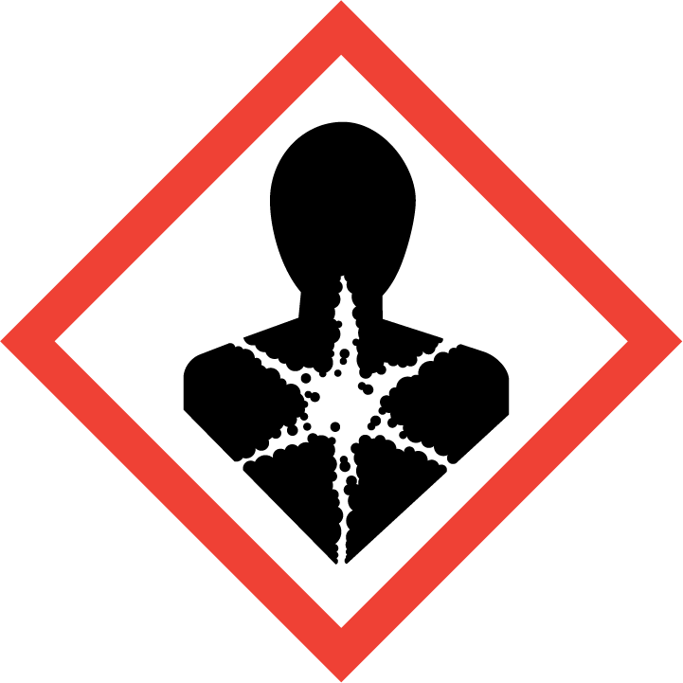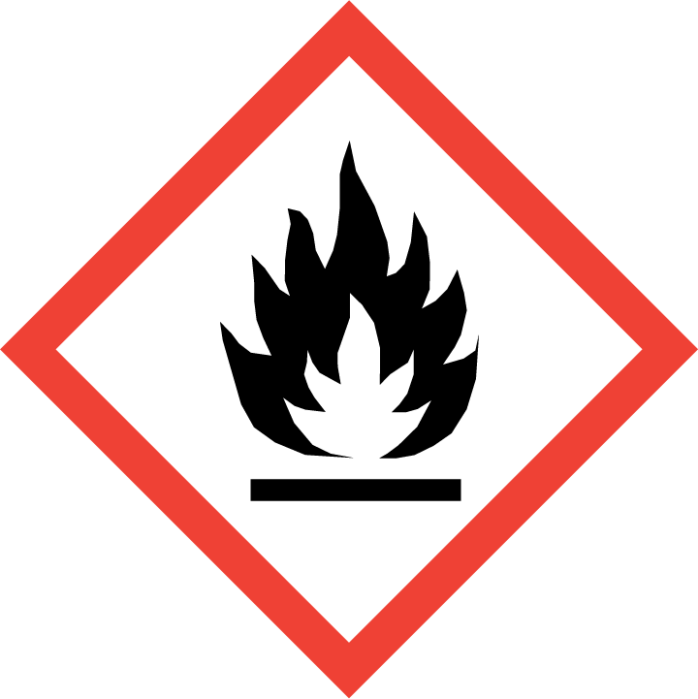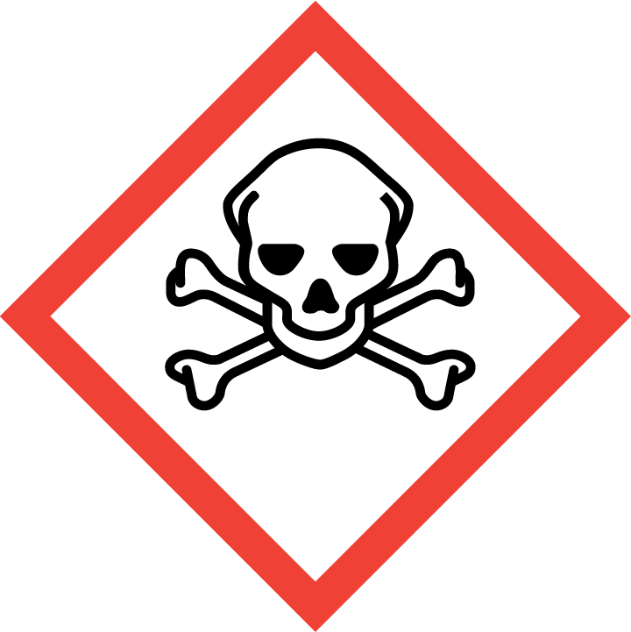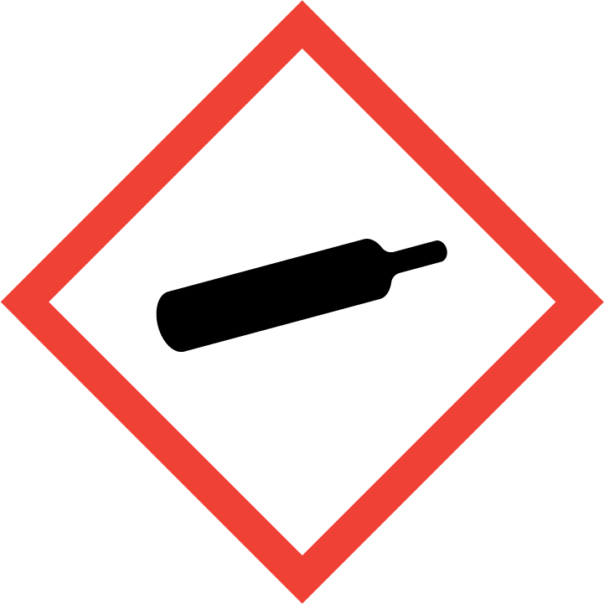
Danger

Hazard Classification:
Acute Gas Inhale Toxicity (Category 1)
Aspiration Hazard (Category 1)
Eye Effects (Category 2.B)
Flammable (Category 1)
Flammable Aerosol (Category 1)
Gases Under Pressure

Hazard Statements:
Causes eye irritation
Contains gas under pressure; may explode if heated
Extremely flammable aerosol
Extremely flammable gas
Fatal if inhaled
May be fatal if swallowed and enters airways

Precautionary Statements
Prevention:
Wash thoroughly after handling.
[In case of inadequate ventilation] wear respiratory protection.
Do not breathe dust/fume/gas/mist/ vapors/spray..
Use only outdoors or in a well-ventilated area.
Keep away from heat/sparks/open flames/hot surfaces. - No smoking.
Pressurized container: Do not pierce or burn, even after use.
Do not spray on an open flame or other ignition source.

Response:
Eliminate all ignition sources if safe to do so.
Immediately call a poison center or doctor.
Leaking gas fire: Do not extinguish, unless leak can be stopped safely.
Do NOT induce vomiting.
Specific treatment is urgent.
If swallowed: Rinse mouth. Do NOT induce vomiting.
If in eyes: Rinse cautiously with water for several minutes. Remove contact lenses, if present and easy to do. Continue rinsing.
If inhaled: Remove person to fresh air and keep comfortable for breathing.

Storage:
Store in a well-ventilated place. Keep container tightly closed.
Protect from sunlight.
Store locked up.
Do not expose to temperatures exceeding 50C/122F.

Disposal:
Dispose of contents and/or container in accordance with applicable regulations.

Section 3: Composition/Information on Ingredients

CAS #
74-85-1

Chemical Substance | Chemical Family | Trade Names
ETHYLENE | hydrocarbons, aliphatic | ACETENE; ETHENE; ETHYLENE, COMPRESSED GAS; OLEFIANT GAS; BICARBURETTED HYDROGEN; UN 1962; C2H4

Section 4: First Aid Measures
Skin Contact | Eye Contact | Ingestion | Inhalation | Note to Physicians
If frostbite or freezing occur, immediately flush with plenty of lukewarm water (105-115 F; 41-46 C). DO NOT USE HOT WATER. If warm water is not available, gently wrap affected parts in blankets. Get immediate medical attention. | Contact with liquid: Immediately flush eyes with plenty of water for at least 15 minutes. Then get immediate medical attention. | Do not induce vomiting. Seek immediate medical attention. Check for frostbite. Thaw frostbite slowly with lukewarm water. Avoid mouth-to-mouth contact by using a mouth shield or guard to perform artificial respiration. | If adverse effects occur, remove to uncontaminated area. Give artificial respiration if not breathing. If breathing is difficult, oxygen should be administered by qualified personnel. Get immediate medical attention. | For inhalation, consider oxygen.

Section 5: Fire Fighting Measures
Suitable Extinguishing Media | Products of Combustion | Protection of Firefighters
Carbon dioxide, regular dry chemical Large fires: Flood with fine water spray. | Carbon monoxide, carbon dioxide and toxic and irritating fumes | - Any self-contained breathing apparatus with a full facepiece.  - Any self-contained breathing apparatus with a full facepiece.

Section 6: Accidental Release Measures
Personal Precautions | Environmental Precautions | Methods for Containment
Keep unnecessary people away, isolate hazard area and deny entry. Do not touch spilled material. Ventilate closed spaces before entering. | Avoid heat, flames, sparks and other sources of ignition. | Stop leak if possible without personal risk. Reduce vapors with water spray. Remove sources of ignition.

Methods for Cleanup | Other Information
Avoid ignition sources. Evacuate area, contact emergency personnel. Use fine water spray. | None

Section 7: Handling and Storage
Handling | Storage
Store and handle in accordance with all current regulations and standards. Protect from physical damage. Store in a cool, dry place. Store in a well-ventilated area. Subject to storage regulations: U.S. OSHA 29 CFR 1910.101. Keep separated from incompatible substances. | Avoid heat, flames, sparks and other sources of ignition. Grounding and bonding required.

Section 8: Exposure Controls/Personal Protection
Exposure Guidelines
TLV-TWA: 200ppm Carcinogenicity Designation A4 (ACGIH)

Engineering Controls
Handle only in fully enclosed systems.
Eye Protection | Skin Protection | Respiratory Protection
For the gas: Eye protection not required, but recommended. For the liquid: Wear splash resistant safety goggles. Contact lenses should not be worn. Provide an emergency eye wash fountain and quick drench shower in the immediate work area. | For the gas: Protective clothing is not required. For the liquid: Wear appropriate protective, cold insulating clothing. | Any self-contained breathing apparatus with a full facepiece.

General Hygiene considerations
- Avoid breathing vapor or mist
- Avoid contact with eyes and skin
- Wash thoroughly after handling and before eating or drinking

Section 9: Physical and Chemical Properties
Physical State | Appearance | Color | Change in Appearance | Physical Form | Odor | Taste
Gas | Colorless | Colorless | N/A | Compressed gas | Sweet odor | Sweet taste

Flash Point | Flammability | Partition Coefficient | Autoignition Temperature | Upper Explosive Limits | Lower Explosive Limits
Approximately -212.8 F (-136 C) (CC); extremely flammable gas | Not available | 281.84 (log = 2.45) (estimated from water solubility) | 842 F (450 C) | 0.36 | 0.027

Boiling Point | Freezing Point | Vapor Pressure | Vapor Density | Specific Gravity | Water Solubility | pH | Odor Threshold | Evaporation Rate | Viscosity
-155 F (-104 C) | -272 F (-169 C) | 760 mmHg @ -104 C | 0.978 @ 0 C; 0.969 @ 21.1 C (air = 1) | Not applicable | 0.226 | Not applicable | Wide range of reported values: 17 to 959 ppm. Acceptable values are: 270 ppm (310 mg/m3) (detection); 418 ppm (480 mg/m3) (recognition) | Not applicable | LIQUEFIED GAS: 0.16 mPa.s (0.16 centipoise) @ -100 C (18); 0.07 mPa.s (0.07 centipoise) @ 0 C

Molecular Weight | Molecular Formula | Density | Weight per Gallon | Volatility by Volume | Volatility | Solvent Solubility
28.05 | C-H2-C-H2 | 1.261 g/L @ 0 C | Not available | 100% | 1 | Soluble: Alcohol, ether, acetone, benzene

Section 10: Stability and Reactivity
Stability | Conditions to Avoid | Incompatible Materials
May polymerize. Avoid storage and use above room temperature. | May polymerize. Avoid storage and use above room temperature. | Acids, metal salts, halogens, halo carbons, oxidizing materials, metals, peroxides, chlorine, aluminum chloride, nitrogen dioxide or ozone, copper, 5A molecular sieves

Hazardous Decomposition Products | Possibility of Hazardous Reactions
Carbon monoxide, carbon dioxide, hydrocarbons | Polymerizes with evolution of heat. Store in a cool, dry place.

Section 11: Toxicology Information

Acute Effects
Oral LD50 | Dermal LD50 | Inhalation
LC50 (inhalation, mouse) = 96 pph | Not available | Nausea, vomiting, symptoms of drunkenness, bluish skin color, suffocation, convulsions, coma

Eye Irritation | Skin Irritation | Sensitization
Frostbite, blurred vision | Blisters, frostbite | Central nervous system depression, difficulty breathing, asphyxiant

Chronic Effects
Carcinogenicity | Mutagenicity | Reproductive Effects | Developmental Effects
IARC: Human Inadequate Evidence, Animal Inadequate Evidence, Group 3; ACGIH: A4 -Not Classifiable as a Human Carcinogen | Not available | Not available | No data

Section 12: Ecological Information

Fate and Transport
Eco toxicity | Persistence / Degradability | Bioaccumulation / Accumulation | Mobility in Environment
Fish toxicity: 22000-25000 ug/L 1 day(s) LC100 (Mortality) Orangespotted sunfish (Lepomis humilis)  Invertibrate toxicity: Not available  Algal toxicity: Not available  Phyto toxicity: Lemon = 0.025-0.05; epinasty  Other toxicity: Tomato = 0.04-0.1 ppm/3-48 hours; leaf epinasty. | Relatively non-persistent in the environment. Moderately volatile from water. | Accumulates very little in the bodies of living organisms. | Leaches through the soil or the sediment at a slow rate.

Section 13: Disposal Considerations
Dispose in accordance with all applicable regulations. Subject to disposal regulations: U.S. EPA 40 CFR 262. Hazardous Waste Number(s): D001.

Section 14: Transportation Information

U.S. DOT 49 CFR 172.101
Proper Shipping Name | ID Number | Hazard Class or Division | Packing Group | Labeling Requirements | Passenger Aircraft or Railcar Quantity Limitations | Cargo Aircraft Only Quantity Limitations | Additional Shipping Description
Ethylene | UN1962 | 2.1 | Not applicable | 2.1 | Forbidden | 150 kg | N/A

Canadian Transportation of Dangerous Goods
Shipping Name | UN Number | Class | Packing Group / Risk Group
Ethylene, compressed | UN1962 | 2.1 | Not applicable

Section 15: Regulatory Information

U.S. Regulations
CERCLA Sections | SARA 355.30 | SARA 355.40
Not regulated. | Not regulated. | Not regulated.

SARA 370.21
Acute | Chronic | Fire | Reactive | Sudden Release
Yes | No | Yes | Yes | Yes

SARA 372.65
ETHYLENE

OSHA Process Safety
Not regulated.

State Regulations
CA Proposition 65
Not regulated.

Canadian Regulations
WHMIS Classification
A, B1, D2B

National Inventory Status
US Inventory (TSCA) | TSCA 12b Export Notification | Canada Inventory (DSL/NDSL)
Listed on inventory. | Not listed. | Listed on inventory.

Section 16: Other Information
NFPA Rating
HEALTH=4 FIRE=4 REACTIVITY=2
0 = minimal hazard, 1 = slight hazard, 2 = moderate hazard, 3 = severe hazard, 4 = extreme hazard

