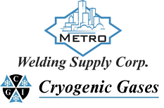 | Safety Data Sheet  Isobutylene

Section 1: Product and Company Identification
Metro Welding Supply Corp.
12620 Southfield Road
Detroit, MI 48223
(313) 834-1660 [phone]
(313) 835-3562 [fax]
http://www.metrowelding.com/

Product Code: Isobutylene

Section 2: Hazards Identification
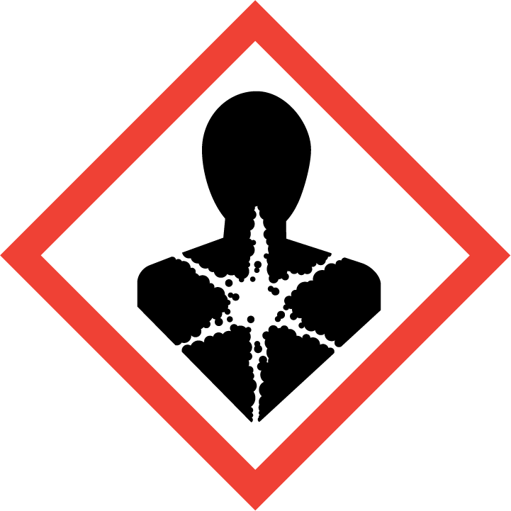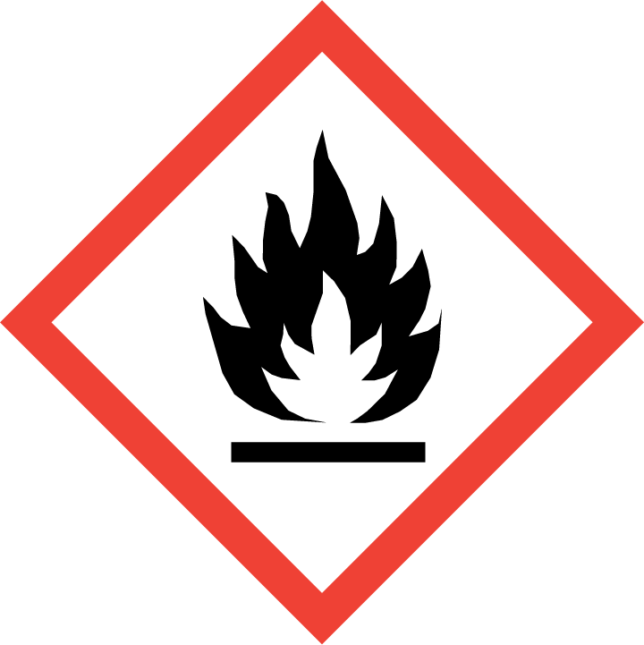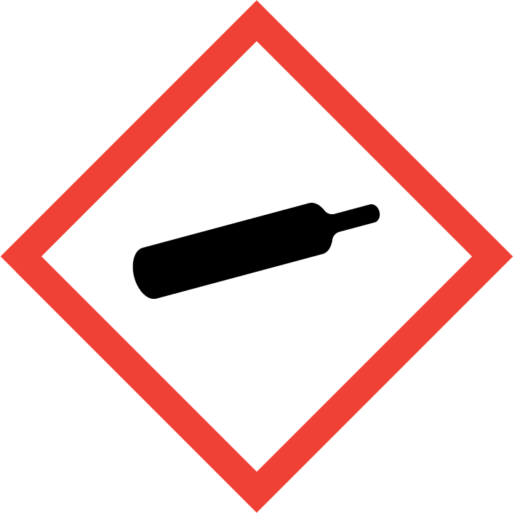
Danger

Hazard Classification:
Acute Oral Toxicity (Category 4)
Aspiration Hazard (Category 1)
Eye Effects (Category 2.B)
Flammable (Category 1)
Flammable Aerosol (Category 1)
Gases Under Pressure

Hazard Statements:
Causes eye irritation
Contains gas under pressure; may explode if heated
Extremely flammable aerosol
Extremely flammable gas
Harmful if swallowed
May be fatal if swallowed and enters airways

Precautionary Statements
Prevention:
Keep away from heat/sparks/open flames/hot surfaces. - No smoking.
Wash thoroughly after handling.
Do not spray on an open flame or other ignition source.
Do not eat, drink or smoke when using this product.
Pressurized container: Do not pierce or burn, even after use.

Response:
Leaking gas fire: Do not extinguish, unless leak can be stopped safely.
Immediately call a poison center or doctor.
Eliminate all ignition sources if safe to do so.
Do NOT induce vomiting.
If swallowed: Rinse mouth. Do NOT induce vomiting.
If in eyes: Rinse cautiously with water for several minutes. Remove contact lenses, if present and easy to do. Continue rinsing.

Storage:
Protect from sunlight.
Store in well-ventilated place.
Store locked up.
Do not expose to temperatures exceeding 50C/122F.

Disposal:
Dispose of contents and/or container in accordance with applicable regulations.

Section 3: Composition/Information on Ingredients

CAS #
115-11-7

Chemical Substance | Chemical Family | Trade Names
ISOBUTYLENE | hydrocarbons, aliphatic | 2-METHYLPROPENE; ISOBUTENE; LIQUIFIED PETROLEUM GAS; 2-METHYL-1-PROPENE; L.P.G.; GAMMA-BUTYLENE; ASYM-DIMETHYL ETHYLENE; UN 1055

Section 4: First Aid Measures
Skin Contact | Eye Contact | Ingestion | Inhalation | Note to Physicians
If frostbite or freezing occur, immediately flush with plenty of lukewarm water (105-115 F; 41-46 C). DO NOT USE HOT WATER. If warm water is not available, gently wrap affected parts in blankets. Get immediate medical attention. | Contact with liquid: Immediately flush eyes with plenty of water for at least 15 minutes. Then get immediate medical attention. | If a large amount is swallowed, get medical attention. | If adverse effects occur, remove to uncontaminated area. Give artificial respiration if not breathing. If breathing is difficult, oxygen should be administered by qualified personnel. Get immediate medical attention. | For inhalation, consider oxygen.

Section 5: Fire Fighting Measures
Suitable Extinguishing Media | Products of Combustion | Protection of Firefighters
Carbon dioxide, regular dry chemical Large fires: Flood with fine water spray. | Carbon monoxide, carbon dioxide, water and toxic and irritating fumes | - Any self-contained breathing apparatus with a full facepiece.  - Any self-contained breathing apparatus with a full facepiece.

Section 6: Accidental Release Measures
Personal Precautions | Environmental Precautions | Methods for Containment
Keep unnecessary people away, isolate hazard area and deny entry. Do not touch spilled material. Ventilate closed spaces before entering. | Avoid heat, flames, sparks and other sources of ignition. | Stop leak if possible without personal risk. Reduce vapors with water spray. Remove sources of ignition.

Methods for Cleanup | Other Information
Evacuate and ventilate area. | None

Section 7: Handling and Storage
Handling | Storage
Store and handle in accordance with all current regulations and standards. Grounding and bonding required. Subject to storage regulations: U.S. OSHA 29 CFR 1910.110. Subject to storage regulations: U.S. OSHA 29 CFR 1910.101. | Keep separated from incompatible substances.

Section 8: Exposure Controls/Personal Protection
Exposure Guidelines
TLV-TWA: 250 ppm Carcinogenicity (ACGIH)

Engineering Controls
Handle only in fully enclosed systems.
Eye Protection | Skin Protection | Respiratory Protection
For the gas: Eye protection not required, but recommended. For the liquid: Wear splash resistant safety goggles. Contact lenses should not be worn. Provide an emergency eye wash fountain and quick drench shower in the immediate work area. | For the gas: Protective clothing is not required. For the liquid: Wear appropriate protective, cold insulating clothing. | Any self-contained breathing apparatus with a full facepiece.

General Hygiene considerations
- Avoid breathing vapor or mist
- Avoid contact with eyes and skin
- Wash thoroughly after handling and before eating or drinking

Section 9: Physical and Chemical Properties
Physical State | Appearance | Color | Change in Appearance | Physical Form | Odor | Taste
Gas | Clear | Colorless | N/A | Liquefied gas | Petroleum odor | N/A

Flash Point | Flammability | Partition Coefficient | Autoignition Temperature | Upper Explosive Limits | Lower Explosive Limits
-105 F (-76 C) | Not available | Not available | 869 F (465 C) | 0.096 | 0.018

Boiling Point | Freezing Point | Vapor Pressure | Vapor Density | Specific Gravity | Water Solubility | pH | Odor Threshold | Evaporation Rate | Viscosity
19 F (-7 C) | -220 F (-140 C) | 3278 mmHg @ 37.7 C | 1.9 (Air=1) | 0.5879 @ 25 C | Almost insoluble | Not applicable | 20 ppm (46 mg/m3) (unspecified) | Not applicable | Not available

Molecular Weight | Molecular Formula | Density | Weight per Gallon | Volatility by Volume | Volatility | Solvent Solubility
56.12 | C4-H8 | Not available | Not available | 100% | Not applicable | Soluble: Organic solvents, alcohol, ether, sulfuric acid

Section 10: Stability and Reactivity
Stability | Conditions to Avoid | Incompatible Materials
Stable at normal temperatures and pressure. | Stable at normal temperatures and pressure. | Oxidizing materials

Hazardous Decomposition Products | Possibility of Hazardous Reactions
Oxides of carbon | Can polymerize in the presence of catalysts.

Section 11: Toxicology Information

Acute Effects
Oral LD50 | Dermal LD50 | Inhalation
LC50 (rat, inhalation) = 620 g/m 3 /4 hours LC50 (mouse, inhalation) = 415 g/m 3 /2 hours | Not available | Irritation, nausea, vomiting, headache, symptoms of drunkenness, disorientation, tingling sensation, suffocation, convulsions, coma

Eye Irritation | Skin Irritation | Sensitization
Irritation, frostbite, blurred vision | Liquid: burns, frostbite | Central nervous system depression, difficulty breathing

Chronic Effects
Carcinogenicity | Mutagenicity | Reproductive Effects | Developmental Effects
Not listed. | Not established | Not established | No data

Section 12: Ecological Information

Fate and Transport
Eco toxicity | Persistence / Degradability | Bioaccumulation / Accumulation | Mobility in Environment
Fish toxicity: Not available  Invertibrate toxicity: Not available  Algal toxicity: Not expected  Phyto toxicity: Not expected  Other toxicity: Not available | Not available | Not available | Dissipates rapidly.

Section 13: Disposal Considerations
Dispose in accordance with all applicable regulations. Subject to disposal regulations: U.S. EPA 40 CFR 262. Hazardous Waste Number(s): D001.

Section 14: Transportation Information

U.S. DOT 49 CFR 172.101
Proper Shipping Name | ID Number | Hazard Class or Division | Packing Group | Labeling Requirements | Passenger Aircraft or Railcar Quantity Limitations | Cargo Aircraft Only Quantity Limitations | Additional Shipping Description
ISOBUTYLENE see also PETROLEUM GASES, LIQUEFIED | UN1055 | 2.1 | Not applicable | 2.1 | Forbidden | 150 kg | N/A

Canadian Transportation of Dangerous Goods
Shipping Name | UN Number | Class | Packing Group / Risk Group
Isobutylene | UN1055 | 2.1 | Not applicable

Section 15: Regulatory Information

U.S. Regulations
CERCLA Sections | SARA 355.30 | SARA 355.40
Not regulated. | Not regulated. | Not regulated.

SARA 370.21
Acute | Chronic | Fire | Reactive | Sudden Release
Yes | No | Yes | No | Yes

SARA 372.65
Not regulated.

OSHA Process Safety
Not regulated.

State Regulations
CA Proposition 65
Not regulated.

Canadian Regulations
WHMIS Classification
A,B1

National Inventory Status
US Inventory (TSCA) | TSCA 12b Export Notification | Canada Inventory (DSL/NDSL)
Listed on inventory. | Not listed. | Listed on inventory.

Section 16: Other Information
NFPA Rating
HEALTH=1 FIRE=4 REACTIVITY=0
0 = minimal hazard, 1 = slight hazard, 2 = moderate hazard, 3 = severe hazard, 4 = extreme hazard

