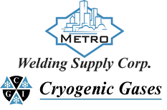 | Safety Data Sheet  Nitrogen Dioxide

Section 1: Product and Company Identification
Metro Welding Supply Corp.
12620 Southfield Road
Detroit, MI 48223
(313) 834-1660 [phone]
(313) 835-3562 [fax]
http://www.metrowelding.com/

Product Code: Nitrogen Dioxide

Section 2: Hazards Identification
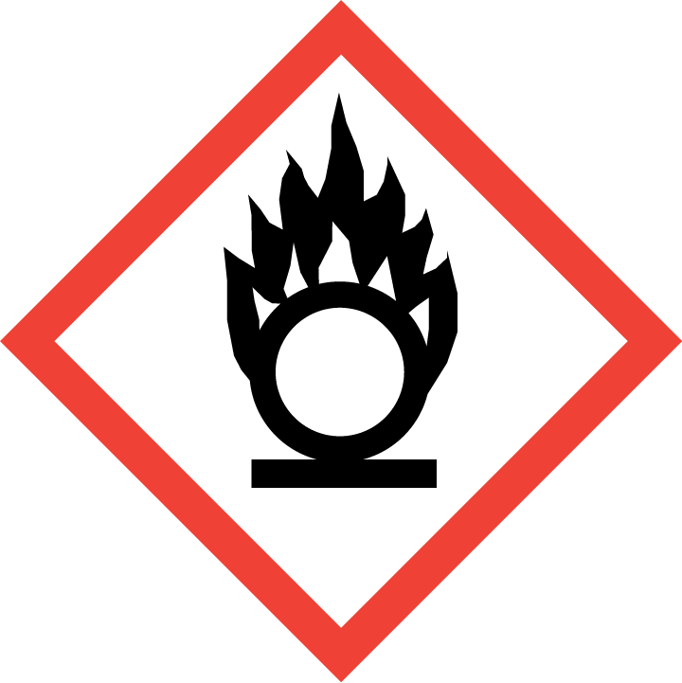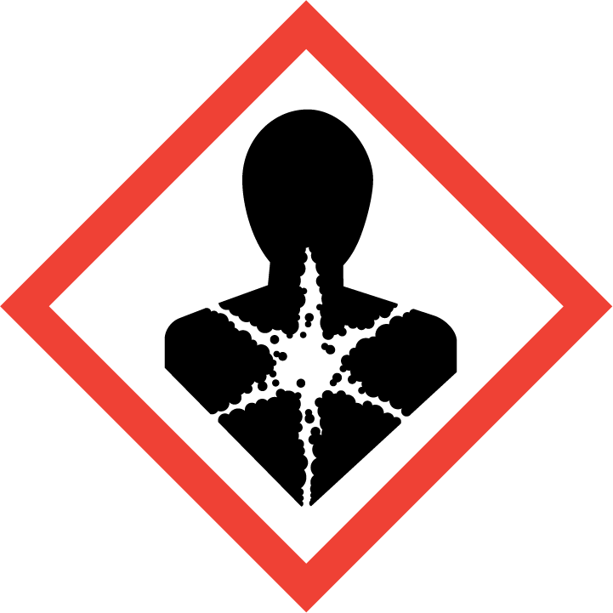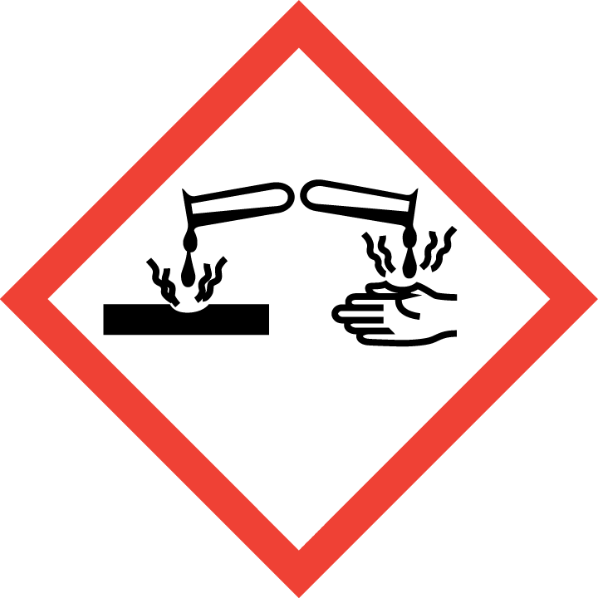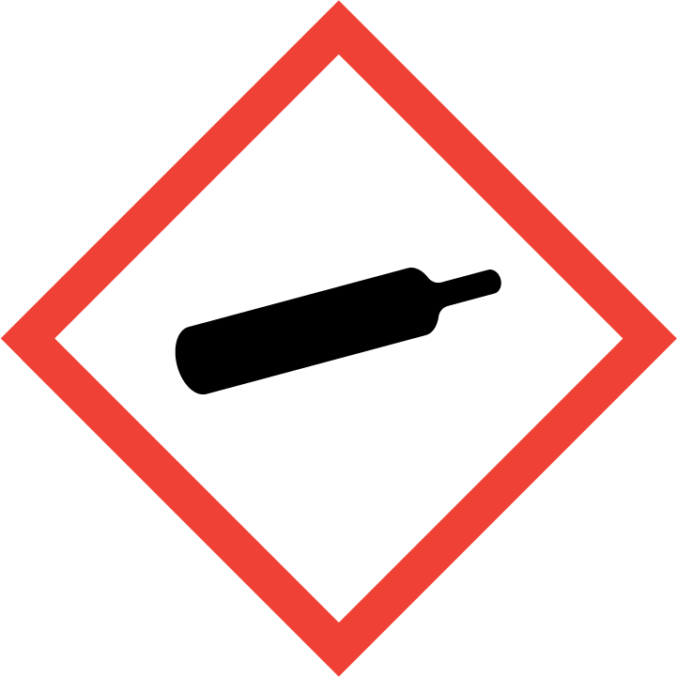
Danger

Hazard Classification:
Acute Oral Toxicity (Category 4)
Aspiration Hazard (Category 1)
Carcinogenicity (Category 2)
Corrosive To Metal (Category 1)
Eye Effects (Category 2.B)
Gases Under Pressure
Oxidizing Gas (Category 1)
Reproductive Toxicity (Category 2)

Hazard Statements:
Causes eye irritation
Contains gas under pressure; may explode if heated
Harmful if swallowed
May be corrosive to metals
May be fatal if swallowed and enters airways
May cause or intensify fire; oxidizer
Suspected of causing cancer
Suspected of damaging fertility or the unborn child

Precautionary Statements
Prevention:
Wash thoroughly after handling.
Do not eat, drink or smoke when using this product.
Keep and store away from clothing and combustible materials.
Do not handle until all safety precautions have been read and understood.
Keep reduction valves/valves and fittings free from oil and grease.
Keep only in original container.
Wear protective gloves, protective clothing, eye protection and face protection.
Obtain special instructions before use.

Response:
Immediately call a poison center or doctor.
In case of fire: Stop leak if safe to do so.
Do NOT induce vomiting.
Absorb spillage to prevent material damage.
If swallowed: Rinse mouth. Do NOT induce vomiting.
If exposed or concerned: Get medical advice/attention.
If in eyes: Rinse cautiously with water for several minutes. Remove contact lenses, if present and easy to do. Continue rinsing.

Storage:
Store in corrosive resistant container with a resistant inner liner.
Protect from sunlight.
Store in well-ventilated place.
Store locked up.

Disposal:
Dispose of contents and/or container in accordance with applicable regulations.

Section 3: Composition/Information on Ingredients

CAS #
10102-44-0

Chemical Substance | Chemical Family | Trade Names
NITROGEN DIOXIDE | Inorganic nitrogen compound / nitrogen oxide / inorganic gas | Dinitrogen tetroxide  Dinitrogen tetroxide, liquefied  Nitrogen dioxide, liquefied  Nitrogen oxide  Nitrogen peroxide  Nitrogen peroxide, liquefied  Nitrogen tetroxide

Section 4: First Aid Measures
Skin Contact | Eye Contact | Ingestion | Inhalation | Note to Physicians
Wash skin with soap and water for at least 15 minutes while removing contaminated clothing and shoes. Get medical attention, if needed. Thoroughly clean and dry contaminated clothing and shoes before reuse. | Flush eyes with plenty of water for at least 15 minutes. Then get immediate medical attention. | Not applicable route of exposure | If adverse effects occur, remove to uncontaminated area. Give artificial respiration if not breathing. If breathing is difficult, oxygen should be administered by qualified personnel. Get immediate medical attention. | None

Section 5: Fire Fighting Measures
Suitable Extinguishing Media | Products of Combustion | Protection of Firefighters
Non-flammable gas. Use suitable extinguishing media for surrounding fire. | Thermal decomposition to give nitric oxide and oxygen when heated above 160 deg C | - Any self-contained breathing apparatus with a full facepiece. Use a chemical protective suit.  - Any self-contained breathing apparatus with a full facepiece. Use a chemical protective suit.

Section 6: Accidental Release Measures
Personal Precautions | Environmental Precautions | Methods for Containment
Keep unnecessary people away, isolate hazard area and deny entry. Stay upwind and keep out of low areas. | Avoid heat, flames, sparks and other sources of ignition. Keep out of water supplies and sewers. | Not available.

Methods for Cleanup | Other Information
Contact emergency personnel | None.

Section 7: Handling and Storage
Handling | Storage
Store and handle in accordance with all current regulations and standards. Subject to storage regulations: U.S. OSHA 29 CFR 1910.101. Keep separated from incompatible substances. | Avoid using in confined spaces.

Section 8: Exposure Controls/Personal Protection
Exposure Guidelines
TLV-TWA: 3 ppm Short-term Exposure Limits (TLV-STEL): 5ppm

Engineering Controls
Handle only in fully enclosed systems.
Eye Protection | Skin Protection | Respiratory Protection
Eye protection not required, but recommended. | Wear appropriate chemical resistant clothing. | Any self-contained breathing apparatus with a full facepiece. Use a chemical protective suit.

General Hygiene considerations
- Avoid breathing vapor or mist
- Avoid contact with eyes and skin
- Wash thoroughly after handling and before eating or drinking

Section 9: Physical and Chemical Properties
Physical State | Appearance | Color | Change in Appearance | Physical Form | Odor | Taste
Gas | Clear | Yellow to dark brown | N/A | Gas | Pungent odor | N/A

Flash Point | Flammability | Partition Coefficient | Autoignition Temperature | Upper Explosive Limits | Lower Explosive Limits
Not applicable | Not available | Not available | Nonflammable | Nonflammable | Nonflammable

Boiling Point | Freezing Point | Vapor Pressure | Vapor Density | Specific Gravity | Water Solubility | pH | Odor Threshold | Evaporation Rate | Viscosity
70.1F | 12 F (-11 C) | 760 mmHg @ 21.1 C | 1.58 (air=1) | 1.449 | Reacts to form nitric acid and nitrous acid; nitrous acid then decomposes to nitric acid and nitric oxide. | Not applicable; solutions are very acidic | Reported values vary. 0.11-0.14 ppm (minimum perceptible value) | Not applicable | 0.42 cP @ 20 C

Molecular Weight | Molecular Formula | Density | Weight per Gallon | Volatility by Volume | Volatility | Solvent Solubility
46.01 (NO2) or 92.01 (N2O4) | N-O2 or N2-O4 | Not available | Not available | 100% | Not available | Soluble: Alkalies, chloroform, carbon disulfide and concentrated nitric and sulfuric acids.

Section 10: Stability and Reactivity
Stability | Conditions to Avoid | Incompatible Materials
Normally stable. Nitrogen dioxide thermally decomposes to nitric oxide and oxygen when heated above 160 deg C. | Normally stable. Nitrogen dioxide thermally decomposes to nitric oxide and oxygen when heated above 160 deg C. | ACETIC ANHYDRIDE, ALCOHOLS, AMMONIA, BORON TRICHLORIDE, CALCIUM, DIMETHYL SULFOXIDE, FORMALDEHYDE , hydrogen, oxygen, metals

Hazardous Decomposition Products | Possibility of Hazardous Reactions
Decomposes in water to form nitric acid and nitrous acid. | Will not polymerize.

Section 11: Toxicology Information

Acute Effects
Oral LD50 | Dermal LD50 | Inhalation
LC50 Inhalation Vapor Rat 790 mg/m3 5 minutes | Not available | Respiratory tract irritation, cough, dyspnea, headache, nausea, irregular heartbeat, fatigue, pulmonary edema, rapid breathing, increased heart rate, dyspnea, chest pain, bleeding from the lungs or small airways and cyanosis (bluish discoloration of the skin)

Eye Irritation | Skin Irritation | Sensitization
Irritation | Liquid: burns | Respiratory tract irritation, difficulty breathing, skin irritation, eye irritation

Chronic Effects
Carcinogenicity | Mutagenicity | Reproductive Effects | Developmental Effects
May be a carcinogen | Mutagenic | May have reproductive effects. | No data

Section 12: Ecological Information

Fate and Transport
Eco toxicity | Persistence / Degradability | Bioaccumulation / Accumulation | Mobility in Environment
Fish toxicity: Acute LC50 19600 ug/L Fresh water Fish - Tench - Tinca tinca - LARVAE - 20 days - 11.18 mm - 11.36 mg 96 hours  Invertibrate toxicity: Acute LC50 79450 ug/L Marine water Crustaceans - Redtail prawn - Penaeus penicillatus - 3.58 to 4.75 cm - 0.4 to 0.69 g 48 hours  Algal toxicity: Not available  Phyto toxicity: Not available  Other toxicity: Not available | Not available | Not available | Not available

Section 13: Disposal Considerations
Dispose in accordance with all applicable federal and local regulations.

Section 14: Transportation Information

U.S. DOT 49 CFR 172.101
Proper Shipping Name | ID Number | Hazard Class or Division | Packing Group | Labeling Requirements | Passenger Aircraft or Railcar Quantity Limitations | Cargo Aircraft Only Quantity Limitations | Additional Shipping Description
DINITROGEN TETROXIDE; or NITROGEN DIOXIDE | UN1067 | 2.3, 5.1 | Not applicable | DINITROGEN TETROXIDE | Forbidden | Forbidden | N/A

Canadian Transportation of Dangerous Goods
Shipping Name | UN Number | Class | Packing Group / Risk Group
DINITROGEN TETROXIDE; or NITROGEN DIOXIDE | UN1067 | 2.3 | Not applicable

Section 15: Regulatory Information

U.S. Regulations
CERCLA Sections | SARA 355.30 | SARA 355.40
Not regulated. | 100 LBS TPQ | 10 LBS RQ

SARA 370.21
Acute | Chronic | Fire | Reactive | Sudden Release
Yes | No | Yes | No | Yes

SARA 372.65
N/A

OSHA Process Safety
Not available

State Regulations
CA Proposition 65
Not regulated

Canadian Regulations
WHMIS Classification
A, C, D1A, D2B, E

National Inventory Status
US Inventory (TSCA) | TSCA 12b Export Notification | Canada Inventory (DSL/NDSL)
Listed on inventory. | Listed | Listed on inventory.

Section 16: Other Information
NFPA Rating
Not available
0 = minimal hazard, 1 = slight hazard, 2 = moderate hazard, 3 = severe hazard, 4 = extreme hazard

