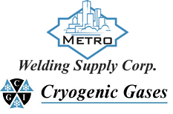 | Safety Data Sheet  Arsine

Section 1: Product and Company Identification
Metro Welding Supply Corp.
12620 Southfield Road
Detroit, MI 48223
(313) 834-1660 [phone]
(313) 835-3562 [fax]
http://www.metrowelding.com/

Product Code: Arsine

Section 2: Hazards Identification
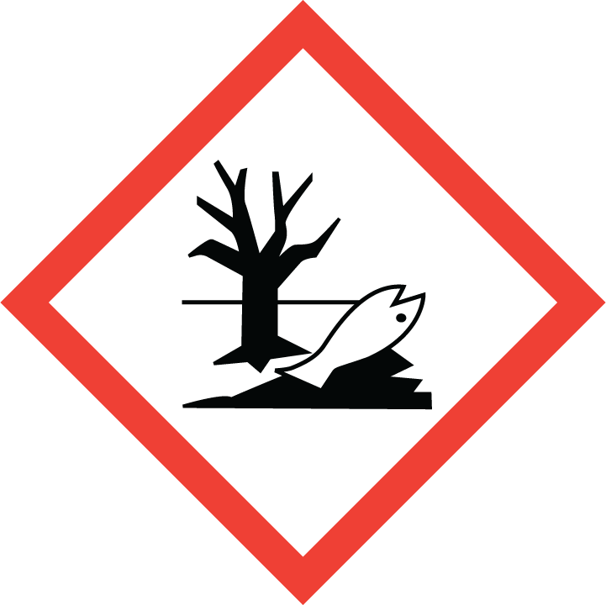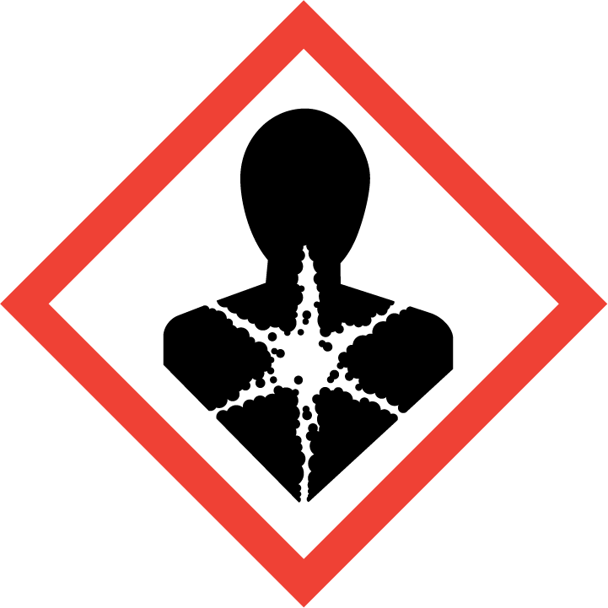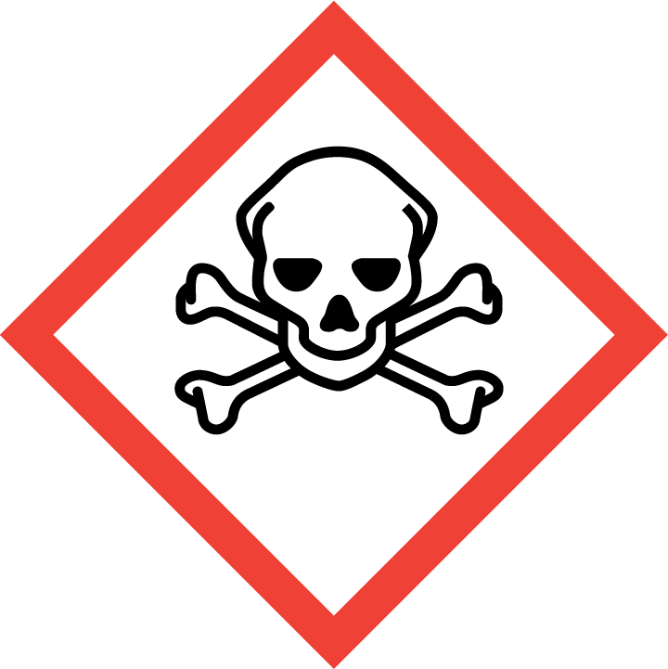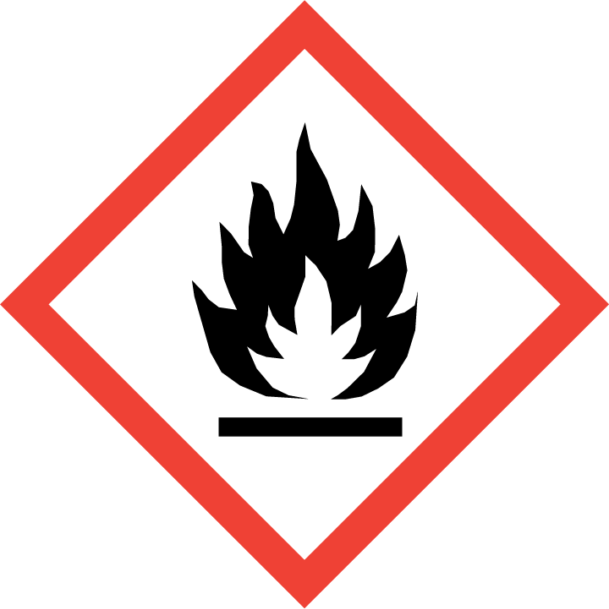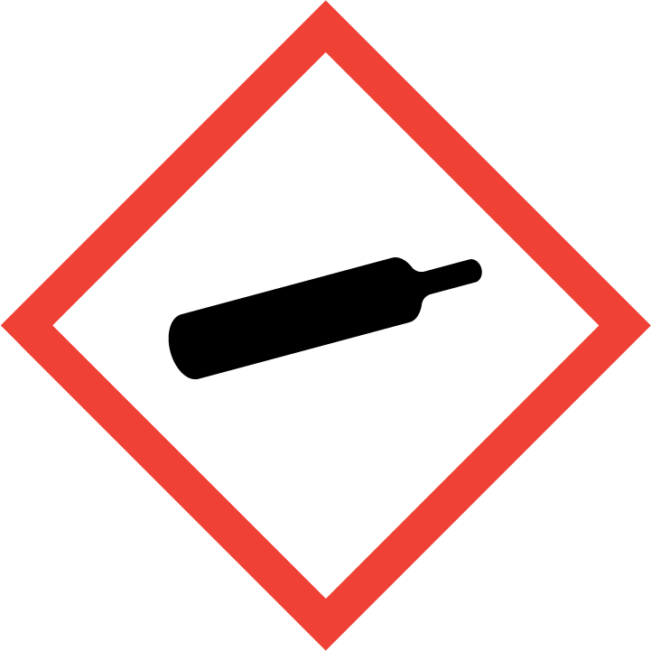
Danger

Hazard Classification:
Acute Aquatic Toxicity (Category 1)
Acute Dust Inhale Toxicity (Category 3)
Acute Gas Inhale Toxicity (Category 1)
Acute Vapor Inhale Toxicity (Category 1)
Carcinogenicity (Category 2)
Chronic Aquatic Toxicity (Category 1)
Flammable (Category 1)
Gases Under Pressure
Specific target organ toxicity (Single Exposure) (Category 2)

Hazard Statements:
Contains gas under pressure; may explode if heated
Extremely flammable gas
Fatal if inhaled
May cause damage to organs
Suspected of causing cancer
Toxic if inhaled
Very toxic to aquatic life
Very toxic to aquatic life with long lasting effects

Precautionary Statements
Prevention:
Do not breathe dust/fume/gas/mist/ vapors/spray..
Do not eat, drink or smoke when using this product.
[In case of inadequate ventilation] wear respiratory protection.
Do not handle until all safety precautions have been read and understood.
Wash thoroughly after handling.
Use only outdoors or in a well-ventilated area.
Wear protective gloves, protective clothing, eye protection and face protection.
Obtain special instructions before use.
Keep away from heat/sparks/open flames/hot surfaces. - No smoking.

Response:
Eliminate all ignition sources if safe to do so.
Immediately call a poison center or doctor.
Leaking gas fire: Do not extinguish, unless leak can be stopped safely.
Specific treatment is urgent.
If swallowed: Rinse mouth. Do NOT induce vomiting.
If exposed or concerned: Get medical advice/attention.
If inhaled: Remove person to fresh air and keep comfortable for breathing.

Storage:
Store in a well-ventilated place. Keep container tightly closed.
Protect from sunlight.
Store locked up.

Disposal:
Dispose of contents and/or container in accordance with applicable regulations.

Section 3: Composition/Information on Ingredients

CAS #
7784-42-1

Chemical Substance | Chemical Family | Trade Names
ARSINE | inorganic, gas | HYDROGEN ARSENIDE; ARSENIC TRIHYDRIDE; ARSENIC HYDRIDE; ARSENIURETTED HYDROGEN; ARSENOUS HYDRIDE; UN 2188

Section 4: First Aid Measures
Skin Contact | Eye Contact | Ingestion | Inhalation | Note to Physicians
If frostbite or freezing occur, immediately flush with plenty of lukewarm water (105-115 F; 41-46 C). DO NOT USE HOT WATER. If warm water is not available, gently wrap affected parts in blankets. Get immediate medical attention. | Contact with liquid: Immediately flush eyes with plenty of water for at least 15 minutes. Then get immediate medical attention. | Not applicable. | If adverse effects occur, remove to uncontaminated area. Give artificial respiration if not breathing. Get immediate medical attention. | Arsine is the most toxic form of arsenic, capable of producing rapid,  massive intravascular hemolysis. Serious arsine poisoning produces symptoms within 30 to 60  minutes; however, symptoms can be delayed for up to 48 hours. Laboratory findings include  severe hemolytic anemia, hemoglobinuria, and hemoglobinemia. Acute renal failure may be an  early complication. Hypotension is occasionally seen; T-wave elevations often observed.  BAL (Dimercaprol) treatment will not protect against hemolysis but may prevent long-term  effects from arsine (arsenic) poisoning. If major hemolysis has occurred, exchange transfusions  may be performed to remove plasma hemoglobin red blood cell debris and arsine-hemoglobin  complexes, in conjunction with hemodialysis to preserve renal function. Hemodialysis may also  assist in decreasing arsenic levels.  Contact the Poison Control Center in your area for additional information on patient  management and follow-up.

Section 5: Fire Fighting Measures
Suitable Extinguishing Media | Products of Combustion | Protection of Firefighters
Let burn unless leak can be stopped immediately. Large fires: Use regular foam or flood with fine water spray. | Arsenic | - Any self-contained breathing apparatus that has a full facepiece and is operated in a pressure-demand or other positive-pressure mode.  - Any supplied-air respirator with full facepiece and operated in a pressure-demand or other positive-pressure mode in combination with a separate escape supply.

Section 6: Accidental Release Measures
Personal Precautions | Environmental Precautions | Methods for Containment
Keep unnecessary people away, isolate hazard area and deny entry. Remove sources of ignition. Ventilate closed spaces before entering. | Avoid heat, flames, sparks and other sources of ignition. Keep out of water supplies and sewers. | Stop leak if possible without personal risk. Reduce vapors with water spray.

Methods for Cleanup | Other Information
Notify Local Emergency Planning Committee and State Emergency Response Commission for release greater than or equal to RQ (U.S. SARA Section 304). If release occurs in the U.S. and is reportable under CERCLA Section 103, notify the National Response Center at (800)424-8802 (USA) or (202)426-2675 (USA). Subject to California Safe Drinking Water and Toxic Enforcement Act of 1986 (Proposition 65). | None

Section 7: Handling and Storage
Handling | Storage
Store and handle in accordance with all current regulations and standards. Store in a cool, dry place. Store in a well-ventilated area. Store outside or in a detached building. Subject to storage regulations: U.S. OSHA 29 CFR 1910.101. Notify State Emergency Response Commission for storage or use at amounts greater than or equal to the TPQ (U.S. EPA SARA Section 302). SARA Section 303 requires facilities storing a material with a TPQ to participate in local emergency response planning (U.S. EPA 40 CFR 355.30). Keep separated from incompatible substances. | Subject to handling regulations: U.S. OSHA 29 CFR 1910.119.

Section 8: Exposure Controls/Personal Protection
Exposure Guidelines
ARSINE: 0.05 ppm (0.2 mg/m3) OSHA TWA 0.05 ppm ACGIH TWA 0.002 mg/m3 NIOSH recommended ceiling 15 minute(s)

Engineering Controls
Handle only in fully enclosed systems.
Eye Protection | Skin Protection | Respiratory Protection
For the gas: Eye protection not required, but recommended. For the liquid: Wear splash resistant safety goggles. Contact lenses should not be worn. Provide an emergency eye wash fountain and quick drench shower in the immediate work area. | For the gas: Wear appropriate chemical resistant clothing. For the liquid: Wear appropriate protective, cold insulating clothing. | Any self-contained breathing apparatus that has a full facepiece and is operated in a pressure-demand or other positive-pressure mode.

General Hygiene considerations
- Avoid breathing vapor or mist
- Avoid contact with eyes and skin
- Wash thoroughly after handling and before eating or drinking

Section 9: Physical and Chemical Properties
Physical State | Appearance | Color | Change in Appearance | Physical Form | Odor | Taste
Gas | Colorless | Colorless | N/A | Gas | Garlic odor | N/A

Flash Point | Flammability | Partition Coefficient | Autoignition Temperature | Upper Explosive Limits | Lower Explosive Limits
Extremely flammable gas |  |  | Not available | 0.78 | 0.051

Boiling Point | Freezing Point | Vapor Pressure | Vapor Density | Specific Gravity | Water Solubility | pH | Odor Threshold | Evaporation Rate | Viscosity
-81 F (-63 C) | -179 F (-117 C) | 11362 mmHg @ 21.1 C | 2.7 (Air=1) | 1.689 @ -55 C | 20% @ 20 C | Aqueous solutions are neutral | 0.5 ppm | Not applicable | Not available

Molecular Weight | Molecular Formula | Density | Weight per Gallon | Volatility by Volume | Volatility | Solvent Solubility
77.95 | As-H3 | Not available | Not available | Not available | Not applicable | Soluble: Benzene, chloroform

Section 10: Stability and Reactivity
Stability | Conditions to Avoid | Incompatible Materials
May react on contact with light. Avoid contact with temperatures above 300 C. May decompose on contact with heat and/or storage and use above room temperature. Can build electrostatic charge due to liquid's low conductivity. | May react on contact with light. Avoid contact with temperatures above 300 C. May decompose on contact with heat and/or storage and use above room temperature. Can build electrostatic charge due to liquid's low conductivity. | Oxidizing materials, halogens, combustible materials, acids

Hazardous Decomposition Products | Possibility of Hazardous Reactions
Oxides of arsenic; on contact with light: arsenic | Will not polymerize.

Section 11: Toxicology Information

Acute Effects
Oral LD50 | Dermal LD50 | Inhalation
LC50 = 20 ppm, 1 hr, mouse | Not established | Garlic breath, sensitivity to light, nausea, vomiting, stomach pain, chest pain, difficulty breathing, headache, dizziness, disorientation, emotional disturbances, lung congestion, blood disorders, liver damage, nerve damage, effects on the brain, coma, death

Eye Irritation | Skin Irritation | Sensitization
Liquid: frostbite | Liquid: frostbite | Potentially fatal if inhaled, blood damage, cancer hazard (in humans)

Chronic Effects
Carcinogenicity | Mutagenicity | Reproductive Effects | Developmental Effects
IARC: Human Sufficient Evidence, Animal Limited Evidence, Group 1 | Not established | Available. | No data

Section 12: Ecological Information

Fate and Transport
Eco toxicity | Persistence / Degradability | Bioaccumulation / Accumulation | Mobility in Environment
Fish toxicity: Not available  Invertibrate toxicity: Not available  Algal toxicity: Not available  Phyto toxicity: Not available  Other toxicity: Not available | Not available | Not available | Not available

Section 13: Disposal Considerations
Dispose in accordance with all applicable regulations. Subject to disposal regulations: U.S. EPA 40 CFR 262. Hazardous Waste Number(s): D001. D003. Hazardous Waste Number(s): D004. Dispose of in accordance with U.S. EPA 40 CFR 262 for concentrations at or above the Regulatory level. Regulatory level- 5.0 mg/L.

Section 14: Transportation Information

U.S. DOT 49 CFR 172.101
Proper Shipping Name | ID Number | Hazard Class or Division | Packing Group | Labeling Requirements | Passenger Aircraft or Railcar Quantity Limitations | Cargo Aircraft Only Quantity Limitations | Additional Shipping Description
Arsine | UN2188 | 2.3 | Not applicable | 2.3; 2.1 | Forbidden | Forbidden | Toxic-Inhalation Hazard Zone A

Canadian Transportation of Dangerous Goods
Shipping Name | UN Number | Class | Packing Group / Risk Group
Arsine | UN2188 | 2.3; 2.1 | Not applicable

Section 15: Regulatory Information

U.S. Regulations
CERCLA Sections | SARA 355.30 | SARA 355.40
Not regulated. | 100 LBS TPQ | 100 LBS RQ

SARA 370.21
Acute | Chronic | Fire | Reactive | Sudden Release
Yes | Yes | Yes | Yes | Yes

SARA 372.65
ARSENIC AND INORGANIC COMPOUNDS (as As)

OSHA Process Safety
100 LBS TQ

State Regulations
CA Proposition 65
Known to the state of California to cause the following: ARSENIC AND INORGANIC COMPOUNDS (as As) Cancer (Feb 27, 1987) Developmental toxicity (May 01, 1997)

Canadian Regulations
WHMIS Classification
Included for disclosure at 0.1% or greater

National Inventory Status
US Inventory (TSCA) | TSCA 12b Export Notification | Canada Inventory (DSL/NDSL)
Listed on inventory. | Not listed. | Not determined.

Section 16: Other Information
NFPA Rating
HEALTH=4 FIRE=4 REACTIVITY=2
0 = minimal hazard, 1 = slight hazard, 2 = moderate hazard, 3 = severe hazard, 4 = extreme hazard

