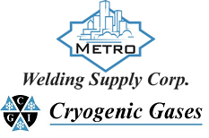 | Safety Data Sheet  Octane

Section 1: Product and Company Identification
Metro Welding Supply Corp.
12620 Southfield Road
Detroit, MI 48223
(313) 834-1660 [phone]
(313) 835-3562 [fax]
http://www.metrowelding.com/

Product Code: Octane

Section 2: Hazards Identification
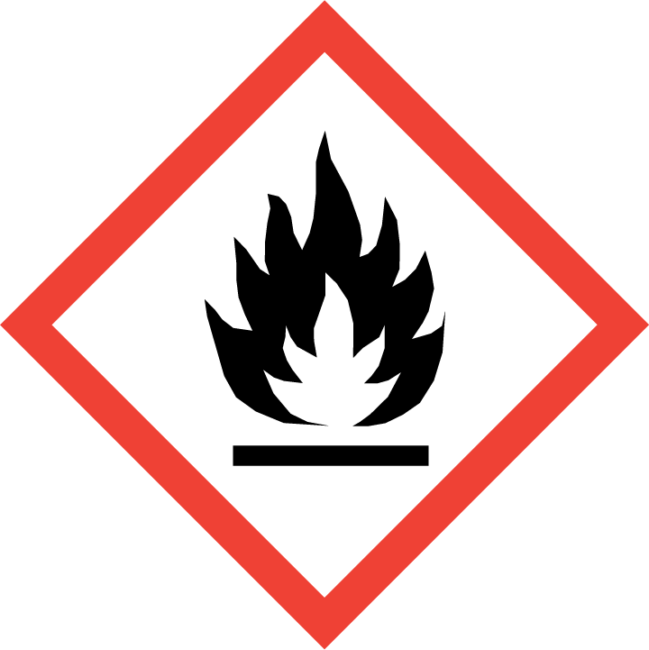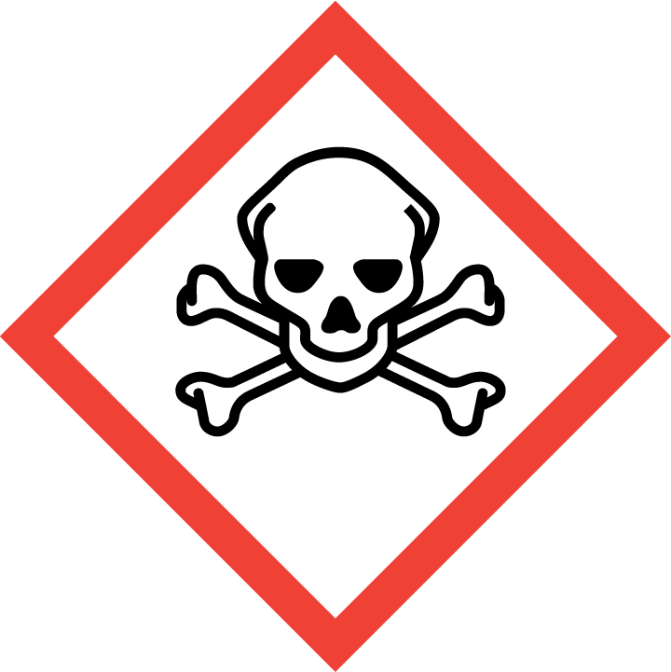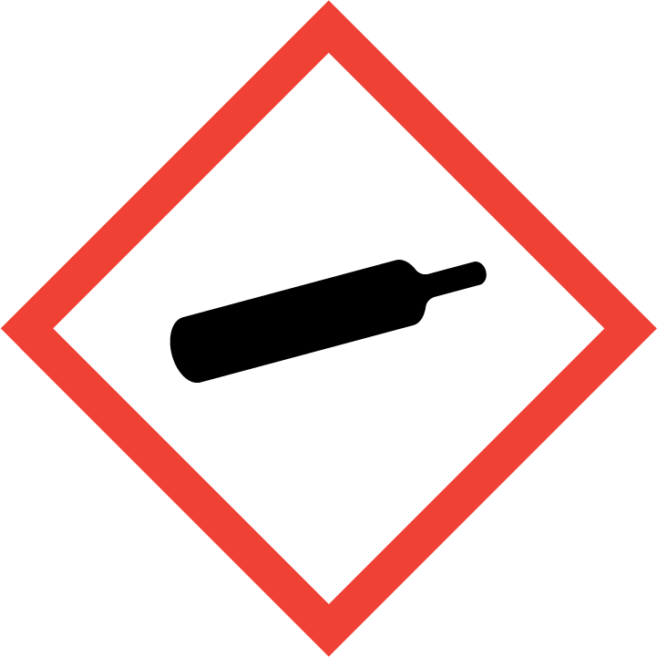
Danger

Hazard Classification:
Acute Gas Inhale Toxicity (Category 2)
Eye Effects (Category 2.B)
Flammable (Category 1)
Flammable Aerosol (Category 1)
Gases Under Pressure

Hazard Statements:
Causes eye irritation
Contains gas under pressure; may explode if heated
Extremely flammable aerosol
Extremely flammable gas
Fatal if inhaled

Precautionary Statements
Prevention:
Wash thoroughly after handling.
[In case of inadequate ventilation] wear respiratory protection.
Do not breathe dust/fume/gas/mist/ vapors/spray..
Use only outdoors or in a well-ventilated area.
Keep away from heat/sparks/open flames/hot surfaces. - No smoking.
Pressurized container: Do not pierce or burn, even after use.
Do not spray on an open flame or other ignition source.

Response:
Eliminate all ignition sources if safe to do so.
Immediately call a poison center or doctor.
Leaking gas fire: Do not extinguish, unless leak can be stopped safely.
Specific treatment is urgent.
If swallowed: Rinse mouth. Do NOT induce vomiting.
If in eyes: Rinse cautiously with water for several minutes. Remove contact lenses, if present and easy to do. Continue rinsing.
If inhaled: Remove person to fresh air and keep comfortable for breathing.

Storage:
Store in a well-ventilated place. Keep container tightly closed.
Protect from sunlight.
Store locked up.
Do not expose to temperatures exceeding 50C/122F.

Disposal:
Dispose of contents and/or container in accordance with applicable regulations.

Section 3: Composition/Information on Ingredients

CAS #
111-65-9

Chemical Substance | Chemical Family | Trade Names
OCTANE | hydrocarbons, aliphatic | N-OCTANE; STCC 4909250; UN 1262; O-3980; C8H18

Section 4: First Aid Measures
Skin Contact | Eye Contact | Ingestion | Inhalation | Note to Physicians
Wash skin with soap and water for at least 15 minutes while removing contaminated clothing and shoes. Get medical attention, if needed. Thoroughly clean and dry contaminated clothing and shoes before reuse. | Flush eyes with plenty of water for at least 15 minutes. Then get immediate medical attention. | Contact local poison control center or physician immediately. Never make an unconscious person vomit or drink fluids. When vomiting occurs, keep head lower than hips to help prevent aspiration. If person is unconscious, turn head to side. Get medical attention immediately. | If adverse effects occur, remove to uncontaminated area. Give artificial respiration if not breathing. Get immediate medical attention. | For ingestion, consider gastric lavage.

Section 5: Fire Fighting Measures
Suitable Extinguishing Media | Products of Combustion | Protection of Firefighters
Regular dry chemical, carbon dioxide, water, regular foam Large fires: Use regular foam or flood with fine water spray. | Carbon monoxide, carbon dioxide | - Any self-contained breathing apparatus with a full facepiece.  - Any self-contained breathing apparatus with a full facepiece.

Section 6: Accidental Release Measures
Personal Precautions | Environmental Precautions | Methods for Containment
Keep unnecessary people away, isolate hazard area and deny entry. | Avoid heat, flames, sparks and other sources of ignition. | Stop leak if possible without personal risk. Reduce vapors with water spray. Remove sources of ignition.

Methods for Cleanup | Other Information
Small spills: Absorb with sand or other non-combustible material. Collect spilled material in appropriate container for disposal. Large spills: Dike for later disposal. | None

Section 7: Handling and Storage
Handling | Storage
Store and handle in accordance with all current regulations and standards. | Avoid heat and sparks. Protect cylinders from damage.

Section 8: Exposure Controls/Personal Protection
Exposure Guidelines
OCTANE: 500 ppm (2350 mg/m3) OSHA TWA 300 ppm (1450 mg/m3) OSHA TWA (vacated by 58 FR 35338, June 30, 1993) 375 ppm (1800 mg/m3) OSHA STEL (vacated by 58 FR35338, June 30, 1993) 300 ppm ACGIH TWA 75 ppm (350 mg/m3) NIOSH recommended TWA 10 hour(s) 385 ppm (1800 mg/m3) NIOSH recommended ceiling 15 minute(s)

Engineering Controls
Handle only in fully enclosed systems.
Eye Protection | Skin Protection | Respiratory Protection
Wear splash resistant safety goggles with a face shield. Provide an emergency eye wash fountain and quick drench shower in the immediate work area. | Wear appropriate chemical resistant clothing. | Any self-contained breathing apparatus with a full facepiece.

General Hygiene considerations
- Avoid breathing vapor or mist
- Avoid contact with eyes and skin
- Wash thoroughly after handling and before eating or drinking

Section 9: Physical and Chemical Properties
Physical State | Appearance | Color | Change in Appearance | Physical Form | Odor | Taste
Liquid | Clear | Colorless | N/A | Liquid | Gasoline odor | N/A

Flash Point | Flammability | Partition Coefficient | Autoignition Temperature | Upper Explosive Limits | Lower Explosive Limits
55 F (13 C) (CC) | IB | Not available | 403 F (206 C) | 0.065 | 0.01

Boiling Point | Freezing Point | Vapor Pressure | Vapor Density | Specific Gravity | Water Solubility | pH | Odor Threshold | Evaporation Rate | Viscosity
259 F (126 C) | -71 F (-57 C) | 11 mmHg @ 20 C | 3.9 (Air=1) | 0.71 | Insoluble | Not available | 150 ppm | Not available | <32 SUS

Molecular Weight | Molecular Formula | Density | Weight per Gallon | Volatility by Volume | Volatility | Solvent Solubility
114.23 | C8-H18 | Not available | Not available | 100% | Not available | Soluble: Ether, acetone, benzene, chloroform, gasolines, petroleum ether

Section 10: Stability and Reactivity
Stability | Conditions to Avoid | Incompatible Materials
Stable at normal temperatures and pressure. | Stable at normal temperatures and pressure. | Oxidizing materials, peroxides, combustible materials

Hazardous Decomposition Products | Possibility of Hazardous Reactions
Oxides of carbon | Will not polymerize.

Section 11: Toxicology Information

Acute Effects
Oral LD50 | Dermal LD50 | Inhalation
LC50 = 50,518 ppmv, 1 hr, rat | Not available | Irritation, nausea, difficulty breathing, headache, drowsiness, symptoms of drunkenness

Eye Irritation | Skin Irritation | Sensitization
Irritation | Irritation, blisters | Respiratory tract irritation, skin irritation, eye irritation, central nervous system depression

Chronic Effects
Carcinogenicity | Mutagenicity | Reproductive Effects | Developmental Effects
Not available | Not available | Not available | No data

Section 12: Ecological Information

Fate and Transport
Eco toxicity | Persistence / Degradability | Bioaccumulation / Accumulation | Mobility in Environment
Fish toxicity: Not available  Invertibrate toxicity: 100000 ug/L 96 hour(s) (Mortality) Coho salmon, silver salmon (Oncorhynchus kisutch)  Algal toxicity: 120 ug/L 1.67 hour(s) EC50 (Food Consumption) Common bay mussel, blue mussel (Mytilus edulis)  Phyto toxicity: 1 ug/L 9 year(s) EC50 (Photosynthesis) Diatom (Skeletonema costatum)  Other toxicity: Not available | Not available | Not available | Not available

Section 13: Disposal Considerations
Dispose in accordance with all applicable regulations.

Section 14: Transportation Information

U.S. DOT 49 CFR 172.101
Proper Shipping Name | ID Number | Hazard Class or Division | Packing Group | Labeling Requirements | Passenger Aircraft or Railcar Quantity Limitations | Cargo Aircraft Only Quantity Limitations | Additional Shipping Description
Octanes | UN1262 | 3 | II | 3 | N/A | N/A | N/A

Canadian Transportation of Dangerous Goods
Shipping Name | UN Number | Class | Packing Group / Risk Group
Octanes | UN1262 | 3 | II

Section 15: Regulatory Information

U.S. Regulations
CERCLA Sections | SARA 355.30 | SARA 355.40
Not regulated. | Not regulated. | Not regulated.

SARA 370.21
Acute | Chronic | Fire | Reactive | Sudden Release
Yes | No | Yes | No | No

SARA 372.65
Not regulated.

OSHA Process Safety
Not regulated.

State Regulations
CA Proposition 65
Not regulated.

Canadian Regulations
WHMIS Classification
B

National Inventory Status
US Inventory (TSCA) | TSCA 12b Export Notification | Canada Inventory (DSL/NDSL)
Listed on inventory. | Not listed. | Not determined.

Section 16: Other Information
NFPA Rating
HEALTH=2 FIRE=3 REACTIVITY=0
0 = minimal hazard, 1 = slight hazard, 2 = moderate hazard, 3 = severe hazard, 4 = extreme hazard

