Safety Data Sheet

Boron Trifluoride

Section 1: Product and Company Identification
Metro Welding Supply Corp.
12620 Southfield Road
Detroit, MI 48223
(313) 834-1660 [phone]
(313) 835-3562 [fax]
http://www.metrowelding.com/

Product Code: Boron Trifluoride

Section 2: Hazards Identification
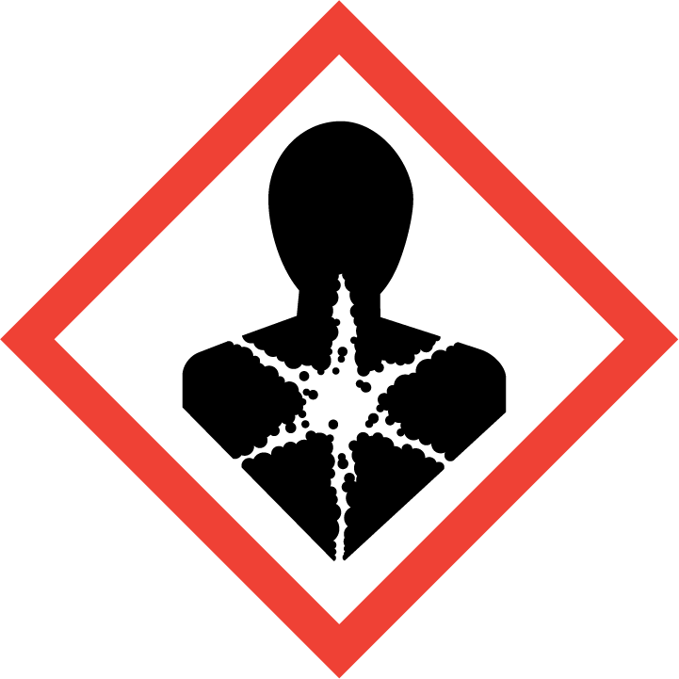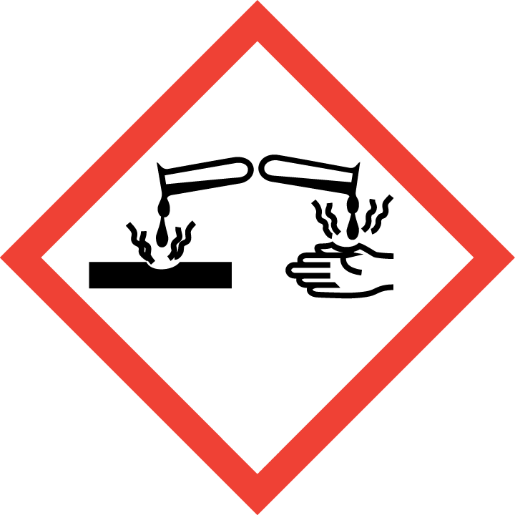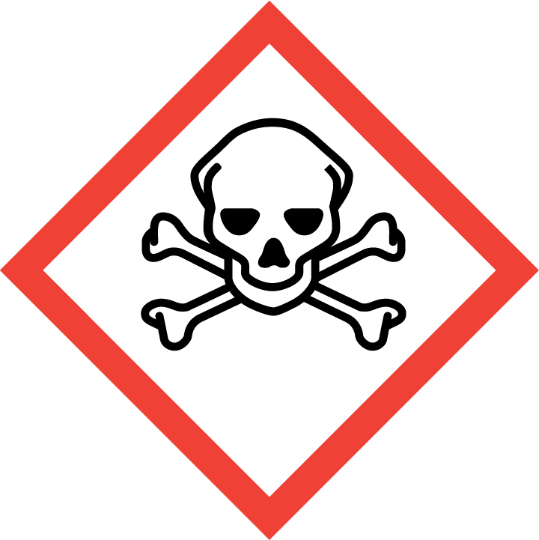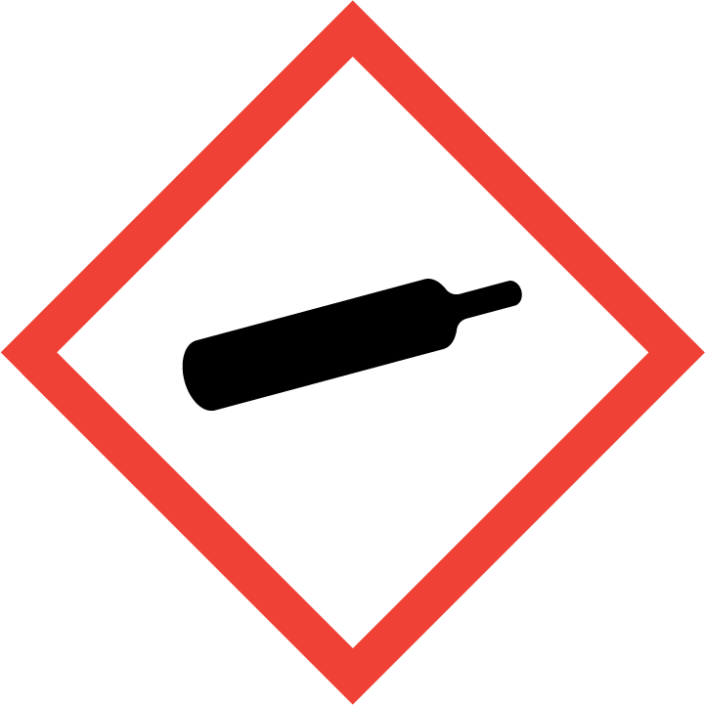
Danger

Hazard Classification:
Acute Gas Inhale Toxicity (Category 3)
Acute Oral Toxicity (Category 4)
Aspiration Hazard (Category 1)
Eye Effects (Category 1)
Gases Under Pressure

Hazard Statements:
Causes serious eye damage
Contains gas under pressure; may explode if heated
Harmful if swallowed
May be fatal if swallowed and enters airways
Toxic if inhaled

Precautionary Statements
Prevention:
Wash thoroughly after handling.
Wear eye protection/face protection.
Do not eat, drink or smoke when using this product.
[In case of inadequate ventilation] wear respiratory protection.
Use only outdoors or in a well-ventilated area.
Avoid breathing dust/fume/gas/mist/ vapors/spray.

Response:
Do NOT induce vomiting.
If in eyes: Rinse cautiously with water for several minutes. Remove contact lenses, if present and easy to do. Continue rinsing.
If swallowed: Rinse mouth. Do NOT induce vomiting.
If inhaled: Remove person to fresh air and keep comfortable for breathing.
Immediately call a poison center or doctor.

Storage:
Store in a well-ventilated place. Keep container tightly closed.
Protect from sunlight.
Store locked up.

Disposal:
Dispose of contents and/or container in accordance with applicable regulations.

Section 3: Composition/Information on Ingredients

CAS #
7637-07-2

Chemical Substance | Chemical Family | Trade Names
BORON TRIFLUORIDE | inorganic, gas, non-metallic, halides | BORON FLUORIDE; BORANE, TRIFLUORIDE; TRIFLUOROBORANE; TRIFLUOROBORON; BORON FLUORIDE (BF3); UN 1008; BF3

Section 4: First Aid Measures
Skin Contact | Eye Contact | Ingestion | Inhalation | Note to Physicians
Wash skin with soap and water for at least 15 minutes while removing contaminated clothing and shoes. Get immediate medical attention. Thoroughly clean and dry contaminated clothing before reuse. Destroy contaminated shoes. | Immediately flush eyes with plenty of water for at least 15 minutes. Then get immediate medical attention. | If a large amount is swallowed, get medical attention. | If adverse effects occur, remove to uncontaminated area. Give artificial respiration if not breathing. If breathing is difficult, oxygen should be administered by qualified personnel. Get immediate medical attention. | For inhalation, consider oxygen.

Section 5: Fire Fighting Measures
Suitable Extinguishing Media | Products of Combustion | Protection of Firefighters
Non-flammable. | Non-flammable | - Any self-contained breathing apparatus with a full facepiece.  - Non-flammable

Section 6: Accidental Release Measures
Personal Precautions | Environmental Precautions | Methods for Containment
Keep unnecessary people away, isolate hazard area and deny entry. Stay upwind and keep out of low areas. Ventilate closed spaces before entering. Evacuation radius: 150 feet. | Environmental effects unknown, avoid contamination of the environment. | Stop leak if possible without personal risk. Reduce vapors with water spray. Do not get water directly on material.

Methods for Cleanup | Other Information
Use self-contained breathing apparatus. | Notify Local Emergency Planning Committee and State Emergency Response Commission for release greater than or equal to RQ (U.S. SARA Section 304). If release occurs in the U.S. and is reportable under CERCLA Section 103, notify the National Response Center at (800)424-8802 (USA) or (202)426-2675 (USA).

Section 7: Handling and Storage
Handling | Storage
Store and handle in accordance with all current regulations and standards. Protect from physical damage. Store outside or in a detached building. Store in a well-ventilated area. Store below 54 C. Store in a cool, dry place. Store in a tightly closed container. Subject to storage regulations: U.S. OSHA 29 CFR 1910.101. Notify State Emergency Response Commission for storage or use at amounts greater than or equal to the TPQ (U.S. EPA SARA Section 302). SARA Section 303 requires facilities storing a material with a TPQ to participate in local emergency response planning (U.S. EPA 40 CFR 355.30). Keep separated from incompatible substances. | Subject to handling regulations: U.S. OSHA 29 CFR 1910.119.

Section 8: Exposure Controls/Personal Protection
Exposure Guidelines
BORON TRIFLUORIDE: 1 ppm (3 mg/m3) OSHA ceiling 1 ppm ACGIH ceiling 1 ppm (3 mg/m3) NIOSH recommended ceiling

Engineering Controls
Handle only in fully enclosed systems.
Eye Protection | Skin Protection | Respiratory Protection
Wear splash resistant safety goggles with a face shield. Provide an emergency eye wash fountain and quick drench shower in the immediate work area. | Wear appropriate chemical resistant clothing. | Any self-contained breathing apparatus with a full facepiece.

General Hygiene considerations
- Avoid breathing vapor or mist
- Avoid contact with eyes and skin
- Wash thoroughly after handling and before eating or drinking

Section 9: Physical and Chemical Properties
Physical State | Appearance | Color | Change in Appearance | Physical Form | Odor | Taste
Gas | Colorless | Colorless | N/A | Compressed gas | Pungent odor | N/A

Flash Point | Flammability | Partition Coefficient | Autoignition Temperature | Upper Explosive Limits | Lower Explosive Limits
Not flammable | Not available | N/A | Nonflammable | Nonflammable | Nonflammable

Boiling Point | Freezing Point | Vapor Pressure | Vapor Density | Specific Gravity | Water Solubility | pH | Odor Threshold | Evaporation Rate | Viscosity
-148 F (-100 C) | -197 F (-127 C) | 653.9 mmHg @ -120 C | 2.3 (Air=1) | Not applicable | Reacts | Not applicable | 1.5 ppm | Not applicable | 0.0171 cP @ 25 C

Molecular Weight | Molecular Formula | Density | Weight per Gallon | Volatility by Volume | Volatility | Solvent Solubility
67.81 | B-F3 | 2.867 g/L | Not available | Not applicable | Not applicable | Soluble: Concentrated sulfuric acid, concentrated nitric acid, benzene, dichlorobenzene, chloroform, carbon tetrachloride, carbon disulfide, aromatic solvents, halogenated solvents

Section 10: Stability and Reactivity
Stability | Conditions to Avoid | Incompatible Materials
May react on contact with water. Releases corrosive gases. Releases toxic gases. | May react on contact with water. Releases corrosive gases. Releases toxic gases. | Metals, oxidizing materials, combustible materials

Hazardous Decomposition Products | Possibility of Hazardous Reactions
Acid halides, halogenated compounds, hydrogen fluoride, organic acids | Will not polymerize.

Section 11: Toxicology Information

Acute Effects
Oral LD50 | Dermal LD50 | Inhalation
1180 mg/m3 inhalation-rat LC50 | Not established | Potentially fatal if inhaled, burns

Eye Irritation | Skin Irritation | Sensitization
Burns | Burns | Potentially fatal if inhaled, respiratory tract burns, skin burns, eye burns, kidney damage

Chronic Effects
Carcinogenicity | Mutagenicity | Reproductive Effects | Developmental Effects
Not available | Not established | Not established | No data

Section 12: Ecological Information

Fate and Transport
Eco toxicity | Persistence / Degradability | Bioaccumulation / Accumulation | Mobility in Environment
Fish toxicity: 15000000 ug/L 24 hour(s) LC50 (Mortality) Bluegill (Lepomis macarochirus)  Invertibrate toxicity: Not available  Algal toxicity: Not available  Phyto toxicity: Not available  Other toxicity: Not available | Not available | Not available | Not available

Section 13: Disposal Considerations
Dispose in accordance with all applicable regulations. Subject to disposal regulations: U.S. EPA 40 CFR 262. Hazardous Waste Number(s): D003.

Section 14: Transportation Information

U.S. DOT 49 CFR 172.101
Proper Shipping Name | ID Number | Hazard Class or Division | Packing Group | Labeling Requirements | Passenger Aircraft or Railcar Quantity Limitations | Cargo Aircraft Only Quantity Limitations | Additional Shipping Description
Boron trifluoride | UN1008 | 2.3 | Not applicable | 2.3 | Forbidden | Forbidden | Toxic-Inhalation Hazard Zone B

Canadian Transportation of Dangerous Goods
Shipping Name | UN Number | Class | Packing Group / Risk Group
Boron trifluoride, compressed | UN1008 | 2.3; 8 | Not applicable

Section 15: Regulatory Information

U.S. Regulations
CERCLA Sections | SARA 355.30 | SARA 355.40
Not regulated. | 500 LBS TPQ | 500 LBS RQ

SARA 370.21
Acute | Chronic | Fire | Reactive | Sudden Release
Yes | Yes | No | Yes | Yes

SARA 372.65
BORON TRIFLUORIDE

OSHA Process Safety
250 LBS TQ

State Regulations
CA Proposition 65
Not regulated.

Canadian Regulations
WHMIS Classification
Included for disclosure at 1% or greater

National Inventory Status
US Inventory (TSCA) | TSCA 12b Export Notification | Canada Inventory (DSL/NDSL)
Listed on inventory. | Not listed. | Not determined.

Section 16: Other Information
NFPA Rating
HEALTH=3 FIRE=0 REACTIVITY=1
0 = minimal hazard, 1 = slight hazard, 2 = moderate hazard, 3 = severe hazard, 4 = extreme hazard

