Safety Data Sheet

Silane

Section 1: Product and Company Identification
Metro Welding Supply Corp.
12620 Southfield Road
Detroit, MI 48223
(313) 834-1660 [phone]
(313) 835-3562 [fax]
http://www.metrowelding.com/

Product Code: Silane

Section 2: Hazards Identification
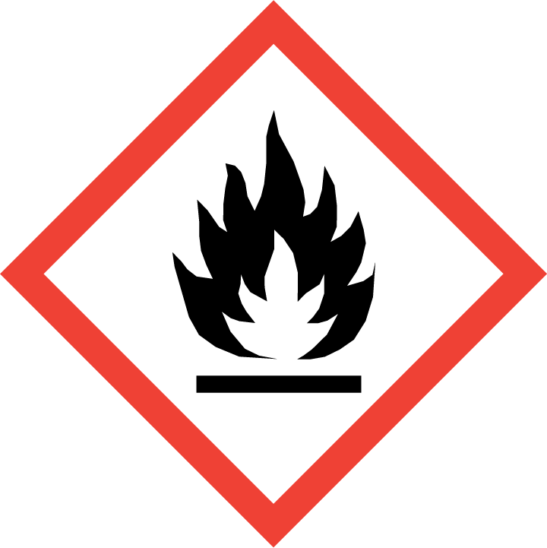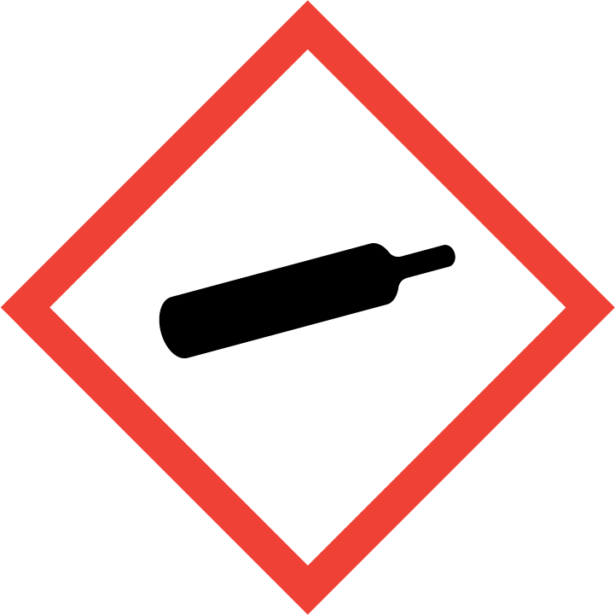
Danger

Hazard Classification:
Eye Effects (Category 2.B)
Flammable (Category 1)
Flammable Aerosol (Category 1)
Gases Under Pressure

Hazard Statements:
Causes eye irritation
Contains gas under pressure; may explode if heated
Extremely flammable aerosol
Extremely flammable gas

Precautionary Statements
Prevention:
Keep away from heat/sparks/open flames/hot surfaces. - No smoking.
Wash thoroughly after handling.
Pressurized container: Do not pierce or burn, even after use.
Do not spray on an open flame or other ignition source.

Response:
If in eyes: Rinse cautiously with water for several minutes. Remove contact lenses, if present and easy to do. Continue rinsing.
Eliminate all ignition sources if safe to do so.
Leaking gas fire: Do not extinguish, unless leak can be stopped safely.

Storage:
Protect from sunlight.
Store in well-ventilated place.
Do not expose to temperatures exceeding 50C/122F.

Section 3: Composition/Information on Ingredients

CAS #
7803-62-5

Chemical Substance | Chemical Family | Trade Names
SILANE | hydrides | MONOSILANE (SIH4); SILICANE; SILICON HYDRIDE (SIH4); SILICON TETRAHYDRIDE; SILICON HYDRIDE; MONOSILANE; STCC 4920168; UN 2203; H4Si

Section 4: First Aid Measures
Skin Contact | Eye Contact | Ingestion | Inhalation | Note to Physicians
Wash skin with soap and water for at least 15 minutes while removing contaminated clothing and shoes. Get medical attention, if needed. Thoroughly clean and dry contaminated clothing and shoes before reuse. | Flush eyes with plenty of water for at least 15 minutes. Then get immediate medical attention. | If a large amount is swallowed, get medical attention. | If adverse effects occur, remove to uncontaminated area. Give artificial respiration if not breathing. Get immediate medical attention. | None

Section 5: Fire Fighting Measures
Suitable Extinguishing Media | Products of Combustion | Protection of Firefighters
Carbon dioxide, regular dry chemical Large fires: Use regular foam or flood with fine water spray. | Pyrophoric or shock-sensitive, dark-colored solids may be formed due to incomplete oxidation | - Any self-contained breathing apparatus with a full facepiece.  - Any self-contained breathing apparatus with a full facepiece.

Section 6: Accidental Release Measures
Personal Precautions | Environmental Precautions | Methods for Containment
Keep unnecessary people away, isolate hazard area and deny entry. Ventilate closed spaces before entering. | Avoid heat, flames, sparks and other sources of ignition. | Stop leak if possible without personal risk. Reduce vapors with water spray. Remove sources of ignition.

Methods for Cleanup | Other Information
Evacuate area. Contact emergency personnel. | None

Section 7: Handling and Storage
Handling | Storage
Store and handle in accordance with all current regulations and standards. Subject to storage regulations: U.S. OSHA 29 CFR 1910.101. Store above -110 C. Store in a tightly closed container. | May ignite on exposure to air. Keep separated from incompatible substances.

Section 8: Exposure Controls/Personal Protection
Exposure Guidelines
SILANE: 5 ppm (7 mg/m3) OSHA TWA (vacated by 58 FR 35338, June 30, 1993) 5 ppm ACGIH TWA 5 ppm (7 mg/m3) NIOSH recommended TWA 10 hour(s).

Engineering Controls
Handle only in fully enclosed systems.
Eye Protection | Skin Protection | Respiratory Protection
Wear helmet with full face shield and fire-proof hood to prevent any possibility of burns if in contact with this substance. | Wear appropriate chemical resistant clothing. | Any self-contained breathing apparatus with a full facepiece.

General Hygiene considerations
- Avoid breathing vapor or mist
- Avoid contact with eyes and skin
- Wash thoroughly after handling and before eating or drinking

Section 9: Physical and Chemical Properties
Physical State | Appearance | Color | Change in Appearance | Physical Form | Odor | Taste
Gas | Clear | Colorless | N/A | Gas | Unpleasant odor | N/A

Flash Point | Flammability | Partition Coefficient | Autoignition Temperature | Upper Explosive Limits | Lower Explosive Limits
Not available | Not available | Not available | Not available | 1 | 0.01

Boiling Point | Freezing Point | Vapor Pressure | Vapor Density | Specific Gravity | Water Solubility | pH | Odor Threshold | Evaporation Rate | Viscosity
-170 F (-112 C) | -301 F (-185 C) | Not available | 1.3 (Air=1) | Not applicable | Insoluble | Not applicable | Not available | Not applicable | 0.01092 cP @ 25 C

Molecular Weight | Molecular Formula | Density | Weight per Gallon | Volatility by Volume | Volatility | Solvent Solubility
32.12 | SI-H4 | 1.342 g/L @ 20 C | Not available | 100% | 1 | Insoluble: Not available

Section 10: Stability and Reactivity
Stability | Conditions to Avoid | Incompatible Materials
May ignite on exposure to air. | May ignite on exposure to air. | Metal salts, bases, halogens, oxidizing materials

Hazardous Decomposition Products | Possibility of Hazardous Reactions
Silicon, hydrogen. Thermal decomposition in the presence of air produces hydrogen gas, silicon, silicon oxides and unidentified dark-colored solid substances that may be pyrophoric or shock-sensitive. | Will not polymerize.

Section 11: Toxicology Information

Acute Effects
Oral LD50 | Dermal LD50 | Inhalation
LC50, 1 hr, rat = 19,200 ppm | Not available | Irritation, nausea, headache

Eye Irritation | Skin Irritation | Sensitization
Irritation , blurred vision | Liquid: irritation, blisters | Respiratory tract irritation, skin irritation, eye irritation

Chronic Effects
Carcinogenicity | Mutagenicity | Reproductive Effects | Developmental Effects
Not available | Available. | Not available | No data

Section 12: Ecological Information

Fate and Transport
Eco toxicity | Persistence / Degradability | Bioaccumulation / Accumulation | Mobility in Environment
Fish toxicity: Not available  Invertibrate toxicity: Not available  Algal toxicity: Not available  Phyto toxicity: Not available  Other toxicity: Not available | Not available | Not available | Not available

Section 13: Disposal Considerations
Subject to disposal regulations: U.S. EPA 40 CFR 262. Hazardous Waste Number(s): D001. Dispose in accordance with all applicable regulations.

Section 14: Transportation Information

U.S. DOT 49 CFR 172.101
Proper Shipping Name | ID Number | Hazard Class or Division | Packing Group | Labeling Requirements | Passenger Aircraft or Railcar Quantity Limitations | Cargo Aircraft Only Quantity Limitations | Additional Shipping Description
Silane | UN2203 | 2.1 | Not applicable | 2.1 | Forbidden | Forbidden | N/A

Canadian Transportation of Dangerous Goods
Shipping Name | UN Number | Class | Packing Group / Risk Group
Silane, compressed | UN2203 | 2.1 | Not applicable

Section 15: Regulatory Information

U.S. Regulations
CERCLA Sections | SARA 355.30 | SARA 355.40
Not regulated. | Not regulated. | Not regulated.

SARA 370.21
Acute | Chronic | Fire | Reactive | Sudden Release
Yes | No | Yes | Yes | Yes

SARA 372.65
Not regulated.

OSHA Process Safety
Not regulated.

State Regulations
CA Proposition 65
Not regulated.

Canadian Regulations
WHMIS Classification
AB

National Inventory Status
US Inventory (TSCA) | TSCA 12b Export Notification | Canada Inventory (DSL/NDSL)
Listed on inventory. | Not listed. | Not determined.

Section 16: Other Information
NFPA Rating
HEALTH=2 FIRE=4 REACTIVITY=3
0 = minimal hazard, 1 = slight hazard, 2 = moderate hazard, 3 = severe hazard, 4 = extreme hazard

