Safety Data Sheet

Air

Section 1: Product and Company Identification
Metro Welding Supply Corp.
12620 Southfield Road
Detroit, MI 48223
(313) 834-1660 [phone]
(313) 835-3562 [fax]
http://www.metrowelding.com/

Product Code: Air

Section 2: Hazards Identification
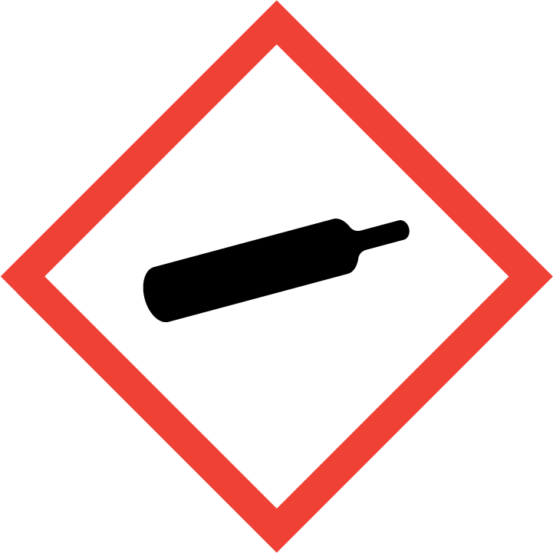
Warning

Hazard Classification:
Gases Under Pressure

Hazard Statements:
Contains gas under pressure; may explode if heated

Precautionary Statements

Storage:
Protect from sunlight.
Store in well-ventilated place.

Section 3: Composition/Information on Ingredients

CAS #
Not assigned.

Chemical Substance | Chemical Family | Trade Names
AIR, COMPRESSED |  | AIR; UN 1002

Section 4: First Aid Measures
Skin Contact | Eye Contact | Ingestion | Inhalation | Note to Physicians
Wash exposed skin with soap and water. | Flush eyes with plenty of water. | If a large amount is swallowed, get medical attention. | If adverse effects occur, remove to uncontaminated area. Get medical attention.

Section 5: Fire Fighting Measures
Suitable Extinguishing Media | Products of Combustion | Protection of Firefighters
Use extinguishing agents appropriate for surrounding fire. |  | - No respirator is required under normal conditions of use.

Section 6: Accidental Release Measures
Personal Precautions | Environmental Precautions | Methods for Containment
 |  | Stop leak if possible without personal risk.

Methods for Cleanup | Other Information

Section 7: Handling and Storage
Handling | Storage
Store and handle in accordance with all current regulations and standards. Subject to storage regulations: U.S. OSHA 29 CFR 1910.101.

Section 8: Exposure Controls/Personal Protection
Exposure Guidelines
AIR, COMPRESSED: No occupational exposure limits established.

Engineering Controls
No specific controls are needed.
Eye Protection | Skin Protection | Respiratory Protection
Eye protection not required under normal conditions. | Protective clothing is not required under normal conditions. | No respirator is required under normal conditions of use.

General Hygiene considerations
- Avoid breathing vapor or mist
- Avoid contact with eyes and skin
- Wash thoroughly after handling and before eating or drinking

Section 9: Physical and Chemical Properties
Physical State | Appearance | Color | Change in Appearance | Physical Form | Odor | Taste
Gas |  | Colorless |  |  | Not available

Flash Point | Flammability | Partition Coefficient | Autoignition Temperature | Upper Explosive Limits | Lower Explosive Limits

Boiling Point | Freezing Point | Vapor Pressure | Vapor Density | Specific Gravity | Water Solubility | pH | Odor Threshold | Evaporation Rate | Viscosity
-317 F (-194 C) | Not available | 760 mmHg @ -194 C | 1 | Not applicable | Slightly soluble | Not applicable | Not available | Not applicable | 0.01853 cP @ 26.85 C

Molecular Weight | Molecular Formula | Density | Weight per Gallon | Volatility by Volume | Volatility | Solvent Solubility
 |  | 1.29 g/L @ 0 C |  |  | Not applicable | Slightly Soluble

Section 10: Stability and Reactivity
Stability | Conditions to Avoid | Incompatible Materials
Stable at normal temperatures and pressure. | Stable at normal temperatures and pressure. | None known

Hazardous Decomposition Products | Possibility of Hazardous Reactions
No hazard expected. | Will not polymerize.

Section 11: Toxicology Information

Acute Effects
Oral LD50 | Dermal LD50 | Inhalation
Not available | Not available

Eye Irritation | Skin Irritation | Sensitization
No information is available | No information is available | No significant target effects reported.

Chronic Effects
Carcinogenicity | Mutagenicity | Reproductive Effects | Developmental Effects
Not available | Not available | No data | No data

Section 12: Ecological Information

Fate and Transport
Eco toxicity | Persistence / Degradability | Bioaccumulation / Accumulation | Mobility in Environment
Fish toxicity: Not available | Not available | Not available | Not available

Section 13: Disposal Considerations
Dispose in accordance with all applicable regulations.

Section 14: Transportation Information

U.S. DOT 49 CFR 172.101
Proper Shipping Name | ID Number | Hazard Class or Division | Packing Group | Labeling Requirements | Passenger Aircraft or Railcar Quantity Limitations | Cargo Aircraft Only Quantity Limitations | Additional Shipping Description
Air, compressed | UN1002 | 2.2 | Not available | 2.2 | Not available | Not available | Not available

Canadian Transportation of Dangerous Goods
Shipping Name | UN Number | Class | Packing Group / Risk Group
Air, compressed | UN1002 | 2.2 | Not available

Section 15: Regulatory Information

U.S. Regulations
CERCLA Sections | SARA 355.30 | SARA 355.40
Not regulated. | Not regulated. | Not regulated.

SARA 370.21
Acute | Chronic | Fire | Reactive | Sudden Release
No | No | No | No | Yes

SARA 372.65
Not regulated.

OSHA Process Safety
Not regulated.

State Regulations
CA Proposition 65
Not regulated.

Canadian Regulations
WHMIS Classification
A

National Inventory Status
US Inventory (TSCA) | TSCA 12b Export Notification | Canada Inventory (DSL/NDSL)
Not listed on inventory. | Not listed. | Not determined.

Section 16: Other Information
NFPA Rating
HEALTH=0 FIRE=0 REACTIVITY=0
0 = minimal hazard, 1 = slight hazard, 2 = moderate hazard, 3 = severe hazard, 4 = extreme hazard

