Safety Data Sheet

Dichlorosilane

Section 1: Product and Company Identification
Metro Welding Supply Corp.
12620 Southfield Road
Detroit, MI 48223
(313) 834-1660 [phone]
(313) 835-3562 [fax]
http://www.metrowelding.com/

Product Code: Dichlorosilane

Section 2: Hazards Identification
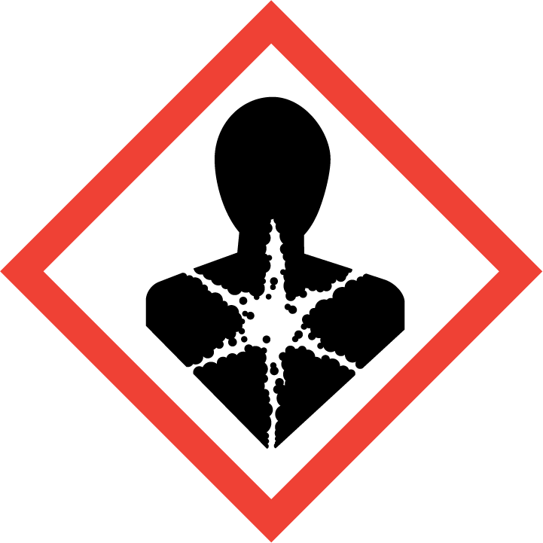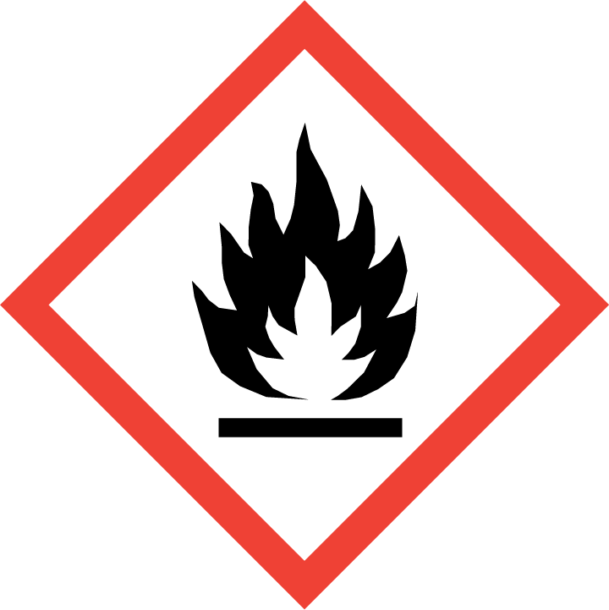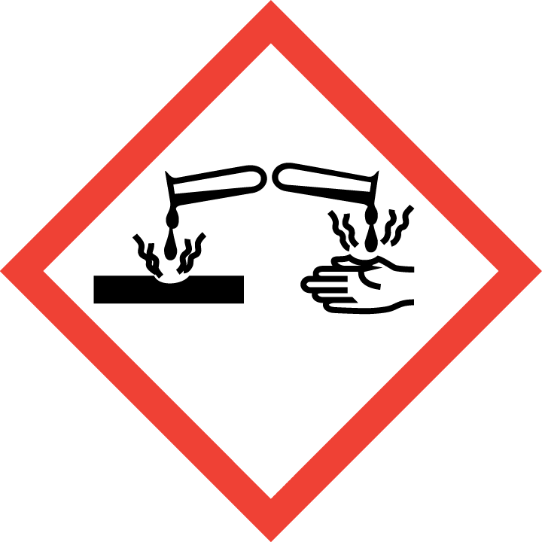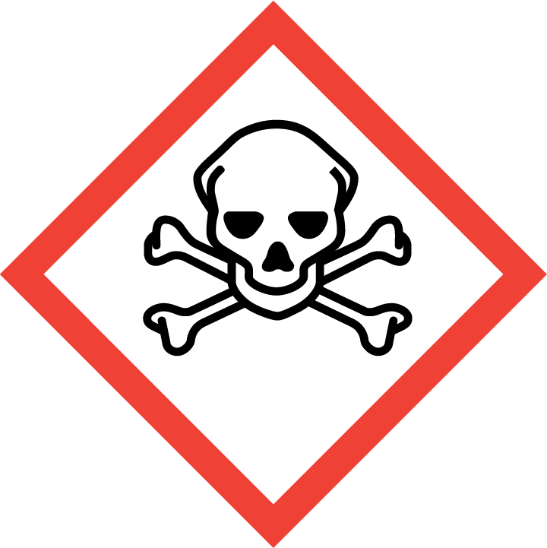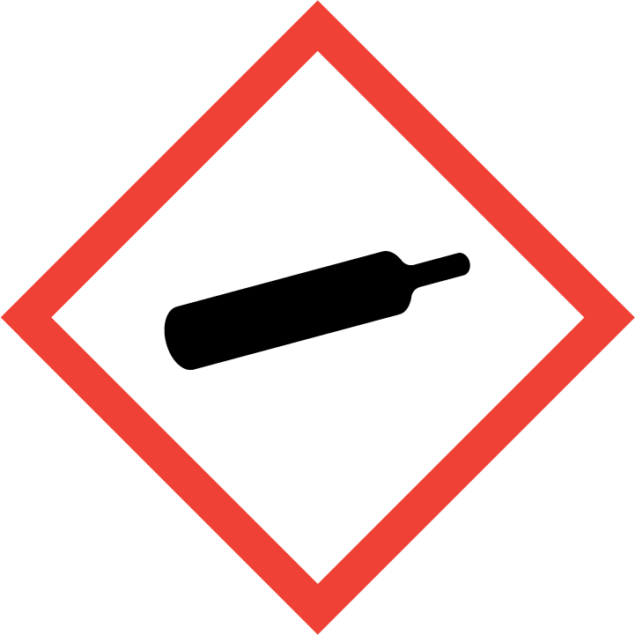
Danger

Hazard Classification:
Acute Gas Inhale Toxicity (Category 2)
Aspiration Hazard (Category 1)
Corrosive To Metal (Category 1)
Eye Effects (Category 1)
Flammable (Category 1)
Flammable Aerosol (Category 1)
Gases Under Pressure

Hazard Statements:
Causes serious eye damage
Contains gas under pressure; may explode if heated
Extremely flammable aerosol
Extremely flammable gas
Fatal if inhaled
May be corrosive to metals
May be fatal if swallowed and enters airways

Precautionary Statements
Prevention:
Do not breathe dust/fume/gas/mist/ vapors/spray..
Wear eye protection/face protection.
[In case of inadequate ventilation] wear respiratory protection.
Keep only in original container.
Use only outdoors or in a well-ventilated area.
Keep away from heat/sparks/open flames/hot surfaces. - No smoking.
Pressurized container: Do not pierce or burn, even after use.
Do not spray on an open flame or other ignition source.

Response:
Eliminate all ignition sources if safe to do so.
Immediately call a poison center or doctor.
Leaking gas fire: Do not extinguish, unless leak can be stopped safely.
Absorb spillage to prevent material damage.
Do NOT induce vomiting.
Specific treatment is urgent.
If swallowed: Rinse mouth. Do NOT induce vomiting.
If in eyes: Rinse cautiously with water for several minutes. Remove contact lenses, if present and easy to do. Continue rinsing.
If inhaled: Remove person to fresh air and keep comfortable for breathing.

Storage:
Store in a well-ventilated place. Keep container tightly closed.
Protect from sunlight.
Store locked up.
Store in corrosive resistant container with a resistant inner liner.
Do not expose to temperatures exceeding 50C/122F.

Disposal:
Dispose of contents and/or container in accordance with applicable regulations.

Section 3: Composition/Information on Ingredients

CAS #
4109-96-0

Chemical Substance | Chemical Family | Trade Names
DICHLOROSILANE | silicon, hydrides | DICHLOROSILICANE; UN 2189

Section 4: First Aid Measures
Skin Contact | Eye Contact | Ingestion | Inhalation | Note to Physicians
Wash skin with soap and water for at least 15 minutes while removing contaminated clothing and shoes. Get immediate medical attention. Thoroughly clean and dry contaminated clothing before reuse. Destroy contaminated shoes. | Immediately flush eyes with plenty of water for at least 15 minutes. Then get immediate medical attention. | If a large amount is swallowed, get medical attention. | If adverse effects occur, remove to uncontaminated area. Give artificial respiration if not breathing. If breathing is difficult, oxygen should be administered by qualified personnel. Get immediate medical attention. | For inhalation, consider oxygen.

Section 5: Fire Fighting Measures
Suitable Extinguishing Media | Products of Combustion | Protection of Firefighters
If safe to do so, stop the flow of gas. Let fire burn if gas flow cannot be stopped. Otherwise, carbon dioxide, regular dry chemical. Avoid, water, most foams, halocarbons, dry chemical extinguishers, cationic and anionic surfactants. | Thermal decomposition forms silane, chlorosilane, silicon, hydrogen chloride gas and hydrogen gas. | - Respiratory protection may be needed for frequent or heavy exposure. Any supplied-air respirator with full facepiece and operated in a pressure-demand or other positive-pressure mode in combination with a separate escape supply.  - Respiratory protection may be needed for frequent or heavy exposure.

Section 6: Accidental Release Measures
Personal Precautions | Environmental Precautions | Methods for Containment
Keep unnecessary people away, isolate hazard area and deny entry. Do not touch spilled material. | Avoid heat, flames, sparks and other sources of ignition. | Stop leak if possible without personal risk. Reduce vapors with water spray. Do not get water inside container. Remove sources of ignition.

Methods for Cleanup | Other Information
Small spills: Absorb with sand or other non-combustible material. Collect spilled material in appropriate container for disposal. Large spills: Dike for later disposal. | None

Section 7: Handling and Storage
Handling | Storage
Store and handle in accordance with all current regulations and standards. | Keep separated from incompatible substances.

Section 8: Exposure Controls/Personal Protection
Exposure Guidelines
DICHLOROSILANE: No occupational exposure limits established.

Engineering Controls
Handle only in fully enclosed systems.
Eye Protection | Skin Protection | Respiratory Protection
Wear splash resistant safety goggles with a face shield. Provide an emergency eye wash fountain and quick drench shower in the immediate work area. | Wear appropriate chemical resistant clothing. | Respiratory protection may be needed for frequent or heavy exposure. Any supplied-air respirator with full facepiece and operated in a pressure-demand or other positive-pressure mode in combination with a separate escape supply.

General Hygiene considerations
- Avoid breathing vapor or mist
- Avoid contact with eyes and skin
- Wash thoroughly after handling and before eating or drinking

Section 9: Physical and Chemical Properties
Physical State | Appearance | Color | Change in Appearance | Physical Form | Odor | Taste
Gas | Colorless | Colorless | N/A | Gas | Irritating odor | N/A

Flash Point | Flammability | Partition Coefficient | Autoignition Temperature | Upper Explosive Limits | Lower Explosive Limits
-35 F (-37 C) | Not available | Not available | 97 F (36 C) | 0.99 | 0.041

Boiling Point | Freezing Point | Vapor Pressure | Vapor Density | Specific Gravity | Water Solubility | pH | Odor Threshold | Evaporation Rate | Viscosity
46 F (8 C) | -188 F (-122 C) | 1252 mm Hg @ 20 C | 3.5 (Air =1) | 1.2 | Reacts violently with water | Acidic in solution | Not available; releases very toxic and corrosive hydrogen chloride gas on contact with humid air or water | Not applicable (gas). Liquefied gas rapidly returns to the gaseous state at room temperature. | Not available

Molecular Weight | Molecular Formula | Density | Weight per Gallon | Volatility by Volume | Volatility | Solvent Solubility
101.0 | H2-SI-CL2 | 3.5 (air=1) | Not available | 100% | Not applicable | Soluble: Benzene, carbon tetrachloride, ether

Section 10: Stability and Reactivity
Stability | Conditions to Avoid | Incompatible Materials
May polymerize violently or explosively. Avoid contact with incompatible materials. May ignite spontaneously in air. | May polymerize violently or explosively. Avoid contact with incompatible materials. May ignite spontaneously in air. | Combustible materials, halo carbons, oxidizing materials

Hazardous Decomposition Products | Possibility of Hazardous Reactions
Acid halides, halogenated compounds, crystalline silica, acid halides, oxides of silicon. Hydrolysis in water forms very toxic and corrosive hydrogen chloride gas, extremely flammable hydrogen gas, and polymeric prosiloxanes that may ignite spontaneously. Thermal decomposition in presence of air produces hydrogen chloride gas, hydrogen gas, silicon, silicon oxides (e.g. amorphous silica), and polymeric prosiloxanes that may ignite spontaneously. Thermal decomposition in the absence of air or in closed systems produces silicon, hydrogen chloride gas, chlorine gas, polychlorosilanes, silane, extremely flammable hydrogen gas, and polysilanes. The thermal decomposition mixture may ignite immediately on exposure to air. | May polymerize violently or explosively. Avoid contact with incompatible materials.

Section 11: Toxicology Information

Acute Effects
Oral LD50 | Dermal LD50 | Inhalation
LC50, 1 hr, rat = 314 ppm | Not available | Burns, difficulty breathing, headache, dizziness, bluish skin color, lung congestion

Eye Irritation | Skin Irritation | Sensitization
Irritation (possibly severe) | Burns | Respiratory tract burns, skin burns, eye burns, mucous membrane burns

Chronic Effects
Carcinogenicity | Mutagenicity | Reproductive Effects | Developmental Effects
Not available | Not available | Not available | No data

Section 12: Ecological Information

Fate and Transport
Eco toxicity | Persistence / Degradability | Bioaccumulation / Accumulation | Mobility in Environment
Fish toxicity: Not available  Invertibrate toxicity: Not available  Algal toxicity: Not available  Phyto toxicity: Not available  Other toxicity: Not available | Not available | Not available | Not available

Section 13: Disposal Considerations
Dispose in accordance with all applicable regulations.

Section 14: Transportation Information

U.S. DOT 49 CFR 172.101
Proper Shipping Name | ID Number | Hazard Class or Division | Packing Group | Labeling Requirements | Passenger Aircraft or Railcar Quantity Limitations | Cargo Aircraft Only Quantity Limitations | Additional Shipping Description
Dichlorosilane | UN2189 | 2.3 | Not applicable | 2.3; 2.1; 8 | Forbidden | Forbidden | Toxic-Inhalation Hazard Zone B

Canadian Transportation of Dangerous Goods
Shipping Name | UN Number | Class | Packing Group / Risk Group
Dichlorosilane | UN2189 | 2.3; 2.1; 8 | Not applicable

Section 15: Regulatory Information

U.S. Regulations
CERCLA Sections | SARA 355.30 | SARA 355.40
Not regulated. | Not regulated. | Not regulated.

SARA 370.21
Acute | Chronic | Fire | Reactive | Sudden Release
Yes | No | Yes | Yes | Yes

SARA 372.65
Not regulated.

OSHA Process Safety
2500 LBS TQ

State Regulations
CA Proposition 65
Not regulated.

Canadian Regulations
WHMIS Classification
ABD1F

National Inventory Status
US Inventory (TSCA) | TSCA 12b Export Notification | Canada Inventory (DSL/NDSL)
Listed on inventory. | Not listed. | Not determined.

Section 16: Other Information
NFPA Rating
HEALTH=4 FIRE=4 REACTIVITY=2
0 = minimal hazard, 1 = slight hazard, 2 = moderate hazard, 3 = severe hazard, 4 = extreme hazard

