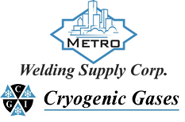 | Safety Data Sheet  Dimethylamine

Section 1: Product and Company Identification
Metro Welding Supply Corp.
12620 Southfield Road
Detroit, MI 48223
(313) 834-1660 [phone]
(313) 835-3562 [fax]
http://www.metrowelding.com/

Product Code: Dimethylamine

Section 2: Hazards Identification
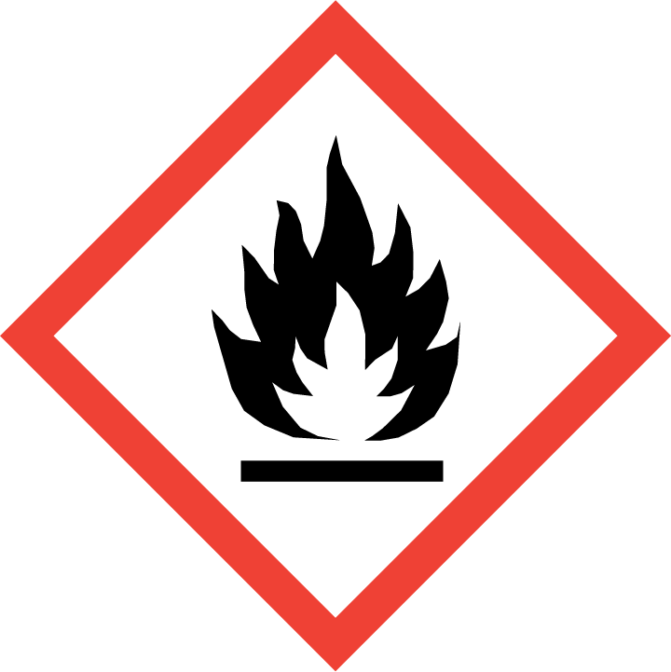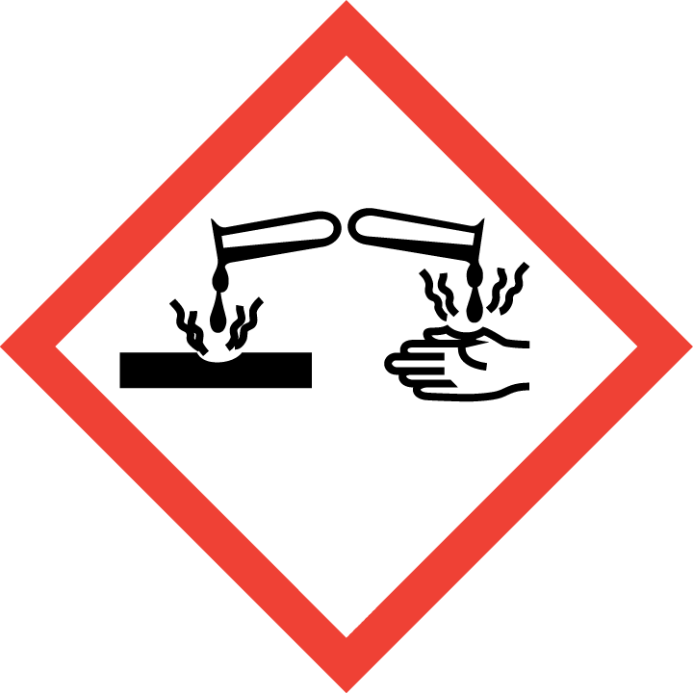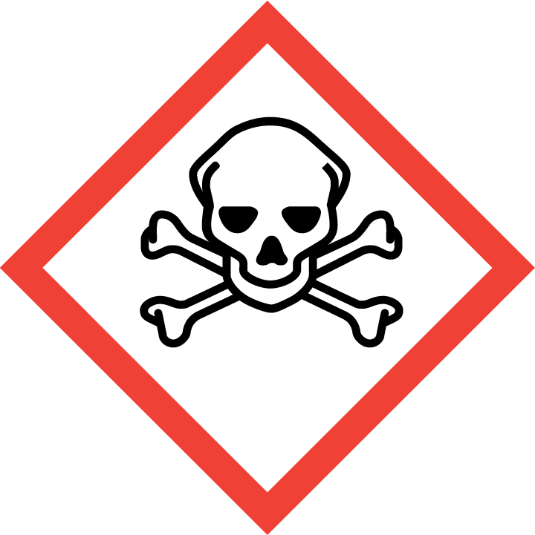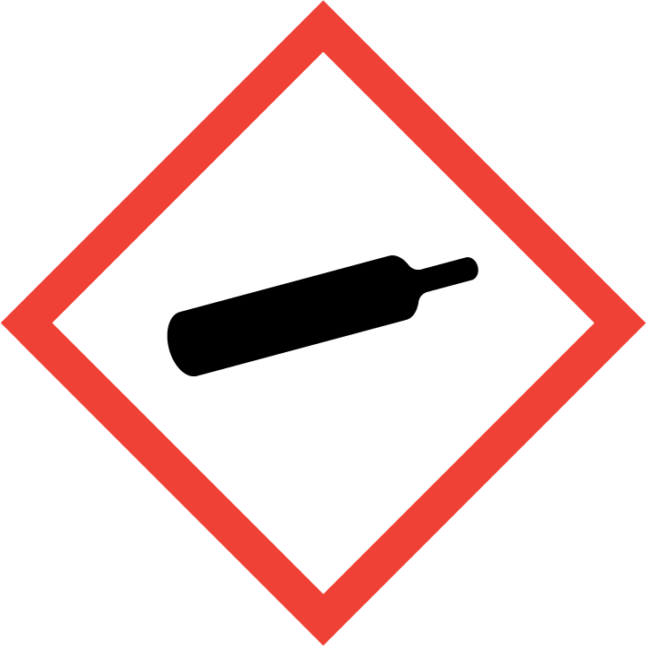
Danger

Hazard Classification:
Acute Dust Inhale Toxicity (Category 4)
Acute Gas Inhale Toxicity (Category 1)
Acute Oral Toxicity (Category 4)
Acute Vapor Inhale Toxicity (Category 3)
Eye Effects (Category 1)
Flammable (Category 1)
Flammable Aerosol (Category 1)
Gases Under Pressure

Hazard Statements:
Causes serious eye damage
Contains gas under pressure; may explode if heated
Extremely flammable aerosol
Extremely flammable gas
Fatal if inhaled
Harmful if inhaled
Harmful if swallowed
Toxic if inhaled

Precautionary Statements
Prevention:
Wash thoroughly after handling.
Wear eye protection/face protection.
Do not eat, drink or smoke when using this product.
[In case of inadequate ventilation] wear respiratory protection.
Do not breathe dust/fume/gas/mist/ vapors/spray..
Use only outdoors or in a well-ventilated area.
Keep away from heat/sparks/open flames/hot surfaces. - No smoking.
Pressurized container: Do not pierce or burn, even after use.
Do not spray on an open flame or other ignition source.

Response:
Eliminate all ignition sources if safe to do so.
Immediately call a poison center or doctor.
Leaking gas fire: Do not extinguish, unless leak can be stopped safely.
Specific treatment is urgent.
If swallowed: Rinse mouth. Do NOT induce vomiting.
If in eyes: Rinse cautiously with water for several minutes. Remove contact lenses, if present and easy to do. Continue rinsing.
If inhaled: Remove person to fresh air and keep comfortable for breathing.

Storage:
Store in a well-ventilated place. Keep container tightly closed.
Protect from sunlight.
Store locked up.
Do not expose to temperatures exceeding 50C/122F.

Disposal:
Dispose of contents and/or container in accordance with applicable regulations.

Section 3: Composition/Information on Ingredients

CAS #
124-40-3

Chemical Substance | Chemical Family | Trade Names
DIMETHYLAMINE, ANHYDROUS | amines, aliphatic | N-METHYLMETHANAMINE; DMA; DIMETHYLAMINE, AQUEOUS SOLUTION; DIMETHYLAMINE SOLUTION; DIMETHYLAMINE; O-2443; RCRA U092; UN 1032

Section 4: First Aid Measures
Skin Contact | Eye Contact | Ingestion | Inhalation | Note to Physicians
Wash skin with soap and water for at least 15 minutes while removing contaminated clothing and shoes. Get medical attention. Thoroughly clean and dry contaminated clothing before reuse. Destroy contaminated shoes. If necessary, and it can be done safely, continue rinsing with water during transport to emergency care facility. | Immediately flush eyes with plenty of water for at least 15 minutes. Then get immediate medical attention. | DO NOT induce vomiting. Never make an unconscious person vomit or drink fluids. Give large amounts of water or milk. When vomiting occurs, keep head lower than hips to help prevent aspiration. If person is unconscious, turn head to side. Get medical attention immediately. | If adverse effects occur, remove to uncontaminated area. Give artificial respiration if not breathing. If breathing is difficult, oxygen should be administered by qualified personnel. Keep warm. Get immediate medical attention. | Victims of overexposure by inhalation should be observed for up to 72 hours for delayed onset of pulmonary edema.  Use of acidics to neutralize swallowed contents is contraindicated.

Section 5: Fire Fighting Measures
Suitable Extinguishing Media | Products of Combustion | Protection of Firefighters
Carbon dioxide, regular dry chemical Large fires: Use regular foam or flood with fine water spray. | Nitrogen oxides, ammonia, hydrogen cyanide, nitriles, isocyanates, nitrosamines, carbon monoxide, carbon dioxide, and other irritating and toxic fumes | - Any self-contained breathing apparatus that has a full facepiece and is operated in a pressure-demand or other positive-pressure mode.  - Any self-contained breathing apparatus that has a full facepiece and is operated in a pressure-demand or other positive-pressure mode.  - Protective material types: nitrile gloves, metatarsal shoes

Section 6: Accidental Release Measures
Personal Precautions | Environmental Precautions | Methods for Containment
Keep unnecessary people away, isolate hazard area and deny entry. Stay upwind and keep out of low areas. | Avoid heat, flames, sparks and other sources of ignition. | Stop leak if possible without personal risk. Reduce vapors with water spray. Remove sources of ignition.

Methods for Cleanup | Other Information
Dig holding area such as lagoon, pond or pit for containment. Collect runoff for disposal as potential hazardous waste. Dike for later disposal. Absorb with sand or other non-combustible material. Add dilute acid. Cover with absorbent sheets, spill-control pads or pillows. Neutralize. Collect with absorbent into suitable container. Absorb with activated carbon. Add a reducing agent. Collect spilled material using mechanical equipment. | Notify Local Emergency Planning Committee and State Emergency Response Commission for release greater than or equal to RQ (U.S. SARA Section 304). If release occurs in the U.S. and is reportable under CERCLA Section 103, notify the National Response Center at (800)424-8802 (USA) or (202)426-2675 (USA).

Section 7: Handling and Storage
Handling | Storage
Store and handle in accordance with all current regulations and standards. Keep separated from incompatible substances. | Protect cylinders from damage. Use a suitable hand truck to move cylinders; do not drag, roll, slide, or drop. Electrical equipment must be non-sparking or explosion-proof. Never attempt to lift a cylinder by its cap; the cap is intended solely to protect the valve. Never insert an object (e.g., wrench, screwdriver, pry bar) into cap openings; doing so may damage the valve and cause a leak. Use an adjustable strap wrench to remove over-tight or rusted caps. Open valve slowly. If valve is hard to open, discontinue use and contact your supplier.

Section 8: Exposure Controls/Personal Protection
Exposure Guidelines
DIMETHYLAMINE, ANHYDROUS: DIMETHYLAMINE: 10 ppm (18 mg/m3) OSHA TWA 5 ppm ACGIH TWA 15 ppm ACGIH STEL 10 ppm (18 mg/m3) NIOSH recommended TWA 10 hour(s)

Engineering Controls
Handle only in fully enclosed systems.
Eye Protection | Skin Protection | Respiratory Protection
Wear splash resistant safety goggles with a face shield. Provide an emergency eye wash fountain and quick drench shower in the immediate work area. | Wear appropriate chemical resistant clothing. | Any self-contained breathing apparatus that has a full facepiece and is operated in a pressure-demand or other positive-pressure mode.

General Hygiene considerations
- Avoid breathing vapor or mist
- Avoid contact with eyes and skin
- Wash thoroughly after handling and before eating or drinking

Section 9: Physical and Chemical Properties
Physical State | Appearance | Color | Change in Appearance | Physical Form | Odor | Taste
Gas | Colorless | Colorless | N/A | Gas | Fishy, ammonia odor | N/A

Flash Point | Flammability | Partition Coefficient | Autoignition Temperature | Upper Explosive Limits | Lower Explosive Limits
0 F (-18 C) (CC) | Not available | Not available | 756 F (402 C) | 0.144 | 0.028

Boiling Point | Freezing Point | Vapor Pressure | Vapor Density | Specific Gravity | Water Solubility | pH | Odor Threshold | Evaporation Rate | Viscosity
45 F (7 C) | -134 F (-92 C) | 1.72 atm @ 20 C | 1.6 (Air =1) | 0.68 @ 0 C (liquid) | Soluble | 11.8 (0.1M solution, 0.45%) (calculated) | 0.047-0.34 ppm | >1.0 (butyl acetate=1) | Not available

Molecular Weight | Molecular Formula | Density | Weight per Gallon | Volatility by Volume | Volatility | Solvent Solubility
45.09 | C2-H7-N | Not available | Not available | 1 | Not applicable | Soluble: Alcohol, ether, alkali solutions

Section 10: Stability and Reactivity
Stability | Conditions to Avoid | Incompatible Materials
Stable at normal temperatures and pressure. | Stable at normal temperatures and pressure. | Metals, acids, combustible materials, halogens, oxidizing materials, nitrating agents, mercury, nitrophenols, lewis acids, alkali metals, acylating agents, epoxides, carbon disulfide, carbon dioxide

Hazardous Decomposition Products | Possibility of Hazardous Reactions
Oxides of carbon, nitrogen Forms corrosive solutions when exposed to water or moist air. | Will not polymerize.

Section 11: Toxicology Information

Acute Effects
Oral LD50 | Dermal LD50 | Inhalation
698 mg/kg oral-rat LD50 | Not available | Irritation (possibly severe), difficulty breathing, lung congestion

Eye Irritation | Skin Irritation | Sensitization
Irritation (possibly severe), blurred vision | Burns | Respiratory tract burns, skin burns, eye burns, mucous membrane burns

Chronic Effects
Carcinogenicity | Mutagenicity | Reproductive Effects | Developmental Effects
ACGIH: A4 -Not Classifiable as a Human Carcinogen | Available. | Not available | No data

Section 12: Ecological Information

Fate and Transport
Eco toxicity | Persistence / Degradability | Bioaccumulation / Accumulation | Mobility in Environment
Fish toxicity: 17000 ug/L 96 hour(s) LC50 (Mortality) Rainbow trout,donaldson trout (Oncorhynchus mykiss)  Invertibrate toxicity: >100000 ug/L 48 hour(s) LC50 (Mortality) Common shrimp (Crangon crangon)  Algal toxicity: 1400 ug/L 7 week(s) (Biomass) Green algae (Scenedesmus quadricauda)  Phyto toxicity: Not available  Other toxicity: Not available | Not available | Not available | Not available

Section 13: Disposal Considerations
Dispose in accordance with all applicable regulations. Subject to disposal regulations: U.S. EPA 40 CFR 262. Hazardous Waste Number(s): U092.

Section 14: Transportation Information

U.S. DOT 49 CFR 172.101
Proper Shipping Name | ID Number | Hazard Class or Division | Packing Group | Labeling Requirements | Passenger Aircraft or Railcar Quantity Limitations | Cargo Aircraft Only Quantity Limitations | Additional Shipping Description
Dimethylamine, anhydrous | UN1032 | 2.1 | Not applicable | 2.1 | Forbidden | 150 kg | None

Canadian Transportation of Dangerous Goods
Shipping Name | UN Number | Class | Packing Group / Risk Group
Dimethylamine, anhydrous | UN1032 | 2.1; 8 | Not applicable

Section 15: Regulatory Information

U.S. Regulations
CERCLA Sections | SARA 355.30 | SARA 355.40
1000 LBS | Not regulated. | Not regulated.

SARA 370.21
Acute | Chronic | Fire | Reactive | Sudden Release
Yes | No | Yes | No | Yes

SARA 372.65
DIMETHYLAMINE

OSHA Process Safety
2500 LBS TQ

State Regulations
CA Proposition 65
Not regulated.

Canadian Regulations
WHMIS Classification
A, B1, D2B, E

National Inventory Status
US Inventory (TSCA) | TSCA 12b Export Notification | Canada Inventory (DSL/NDSL)
Listed on inventory. | Not listed. | Not determined.

Section 16: Other Information
NFPA Rating
HEALTH=3 FIRE=4 REACTIVITY=0
0 = minimal hazard, 1 = slight hazard, 2 = moderate hazard, 3 = severe hazard, 4 = extreme hazard

