Safety Data Sheet

Toluene

Section 1: Product and Company Identification
Metro Welding Supply Corp.
12620 Southfield Road
Detroit, MI 48223
(313) 834-1660 [phone]
(313) 835-3562 [fax]
http://www.metrowelding.com/

Product Code: Toluene

Section 2: Hazards Identification
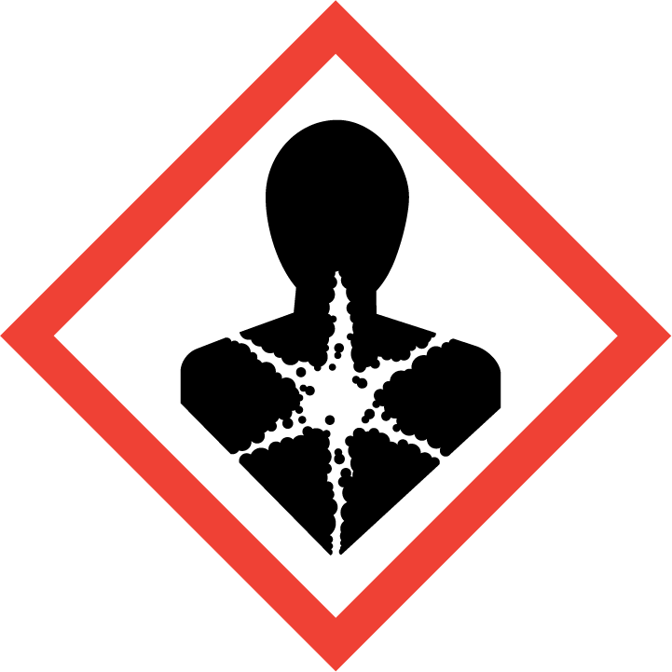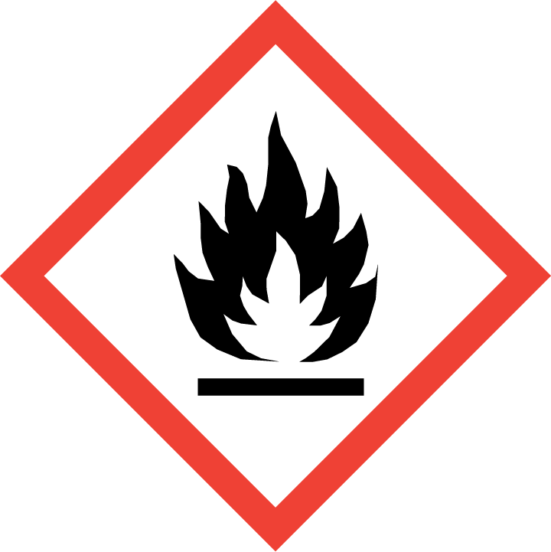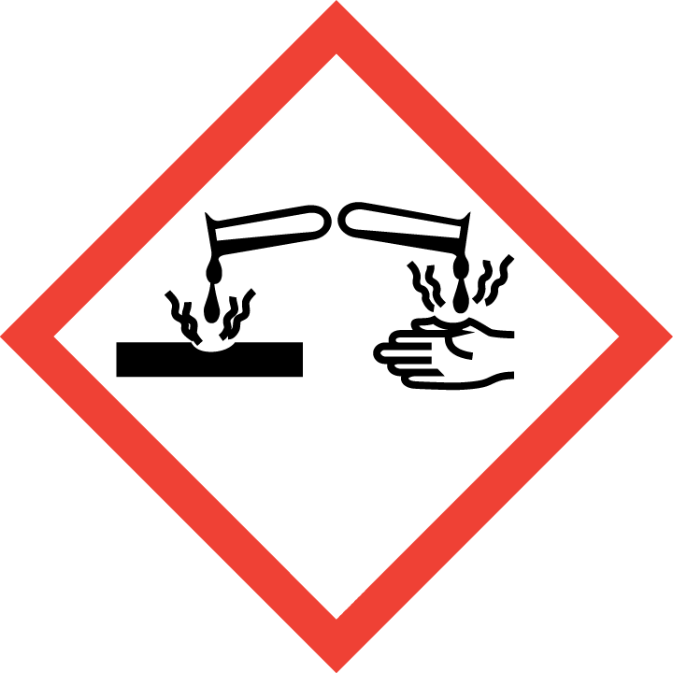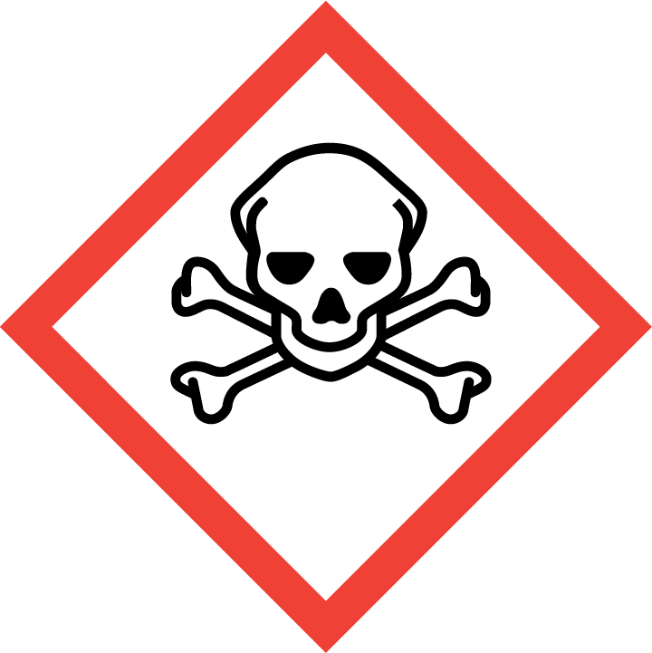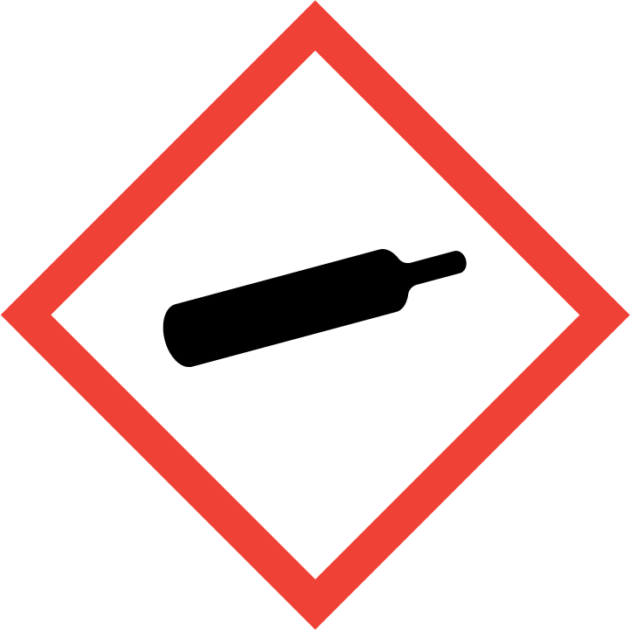
Danger

Hazard Classification:
Acute Gas Inhale Toxicity (Category 1)
Acute Oral Toxicity (Category 4)
Aspiration Hazard (Category 1)
Eye Effects (Category 1)
Flammable (Category 1)
Flammable Aerosol (Category 1)
Gases Under Pressure

Hazard Statements:
Causes serious eye damage
Contains gas under pressure; may explode if heated
Extremely flammable aerosol
Extremely flammable gas
Fatal if inhaled
Harmful if swallowed
May be fatal if swallowed and enters airways
Toxic to aquatic life

Precautionary Statements
Prevention:
Wash thoroughly after handling.
Wear eye protection/face protection.
Do not eat, drink or smoke when using this product.
[In case of inadequate ventilation] wear respiratory protection.
Do not breathe dust/fume/gas/mist/ vapors/spray..
Use only outdoors or in a well-ventilated area.
Keep away from heat/sparks/open flames/hot surfaces. - No smoking.
Pressurized container: Do not pierce or burn, even after use.
Do not spray on an open flame or other ignition source.

Response:
Eliminate all ignition sources if safe to do so.
Immediately call a poison center or doctor.
Leaking gas fire: Do not extinguish, unless leak can be stopped safely.
Do NOT induce vomiting.
Specific treatment is urgent.
If swallowed: Rinse mouth. Do NOT induce vomiting.
If in eyes: Rinse cautiously with water for several minutes. Remove contact lenses, if present and easy to do. Continue rinsing.
If inhaled: Remove person to fresh air and keep comfortable for breathing.

Storage:
Store in a well-ventilated place. Keep container tightly closed.
Protect from sunlight.
Store locked up.
Do not expose to temperatures exceeding 50C/122F.

Disposal:
Dispose of contents and/or container in accordance with applicable regulations.

Section 3: Composition/Information on Ingredients

CAS #
108-88-3

Chemical Substance | Chemical Family | Trade Names
TOLUENE | hydrocarbons, aromatic | METHYLBENZENE; TOLUOL; METHYLBENZOL; PHENYLMETHANE; METHACIDE; RCRA U220; UN 1294; C7H8

Section 4: First Aid Measures
Skin Contact | Eye Contact | Ingestion | Inhalation | Note to Physicians
Wash skin with soap and water for at least 15 minutes while removing contaminated clothing and shoes. Get medical attention, if needed. Thoroughly clean and dry contaminated clothing and shoes before reuse. | Flush eyes with plenty of water for at least 15 minutes. Then get immediate medical attention. | Aspiration hazard. DO NOT induce vomiting. If vomiting occurs, keep head lower than hips to help prevent aspiration. Get immediate medical attention. Give artificial respiration if not breathing. | If adverse effects occur, remove to uncontaminated area. Give artificial respiration if not breathing. Get immediate medical attention. | None

Section 5: Fire Fighting Measures
Suitable Extinguishing Media | Products of Combustion | Protection of Firefighters
Regular dry chemical, carbon dioxide, water, regular foam Large fires: Use regular foam or flood with fine water spray. | Carbon monoxide, carbon dioxide and toxic and irritating fumes | - Any self-contained breathing apparatus with a full facepiece.  - Any self-contained breathing apparatus with a full facepiece.

Section 6: Accidental Release Measures
Personal Precautions | Environmental Precautions | Methods for Containment
Keep unnecessary people away, isolate hazard area and deny entry. Stay upwind and keep out of low areas. | Avoid heat, flames, sparks and other sources of ignition. Keep out of water supplies and sewers. | Stop leak if possible without personal risk. Reduce vapors with water spray. Remove sources of ignition. Dig holding area such as lagoon, pond or pit for containment.

Methods for Cleanup | Other Information
Small spills: Absorb with sand or other non-combustible material. Collect spilled material in appropriate container for disposal. Large spills: Dike for later disposal. Collect with absorbent into suitable container. Absorb with activated carbon. Collect spilled material using mechanical equipment. Cover with absorbent sheets, spill-control pads or pillows. Apply detergents, soaps, alcohols or another surface active agent. Remove trapped material with suction hoses. | Notify local Emergency Planning Committee and State Emergency Response Commission for release greater than or equal to RQ (U.S. SARA Section 304). If release occurs in the U.S. and is reportable under CERCLA Section103, notify the National Response Center at (800)424-8802 (USA) or (202)426-2675 (USA). Subject to California Safe Drinking Water and Toxic Enforcement Act of 1986 (Proposition 65).

Section 7: Handling and Storage
Handling | Storage
Store and handle in accordance with all current regulations and standards. Subject to storage regulations: U.S. OSHA 29 CFR 1910.106. Store outside or in a detached building. Store with flammable liquids. Store in a tightly closed container. Store in a cool, dry place. | Protect from physical damage. Keep separated from incompatible substances. Grounding and bonding required.

Section 8: Exposure Controls/Personal Protection
Exposure Guidelines
TOLUENE: 200 ppm OSHA TWA 300 ppm OSHA ceiling 500 ppm OSHA peak 10 minute(s) 100 ppm (377 mg/m3) OSHA TWA (vacated by 58 FR 35338, June 30, 1993) 150 ppm (565 mg/m3) OSHA STEL (vacated by 58 FR 35338, June 30, 1993) 50 ppm ACGIH TWA (skin) 100 ppm (375mg/m3) NIOSH recommended TWA 10 hour(s) 150 ppm (560 mg/m3) NIOSH recommended STEL

Engineering Controls
Handle only in fully enclosed systems.
Eye Protection | Skin Protection | Respiratory Protection
Wear splash resistant safety goggles with a face shield. Provide an emergency eye wash fountain and quick drench shower in the immediate work area. | Wear appropriate chemical resistant clothing. | Any self-contained breathing apparatus with a full facepiece.

General Hygiene considerations
- Avoid breathing vapor or mist
- Avoid contact with eyes and skin
- Wash thoroughly after handling and before eating or drinking

Section 9: Physical and Chemical Properties
Physical State | Appearance | Color | Change in Appearance | Physical Form | Odor | Taste
Liquid | Clear | Colorless | N/A | Liquid | Distinct odor | N/A

Flash Point | Flammability | Partition Coefficient | Autoignition Temperature | Upper Explosive Limits | Lower Explosive Limits
39 F (4 C) (CC) | IB | Not available | 896 F (480 C) | 0.071 | 0.012

Boiling Point | Freezing Point | Vapor Pressure | Vapor Density | Specific Gravity | Water Solubility | pH | Odor Threshold | Evaporation Rate | Viscosity
232 F (111 C) | -139 F (-95 C) | 22 mmHg @ 20 C | 3.14 (Air=1) | 0.8669 | 0.05% @ 20 C | Not available | 10-15 ppm | 2.24 (butyl acetate=1) | 0.560 mPa.s @ 25 C

Molecular Weight | Molecular Formula | Density | Weight per Gallon | Volatility by Volume | Volatility | Solvent Solubility
92.14 | C6-H5-C-H3 | Not available | Not available | 100% | 1 | Soluble: Alcohol, ether, benzene, acetone, ligroin, chloroform, acetic acid, carbon disulfide

Section 10: Stability and Reactivity
Stability | Conditions to Avoid | Incompatible Materials
Stable at normal temperatures and pressure. | Stable at normal temperatures and pressure. | Halogens, combustible materials, acids, oxidizing materials, metal salts

Hazardous Decomposition Products | Possibility of Hazardous Reactions
Oxides of carbon, hydrocarbons | Will not polymerize.

Section 11: Toxicology Information

Acute Effects
Oral LD50 | Dermal LD50 | Inhalation
636 mg/kg oral-rat LD50 | 14100 ul/kg skin-rabbit LD50 | Irritation, metallic taste, nausea, headache, drowsiness, symptoms of drunkenness, tingling sensation, dilated pupils, kidney damage, liver damage, nerve damage

Eye Irritation | Skin Irritation | Sensitization
Irritation (possibly severe), tearing | Irritation | Respiratory tract irritation, skin irritation, eye irritation, aspiration hazard, central nervous system depression, nerve damage

Chronic Effects
Carcinogenicity | Mutagenicity | Reproductive Effects | Developmental Effects
IARC: Human Inadequate Evidence, Animal Evidence Suggesting Lack of Carcinogenicity, Group 3; ACGIH: A4 -Not Classifiable as a Human Carcinogen | Available. | Available. | No data

Section 12: Ecological Information

Fate and Transport
Eco toxicity | Persistence / Degradability | Bioaccumulation / Accumulation | Mobility in Environment
Fish toxicity: 8110 ug/L 96 hour(s) LC50 (Mortality) Coho salmon, silver salmon (Oncorhynchus kisutch)  Invertibrate toxicity: 6000 ug/L 48 hour(s) EC50 (Immobilization) Water flea (Daphnia magna)  Algal toxicity: 9400 ug/L 8 hour(s) EC50 (Growth) Green algae (Selenastrum capricornutum)  Phyto toxicity: Not available  Other toxicity: Not available | Not available | Not available | Not available

Section 13: Disposal Considerations
Dispose in accordance with all applicable regulations. Subject to disposal regulations: U.S. EPA 40 CFR 262. Hazardous Waste Number(s): U220.

Section 14: Transportation Information

U.S. DOT 49 CFR 172.101
Proper Shipping Name | ID Number | Hazard Class or Division | Packing Group | Labeling Requirements | Passenger Aircraft or Railcar Quantity Limitations | Cargo Aircraft Only Quantity Limitations | Additional Shipping Description
Toluene | UN1294 | 3 | II | 3 | 5 kg or L | 60L | N/A

Canadian Transportation of Dangerous Goods
Shipping Name | UN Number | Class | Packing Group / Risk Group
Toluene | UN1294 | 3 | II

Section 15: Regulatory Information

U.S. Regulations
CERCLA Sections | SARA 355.30 | SARA 355.40
1000 LBS RQ | Not regulated. | Not regulated.

SARA 370.21
Acute | Chronic | Fire | Reactive | Sudden Release
Yes | Yes | Yes | No | No

SARA 372.65
TOLUENE

OSHA Process Safety
Not regulated.

State Regulations
CA Proposition 65
Known to the state of California to cause the following: TOLUENE Developmental toxicity (Jan 01, 1991)

Canadian Regulations
WHMIS Classification
BD2

National Inventory Status
US Inventory (TSCA) | TSCA 12b Export Notification | Canada Inventory (DSL/NDSL)
Listed on inventory. | Not listed. | Not determined.

Section 16: Other Information
NFPA Rating
HEALTH=2 FIRE=3 REACTIVITY=0
0 = minimal hazard, 1 = slight hazard, 2 = moderate hazard, 3 = severe hazard, 4 = extreme hazard

