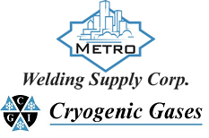 | Safety Data Sheet  Methyl Mercaptan

Section 1: Product and Company Identification
Metro Welding Supply Corp.
12620 Southfield Road
Detroit, MI 48223
(313) 834-1660 [phone]
(313) 835-3562 [fax]
http://www.metrowelding.com/

Product Code: Methyl Mercaptan

Section 2: Hazards Identification
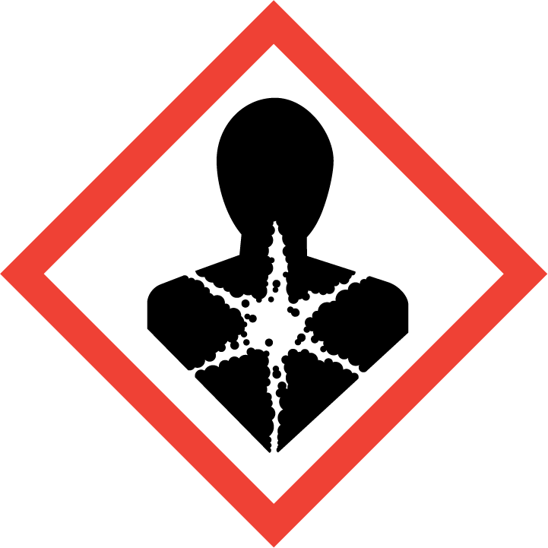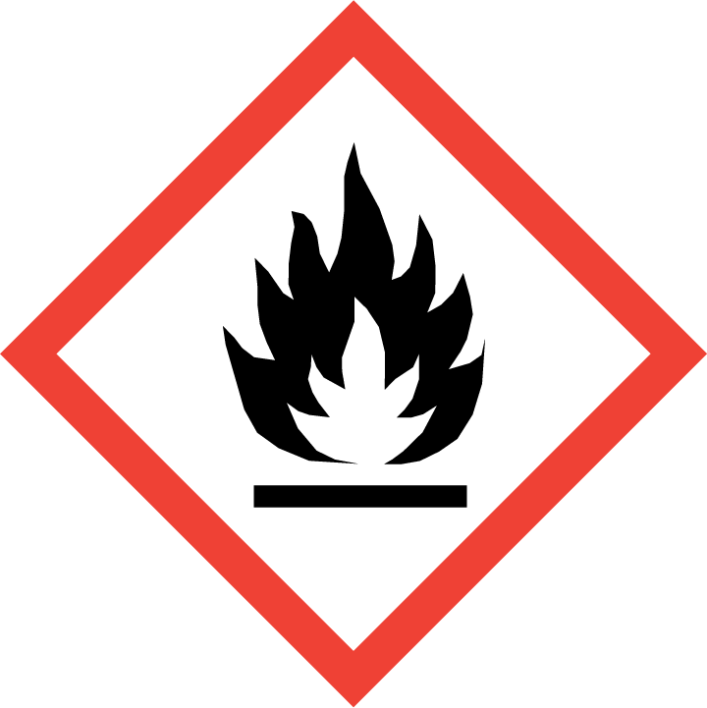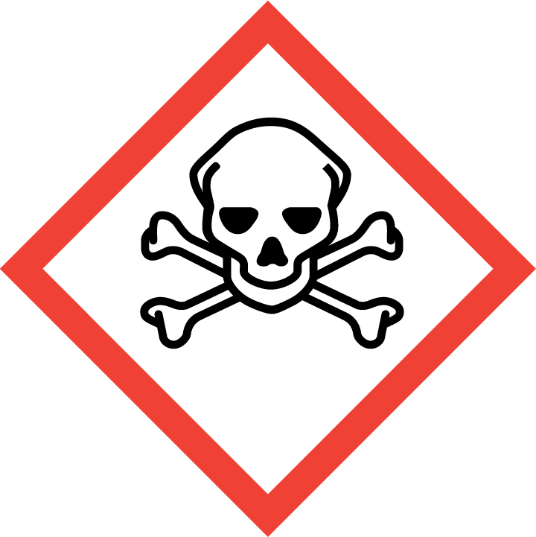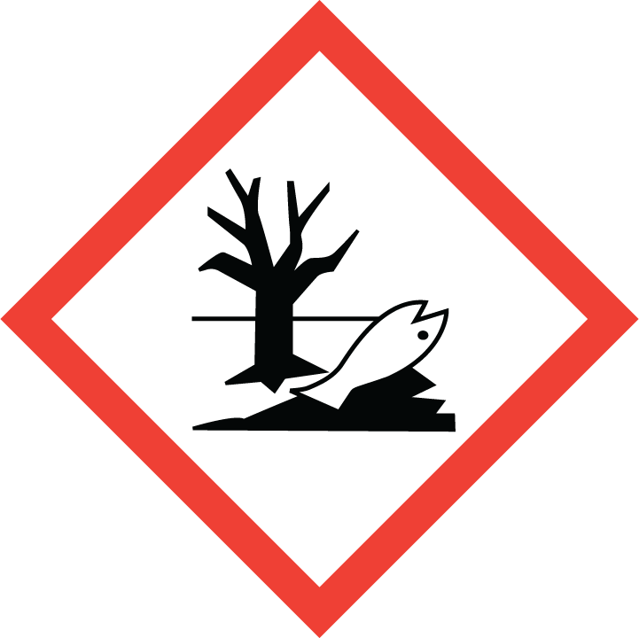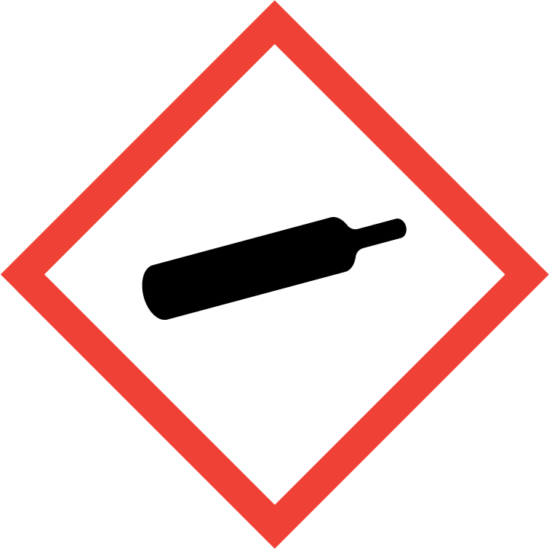
Danger

Hazard Classification:
Acute Aquatic Toxicity (Category 1)
Acute Gas Inhale Toxicity (Category 3)
Acute Oral Toxicity (Category 4)
Aspiration Hazard (Category 1)
Eye Effects (Category 2.B)
Flammable (Category 1)
Flammable Aerosol (Category 1)
Gases Under Pressure

Hazard Statements:
Causes eye irritation
Contains gas under pressure; may explode if heated
Extremely flammable aerosol
Extremely flammable gas
Harmful if swallowed
May be fatal if swallowed and enters airways
Toxic if inhaled
Very toxic to aquatic life

Precautionary Statements
Prevention:
Wash thoroughly after handling.
Avoid breathing dust/fume/gas/mist/ vapors/spray.
Do not eat, drink or smoke when using this product.
[In case of inadequate ventilation] wear respiratory protection.
Use only outdoors or in a well-ventilated area.
Keep away from heat/sparks/open flames/hot surfaces. - No smoking.
Pressurized container: Do not pierce or burn, even after use.
Do not spray on an open flame or other ignition source.

Response:
Eliminate all ignition sources if safe to do so.
Immediately call a poison center or doctor.
Leaking gas fire: Do not extinguish, unless leak can be stopped safely.
Do NOT induce vomiting.
If swallowed: Rinse mouth. Do NOT induce vomiting.
If in eyes: Rinse cautiously with water for several minutes. Remove contact lenses, if present and easy to do. Continue rinsing.
If inhaled: Remove person to fresh air and keep comfortable for breathing.

Storage:
Store in a well-ventilated place. Keep container tightly closed.
Protect from sunlight.
Store locked up.
Do not expose to temperatures exceeding 50C/122F.

Disposal:
Dispose of contents and/or container in accordance with applicable regulations.

Section 3: Composition/Information on Ingredients

CAS #
74-93-1

Chemical Substance | Chemical Family | Trade Names
METHYL MERCAPTAN | mercaptans | METHANETHIOL; THIOMETHANOL; MERCAPTOMETHANE; METHYL SULFHYDRATE; THIOMETHYL ALCOHOL; RCRA U153; STCC 4905520; UN 1064; CH4S

Section 4: First Aid Measures
Skin Contact | Eye Contact | Ingestion | Inhalation | Note to Physicians
If frostbite or freezing occur, immediately flush with plenty of lukewarm water (105-115 F; 41-46 C). DO NOT USE HOT WATER. If warm water is not available, gently wrap affected parts in blankets. Get immediate medical attention. | Wash eyes immediately with large amounts of water, occasionally lifting upper and lower lids, until no evidence of chemical remains. Get medical attention immediately. | If a large amount is swallowed, get medical attention. | If adverse effects occur, remove to uncontaminated area. Give artificial respiration if not breathing. If breathing is difficult, oxygen should be administered by qualified personnel. Get immediate medical attention. | For inhalation, consider oxygen.

Section 5: Fire Fighting Measures
Suitable Extinguishing Media | Products of Combustion | Protection of Firefighters
Carbon dioxide, alcohol resistant foam Let burn unless leak can be stopped immediately. Large fires: Use regular foam or flood with fine water spray. | Sulfur oxides, hydrogen sulfide | - Any self-contained breathing apparatus with a full facepiece. Use a chemical protective suit.  - Any self-contained breathing apparatus with a full facepiece. Use a chemical protective suit.

Section 6: Accidental Release Measures
Personal Precautions | Environmental Precautions | Methods for Containment
Keep unnecessary people away, isolate hazard area and deny entry. Stay upwind and keep out of low areas. Ventilate closed spaces before entering. Evacuation radius: 150 feet. For tank, rail car or tank truck: 800 meters (1/2 mile). Do not get water directly on material. Do not touch spilled material. | Avoid heat, flames, sparks and other sources of ignition. | Stop leak if possible without personal risk. Remove sources of ignition. Reduce vapors with water spray.

Methods for Cleanup | Other Information
Dig holding area such as lagoon, pond or pit for containment. Dike for later disposal. Absorb with sand or other non-combustible material. Absorb with activated carbon. Collect spilled material using mechanical equipment. | Notify Local Emergency Planning Committee and State Emergency Response Commission for release greater than or equal to RQ (U.S. SARA Section 304). If release occurs in the U.S. and is reportable under CERCLA Section 103, notify the National Response Center at (800)424-8802 (USA) or (202)426-2675 (USA).

Section 7: Handling and Storage
Handling | Storage
Store and handle in accordance with all current regulations and standards. Subject to storage regulations: U.S. OSHA 29 CFR 1910.101. Notify State Emergency Response Commission for storage or use at amounts greater than or equal to the TPQ (U.S. EPA SARA Section 302). SARA Section 303 requires facilities storing a material with a TPQ to participate in local emergency response planning (U.S. EPA 40 CFR 355.30). | Grounding and bonding required. Keep separated from incompatible substances.

Section 8: Exposure Controls/Personal Protection
Exposure Guidelines
METHYL MERCAPTAN: 10 ppm (20 mg/m3) OSHA ceiling 0.5 ppm (1 mg/m3) OSHA TWA (vacated by 58 FR 35338, June 30, 1993) 0.5 ppm ACGIH TWA 0.5 ppm (1 mg/m3) NIOSH recommended ceiling 15 minute(s)

Engineering Controls
Handle only in fully enclosed systems.
Eye Protection | Skin Protection | Respiratory Protection
Wear splash resistant safety goggles with a face shield. Provide an emergency eye wash fountain and quick drench shower in the immediate work area. | For the gas: Wear appropriate chemical resistant clothing. For the liquid: Wear appropriate protective, cold insulating clothing. | Any self-contained breathing apparatus with a full facepiece. Use a chemical protective suit.

General Hygiene considerations
- Avoid breathing vapor or mist
- Avoid contact with eyes and skin
- Wash thoroughly after handling and before eating or drinking

Section 9: Physical and Chemical Properties
Physical State | Appearance | Color | Change in Appearance | Physical Form | Odor | Taste
Gas | Clear | Colorless | N/A | Gas | Garlic odor | N/A

Flash Point | Flammability | Partition Coefficient | Autoignition Temperature | Upper Explosive Limits | Lower Explosive Limits
<0 F (<-18 C) (OC) | Not available | Not available | Not available | 0.218 | 0.039

Boiling Point | Freezing Point | Vapor Pressure | Vapor Density | Specific Gravity | Water Solubility | pH | Odor Threshold | Evaporation Rate | Viscosity
43 F (6 C) | -189 F (-123 C) | 1535 mmHg @ 21.1 C | 1.66 (Air=1) | Not applicable | 2.4% @ 20 C | Not applicable | 0.0021 ppm | Not applicable | Not available

Molecular Weight | Molecular Formula | Density | Weight per Gallon | Volatility by Volume | Volatility | Solvent Solubility
48.11 | C-H3-S-H | 1.999 g/L @ 20 C | Not available | 100% | Not applicable | Soluble: Alcohol, ether, petroleum ether, naphtha

Section 10: Stability and Reactivity
Stability | Conditions to Avoid | Incompatible Materials
Contact with water or moist air may form flammable and/or toxic gases or vapors. | Contact with water or moist air may form flammable and/or toxic gases or vapors. | Acids, metals, combustible materials, halo carbons, reducing agents, metal oxides, peroxides, oxidizing materials, nitric acid, mercury oxide, calcium hypochlorite

Hazardous Decomposition Products | Possibility of Hazardous Reactions
Oxides of sulfur | Will not polymerize.

Section 11: Toxicology Information

Acute Effects
Oral LD50 | Dermal LD50 | Inhalation
LC50, Inhalation, rat = 675 ppm. | Not available | Irritation, nausea, vomiting, wheezing, irregular heartbeat, headache, symptoms of drunkenness, bluish skin color, suffocation, lung congestion, blood disorders, kidney damage, liver damage, convulsions, coma

Eye Irritation | Skin Irritation | Sensitization
Irritation, blurred vision | Irritation, blisters | Harmful if inhaled, respiratory tract irritation, skin irritation, eye irritation, central nervous system depression

Chronic Effects
Carcinogenicity | Mutagenicity | Reproductive Effects | Developmental Effects
Not available | Available. | Not available | No data

Section 12: Ecological Information

Fate and Transport
Eco toxicity | Persistence / Degradability | Bioaccumulation / Accumulation | Mobility in Environment
Fish toxicity: 500 ug/L 5 hour(s) (Mortality) Spotfin shiner (Notropis spilopterus)  Invertibrate toxicity: 50000 ug/L 48 hour(s) (Mortality) Midge (Chironomus sp)  Algal toxicity: Not available  Phyto toxicity: Not available  Other toxicity: Not available | Not available | Not available | Not available

Section 13: Disposal Considerations
Dispose in accordance with all applicable regulations. Subject to disposal regulations: U.S. EPA 40 CFR 262. Hazardous Waste Number(s): U153.

Section 14: Transportation Information

U.S. DOT 49 CFR 172.101
Proper Shipping Name | ID Number | Hazard Class or Division | Packing Group | Labeling Requirements | Passenger Aircraft or Railcar Quantity Limitations | Cargo Aircraft Only Quantity Limitations | Additional Shipping Description
Methyl mercaptan | UN1064 | 2.3 | Not applicable | 2.3; 2.1 | Forbidden | Forbidden | Toxic-Inhalation Hazard Zone C

Canadian Transportation of Dangerous Goods
Shipping Name | UN Number | Class | Packing Group / Risk Group
Methyl mercaptan | UN1064 | 2.3; 2.1 | Not applicable

Section 15: Regulatory Information

U.S. Regulations
CERCLA Sections | SARA 355.30 | SARA 355.40
100 LBS RQ | 500 LBS TPQ | 100 LBS RQ

SARA 370.21
Acute | Chronic | Fire | Reactive | Sudden Release
Yes | No | Yes | No | Yes

SARA 372.65
METHYL MERCAPTAN: Administrative stay issued Aug. 22, 1994

OSHA Process Safety
5000 LBS TQ

State Regulations
CA Proposition 65
Not regulated.

Canadian Regulations
WHMIS Classification
ABD1

National Inventory Status
US Inventory (TSCA) | TSCA 12b Export Notification | Canada Inventory (DSL/NDSL)
Listed on inventory. | METHANETHIOL CAS NUMBER: 74-93-1 SECTION 4 | Not determined.

Section 16: Other Information
NFPA Rating
HEALTH=4 FIRE=4 REACTIVITY=0
0 = minimal hazard, 1 = slight hazard, 2 = moderate hazard, 3 = severe hazard, 4 = extreme hazard

