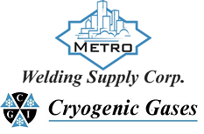 | Safety Data Sheet  Monomethylamine

Section 1: Product and Company Identification
Metro Welding Supply Corp.
12620 Southfield Road
Detroit, MI 48223
(313) 834-1660 [phone]
(313) 835-3562 [fax]
http://www.metrowelding.com/

Product Code: Monomethylamine

Section 2: Hazards Identification
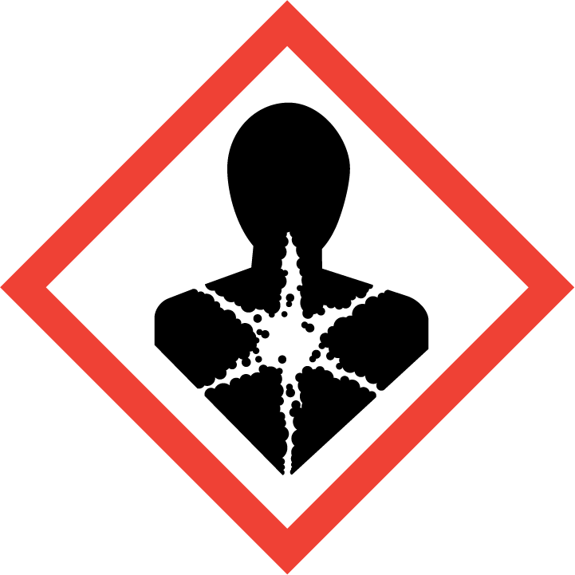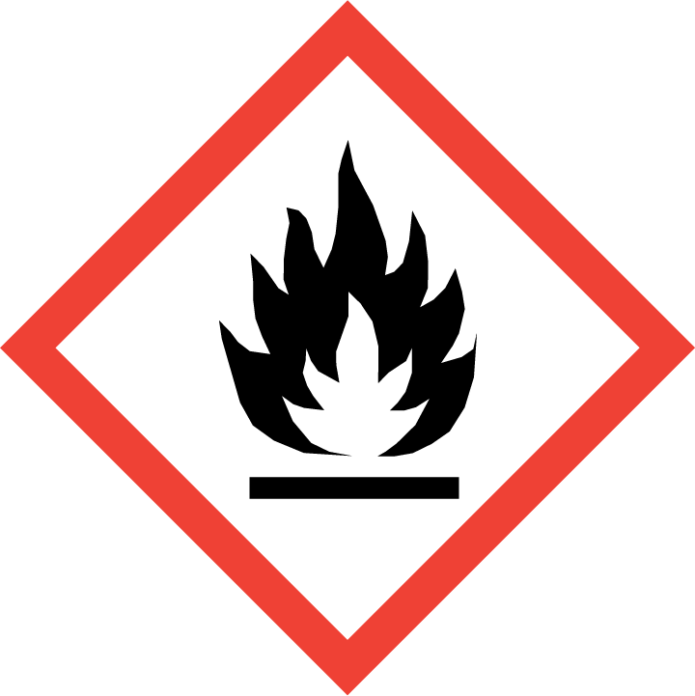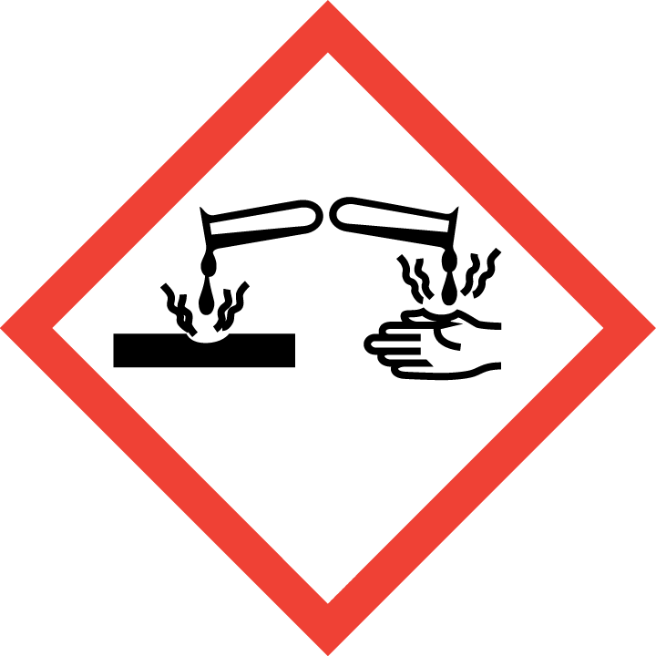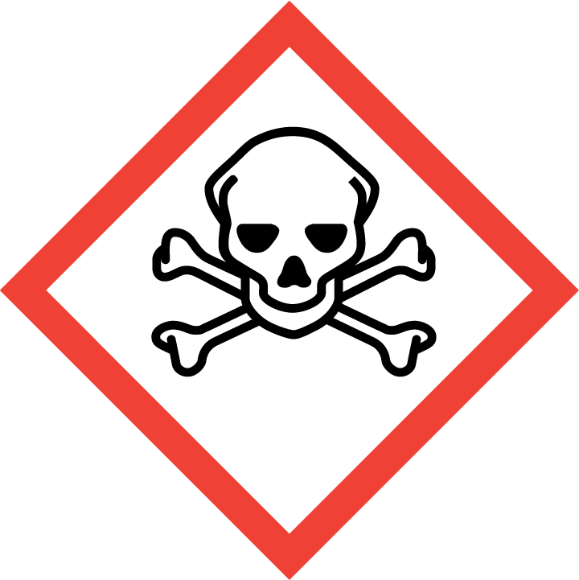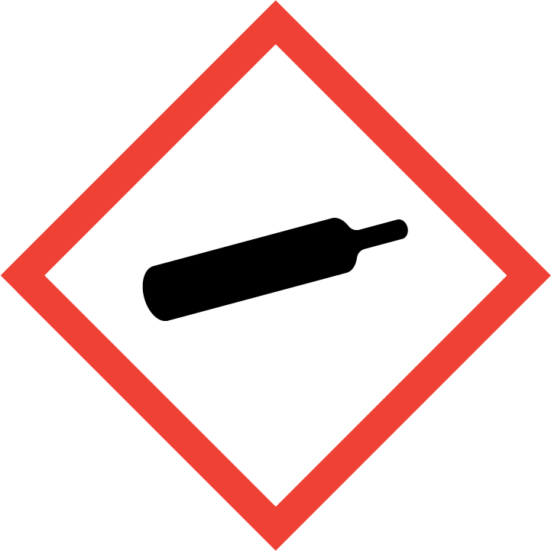
Danger

Hazard Classification:
Acute Dermal Toxicity (Category 2)
Acute Gas Inhale Toxicity (Category 3)
Acute Oral Toxicity (Category 3)
Aspiration Hazard (Category 1)
Eye Effects (Category 1)
Flammable (Category 1)
Flammable Aerosol (Category 1)
Gases Under Pressure
Skin Corrosion (Category 2)

Hazard Statements:
Causes serious eye damage
Causes skin irritation
Contains gas under pressure; may explode if heated
Extremely flammable aerosol
Extremely flammable gas
Fatal in contact with skin
May be fatal if swallowed and enters airways
Toxic if inhaled
Toxic if swallowed

Precautionary Statements
Prevention:
Wash thoroughly after handling.
Wear eye protection/face protection.
Do not eat, drink or smoke when using this product.
[In case of inadequate ventilation] wear respiratory protection.
Do not get in eyes, on skin, or on clothing.
Use only outdoors or in a well-ventilated area.
Keep away from heat/sparks/open flames/hot surfaces. - No smoking.
Avoid breathing dust/fume/gas/mist/ vapors/spray.
Pressurized container: Do not pierce or burn, even after use.
Do not spray on an open flame or other ignition source.

Response:
Eliminate all ignition sources if safe to do so.
Immediately call a poison center or doctor.
Leaking gas fire: Do not extinguish, unless leak can be stopped safely.
Do NOT induce vomiting.
Take off immediately all contaminated clothing and wash it before reuse.
If swallowed: Rinse mouth. Do NOT induce vomiting.
If skin irritation occurs: Get medical advice/attention.
If in eyes: Rinse cautiously with water for several minutes. Remove contact lenses, if present and easy to do. Continue rinsing.
Wash with plenty of water
If inhaled: Remove person to fresh air and keep comfortable for breathing.

Storage:
Store in a well-ventilated place. Keep container tightly closed.
Protect from sunlight.
Store locked up.
Do not expose to temperatures exceeding 50C/122F.

Disposal:
Dispose of contents and/or container in accordance with applicable regulations.

Section 3: Composition/Information on Ingredients

CAS #
74-89-5

Chemical Substance | Chemical Family | Trade Names
METHYLAMINE, ANHYDROUS | amines, aliphatic | MONOMETHYLAMINE; CARBINAMINE; AMINOMETHANE; METHANAMINE; M-223; MMA; METHYLAMINE; UN 1061; METHYLAMINE, GAS; ANHYDROUS METHYLAMINE; CH5N

Section 4: First Aid Measures
Skin Contact | Eye Contact | Ingestion | Inhalation | Note to Physicians
Remove contaminated clothing, jewelry, and shoes immediately. Wash with soap or mild detergent and large amounts of water until no evidence of chemical remains (at least 15-20 minutes). For burns, cover affected area securely with sterile, dry, loose-fitting dressing. Get medical attention. | Immediately flush eyes with plenty of water for at least 15 minutes. Then get immediate medical attention. | DO NOT induce vomiting. Never make an unconscious person vomit or drink fluids. Give large amounts of water or milk. When vomiting occurs, keep head lower than hips to help prevent aspiration. If person is unconscious, turn head to side. Get medical attention immediately. | If adverse effects occur, remove to uncontaminated area. Give artificial respiration if not breathing. If breathing is difficult, oxygen should be administered by qualified personnel. Get immediate medical attention. | For inhalation, consider oxygen. For skin contact, consider dilute acidic solution. For ingestion, consider esophagoscopy. Avoid gastric lavage.

Section 5: Fire Fighting Measures
Suitable Extinguishing Media | Products of Combustion | Protection of Firefighters
Regular dry chemical Large fires: Use regular foam or flood with fine water spray. avoid carbon dioxide | Nitrogen oxides, ammonia, hydrogen cyanide, nitriles, isocyanates, nitrosamines, carbon monoxide, carbon dioxide and other irritating and toxic fumes | - Any supplied-air respirator with a full facepiece. Use chemical protective suit.  - Any supplied-air respirator with a full facepiece. Use chemical protective suit.

Section 6: Accidental Release Measures
Personal Precautions | Environmental Precautions | Methods for Containment
Keep unnecessary people away, isolate hazard area and deny entry. | Avoid heat, flames, sparks and other sources of ignition. | Stop leak if possible without personal risk. Reduce vapors with water spray. Remove sources of ignition.

Methods for Cleanup | Other Information
Collect runoff for disposal as potential hazardous waste. Trap spilled material at bottom in deep water pockets, excavated holding areas or within sand bag barriers. Dike for later disposal. Absorb with sand or other non-combustible material. Add dilute acid. Cover with absorbent sheets, spill-control pads or pillows. Neutralize. Collect with absorbent into suitable container. Add a reducing agent. Collect spilled material using mechanical equipment. | Notify Local Emergency Planning Committee and State Emergency Response Commission for release greater than or equal to RQ (U.S. SARA Section 304). If release occurs in the U.S. and is reportable under CERCLA Section 103, notify the National Response Center at (800)424-8802 (USA) or (202)426-2675 (USA).

Section 7: Handling and Storage
Handling | Storage
Store and handle in accordance with all current regulations and standards. Subject to storage regulations: U.S. OSHA 29 CFR 1910.101. Inside storage: Store in a cool, dry place. Store in a well-ventilated area. Avoid heat, flames, sparks and other sources of ignition. | Protect from physical damage. Store outside or in a detached building. Store with flammable liquids. Keep separated from incompatible substances.

Section 8: Exposure Controls/Personal Protection
Exposure Guidelines
METHYLAMINE, ANHYDROUS: METHYLAMINE: 10 ppm (12 mg/m3) OSHA TWA 5 ppm ACGIH TWA 15 ppm ACGIH STEL 10 ppm (12 mg/m3) NIOSH recommended TWA 10 hour(s)

Engineering Controls
Handle only in fully enclosed systems.
Eye Protection | Skin Protection | Respiratory Protection
Wear splash resistant safety goggles with a face shield. Provide an emergency eye wash fountain and quick drench shower in the immediate work area. | Wear appropriate chemical resistant clothing. | Any supplied-air respirator with a full facepiece. Use chemical protective suit.

General Hygiene considerations
- Avoid breathing vapor or mist
- Avoid contact with eyes and skin
- Wash thoroughly after handling and before eating or drinking

Section 9: Physical and Chemical Properties
Physical State | Appearance | Color | Change in Appearance | Physical Form | Odor | Taste
Gas | Clear | Colorless | N/A | Gas | Ammonia odor | N/A

Flash Point | Flammability | Partition Coefficient | Autoignition Temperature | Upper Explosive Limits | Lower Explosive Limits
-32 F (-0 C) TOC | Not available | Not available | 806 F (430 C) | 0.207 | 0.049

Boiling Point | Freezing Point | Vapor Pressure | Vapor Density | Specific Gravity | Water Solubility | pH | Odor Threshold | Evaporation Rate | Viscosity
21 F (-6 C) | -137 F (-94 C) | 2250 mmHg @ 20 C | 1.08 (Air=1) | Not applicable | 108% @ 25 C | Basic | 0.02 ppm | >1 (butyl acetate=1) | 0.00666 cP @ 25 C

Molecular Weight | Molecular Formula | Density | Weight per Gallon | Volatility by Volume | Volatility | Solvent Solubility
31.06 | C-H3-N-H2 | 1.302 g/L @ 20 C | Not available | Not available | Not applicable | Soluble: Alcohol, ether, acetone, benzene

Section 10: Stability and Reactivity
Stability | Conditions to Avoid | Incompatible Materials
Stable at normal temperatures and pressure. | Stable at normal temperatures and pressure. | Acids, metals, halogens, combustible materials, oxidizing materials, halogenating agents, epoxides, carbon dioxide

Hazardous Decomposition Products | Possibility of Hazardous Reactions
Oxides of carbon, nitrogen | Will not polymerize.

Section 11: Toxicology Information

Acute Effects
Oral LD50 | Dermal LD50 | Inhalation
100 mg/kg oral-rat LD50 | Irritation : : 100 mg open skin-guinea pig severe | Irritation (possibly severe), nausea, difficulty breathing, headache, lung congestion, convulsions

Eye Irritation | Skin Irritation | Sensitization
Irritation (possibly severe), tearing, blindness | Irritation (possibly severe), allergic reactions, nausea, headache | Harmful if inhaled, respiratory tract burns, skin burns, eye burns, mucous membrane burns, allergic reactions

Chronic Effects
Carcinogenicity | Mutagenicity | Reproductive Effects | Developmental Effects
Not available | Available. | Not available | No data

Section 12: Ecological Information

Fate and Transport
Eco toxicity | Persistence / Degradability | Bioaccumulation / Accumulation | Mobility in Environment
Fish toxicity: 1000000 ug/L 48 hour(s) LC50 (Mortality) Medaka, high-eyes (Oryzias latipes)  Invertibrate toxicity: 163000 ug/L 48 hour(s) EC50 (Immobilization) Water flea (Daphnia magna)  Algal toxicity: 3100 ug/L 96 hour(s) (Physiological) Green algae (Gloeotaenium loitlesbergerianu)  Phyto toxicity: Not available  Other toxicity: Not available | Not available | 6910 ug/L 24 hour(s) BCF (Residue) Diatom (Cyclotella cryptica) 110 ug/L | Not available

Section 13: Disposal Considerations
Dispose in accordance with all applicable regulations. Subject to disposal regulations: U.S. EPA 40 CFR 262.

Section 14: Transportation Information

U.S. DOT 49 CFR 172.101
Proper Shipping Name | ID Number | Hazard Class or Division | Packing Group | Labeling Requirements | Passenger Aircraft or Railcar Quantity Limitations | Cargo Aircraft Only Quantity Limitations | Additional Shipping Description
Methylamine, anhydrous | UN1061 | 2.1 | Not applicable | 2.1 | Forbidden | 150 kg | N/A

Canadian Transportation of Dangerous Goods
Shipping Name | UN Number | Class | Packing Group / Risk Group
Methylamine, anhydrous | UN1061 | 2.1 | Not applicable

Section 15: Regulatory Information

U.S. Regulations
CERCLA Sections | SARA 355.30 | SARA 355.40
100 LBS RQ | Not regulated. | Not regulated.

SARA 370.21
Acute | Chronic | Fire | Reactive | Sudden Release
Yes | Yes | Yes | No | Yes

SARA 372.65
Not regulated.

OSHA Process Safety
1000 LB TQ

State Regulations
CA Proposition 65
Not regulated.

Canadian Regulations
WHMIS Classification
ABD1E

National Inventory Status
US Inventory (TSCA) | TSCA 12b Export Notification | Canada Inventory (DSL/NDSL)
Listed on inventory. | Not listed. | Not determined.

Section 16: Other Information
NFPA Rating
HEALTH=4 FIRE=4 REACTIVITY=0
0 = minimal hazard, 1 = slight hazard, 2 = moderate hazard, 3 = severe hazard, 4 = extreme hazard

